**YORK CONDOMINIUM CORPORATION NUMBER 84**

**FIFTY (50) of us have requested notices to be delivered electronically, to provided email addresses. This package is being delivered on paper. It is just too large to send by email.**

**After the October 30 AGM, accepted information, from this package, will be published on the Corporation’s website, www.ycc84.ca**

**This October 30 Annual General Meeting is arguably about the most important members’ meeting ever held.**

**Our operating by-law # 1 has been in effect since the very beginning (1973). The corporation is now governed by a third Condominium Act of Ontario. other by-laws were developed by the directors and property manager without review by a lawyer.**

**Times have changed. To protect all interests, a specialist condominium lawyer was contracted to review and propose amendments. These are attached.**

**In person; or, BY proxy acceptance is necessary.**

**YOUR VOTE IS NEEDED – DO NOT MISS THIS OPPORTUNITY.**

|  |  |
| --- | --- |
| **YORK CONDOMINIUIM CORPORATION NUMBER 84** | **Preliminary Notice of Meeting of Owners**  **OCTOBER 30, 2019-Highcastle School-7 PM**  **Advance information for owners about a proposed meeting of owners** |

September 25, 2019

Our Annual General Meeting is scheduled for 7 PM on Wednesday October 30 at Highcastle School.

The agenda will be:

1. President’s Address
2. Accept the minutes of the 2018 Annual General Meeting as previously distributed
3. Accept the audited financial report
4. Nominate and appoint the external auditor for the term ending May 31, 2020
5. Accept proposed **By-law 19** (General Operating By-law) to replace By-law 1.

By-law Nos. 1, 2, 3, 4, 5, 6, 7, 8, 9, 10, 11, 12, 13, 15, 16, and 17 are repealed.

1. Accept proposed **By-law 18** (Standard Unit) replacing the current By-law 15.
2. Accept proposed **By-law 20** (Mediation and Arbitration)
3. Accept proposed **By-law 21** (Authorizing Electronic Voting by Members).

This is a business by-law requiring only 50% affirmative votes of the attendees.

1. Director – Ratify Sandy Mantini as a director for the next two years being the last two years of a three years term. After the last AGM the board was short one director. Sandy agreed to fill that position until the next AGM – that being tonight.
2. **Nominate and elect** directors for three expiring directors’ positions.
3. Close the meeting.

Attached is the formal Preliminary Notice of Meeting of Owners. This is a Province of Ontario standardized form being used by all condominium corporations in Ontario. This is a requirement of the revised Condominium Act of Ontario. Shortly you will be receiving the Notice of Meeting and a Proxy form – the revised Act has also standardized these forms. With the Notice of Meeting you will also receive a proposed new by-law Authorizing Electronic Voting by Members.

You are strongly urged to attend this AGM on October 30.

YORK CONDOMINIUM CORPORATION

Management

**Electronic Notices** – You are receiving this paper/hard copy notice because you have not provided permission for notices to be sent direct to your email address. Please contact management and they will provide a copy of the required Province of Ontario Agreement to Receive Notices Electronically form – it takes less than a minute to complete.

|  |  |
| --- | --- |
| **YORK CONDOMINIUM CORPORATION NUMBER 84** 331 Military Trail, Toronto, ON M1E 4E3 | **Preliminary Notice of Meeting of Owners**  **OCTOBER 30 2019-Highcastle School-7 PM**  **Advance information for owners about a proposed meeting of owners** |

**Instruction: -** The purpose of this preliminary notice of meeting is to provide additional advance notice of a planned owners’ meeting, before the notice of meeting is prepared and sent to owners. Among other things, this preliminary notice provides ways for owners to suggest material to be included in the notice of meeting. The corporation is still required to send out a notice of meeting to confirm the meeting date and provide additional information to owners about the meeting.

**Section 2:** You may provide information to the board in response to this notice in the following way:

By delivering the information to: K.R. Property Management Agency Inc.

**Section 3:** Summary of the Purpose of the Meeting: Annual General Meeting of members as required by the Condominium Act.

**Section 4:** This meeting will include discussion of a proposed change to the by-laws. **The purposes of the proposed changes are:**

To meet the requirements of the Condominium Act regarding a by-law:

1. Proposed **By-law 19** (General Operating By-law)
2. Proposed **By-law 18** (Standard Unit)
3. Proposed **By-law 20** (Mediation and Arbitration)
4. Proposed **By-law 21** (Authorizing Electronic Voting by Members)

To ratify one director’s position for a two years term and to elect directors to fill three positions which expire with this meeting.

**Section 5:** Request by owners to include material (including any record of the corporation) in the upcoming Notice of Meeting.

**If you will to be a candidate for a director position and have your name printed on the meeting Proxy form Management must receive email/written notice of your intention by 2019/10/04.**

If you wish to request that any material be included in the notice calling this meeting, please deliver the material to the Board to the addresses or in the manner specified above (see item 2 of this form) by the date **2019/10/04**.

Although you can request that material be included in the notice of meeting, the board is not obligated to include this material unless, among other requirements the owners of a least 15% of the units request that the material be included. For more detail, please refer to the form called “Submission to Include Material in the Notice of Meeting of Owners” which is available on the Government of Ontario website, and s. 12.8(1)(a) of Ontario Regulation 48/01 under the Condominium Act, 1998.

**Note: A**ll references in this form to “unit(s)” should(s) be read as references to “common interest(s) in the corporation, and all references to “unit owner(s)” should be read as references to “the owner(s)” of a common interest in the corporation”.

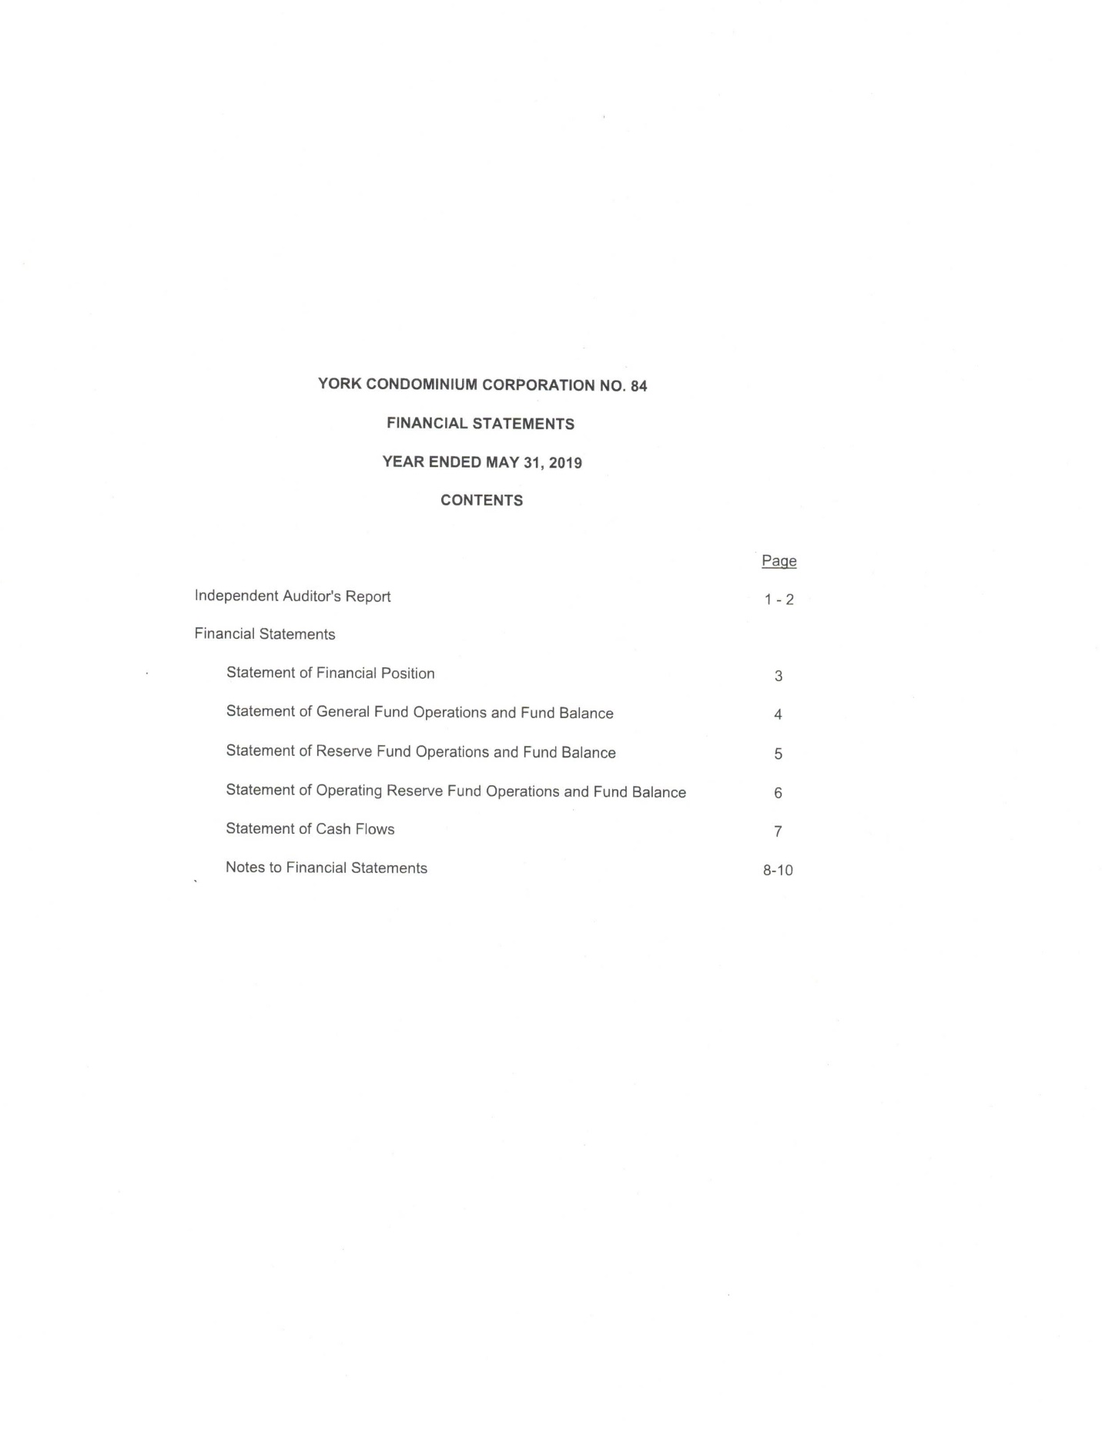

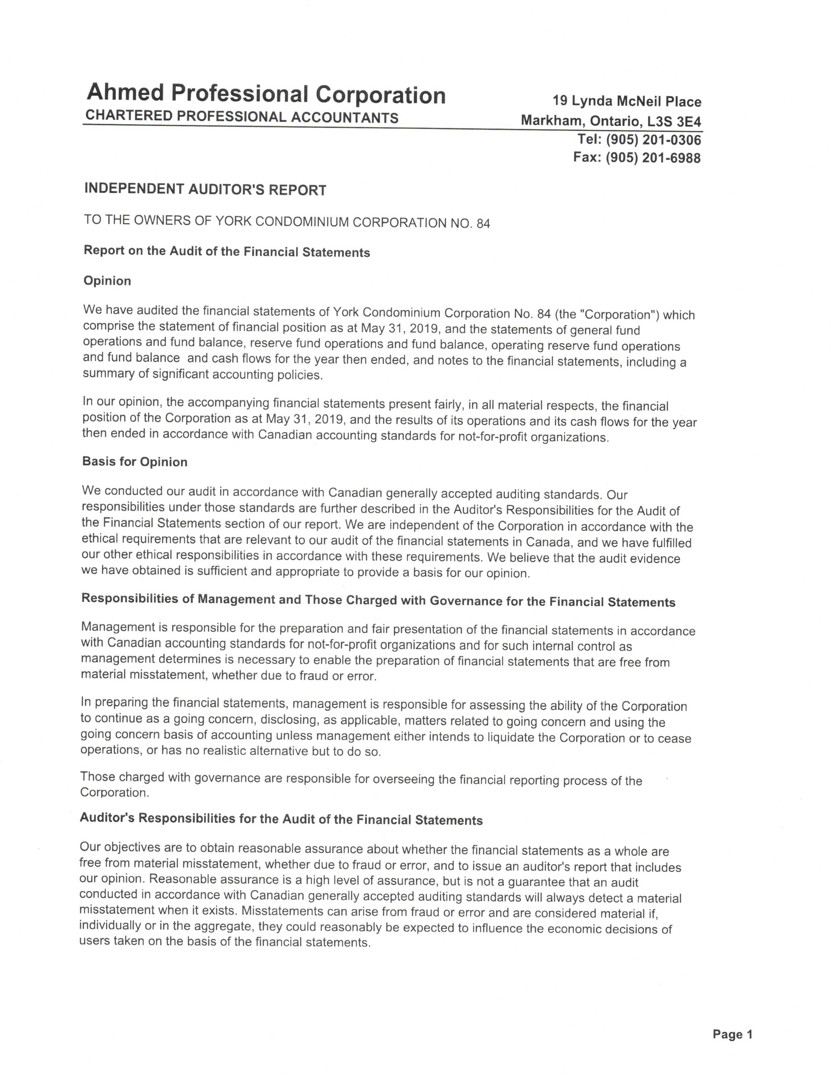

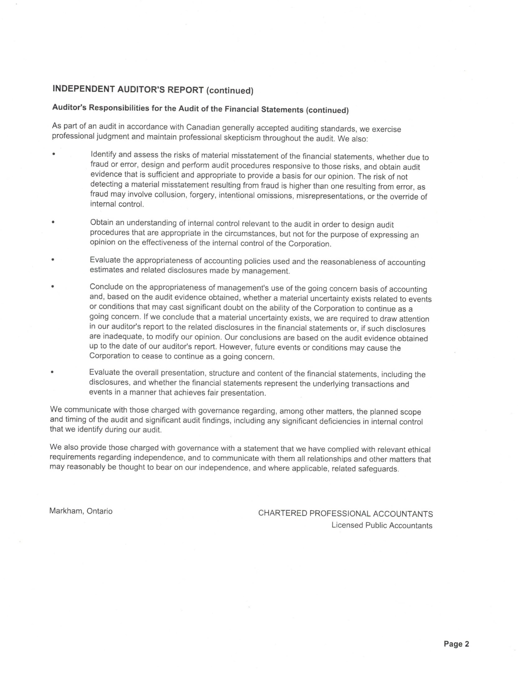

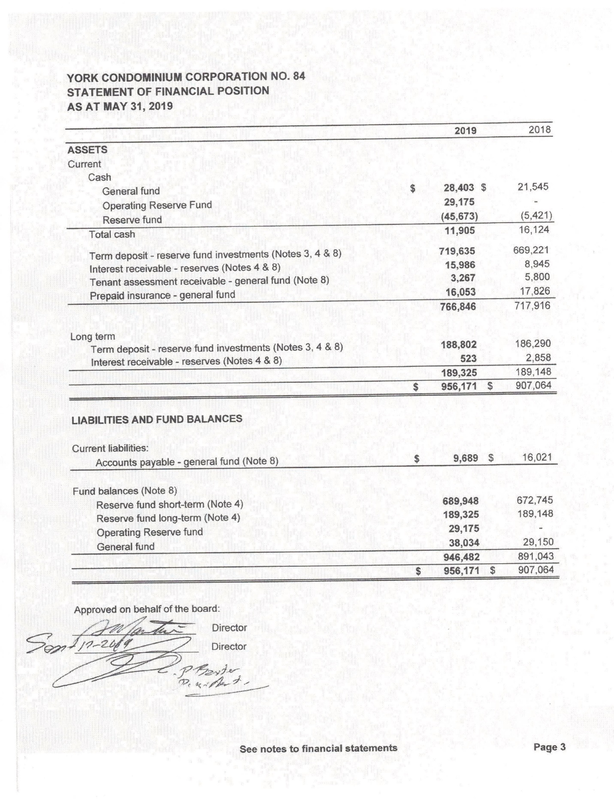

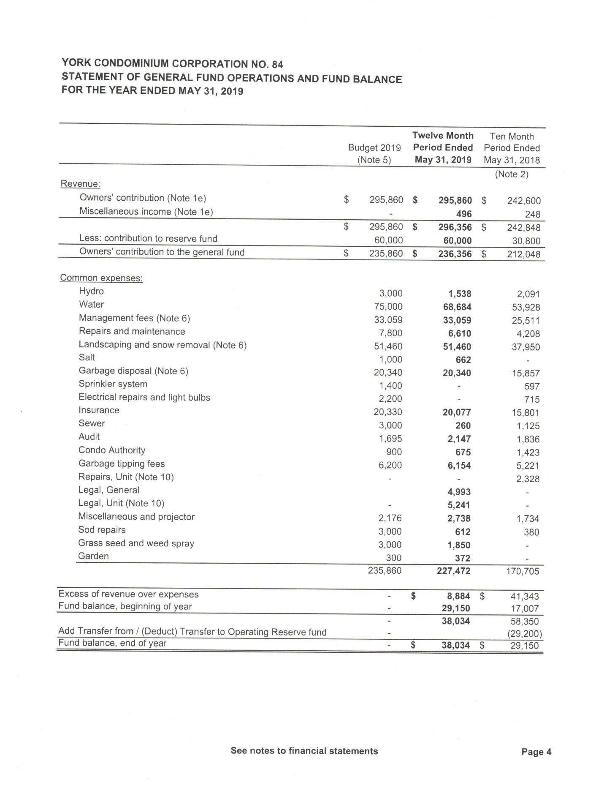

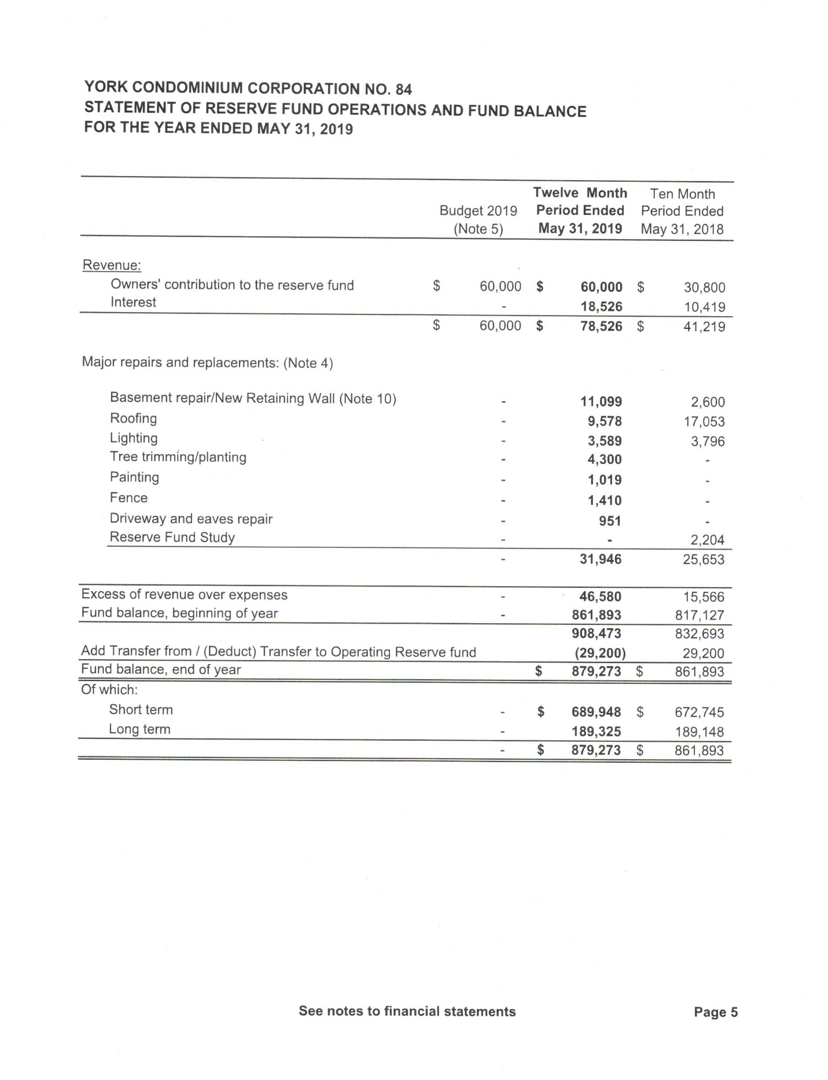

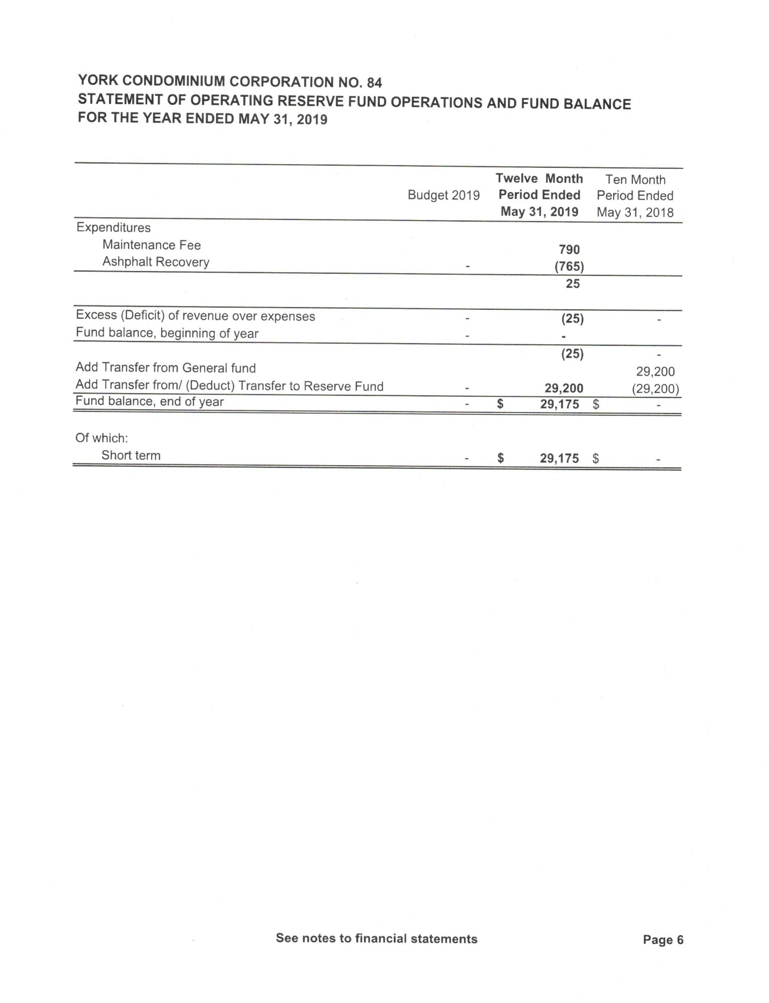

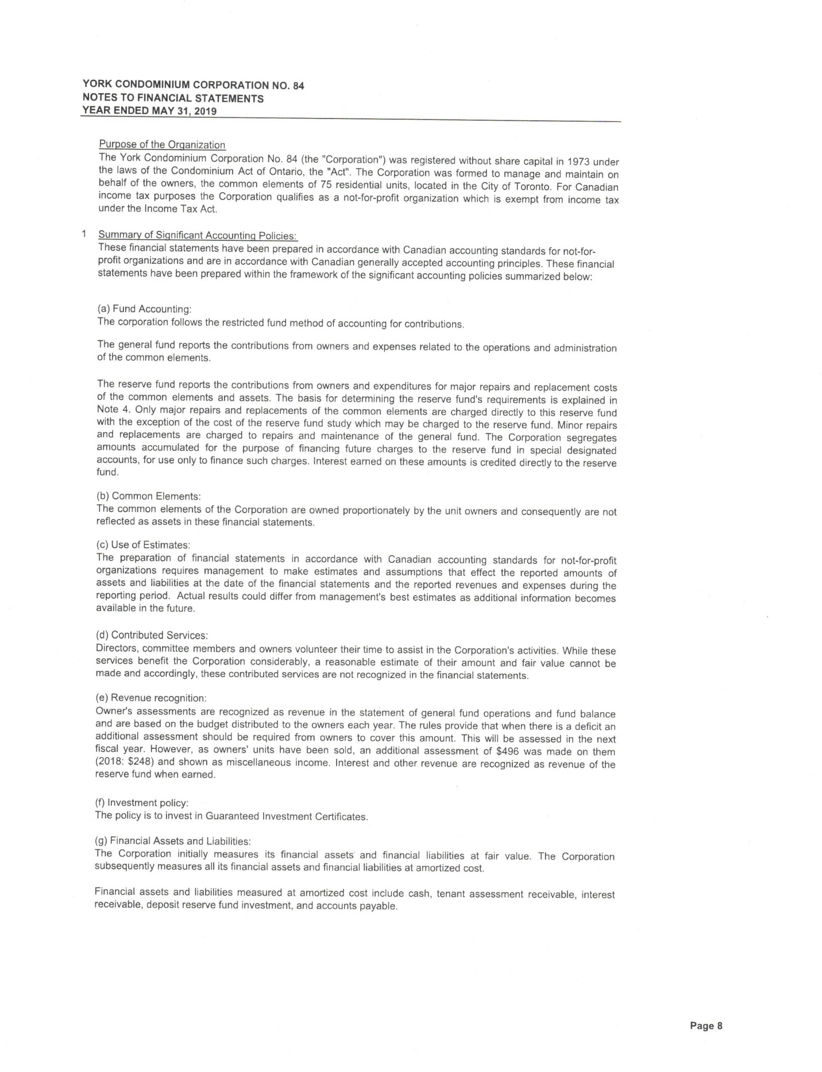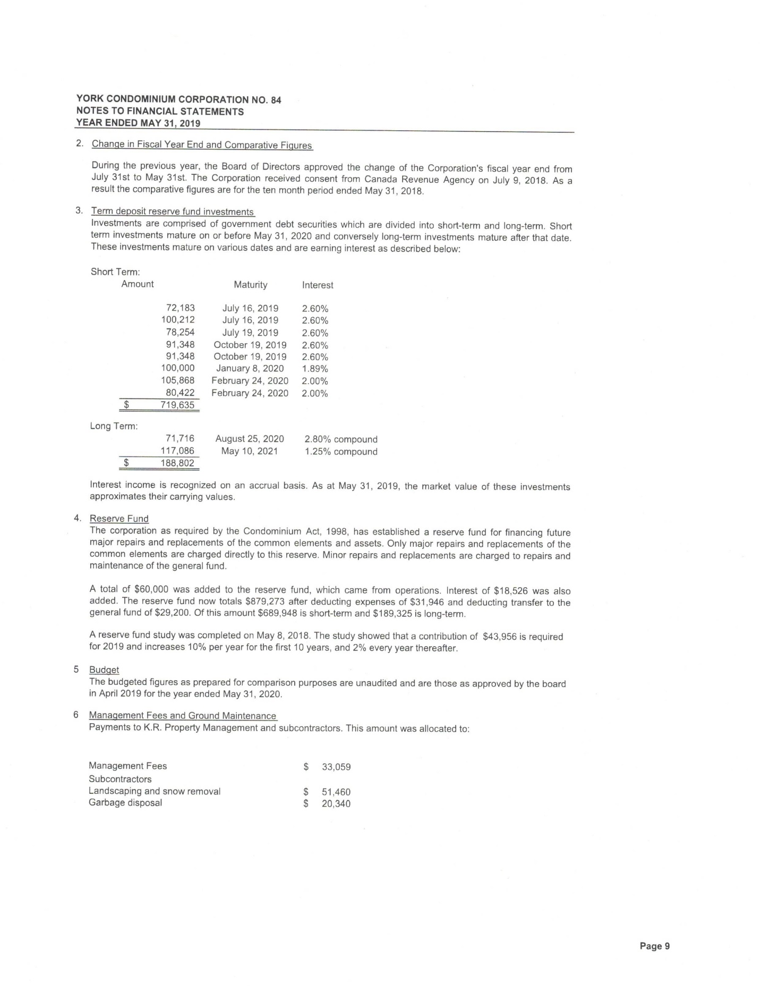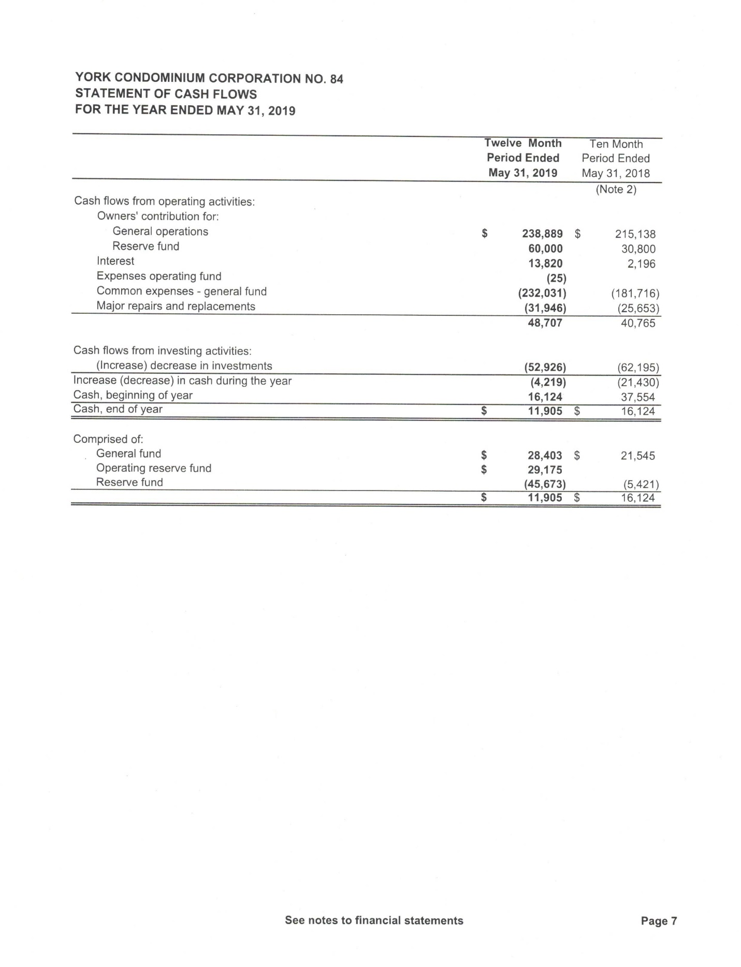

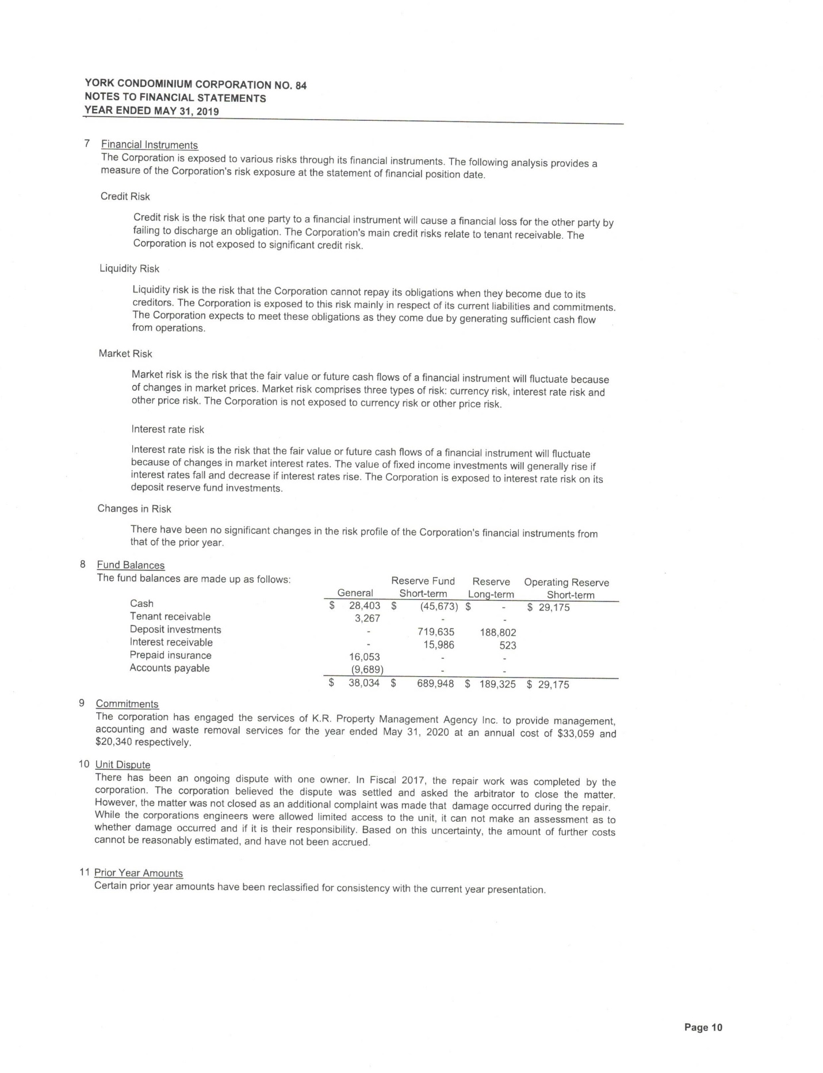

**YORK CONDOMINIUM CORPORATION NO. 84**

**GENERAL OPERATING**

**BY-LAW # 19**

**BY-LAW NO. 19**

**YORK CONDOMINIUM CORPORATION NUMBER 84**

**TABLE OF CONTENTS**

**Page No.**

**ARTICLE 1 SEAL 1**

**ARTICLE 2 YEAR-END 1**

**ARTICLE 3 RECORDS OF THE CORPORATION 1**

3.1 Records Required to be Maintained 1

3.2 Core Records 3

**ARTICLE 4 DUTIES OF THE CORPORATION 4**

4.1 Duties Of The Corporation 4

**ARTICLE 5 POWERS OF THE CORPORATION 5**

5.1 Powers Of The Corporation 5

**ARTICLE 6 NOTICE 7**

6.1 Notice to Owner/Mortgagee 7

6.2 Notice Exception 7

6.3 Notice To The Board Or Corporation 7

6.4 Receipt of Notice 7

6.5 Omissions And Errors 8

**ARTICLE 7 BOARD OF DIRECTORS 8**

7.1 Duties 8

7.2 Number and Quorum 8

7.3 Qualifications 8

7.4 Disqualification 9

7.5 Code Of Ethics Breach 9

7.6 Disclosure Obligations 10

7.7 Timing of Disclosure Obligations 11

7.8 Election And Term 11

7.9 Calling Of Meetings 11

7.10 Declaration Of Interest 12

7.11 Confidentiality 12

7.12 Conflict of Interest 12

7.13 Protection Of Directors And Officers 12

7.14 Indemnity Of Directors And Officers 13

7.15 Consents 13

**ARTICLE 8 OFFICERS 13**

8.1 Election Of President 13

8.2 Appointed Officers 13

8.3 Term Of Office 13

8.4 President 13

8.5 Vice-President 14

8.6 Secretary 14

8.7 Treasurer 14

8.8 Condominium Management 14

8.9 Officers 15

8.10 Committees 15

**ARTICLE 9 MEETINGS OF THE OWNERS 15**

9.1 Annual Meetings 15

9.2 Special Meetings 15

9.3 Preliminary Notice 15

9.4 Notices Of Meetings of Owners 15

9.5 Persons Entitled To Be Present 15

9.6 Quorum 16

9.7 Voting 16

9.8 Method of Voting 16

9.9 Representatives 17

9.10 Proxies 17

9.11 Co-Owners 17

9.12 Owners’ Charter of Rights and Responsibilities 17

**ARTICLE 10 ADDITIONAL RIGHTS OF THE CORPORATION 17**

10.1 Rights of the Corporation 17

10.2 Occupancy Standards 18

10.3 Non-Resident Access to Common Elements 18

10.4 Indemnification and Insurance Deductible 19

**ARTICLE 11 ASSESSMENT AND COLLECTION OF COMMON EXPENSES 19**

11.1 Annual Budget 19

11.2 Reserve Fund 19

11.3 Extraordinary Expenditures 20

11.4 Owners’ Obligations To Pay Assessments 20

11.5 Default In Payment 20

**ARTICLE 12 BANKING ARRANGEMENTS, CONTRACTS AND EXECUTION OF INSTRUMENTS 21**

12.1 Banking Arrangements 21

12.2 Execution of Instruments 21

12.3 Execution of Status Certificates, Certificates of Lien and Discharges of Liens, Information Certificates, Condominium Returns and Notices of Change 21

**ARTICLE 13 MISCELLANEOUS 21**

13.1 Severability 21

13.2 Waiver 21

13.3 Headings 21

13.4 Amendment 21

13.5 Inconsistencies/Conflicts 21

**SCHEDULES**

The Corporation may amend or rescind Schedule items without membership approval.

A DIRECTORS’ CODE OF ETHICS

B OWNERS’ CHARTER OF RIGHTS AND RESPONSIBILITIES

**BY-LAW NO. 19  
YORK CONDOMINIUM CORPORATION NO. 84**

**BE IT ENACTED** as a By-law of York Condominium Corporation No. 84 (the “**Corporation**”) as follows:

By-law Nos. 1, 2, 3, 4, 5, 6, 7, 8, 9, 10, 11, 12, 13, 15, 16, and 17 of York Condominium Corporation No. 84 are hereby repealed.

In addition to those words, terms and/or phrases specifically defined in this By-law, the words, terms and/or phrases used herein which are defined in the *Condominium Act*, *1998*, S.O. 1998, C.19 as amended and the regulations made thereunder (hereinafter collectively referred to as the “**Act**”) and in the declaration of the Corporation (hereinafter referred to as the “**Declaration**”) shall have ascribed to them the meanings set out in the Act or the Declaration, unless the context requires otherwise.

**SEAL**

Notwithstanding that the Corporation has a seal, any documents or instruments executed by or on behalf of the Corporation and intended to bind the Corporation (including any documents or instruments that would ordinarily require the seal of the Corporation to be affixed thereto) need not be executed under seal, provided the statement “I/We have the authority to bind the Corporation” is noted below the signature(s) of the person(s) duly authorized to sign any such documents or instruments for and on behalf of the Corporation, and such documents shall accordingly have the same force and effect for all purposes as if same had been executed under the seal of the Corporation.

**YEAR-END**

The fiscal year-end of the Corporation shall be ⚫ in each year or such other date as the board of directors (the “**Board**”) may by resolution determine.

**RECORDS OF THE CORPORATION**

**Records Required to be Maintained**

The Corporation shall maintain all records required by sections 46.1 and 55 of the Act for the periods of time specified by the Act, including the following records:

all core records listed in Article 3.2 herein;

the financial records of the Corporation;

a minute book containing the minutes of owners’ meetings and the minutes of Board meetings;

all information returns and notices of change filed with the Registrar pursuant to the Act;

a copy of all status certificates issued by the Corporation together with all notices issued by or to the Corporation which accompany or are referred to in the said status certificates;

a record of the statements and information provided to the Board or the Corporation in accordance with Article 7.6 herein;

all material and records provided to or obtained by the Corporation with respect to training courses completed by a person who is or was a director of the Corporation;

all records that it has (or which are under its control) related to employees of the Corporation;

all records relating to actual or contemplated litigation (or insurance claims or investigations) involving the Corporation that the Corporation creates or receives, together with copies of any court order where the Corporation was a party to the proceedings and any judgment against the Corporation;

all records that relate to specific units or owners that the Corporation creates or receives;

an up-to-date record of which units are in arrears of common expenses;

the following documents and information that the Corporation receives and that relates to the property or to any real or personal property that the Corporation owns or that is the subject of a shared facilities agreement to which the Corporation is a party: (i) existing and expired warranties and guarantees; (ii) reports and opinions of an architect, engineer, or other person whose profession lends credibility to the report or opinion; and (iii) drawings and plans;

records that relate to a right, title, interest, encumbrance or demand of any kind affecting land in relation to the Corporation, but not including the interest of an owner in the owner’s unit or common interest, and that the Corporation creates or receives;

records that relate to a change (or modification, as applicable) under section 97 or 98 of the Act and that the Corporation creates or receives;

all proxy instruments or ballots for a meeting of owners;

a record of all recorded votes cast at a meeting of owners by a recorded vote that is indicated by telephonic or electronic means;

a copy of all agreements entered into by or on behalf of the Corporation that are current and that have expired;

a copy of all insurance policies that the Corporation has obtained and maintains, and that have expired;

a copy of all redacted versions of any of the records listed in this Article 3.1;

a copy of all applications made under Section 109 of the Act to amend the Declaration (if applicable) for which the court has not made an order;

copies of any resolution of the Board changing the address for service or mailing address of the Corporation;

a copy of any order appointing an inspector or administrator, if applicable, pursuant to section 130 or 131 of the Act, together with any report that the Corporation receives from an inspector in accordance with subsection 130(4) of the Act;

any report or opinion received from an inspector, administrator, mediator, arbitrator, appraiser, lawyer, auditor, engineer, contractor or agent;

a copy of all minutes of settlement and/or written decisions made by any mediator or arbitrator appointed pursuant to section 132 of the Act regarding any issue(s) in dispute involving the Corporation (or to which the Corporation is a party), together with copies of all court orders issued in those circumstances where the Corporation was a party to the proceeding or otherwise directly affected thereby;

a copy of all orders made by the Condominium Authority Tribunal regarding any issues in dispute involving the Corporation (or to which the Corporation is a party);

the names of directors and officers, their mailing address and other contact information and respective terms of office and all directors’ signed consent forms;

a copy of all annual notices of assessment and notices of any extraordinary assessments;

a copy of all notices of lien issued by the Corporation to delinquent owners pursuant to subsection 85(4) of the Act, in respect of which the corresponding certificates of lien have not been discharged or vacated by court order;

the seal of the Corporation;

bills of sale or transfers for all items that are assets of the Corporation but not part of the property;

a record of all reserve fund studies, updates, notices of future funding, reserve fund summaries, funding plans, statements of differences and investment plans of the Corporation; and

any other information required to be maintained as records by the Act or specified in any other by-law of the Corporation.

**Core Records**

The following records constitute core records pursuant to the Act:

a copy of the Declaration, by-laws, and rules of the Corporation;

the budget for the Corporation’s current fiscal year and all amendments, if any, made to that budget;

the most recent financial statements that the board has approved under subsection 66(3) of the Act;

the most recent auditor’s report presented to the audit committee or to the board under subsection 67(6) of the Act;

the current plan proposed by the board under subsection 94(8) of the Act for future funding of the reserve fund;

the owners’ names and identification of the units, and the owners’ addresses for service if the addresses for service are in Ontario, if the owners give notice to the Corporation in writing with such information;

the names of the mortgagees, identification of the units, and the mortgagees’ addresses for service, if: (i) the mortgagee gives notice to the Corporation in writing, setting out the mortgagee’s names and, in accordance with the Act, identifies the unit that is the subject of the mortgage; (ii) under the terms of the mortgage, the mortgagee has the right to vote at a meeting of owners in the place of the unit owner or to consent in writing in the place of the unit owner, and the mortgagee notifies the Corporation of such right, including any change in the address for service; and (iii) the mortgagee’s addresses for service is in Ontario;

the names of all owners or mortgagees who have agreed in writing to a method of electronic communication and a statement of that method;

a record of all written notices from an owner that a unit is leased, together with the lessee’s name, the owner’s address and a copy of the lease or renewal or summary of it, in the form prescribed by the Minister;

a record of all written notices from an owner that a lease of a unit is terminated and not renewed;

all periodic information certificates that the Corporation, within the twelve (12) month period before receiving the request for records or a requester’s response, sent to the owners under section 26.3 of the Act or was required by that section to send to the owners; and

the minutes of owners or meetings of the board within the twelve (12) month period before the Corporation receives a request for records or a requester’s response.

**DUTIES OF THE CORPORATION**

**Duties Of The Corporation**

In addition to the duties and obligations set forth in the Declaration, the duties of the Corporation shall include, but shall not be limited to the following:

control, management and administration of the common elements, the assets of the Corporation and any unit (if applicable) in a fit and proper condition, including, without limitation, the operation, care, upkeep, maintenance, replacement and repair of the common elements and assets; the maintenance of units when an owner fails to maintain the unit within a reasonable time and if the failure presents a potential risk of personal injury to persons on the property or a potential risk of damage to the property; and the repair after damage of units where the owner fails to carry out a repair after damage to the unit in accordance with the Declaration and section 92 of the Act;

the assessment of contributions toward common expenses from the owners;

taking all reasonable steps to collect contributions towards common expenses from all of the owners, and maintaining and enforcing the Corporation’s lien arising pursuant to the Act against each unit in respect of which the owner has defaulted in the payment of common expenses and instructing legal counsel and/or the Corporation’s condominium manager to prepare, register and discharge, following payment, certificates of lien;

arranging for the supply of and collection of charges for utilities to the common elements and the units (unless separately metered), except where prevented from carrying out such duty by reason of any event beyond the reasonable control of the Corporation on the express understanding that if any apparatus or equipment used in the supply of any utility service(s) becomes incapable, at any time, of fulfilling its function or is damaged or destroyed, then the Corporation shall have a reasonable time within which to repair or replace such apparatus or equipment and the Corporation shall not be liable for indirect or consequential damages or for damages for personal discomfort or illness by reason of the breach of such duty;

obtaining and maintaining insurance for the property as may be required by the Act, Declaration or by-laws, including insurance for damage to the common elements, units and those pre-registration improvements to units as described in the Declaration or the standard unit by-law, together with any required insurance appraisals of the full replacement cost of the common elements and assets of the Corporation, the units and any pre-registration improvements made to units for which the Corporation is responsible; insurance against the Corporation’s liability resulting from a breach of duty as occupier of the common elements or land that the Corporation holds as an asset; and insurance against liability arising from the ownership, use or operation by or on its behalf of boilers, machinery, pressure vessels and motor vehicles;

the preparation and delivery of status certificates as required by the Act (together with all requisite accompanying documents, statements and information as provided by the Act) and the Corporation shall be entitled to a fee up to the maximum amount prescribed by the Act from time to time for providing the same;

the preparation and delivery of information certificates to be sent to owners in accordance with section 26.3 of the Act, unless exempted pursuant to the Act;

the preparation of an annual budget in accordance with Article 11.1 of this By-law;

causing audits to be made after every fiscal year-end and providing financial statements and auditor’s report to the owners in accordance with the Act;

the payment of all fees and assessments levied from time to time by the Condominium Authority of Ontario from time to time pursuant to the Act;

the preparation and filing of all returns and notices with the Registrar as may be required from time to time by the Act and in accordance with the prescribed timelines set out in the Act;

the employment and dismissal of personnel necessary for the maintenance and operation of the common elements, assets and portions of units that the Corporation is obligated to maintain (if applicable);

the investment of monies held by the Corporation in accordance with section 115 of the Act;

obtaining and maintaining insurance for the benefit of all directors and officers (with an extended discovery period clause in the case of change of insurers to ensure that directors’ and officers’ actions are protected when the Corporation changes insurers) in respect of anything done, or required to be done or permitted to be done by them in respect of the execution of the duties of their offices, except insurance against a liability, cost, charge or expense of such directors or officers incurred as a result of a contravention of any of the duties imposed upon them pursuant to the Act;

the preparation and maintenance of the records to be kept by the Corporation in accordance with the Act and the by-laws;

the calling and holding of meetings of owners and the Board and the giving of notices, including preliminary notices, as required;

taking all reasonable steps to ensure that the owners, the occupiers of units, the lessees of the common elements (if any), and the agents and employees of the Corporation comply with the provisions of Act, the Declaration, the by-laws and the rules of the Corporation in a consistent and timely manner;

establishing and maintaining one or more adequate reserve funds for the major repair and replacement of the units, the common elements, and assets of the Corporation, if the Corporation has the obligation to repair in that regard under the Act, or for any other purposes in accordance with the Act, and assessing owners for their appropriate contributions in accordance with a comprehensive reserve fund study when required, updates thereto, the funding plan, notice of future funding and the investment plan in accordance with the Act;

compliance with all pre-existing or future agreements entered into by or on behalf of the Corporation including any site plan agreement, agreement granting the declarant a license to enter upon the common elements for the purpose of fulfilling its obligations with respect to any site plan agreement;

compliance with any procurement process prescribed by the Act prior to entering into a prescribed contract or transaction (if applicable);

the supervision of all public and private service companies which enter upon the common elements for the purpose of supplying, installing, replacing and servicing the systems or equipment installed or supplied by them; and

the carrying out of the duties of the Corporation and or the Board as required by the Act, the Corporation’s Declaration, by-laws, or existing agreements.

**POWERS OF THE CORPORATION**

**Powers Of The Corporation**

The powers of the Corporation shall include, but shall not be limited to the following:

the entering into of an agreement with any one or more persons or corporations with respect to management, maintenance, contracting, telecommunications, insurance, security, landscaping, supervision, cleaning, administrative, audit, legal, engineering and all other services as may be required by the Corporation, subject to such compensation, provisions and terms as the Board may authorize, and any other agreements permitted by the Act and the Declaration, which are deemed advisable, desirable or necessary by the Board;

the authority to object to assessments under the *Assessment Act*, or any successor thereof, on behalf of the owners provided that the Corporation gives notice of the objections to the owners; and the authority to defray the costs of objections out of the common expenses on the express understanding that if any owner notifies the Corporation in writing of such owner’s desire that their unit assessment appeal not proceed or be withdrawn, then the Corporation shall take all reasonable steps to formally withdraw any appeal filed on behalf of such owner in respect of their unit assessment. Any reduction in the realty tax assessment applicable to any units and reduced municipal taxes shall accrue to the benefit of the owners of such units;

the obtaining and maintaining of fidelity bonds, for any person dealing with the Corporation’s monies in such amounts as the Board may deem reasonable;

the right to lease or grant a license, easement or access rights in favour of any telecommunications provider or utility provider which provides services to the owners and residents of the units, with respect to any part of the common elements and assets of the Corporation (except such common elements over which an owner has the exclusive use), for such consideration, during such term and upon such provisions and conditions as the Board may determine to be in the best interests of the owners from time to time;

the right to enter into a bulk telecommunications agreement with a telecommunications provider who shall provide telecommunication services to the owners and residents of units for such consideration, during such term and upon such provisions and conditions as the Board may determine to be in the best interests of the owners from time to time, in which event the Corporation shall have a duty to pay the bulk telecommunications fee and any related expense which it contracts to incur, which amounts shall constitute a common expense of the Corporation;

the right to lease any part of the non-exclusive use common elements, or grant or transfer any easement, right-of-way or licence over, upon, under or through (or otherwise affecting) any part or parts of the common elements, and/or the right to release and abandon any easement(s) or right(s)-of-way heretofore or hereafter granted to or created in favour of the Corporation, and the right to enter into any agreement relating to the foregoing upon such terms and conditions as the Board deems reasonable;

the right to authorize and include in the budget for the Corporation for any fiscal year the amounts (up to one-twelfth of the annual budgeted common expenses for the current fiscal year) that the Board in its discretion decides are necessary that the Corporation borrow in order to protect, maintain, preserve or ensure the due and continued operation of the property;

the borrowing of such amounts in any fiscal year (either not included in the budget of the Corporation or where included in the budget, if in excess of the limit set out in Article 5.1(g) above) as the Board determines is necessary or desirable in order to protect, maintain, preserve or ensure the due and continued operation of the property in accordance with the Act, Declaration and by-laws of the Corporation, subject in each case to approval by a vote of the owners at a meeting called for that purpose;

the right to charge, mortgage, hypothecate or pledge any asset of the Corporation (other than the reserve fund), including book debts and rights, as security for any money borrowed, or other debts, or any obligation or liability of the Corporation, subject in each case to approval by a vote of the owners at a meeting called for that purpose;

the holding of residents’ social activities and purchase of gifts or making donations where there is a death or illness of an owner or resident or for a service award for an employee, or an owner’s or resident’s volunteer contribution to the Corporation;

entering into, or amending, any agreement with one or more other condominium corporations with respect to any shared services, amenities or facilities if and where applicable and appointing members of the Board as representatives to the shared facilities committee and enacting a resolution as to the powers and duties of those representatives, if applicable;

commencing, responding to, settling, adjusting or referring to the Condominium Authority Tribunal, mediation and/or arbitration or litigation any disputes and/or claims which may be made upon or which may be asserted on behalf of the Corporation;

periodically conducting an audit of the building and/or the operations of the Corporation, as and when deemed appropriate by the Board;

the delegation to such one or more of the officers and/or directors of the Corporation as may be designated by the directors, all or any of the powers conferred by the foregoing clauses of Article 5.1 of this By-law to such extent and in such manner as the directors shall determine at the time of such delegation; and

entering into any other agreements which may be permitted by the Act and the Declaration and which are deemed advisable, desirable or necessary by the Board.

**NOTICE**

**Notice to Owner/Mortgagee**

Subject always to any specific provision to the contrary in the Act, any notice, communication or other document, including budgets and notices of assessment, required to be given by the Corporation to any owner or mortgagee shall be sufficiently given if:

delivered personally to the person to whom it is to be given; or

sent by prepaid ordinary mail addressed to the person at the address shown on the records of the Corporation; or

sent by facsimile transmission, electronic mail or any other method of electronic communication if the person agrees in writing in the prescribed manner, that the party giving the notice may give the notice by that method and a statement of that method of giving notice appears in the record of the Corporation; or

in the case of an owner only, delivered at the owner’s unit or at the mail box for the unit, unless: (i) the owner has given an address for service that is not the address of the unit of the owner or the address for the mail box for the unit; or (ii) the Corporation has received a written request from the owner that the notice not be given in this manner by the following times;

in the case of a notice of meeting of owners, at least twenty (20) days before the day of the meeting; or

in the case of a preliminary notice or any other notice to owners that is not a notice of meeting of owners, at least five (5) days before the day the notice is given.

**Notice Exception**

The Corporation shall not be obliged to give notice to any owner who has not notified the Corporation in writing that they have become an owner or to any mortgagee who has not notified the Corporation in writing that they have become a mortgagee.

**Notice To The Board Or Corporation**

Except as otherwise provided in the Act, any notice, communication or other document required or desired to be given to the Corporation, shall be given by giving same personally to any director or officer of the Corporation, or by courier or registered mail, postage prepaid, addressed to the Corporation at its address for service, or sent by facsimile transmission, electronic mail or any other method of electronic communication if the Board has, by resolution, decided that it is a method for the Corporation to receive delivery.

**Receipt of Notice**

Any notice, communication or document shall be deemed to have been received:

when it is delivered personally or delivered to the latest address shown on the records of the Corporation;

when sent by facsimile, as evidenced by a confirmation of transmission, if the recipient has agreed to this method of communication;

when sent by electronic mail or any other method of electronic communication if the recipient has agreed in writing, in the prescribed manner, to this method of communication;

the date of delivery receipt, if sent by courier; or

if mailed, on the day that the notice, communication or document is deposited in a post office or public letter box.

**Omissions And Errors**

The accidental omission to give any notice to anyone entitled to notice or the non-receipt of any notice or any error in any notice not affecting the substance of the notice shall not invalidate any action taken at any meeting held pursuant to such notice or otherwise founded on it.

**BOARD OF DIRECTORS**

**Duties**

The affairs of the Corporation shall be managed by the Board.

The Board shall have the obligation to perform all of the duties of the Corporation; however, the Board may delegate certain specific duties to the condominium manager by a duly enacted resolution of the Board and pursuant to the terms of any management agreement between the Corporation and the condominium manager.

All directors shall abide by the current form of Directors’ Code of Ethics from time to time adopted by resolution of the Board. The current form of the Directors’ Code of Ethics as at the date on which this By-law is effective is attached as Schedule “A” to this By-law, it being understood that the Directors’ Code of Ethics may from time to time be amended or replaced by resolution of the Board.

**Number and Quorum**

The number of directors shall be seven (7) of whom four (4) shall constitute a quorum for the transaction of business at any meeting of the Board, irrespective of any vacancy that arises in the Board.

**Qualifications**

No person shall be nominated, elected or appointed to the Board unless they meet the following criteria:

the person must be an individual;

the person must be 18 years of age or older;

the person has complied with the disclosure obligations within the prescribed time in accordance with the Act, as set out in Article 7.6 and 7.7 herein;

the person shall not have the status of bankrupt;

the person shall not have been found to be incapable of managing property within the meaning of the *Substitute Decisions Act, 1992*, or the *Mental Health Act*, or subject to the Act, shall not have been found to be incapable by any court in Canada or elsewhere;

the person shall not have been convicted of a crime under the *Criminal Code* within the past six (6) years, or be a person with respect to whom the Corporation’s insurer declines to provide errors and omissions insurance or fidelity bonding;

the person shall be a resident-owner or reside with a resident-owner of a unit in the Corporation;

the person shall not reside or jointly own a unit with a person:

who is currently a director; or

who has already been nominated to be a director at the same meeting of owners;

the person shall not have a certificate of lien for common expenses registered against their unit;

the person shall not be a condominium manager or staff member of the Corporation or its condominium management company or any contractor or agent thereof; and

the person and/or spouse, child or parent of the person and/or the child or parent of the spouse of the person shall not be a party to litigation, mediation and/or arbitration against the Corporation or be party to a proceeding brought before the Condominium Authority Tribunal.

The appointment or election of a person as a director is not effective unless:

the person was present at the meeting at which the person was elected or appointed and did not refuse at the meeting to act as a director; or

where the person was not present at the meeting at which the person was elected or appointed, the person consented in writing to act as a director before the person’s election or appointment or within ten days after the meeting.

**Disqualification**

A person immediately ceases to be a director if:

the director no longer meets the qualifications in Article 7.3(c), (d), (e), (f), (g), (h), (j), or (k);

the director has not completed the required director training within six (6) months of being elected or appointed to the Board and/or has not sent evidence of same within fifteen (15) days of completion, unless the director’s current term commenced prior to November 1, 2017;

a certificate of lien has been registered against a unit owned by the director and the director does not obtain a discharge of the lien within ninety (90) days of the registration of the certificate of lien;

the director misses three (3) consecutive Board meetings or a total of five (5) meetings in any year commencing at the date of the annual general meeting and is unable to provide an explanation for their absence that is satisfactory to the Board, acting reasonably;

the director breaches the Directors’ Code of Ethics and the director is deemed to be disqualified as set out in Article 7.5; and

the director breaches the confidentiality provisions in Article 7.11.

**Code Of Ethics Breach**

Where a director is the subject of allegations regarding a breach of the Directors’ Code of Ethics:

for the first alleged breach (or any subsequent alleged breach where the Board determined that any prior alleged breach(es) were not founded):

the breach shall be discussed with the director at a Board meeting. After hearing the position of persons alleging the breach and/or the remainder of the Board, the director alleged to be in breach shall have an opportunity to respond to the allegations. After these presentations, the director alleged to be in breach shall not be present for any portion of meeting where the breach is discussed by the remaining directors and shall not participate in any decision with respect thereto. The remaining directors shall vote on whether the director is in breach of the Directors’ Code of Ethics and whether the director should be reprimanded, as appropriate in the circumstances. If the majority of the remaining directors at the meeting determine that the director has breached the Directors’ Code of Ethics, they shall then determine whether and how the director should be reprimanded. The director shall be advised of the result of the vote with respect to the breach immediately following the vote and such decision shall be included in the minutes of the Board meeting.

in the event that a director is alleged to have breached the Directors’ Code of Ethics on a second or any subsequent occasion (after the Board has determined that a first breach has occurred):

the breach shall be discussed with the director at a Board meeting. After hearing the position of persons alleging the breach and/or the remainder of the Board, the director alleged to be in breach shall have an opportunity to respond to the allegations. After these presentations, the director alleged to be in breach shall not be present for any portion of meeting where the breach is discussed by the remaining directors and shall not participate in any decision with respect thereto. The remaining directors shall vote on whether the director is in breach of the Directors’ Code of Ethics and whether the director should be reprimanded and/or disqualified. If the majority of the remaining directors at the meeting determine that the director has breached the Directors’ Code of Ethics, they shall then determine whether and how the director should be reprimanded and/or disqualified. The director shall be advised of the result of the vote with respect to the breach immediately following the vote, and such decision shall be included in the minutes of the Board meeting. If the majority of the remaining directors at the meeting determine that the director should be disqualified, the director shall be advised immediately following the vote, at which point, the director shall be deemed to be disqualified and such decision shall be included in the minutes of the Board meeting; and

separate in-camera minutes shall be kept for the portion of the meeting where the issue of breach of the Directors’ Code of Ethics was discussed. These minutes shall be kept strictly confidential and shall not be available to unit owners or the director who is the subject of the allegations.

**Disclosure Obligations**

The following statements, which shall be current as of the time such statements are provided, shall be provided as set out in Article 7.7 and by those persons described therein:

if the person is a party to any legal action to which the Corporation is a party, a statement of that fact and a brief general description of the action;

if the spouse, child or parent of the person, or the child or parent of the spouse of the person, is a party to any legal action to which the Corporation is a party, a statement of that fact, the name of the spouse, child or parent and a brief general description of the action;

if an occupier of a unit that the person or the person’s spouse owns or that the person occupies with the occupier is a party to any legal action to which the Corporation is a party, a statement of that fact, the name of the occupier and a brief general description of the action;

if the person has been convicted of an offence under the Act within the preceding ten (10) years, a statement of that fact and a brief general description of the offence;

if the person has, directly or indirectly, a material interest in a contract or transaction to which the Corporation is a party, in a capacity other than as a purchaser, mortgagee, owner or occupier of a unit, a statement of that fact and a statement of the nature and extent of the interest;

if the person has, directly or indirectly, a material interest in a contract or transaction to which the declarant or declarant affiliate is a party, in a capacity other than as a purchaser, mortgagee, owner or occupier of a unit, a statement of that fact and a statement of the nature and extent of the interest;

if the person is an owner in the Corporation and if the contributions to the common expenses payable for the person’s unit are in arrears for sixty (60) days or more, a statement of that fact;

if the person is not an owner of a unit in the Corporation, a statement of that fact; and

if the person is not an occupier of a unit in the Corporation, a statement of that fact.

**Timing of Disclosure Obligations**

The statements described in Article 7.6 shall be provided by the person listed below and as set out below:

if the person provides notice to the Board of their intention to be a candidate in the election by the date specified in the preliminary notice, at the time of providing such notice;

if the person does not provide notice to the Board of its intention to be a candidate in the election by the date specified in the preliminary notice but is a candidate in the election of one or more directors at a meeting, at the meeting;

if the person is appointed to the Board, at any time before being appointed;

at the times prescribed by the Act, if the person is a director:

the statements described in Articles 7.6(b), (c), (d), and (e) shall be required, unless the director has already provided such statements in accordance with the Act;

the statement described in Article 7.6(f) shall be required; and

the statements described in Article 7.6(a), (g), (h), and (i) shall not be required, except as required pursuant to Article 7.7(a) or (b); and

as otherwise prescribed by the Act.

**Election And Term**

Subject to the Act,

The directors of the Corporation shall be elected in rotation and shall be eligible for re-election. Those directors who have been elected to office and whose terms have not expired at the meeting at which the owners approve this By-law, will complete the terms for which they have been elected;

At each annual meeting a number of directors equal to the number of directors retiring at the end of their terms in such year shall be elected for a term of three (3) years;

If applicable, the candidates(s) receiving the greatest number of votes shall be elected to the longest available term(s);

Directors may be removed before the expiration of their term in accordance with the procedure set forth in the Act and this By-law; and

Election to the Board shall be by ballot, unless the election is by acclamation.

**Calling Of Meetings**

Meetings of the Board shall be held from time to time at such places and at such times and on such days as either the President or a Vice-President, or any two (2) directors may determine, and the Secretary shall call meetings when directly authorized by the President or by the Vice-President and/or any other two (2) directors. Notice of any meeting shall be given personally, by ordinary prepaid mail, electronic communication, courier delivery or facsimile to each director at the address for service given by each director to the Corporation, or if no such address has been given, to their last known place of residence, not less than forty-eight (48) hours (excluding Saturdays, Sundays and statutory holidays in the Province of Ontario) before the time when the meeting is to be held, save that no notice of a meeting shall be necessary if all the directors are present or if those absent waive notice of or otherwise signify in writing their consent to the holding of such meeting.

The Board may appoint a day or days in any month or months for regular meetings at a place and hour to be named. A copy of the resolution of the Board fixing a place and time of regular meetings of the Board shall be given to each director forthwith after being passed, but no other notice shall be required for any such regular meeting.

A meeting of the Board may be held or convened by way of teleconference or another form of communications system that allows the directors to participate concurrently, if all directors of the Corporation consent to the means used for holding the meeting. The Board may, by resolution signed by all the directors, provide their consent, in advance, to have meetings of the Board conducted in the manner contemplated herein, without the necessity of requiring new consents prior to each and every meeting, provided that such resolution (and the standing consent referred to therein) shall be automatically rendered ineffective from and after (but not prior to) the delivery to the Board by any director of a written notice revoking their consent to such resolution.

**Declaration Of Interest**

The provisions in the Act relating to the declaration of interest of any director in any contract or arrangement entered into by or on behalf of the Corporation shall be followed and complied with; and

the Board shall, prior to voting on any contract in which a director is interested, obtain at least two (2) other independent bids from other contractors to supply or provide the same supplies or services to the Corporation.

**Confidentiality**

All matters discussed at a Board meeting, including all documents and information, are strictly privileged and confidential and may not be disclosed to any person (including a spouse) unless such information or documentation is determined by the Board in writing or as evidenced by the minutes of the Corporation, not to be privileged and confidential. The duty not to disclose information extends to all information obtained as a result of a director’s position on the Board.

**Conflict of Interest**

Any information gained, including but not limited to any information respecting units, unit owners, tenants or residents, as a result of a director’s position on the Board, may not be used for personal benefit, whether monetary or otherwise.

**Protection Of Directors And Officers**

No director or officer of the Corporation shall be liable for:

the acts, neglect or default of any other director or officer;

any loss or expense incurred by the Corporation through the insufficiency or deficiency of title to any property acquired by order of the Board for or on behalf of the Corporation;

the insufficiency or deficiency of any certificate or instrument in or upon which any of the monies of the Corporation shall be invested, provided always that the investment certificate or instrument conforms with the provisions of the Act;

any loss or damage arising from the bankruptcy, insolvency or tortious act of any person with whom any of the monies, certificates, term deposits, instruments or effects of the Corporation shall be deposited;

any loss occasioned by an error of judgment or oversight on their part, provided that they have acted in accordance with their obligations and duties pursuant to the Act; or

any other loss, damage or misfortune whatsoever which shall happen in the execution of the duties of their office or in relation thereto;

unless the same shall happen through their own dishonest or fraudulent act or acts, bad faith, failure to meet the standard of care established in the Act, wilful blindness or intentional misconduct.

**Indemnity Of Directors And Officers**

Every director and every officer of the Corporation and their heirs, executors, administrators, estate trustees and other legal personal representatives, respectively, shall from time to time be indemnified and saved harmless by the Corporation from and against:

any liability and all costs, charges and expenses that the director or officer sustains or incurs in respect of any action, suit or proceeding that is proposed or commenced against the person for or in respect of anything that person has done, omitted to do or permitted in respect of the execution of the duties of office; and

all other costs, charges and expenses that the person properly sustains or incurs in respect of the affairs of the Corporation;

unless the loss occurs through their own dishonest or fraudulent act or acts, bad faith, failure to meet the standard of care established in the Act, wilful blindness or intentional misconduct, and on the express understanding that the Corporation is to be advised of any such action, suit or other proceeding (and liabilities, costs, charges and expenses in connection therewith) forthwith after the director or officer receives notice thereof or otherwise becomes aware of same and the Corporation is given the right to join in the defence of any such action, suit or proceeding.

**Consents**

Any consent required under the provisions of the Act, the Declaration, the by-laws or the rules shall be given by the Board in writing after a resolution for same has been passed.

**OFFICERS**

**Election Of President**

At the first meeting of the Board, after each election of directors, or when a vacancy occurs, the Board shall elect from among its members a President. In default of such election the then incumbent President, if a member of the Board, shall hold office until their successor is elected.

**Appointed Officers**

At the first meeting of the Board after each election of directors, the Board shall appoint the officers of the Corporation. The Board shall appoint a Secretary and may appoint one (1) or more Vice-Presidents, a Treasurer and such other officers as the Board may determine, including one (1) or more assistants to any of the officers so appointed. The President, Vice-President, Secretary and Treasurer shall be directors and any other officer may, but need not be, a member of the Board. One (1) person other than the President may hold more than one office and if the same person holds both the office of Secretary and the office of Treasurer, they may be known as Secretary-Treasurer.

**Term Of Office**

In the absence of a written agreement to the contrary, officers shall hold office until removed by the Board. All officers shall adhere to and be governed by the same qualifications as apply to directors pursuant to Articles 7.3 and 7.4. Officers shall have such authority and perform such duties as the Board may, from time to time determine that are consistent with the Act, the Declaration and by-laws of the Corporation.

**President**

The President shall:

when present, be the chairperson at all meetings of the Board and of the owners or designate the chairperson at all such meetings;

have one (1) vote only at all meetings of the Board;

co-ordinate the activities of the remaining members of the Board and officers;

be charged with the general supervision of the business and affairs of the Corporation and in the absence of a resolution of the Board specifying another officer, deal directly with the condominium manager and the Corporation’s solicitor in all areas of concern;

in the absence of a resolution of the Board specifying another officer, cast votes on behalf of the Corporation for units owned by the Corporation, except for units that are intended for parking or storage purposes or for the purpose of housing services or facilities or mechanical installations; and

direct the enforcement of the Act, the Declaration, the by-laws and the rules of the Corporation by all lawful means at the Board’s disposal.

**Vice-President**

The Vice-President shall during the absence of the President, perform their duties and exercise their powers. If there is more than one (1) Vice-President then the Vice-Presidents, in order of seniority as determined by the Board, shall perform the functions of the President. If a Vice-President exercises any such duty or power, the absence of the President shall be presumed. A Vice-President shall also perform such duties and exercise such powers as the Board may prescribe from time to time.

**Secretary**

The Secretary shall:

supervise the giving of all notices required to be given to the owners, directors, mortgagees and all others entitled thereto pursuant to the Act or the Declaration, by-laws or rules or any contracts to which the Corporation is a party;

attend all meetings of the directors and of the owners;

enter or cause to be entered in books kept for that purpose minutes of all proceedings at such meetings;

supervise and control all books, papers, records, documents and other instruments belonging to the Corporation of which the condominium manager shall be the custodian; and

cause to have the by-laws registered on title and notice of the by-laws and of the rules to be sent to all owners and mortgagees as required by the Act.

**Treasurer**

The Treasurer shall:

keep or cause to be kept full and accurate books of account in which shall be recorded all receipts and disbursements of the Corporation;

prepare or cause to be prepared, in consultation with the condominium manager, the annual budget and the annual financial statements to be presented to the owners at the annual general meeting;

prepare or cause to be prepared, in consultation with the condominium manager and others as selected by the Board, a reserve fund plan, when required; and

prepare or cause to be prepared, in consultation with those selected by the Board, an investment plan for the Corporation’s funds.

**Condominium Management**

Only a licensed condominium manager or licensed condominium management service provider under the *Condominium Management Services Act, 2015* (the “**condominium manager**”) may be appointed by the Board from time to time. The condominium manager shall be responsible for the general management and direction of the Corporation’s business affairs, subject to the overriding authority of the Board and supervision by the President. The duties, services, remuneration and any contractual provisions applicable to the condominium manager shall be specified in writing as determined from time to time by the Board. The Board may permit the condominium manager to exercise some or all of the specified services normally provided by a condominium manager, subject to any appropriate adjustments to any condominium management agreement currently in effect as may be mutually agreed with the condominium manager. The services rendered by the condominium manager shall be specified in writing and shall be exclusive of the services rendered by the directors.

**Officers**

The officers of the Corporation shall have such additional responsibilities as may be approved by resolution of the Board.

**Committees**

In order to assist the Board in managing the affairs of the Corporation, the Board may from time to time constitute such advisory committees to advise and make recommendations to the Board in connection with the activities, management, budgets, rules, or any other matter related to the common elements or any other property to which the Corporation has any rights or shares or obligations.

The members of such committees shall be appointed by the Board to hold office and may be removed at any time by resolution of the Board.

**MEETINGS OF THE OWNERS**

**Annual Meetings**

The annual meeting of the owners shall be held within the City of Toronto at such time and on such day in each year as the Board may determine, for the purpose of hearing and receiving the financial reports and statements required to be presented before the owners at an annual meeting; electing directors; the appointing of the auditor and fixing or authorizing the Board to fix the auditor’s compensation; and for the transaction of such other business as may properly be brought before the meeting.

Each annual meeting is to take place no later than six (6) months following the end of the Corporation’s fiscal year.

**Special Meetings**

The Board shall have the power at any time to call a special meeting of the owners for the transaction of any business, the nature of which shall be specified in the notice calling the meeting.

**Preliminary Notice**

At least twenty (20) days before the Board sends out a notice of each meeting of the owners, or as otherwise set out in the Act, the Board shall send a preliminary notice, prepared in accordance with the Act, to the owners and mortgagees that appear on the record at least five (5) days before the day the preliminary notice is given.

**Notices Of Meetings of Owners**

At least fifteen (15) days’ written notice of each meeting of the owners of the Corporation specifying the place, the date and the hour of the meeting and the nature of the business to be presented (or have appended to the notice a copy of the meeting agenda) shall be given to the auditor of the Corporation and to each owner and to each mortgagee, whose name and address for service is listed on the records of the Corporation twenty (20) days before the date of the meeting and who is therefore entitled to vote in accordance with the Act. A copy of the financial statements and the auditor’s report, as well as all other material required by the Act, shall be attached to or included in the notice of the annual meeting.

**Persons Entitled To Be Present**

The only persons entitled to attend a meeting of owners shall be:

the owners and mortgagees entered on the Corporation’s records and who are entitled to receive notice of and entitled to vote at the meeting in accordance with the Act;

any other person entitled to vote at the meeting;

the auditor of the Corporation, the directors of the Corporation, a representative of the Corporation’s condominium manager and any others who, although not entitled to vote, are entitled or required under the provisions of the Act or the by-laws of the Corporation to be present at the meeting; and

any other person on the invitation of the Chairperson of the meeting or with the consent of the majority of owners present at the meeting.

**Quorum**

A quorum for the transaction of business at a meeting of owners other than those meetings described in Article 9.6(b) herein, is those owners who together own twenty-five percent (25%) of the units in the Corporation;

Where quorum is not present at the first and second attempt to hold: (i) an annual general meeting; (ii) a meeting to elect one (1) or more directors; or (iii) a meeting to appoint an auditor, a quorum for the transaction of business at any third or subsequent attempt to hold such meeting is those owners who together own fifteen percent (15%) of the units in the Corporation, except that this Article 9.6(b) shall not apply to any part of the business of such meeting that concerns the removal of a director or the removal of an auditor; and

If quorum is not present within a reasonable time after the time appointed for the holding of any meeting of owners (such reasonable time to be determined by the chairperson of the meeting) the Board shall call a further meeting of owners in accordance with the Act.

**Voting**

At each meeting of owners, subject to the provisions of the Act, every owner shall be entitled to vote who is entitled to receive notice of the meeting and is not in arrears of common expenses for thirty (30) days or more at the time of the meeting.

If the unit has been mortgaged and the right to vote has been given to the mortgagee, the owner (or their proxy) may, subject to Article 9.7(c) herein, nevertheless represent such unit at meetings and vote in respect thereof.

In the event the mortgagee has notified the Corporation and the owner of the mortgagee’s intention to exercise such right at least four (4) days before the date specified in the notice of meeting, the mortgagee or the mortgagee’s proxy may exercise the right to vote.

Any dispute over the right to vote shall be resolved by the chairperson of the meeting upon such evidence as they may deem sufficient.

The chairperson shall not, in the case of a tie, cast a deciding vote.

**Method of Voting**

Unless otherwise provided in the Act, all questions proposed for consideration of the owners at a meeting of owners shall be determined by a majority of the votes cast by owners at the meeting and a vote may be cast by a show of hands, personally or by proxy, or a recorded vote that is marked on a ballot cast personally or by a proxy, marked on an instrument appointing a proxy or indicated by telephonic or electronic means.

A vote for the election of directors shall only be by ballot, proxy or indicated by telephonic or electronic means.

In the event election of the position on the board reserved for voting by non-leased units (or owner-occupied units, as applicable) is required, only those owners of non-leased voting units (or owner-occupied units, as applicable) shall be entitled to nominate and elect a person to fill such position.

Anyone who has a right to vote may demand a vote not be cast by show of hands, and upon such demand the vote shall be cast by a recorded vote that is marked on a ballot cast personally or by a proxy, marked on an instrument appointing a proxy, or indicated by telephonic or electronic means unless the demand is withdrawn before the ballots are distributed.

All voting by owners shall be on the basis of and in accordance with the Act.

When all ballots have been deposited into the ballot box the scrutineers shall then tabulate the votes for and against the matter being voted upon.

**Representatives**

An executor, administrator, committee of a mentally incompetent person, guardian, trustee or representative of a corporate owner or mortgagee, upon filing with the secretary of the meeting sufficient proof of their appointment shall represent the owner or mortgagee at all meetings of the owners and may vote in the same manner and to the same extent as such owner. If there is more than one executor, administrator, committee, guardian or trustee, the provisions of Article 9.11 relating to co-owners shall apply.

**Proxies**

Every owner or mortgagee entitled to vote at meetings of owners may by instrument in writing appoint a proxy (who need not be an owner, mortgagee or resident) to attend, act and/or vote at the meeting in the same manner, to the extent and with the power granted to the proxy on the proxy instrument.

The proxy instrument shall be in the prescribed form in accordance with the Act. The instrument appointing a proxy shall be deposited with the secretary of the meeting before any vote.

Proxies shall be held in safekeeping by the registrar until delivered to the scrutineers for tabulation.

Proxies shall not be made irrevocable. The later proxy shall supersede an earlier proxy granted by an owner or mortgagee. A proxy instrument showing the latest date and time of signing shall supersede an earlier proxy or an undated proxy instrument. Only a proxy instrument signed by the owner, a mortgagee of the unit or an attorney pursuant to a valid, written power of attorney, will be deemed valid.

The Board may establish, by resolution of the Board, procedures for the depositing and registration of proxies, which shall have the same force and effect as if said procedures were part of this By-law.

**Co-Owners**

If a unit or a mortgage on a unit is owned by two (2) or more persons, any one of them present or represented by proxy may, in the absence of the other or others, vote, but if more than one (1) of them are present or represented by proxy, the majority of them, present at the meeting in person or by proxy, may exercise the right to vote in respect to that unit. The vote shall not be counted if two (2) or more owners or mortgagees of the unit present at the meeting are evenly divided on how to exercise the vote.

**Owners’ Charter of Rights and Responsibilities**

Owners are expected to participate in the governing of the Corporation by abiding by the Act, the Declaration, the by-laws and the rules of the Corporation and by understanding and abiding by the Owners’ Charter of Rights and Responsibilities as set out in Schedule “B” attached to this By-law, as the same may from time to time be amended or replaced by resolution of the Board.

**ADDITIONAL RIGHTS OF THE CORPORATION**

**Rights of the Corporation**

The contravention of any provisions of the Act, Declaration, by-laws and/or rules of the Corporation, shall give the Board, subject to its duty to act reasonably, in addition to any other rights set forth in the Act and the Declaration, the right to:

prohibit any person from using the facilities or any part of the common elements of the Corporation for any period of time that the Board, acting reasonably, determines appropriate;

upon reasonable notice to an owner, or without notice in case of emergency, enter the unit, or any part of the common elements of which the owner has exclusive use in which or with respect to which such contravention exists and to summarily abate and remove at the expense of the owner of the unit, any structure, item or condition that may exist in or about the unit or any part of the common elements contrary to the intent and meaning of the provisions of the Act, Declaration, by-laws and/or rules and the Board shall not be deemed guilty of any manner of trespass;

enjoin, abate or remedy by appropriate legal proceedings, either at law or in equity, the continuance of any such contravention, including without limiting the generality of the foregoing, any proceeding for compliance pursuant to the provisions of the Act; and/or

deem all costs incurred by the Corporation pursuant to Article 10.1 to be common expenses attributable to the unit and collected in the same manner as common expenses.

**Occupancy Standards**

No more than two (2) persons per Sleeping Room shall reside in a dwelling unit. This standard is the “occupant load” established under the *Ontario Building Code*, as amended from time to time (the “Occupancy Standard”). Owners have a duty to prohibit persons from residing in their units in excess of the Occupancy Standard. A person is deemed to reside in a unit if they occupy the unit for a period of one (1) month or more, unless they provide evidence to contrary that is satisfactory to the Board in its sole discretion. For the purpose of this Article 10.2, the term “Sleeping Room” means a bedroom or other area in a dwelling unit designed for sleeping as established by the as-built building plans, architectural plans or the Corporation’s registered description. For clarity, the term “Sleeping Room” shall not include a kitchen, living room, dining room, bathroom, foyer, lobby, closet, laundry room, utility room, or pantry.

In the event that excess persons reside in the unit contrary to the Occupancy Standard, an owner shall, within fifteen (15) days of receiving written notice of the breach, eject the excess people. Where the owner fails to rectify the breach above, the Board may by resolution levy against the unit for the entire period during which the breach occurred:

an assessment for the amount, as determined by the Board, that reasonably reflects the amount by which the contravention increases the cost of maintaining the common elements and repairing them after damage; and

an assessment for the amount, as determined by the Board, that reasonably reflects the amount by which the contravention increases the cost of using the utilities that form part of the common expenses.

The Board may obtain professional condominium management, accounting, engineering and/or legal advice to assist it in determining the amounts of the aforesaid assessments.

Before levying the said assessment, the Board shall provide the owner with ten days prior written notice of its intention to levy the assessment, which notice will set out the proposed assessment amount.

**Non-Resident Access to Common Elements**

Those persons who are not residents or guests of residents are not entitled to use any of the facilities or amenities, which are common elements and assets of the Corporation.

**Indemnification and Insurance Deductible**

The owner of a unit is responsible for the lesser of the amount of the deductible contained in the Corporation’s insurance policy and the cost to repair the damage to the common elements or other units incurred or to be incurred by the Corporation, that may have been caused through an act or omission by the owner or any person, thing or animal for whom or for which the owner is responsible or where the origin of the damage is from the owner’s unit.

Where damage occurs in or to a unit in the Corporation (excluding the owner’s improvements and personal belongings), and the damage is not caused by an act or omission of the Corporation, the owner of the unit where the damage occurs shall be responsible for the lesser of the amount of the deductible contained in the Corporation’s insurance policy or the cost to repair the damage.

Each owner shall indemnify and save the Corporation harmless from and against any and all claims, damages, losses, liabilities and/or costs, which the Corporation may suffer or incur resulting from, or caused through an act or omission by the owner, a lessee of an owner, a person residing in the owner’s unit with the permission or knowledge of the owner, or any other person or thing that is prescribed by the Act, including, but not limited to:

all legal costs and disbursements on a substantial indemnity basis, including, without limiting the generality of the foregoing, legal costs incurred to defend or respond to legal proceedings commenced by an owner, a lessee of an owner, or a person residing in the owner’s unit with the permission or knowledge of the owner where the Corporation is found to be wholly successful in such legal proceedings; and

all costs incurred by the Corporation:

* + - * 1. to redress, rectify and/or obtain relief from any injury or damage;
        2. by reason of breach of the Act, Declaration, by-laws and/or any rules of the Corporation in force from time to time; and/or
        3. in relation to the enforcement of any rights or duties pursuant to the Act, the Declaration, the by-laws and/or the rules of the Corporation.

All amounts for which the unit owner is responsible pursuant to this Article 10.4 shall form part of the contributions to the common expenses payable for the particular unit.

**ASSESSMENT AND COLLECTION OF COMMON EXPENSES**

**Annual Budget**

At least thirty (30) days before the start of each fiscal year, the Board shall prepare, in accordance with the Act, a budget for the ensuing fiscal year that covers the Corporation’s general and reserve fund accounts.

Within fifteen (15) days of preparing a budget described in Article 11.1, the Board shall provide a notice to the owners, in accordance with the Act, containing a copy of the budget.

The Board may amend a budget of the Corporation for any fiscal year at any time before the end of the fiscal year.

Within fifteen (15) days of amending a budget the Board shall provide a notice to the owners, in accordance with the Act, containing a copy of the budget.

**Reserve Fund**

The Board shall establish and maintain a reserve fund(s) in accordance with the Act and make sufficient provision for such reserve funding in the Corporation’s annual budget. The Corporation shall collect from the owners as part of their contributions towards common expenses amounts that the Board determines sufficient for the major repair and replacement of the units, common elements and assets of the Corporation, if the Corporation has the obligation to repair in that regard under the Act, or for any other purposes in accordance with the Act.

The reserve fund(s) shall be kept in a separate interest-bearing account with an institution in accordance with the Act and may be invested in accordance with the Act.

**Extraordinary Expenditures**

Any expenditure not contemplated in the budget and for which the Board does not have sufficient funds, as well as any funds required to establish or augment reserves for contingencies and foreseeable or potential deficits, may be assessed at any time during the year, in addition to the annual assessment, by the Board serving notice of such further special assessments on all owners, which shall include a written statement setting out the reasons for the special assessment and any other requirements of the Act.

**Owners’ Obligations To Pay Assessments**

Each owner shall be obliged to pay to the Corporation the amount of annual common expenses assessed against such owner’s unit, in equal monthly instalments, which shall be due and payable on the first day of each and every month throughout the fiscal year (or other period of time) to which such assessment relates, until such time as a new budget or assessment is given to the owners. Each owner shall deliver to the Corporation twelve (12) post-dated cheques or, at the option of the Corporation, execute whatever documentation is necessary to implement a pre-authorized payment plan, to permit the Corporation to debit the bank account of the owner to collect monthly instalments of common expenses.

Extraordinary assessments shall be payable by each owner within ten (10) days after the giving of notice thereof to such owner, unless a further period of time has been determined by resolution of the Board and set out in such notice.

**Default In Payment**

Arrears of any payment required to be made under the provisions of the Act, the Declaration or by-laws shall bear interest at the rate of 18% percent per annum compounded monthly, or such other rate as the Board may by resolution determine, until payment has been received in full from the owner. Interest at the aforesaid rate shall be charged from time to time on the unpaid balance plus unpaid interest and any legal costs on a substantial indemnity basis incurred by the Corporation in the collection or attempted collection of the unpaid amount, and interest shall be charged upon the aggregate total amount monthly and shall be compounded monthly until paid.

In any collection or attempted collection proceedings, including lien proceedings and/or sale or other court proceedings instituted by the Corporation to collect common expenses, or other amounts deemed to be common expenses, from the owner, there shall be added to any amount found due all costs incurred by the Corporation and all legal costs on a substantial indemnity basis incurred in such action.

To ensure each owner contributes the owner’s proportionate share of the common expenses on a timely basis, the Corporation’s condominium manager and lawyer are hereby authorized and directed to proceed expeditiously to collect any arrears of common expenses and to execute and register such documents as may be necessary to do so.

The Corporation may apply any payment or payments made by or on behalf of an owner towards any amounts due and owing to the Corporation as at the date of payment, notwithstanding any designation, notation or direction by the owner or payor. Without limiting the foregoing, the payments received by the Corporation may be credited to the oldest amounts due and owing and not necessarily to the month when the payment is made.

**BANKING ARRANGEMENTS, CONTRACTS AND EXECUTION OF INSTRUMENTS**

**Banking Arrangements**

The banking business of the Corporation or any part thereof shall be transacted with such bank or trust company as the Board may designate or authorize from time to time by resolution, and all such banking business, or any part thereof, shall be transacted on the Corporation’s behalf by at least two (2) people, one (1) of whom shall be a member of the Board, and another person(s), as the Board may designate or authorize from time to time by resolution specifically for the operation of the Corporation’s accounts, the making, signing, drawing, accepting, endorsing, negotiating, lodging, depositing or transferring of any cheques, electronic payments, promissory notes, drafts, acceptances, bills of exchange and orders relating to any such banking business, and the defining of the rights and powers of the parties thereto and any act or thing on the Corporation’s behalf to facilitate such banking business.

**Execution of Instruments**

Subject to the provisions of the Act, all deeds, transfers, assignments, contracts and obligations on behalf of the Corporation may be signed by the President or the Vice-President, together with the Secretary or any other director. Any contract or obligation within the scope of any management agreement entered into by the Corporation may be executed on behalf of the Corporation in accordance with the provisions of such management agreement. Notwithstanding any provisions of the Act, the Board may by resolution at any time and from time to time, direct the manner in which, and the person(s) by whom any particular deed, transfer, contract or obligation or any class of deeds, transfers, contracts or obligations of the Corporation may or shall be signed.

**Execution of Status Certificates, Certificates of Lien and Discharges of Liens, Information Certificates, Condominium Returns and Notices of Change**

Status certificates, certificates and discharges of lien, information certificates, condominium returns and notices of change as required by the Act may be signed by any officer or any director of the Corporation, or any person authorized by resolution of the Board with or without the seal of the Corporation affixed thereto, provided that the Board may, by resolution, direct the manner in which, and the person(s) by whom, such certificates or documents may or shall be signed.

**ARTICLE 13 MISCELLANEOUS**

**Severability**

Each of the provisions of this By-law shall be deemed to be independent and severable. The invalidity of any part of this By-law shall not impair or affect in any manner the validity and enforceability or effect of the balance of this By-law.

**Waiver**

No restriction, condition, obligation or provision contained in this By-law shall be deemed to have been abrogated or waived by reason of any failure to enforce the same, irrespective of the number of violations or breaches of this By-law which may occur.

**Headings**

The headings in the body of this By-law form no part of it but shall be deemed to be inserted for convenience of reference only.

**Amendment**

This By-law or any part of it may be varied, altered or repealed by a by-law passed in accordance with the provisions of the Act and the Declaration.

**Inconsistencies/Conflicts**

in the case of an inconsistency or conflict between the provisions of the Act and any provision in the Declaration, by-laws or rules, the Act shall prevail;

in the case of an inconsistency or conflict between the provisions in the Declaration and any provision in the by-laws or rules, the Declaration shall prevail; and

in the event the provisions of the Act or the Declaration are silent the provisions of the by-laws shall prevail.

**WITNESS** the corporate seal of the Corporation on this ____ day of _________________, 201__.

|  |  |  |
| --- | --- | --- |
|  | **YORK CONDOMINIUM CORPORATION NO. 84** | |
|  |  |  |
|  |  |  |
|  | Per: |  |
|  |  | Print Name: |
|  |  | Title: |
|  |  |  |
|  |  |  |
|  | Per: |  |
|  |  | Print Name: |
|  |  | Title: |
|  |  | I/We have the authority to bind the Corporation |

**DIRECTORS’ CODE OF ETHICS**

**York Condominium Corporation No. 84  
(the “Corporation”)**

I have consented to act as a director of the Corporation and I agree to comply with the following **Directors’ Code of Ethics** throughout my term as a director:

**Honesty and Good Faith -** I will act honestly and in good faith. I will do nothing to violate the trust of the unit owners I serve.

**Care, Diligence and Skill -** I will exercise the degree of care, diligence and skill of a reasonably prudent person in comparable circumstances. I will make a concerted effort to attend all Board and owners’ meetings. I will act responsibly and with due diligence to become familiar with the affairs of the Corporation and to uphold its Declaration, description plans, by-laws, rules, resolutions, policies, agreements and requirements of the Condominium Act and the regulations made thereunder and other applicable legislation.

**Conflict of Interest -** I am not currently aware of any actual or potential conflict of interest with respect to any contract, transaction, building deficiency claim, warranty claim, legal action, proceedings or any matter detrimental to the Corporation. If I become aware of any conflict, I will immediately disclose it to the Board and provide a statement of that fact and the nature and extent of my interest. I will not promote my own interests or those of any owner, resident, family member, friend or contractor to the detriment of the Corporation. I will not seek any special benefits or privileges as a director or officer or accept any compensation either personally or on behalf of any other person except as permitted by a by-law. I will act only in the best interests of the Corporation as a whole, and I will not favour the interests of any individual or group of owners or residents.

**Confidentiality -** I will not disclose to any person (including my spouse) information decided by the Board to be strictly privileged and confidential or which reasonably ought to be deemed confidential, including all matters discussed at Board meetings, all documents and information unless such information or documentation is determined by the Board in writing or as evidenced by the minutes of the Corporation, not to be privileged and confidential. I will not disclose any information that is strictly privileged and confidential or which reasonably ought to be deemed confidential, obtained as a result of a director’s position on the Board. When in doubt, I will request determination by a resolution of the Board.

**Good Conduct -** At all times, I will conduct myself in a professional and businesslike manner at meetings of directors or owners. I will approach all Board issues with an open mind, preparing to make the best decisions on behalf of the Corporation. I will avoid shouting, interrupting, monopolizing discussions, rude comments, disruptions or dirty tricks. I will avoid ego trips. I will hold my temper. If my voice rises in pitch or volume, I will get it under control. I will act ethically with integrity and in accordance with legal criteria. I will comply with rules of good conduct and will deal with others in a respectful manner.

**Support -** I will abide by decisions of the majority of the directors even though I may disagree and will not deprecate directors with whom I disagree, but I reserve the right to express my own views to owners upon non-confidential issues.

**Defamation -** I will refrain from expressing any detrimental supposition, erroneous or defamatory statement about the Corporation or any owner, resident, director, officer, manager, staff or contractor of the Corporation. I shall only publicly state detrimental information in a manner which is accurate, unbiased and non-malicious.

**Dirty Tricks -** I will not use any “dirty tricks” in the course of an election, but will act honestly, honourably, fairly and in a straight-forward manner. I shall not seek election as a director by trashing the reputation of any other person.

**Abuse of Proxies -** When collecting proxies, I will not make any false, misleading, fraudulent or defamatory statement. I will fairly inform the proxy grantor how I intend to exercise any vote with respect to the proxy.

**Minimize Conflict -** I will attempt to prevent or minimize conflict and disruption and will promote good relations amongst persons involved in our condominium community. I will promote a first class image for our Corporation, its units, owners and residents.

**Performance of Duties -** I will commit the necessary efforts, will exercise the appropriate leadership and will assume such duties as may reasonably be required to fulfill my role as a director or officer. I will participate in conducting the Board’s business in the form of resolutions, policies, rules or by-laws as the circumstances require. I will comply with principles of good governance and procedural rules of order. I will become well-informed on issues and agenda items in advance of meetings. I will assist the Board to supervise, monitor and direct the on-going daily management of the Corporation by the condominium manager. I will duly consider the information and advice provided by the condominium manager and others and will seek opinions, when appropriate, from experienced professionals when necessary to reach a proper decision. I will follow the precept: “directors direct; managers manage.”

**Monitor Financial Health -** I will pay particular attention to monitor the financial health, physical state of maintenance and repair, management, administration, appearance and welfare of the Corporation. I will support required funding of the reserve fund and an appropriate funding plan to fulfill the criteria of the Corporation’s reserve fund study. I will assist in preparing or reviewing the Corporation’s annual budget in a manner which appropriately reflects the actual financial needs of the Corporation, regardless of owners’ complaints when it becomes necessary to increase common expenses. I will ensure common expenses are collected on time or liened within the statutory period. I will monitor the investments, bank accounts, interim and year-end financial statements. I will carefully review contract proposals, quotes and tenders in order to assist in negotiating preferred contractual terms for services rendered to the Corporation at a beneficial cost. I will monitor any of such duties which have been delegated.

**Scope of Authority -** If I am elected or appointed as the President, Secretary, Treasurer or other officer of the Board, I will refrain from autocratic governance, but will act properly within the scope of my authority and in response to the will of the Board. I will never exercise authority as a Board member except when acting in a meeting of the Board or as I am delegated to do by the Board.

**Education –** I will comply with the director’s training requirement under the *Condominium Act*.Recognizing that governance of a condominium corporation involves complex and changing requirements. I will continue to educate myself throughout my term as director. I will support attendance by one or more Board members at any condominium seminars presented by the Canadian Condominium Institute (CCI and/or the Community Associations Institute (CAI) at the cost of the Corporation.

**OWNERS’ CHARTER OF RIGHTS AND RESPONSIBILITIES**

Owners are encouraged to participate democratically and ethically in the affairs of the Corporation as follows:

Owners are encouraged to participate in owners’ meetings where important decisions and recommendations are often made that may substantially affect your condominium environment, the value of your unit and the quality of lifestyle at your condominium.

Since the Board of directors is solely responsible to make the vast majority of decisions for the Corporation you should carefully select the candidates you wish to be elected as directors.

It is strongly recommended that owners attend meetings of owners instead of blindingly signing proxy forms. Only appoint as your proxy a person you know, respect and trust.

Do not be swayed by undocumented allegations made during proxy solicitations or in newsletters, unless you are satisfied the information is accurate. Act judicially and hear all sides of the story before voting.

Directorial candidates must comply with their statutory standard of care, diligence and skill and their duty of honesty and good faith. Directors must undertake necessary maintenance and repairs of the common elements and assets and ensure proper funding of the Corporation’s reserve fund, in addition to numerous other duties contained in the Act, Declaration, by-laws and rules of the Corporation. Common expense increases are inevitable as buildings age. Support directors who establish a forward-looking funding plan which calls for necessary common expense increases to avoid special assessments if appropriate.

Recognize the contributions of volunteer directors who have the skills, qualifications, experience and commitment to protect the owners’ best interests, enhance unit values, supervise management of the Corporation’s affairs in a financially responsible manner and promote a harmonious atmosphere.

In a democracy, legitimate criticisms can be expressed where a critic has undertaken the due diligence to ascertain the accuracy of negative statements. Before accepting the validity of accusations, unfounded conjecture, innuendo or other techniques of fear-mongering, owners should question the accuracy of such information and the use of those techniques, especially when attacks on directors are made on a self-serving basis by persons attempting to get themselves elected. Candidates who promise cost savings or other improvements should be asked to provide detailed explanations as to how they can be achieved.

At law, any person who originates, repeats or publishes a libellous or slanderous statement or a rumour which is erroneous and defames the reputation of a person is personally liable for damages, subject to the burden of proof to uphold one of the defences of (a) justification (i.e. proving the truth of the allegation) (b) qualified privilege (where a person has a special duty to make such a statement bona fide and in good faith, if the defamer can prove no malice is present); or (c) fair comment (where a defamer renders a bona fide opinion based upon true facts after conducting due diligence, if the defamer can prove no malice is present).

**YORK CONDOMINIUM CORPORATION NO. 84**

**STANDARD UNIT**

**BY-LAW # 18**

**York CONDOMINIUM CORPORATION NO. 84**

**(THE “CORPORATION”)**

**standard unit**

**BY-LAW NO. 18**

A By-law that identifies the standard unit for the purposes of sections 89 and 99 of the *Condominium Act, 1998* (the “**Act**”)

**PREAMBLE:**

Pursuant to subsection 89(2) of the Act each owner shall repair the owner’s unit;

Pursuant to subsection 99(4) of the Act the obligation of a condominium corporation to obtain and maintain insurance does not include insurance for damage to improvements made to a unit;

Each unit owner is responsible to insure any improvements to their unit;

Any part of a unit, where the part does not constitute a standard unit or part of a standard unit is considered to be an improvement;

Pursuant to section 56(1)(h) of the Act, a by-law may be passed to determine what constitutes an improvement to a unit by reference to a standard unit definition;

For the purposes of defining what constitutes a standard unit, the Corporation has one class of standard unit, as defined herein;

Pursuant to Section 105(3) of the Act, the Corporation may, by by-law, extend the circumstances in which, following damage, a unit owner would be responsible for the cost of the insurance deductible applicable to the repair of their unit or units, and of the common elements and other units.

**BE IT ENACTED** as a By-law of the Corporation as follows:

By-law No. 15 of York Condominium Corporation No. 84 is hereby repealed.

The boundaries of the units are as defined in Schedule “B” of the Corporation’s declaration. This By-law does not amend or affect any definitions set out in the Corporation’s declaration or any obligations or responsibilities set out therein.

For the purposes of this By-law, the Corporation has only one class of standard unit.

The standard unit for all units shall not consist of any components, finishes, or items.

The purpose of this By-law and the definition of standard unit herein is to clearly establish that there are no components within the unit which form part of the standard unit. All components of the unit are considered and defined to be “**Improvements**” and as such, are the sole and exclusive responsibility of the unit owners to properly and adequately insure and repair after damage. The Corporation has no obligations whatsoever with respect to any Improvements.

For greater clarity, unit owners shall be responsible to maintain and repair, and repair after damage, all Improvements and shall insure them with customary coverage provided to condominium unit owners. The Corporation may request in writing from a unit owner and the unit owner shall provide to the Corporation within ten days after receipt of such request, a copy of the owner’s insurance policy or other sufficient evidence that the Improvements are insured. Any repairs, maintenance and or servicing to be conducted by a unit owner in respect of their respective unit shall only be performed by an accredited professional.

Nothing in this By-law shall relieve any unit owner of any obligation to maintain, repair and when necessary, replace any component of their unit as may be set out in the Act and the Corporation’s declaration, By-laws and rules.

Pursuant to subsections 105(2) and (3) of the Act, the owner of a unit is responsible for the lesser of the amount of the deductible contained in the Corporation’s insurance policy and the cost to repair the damage to the common elements or other units, that may have been caused through an act or omission by the owner or any person, thing or animal for whom or for which the owner is responsible, or where the origin of the damage is from the owner’s unit.

Each owner shall indemnify and save the Corporation harmless from and against any and all claims, damages, losses, liabilities and/or costs (including the Corporation’s insurance deductible and its legal costs on a substantial indemnity basis), which the Corporation may suffer or incur as a result of, or in connection with, any act or omission by the owner or any person, thing or animal for whom or for which the owner is responsible, or where the origin is from the owner’s unit that causes any damage to the owner’s unit and/or the common elements (or any portion thereof) and/or to any other units, except for any claims, damages, losses, liabilities and/or costs that are insured against by the Corporation, subject to the insurance deductible.

All amounts for which the unit owner is responsible pursuant to this by-law shall form part of the contributions to the common expenses payable for the particular unit.

Each of the provisions of this By-law shall be deemed to be independent and severable. The invalidity of any part of this By-law shall not impair or affect in any manner the validity and enforceability or effect of the balance of this By-law.

No provision contained in this By-law shall be deemed to have been abrogated or waived by reason of failure to enforce the same, irrespective of the number of violations or breaches of this By-law which may incur.

|  |  |  |
| --- | --- | --- |
|  | **YORK CONDOMINIUM CORPORATION NO. 84** | |
|  |  |  |
|  |  |  |
|  | Per: |  |
|  |  | Title and Print Name |
|  |  |  |
|  |  |  |
|  | Per: |  |
|  |  | Title and Print Name |
|  |  |  |
|  | I/We have the authority to bind the Corporation | |
|  |  |  |

|  |  |  |
| --- | --- | --- |
|  |  |  |
|  |  | |

**STANDARD UNITS RESOLUTION**

**THIS RESOLUTION DOES NOT REQUIRE VOTING**

Whereas the Standard Unit by-law satisfies the legal requirements it is however quit brief. For clarification the Board of Directors accepts this resolution to clarify, in detail, concerned elements itemized in three categories Standard Unit – i) Member Owned and Insured; ii) Condominium Corporation Owned and Insured But For Member Maintenance/Restore/Replacement; and, iii) Condominium Corporation Owned and Insured

For each addition, alteration and improvement the member must provide ongoing insurance for all personal injuries resulting from an addition, alteration or improvement.

1. **STANDARD UNIT – MEMBER OWNED AND INSURED**
   1. All free-standing/not bearing walls
   2. Flooring – all flooring above the sub-floor and the surface of the basement and garage floors
   3. Cabinetry and counters
2. Kitchen
3. Bathrooms (vanity, medicine cabinet, etc.
4. Laundry room
5. Etc.
   1. Electrical systems emanating from the fuse/circuit breaker box
6. Fuses and circuit breakers are member owned
7. Declarant electrical wiring mainly aluminum wire
   1. Plumbing network/systems within the townhouse
8. Hot water generating system (electric, gas, etc.)
   1. All in-house plaster board on walls and ceilings
9. Painting, panelling/tiles. coverings on walls
   1. Basement walls are poured concrete and cinder block. Floors are poured concrete. Inside

these are the member’s premises

* 1. Attic insulation
  2. Venting systems and associated duct systems

1. Kitchen
2. Bathrooms
3. Clothes dryer
4. Etc.
   1. In-house heating systems
5. Electric
6. Gas
7. Etc.
   1. Outside water taps
8. Back patio area
9. In garage – as installed by the declarant
   1. Large front vehicle access GARAGE DOOR, mechanics and tracks
10. The member is responsible for ongoing maintenance, repairs and replacement of springs, tracks and any other mechanisms.
11. The member is responsible for maintenance and repair of the large garage door
12. The Corporation is responsible for periodic painting and paint colour selection of this door with costs being part of the member’s monthly fee
13. At the expense of the member the member is responsible for maintaining this door and repairs to this door. The Corporation has the right to require maintenance, repairs and/or replacement dependent on the condition of the door. While the member has these responsibilities, it is the Corporation which must purchase replacement and installation of these new doors from its supplier
14. At the expense of the member replacement of this door is the responsibility of the Corporation, Door style and colour are the responsibility of the Corporation
    1. Side Garage Door – The member owns this door and door frame.
15. The Corporation is responsible for painting the exterior of this door.
16. There is a rule for the member to replacing this door at the member’s expense.
    1. Garbage Room Door - The member owns this door and door frame.
17. The Corporation is responsible for painting the exterior of this door.
18. There is a rule for the member to replacing this door at the member’s expense.
    1. Front House Access Door

The front house access door has two components

1. The door including its frame as well as the bottom weather strip
2. The side glass panel including its frame
   1. Back Doors from the Back Patio into the House
3. Units in rows 12 to 26; 62 to 72 and 53 to 65

The member owns the sliding door, side glass panel and the frame for these as well as the bottom weather strip

1. All other units, the access door, living room window and their frames
2. The stud between the door and window
3. Window sills
   1. Window sills
   2. The front door glass panel storm window
   3. All house windows and doors; and their screens; and casings
   4. Door bell(s) and the door bell systems
   5. Bathtub(s), shower(s), sinks, vanities
   6. Member installed unit walkways along the length of and adjacent to the unit’s driveway
   7. Porch coverings and painting
   8. Member installed unit’s front and unit’s back gardens (plants & shrubs, etc.) and garden

Boarders

The declarant graded the land so that there was no need for retaining walls between units. Members altered patios and gardens which in some cases necessitated a retain wall to prevent wash out. These retaining walls are the members as well as all responsibility for them.

1. **CONDOMINIUM CORPORATION OWNED & INSURED**

**BUT FOR**

**MEMBER MAINTENANCE/RESTORE/REPLACEMENT**

* 1. On garbage room door a door hung mail box
  2. Front porch – poured concrete without and covering or painting
  3. Outside light over the front porch
  4. Outside vertical wall single light on the back wall beside the back door
  5. Units having back door pre-cast steps (units’ rows 9 to 27; 29 to 51; 7 to 10; 28 to 44; 44 to 60; and, 67 to 79) from the back door to the back patio are responsible for maintaining and replacing these steps.

The “Riser” portion of the front porch step and from the patio and the steps from the back patio to the back door may not exceed 7 7/8 inches in height and the riser for all steps in a series of steps must be of equal height.

* 1. Front and back patios

Member modified front and back exclusive use common element patios – virtually each of these has been member modified.

2.7 Front and back patio area plant and shrubs; and, garden boarders.

1. **CONDOMINIUM CORPORATION OWNED AND INSURED**
   1. All exteriors of buildings
   2. Inside declarant installed staircases
   3. Main water line going between units (found in the basement ceiling)
   4. Main water line shut-off tap/valve for water within the unit, At units 10, 26, 27, 28, 51, 60, 62, 65 and 67 main water line shut-off tap/valve for water within the unit
   5. Electrical system into each unit’s electrical panel
   6. Inside each unit the electrical panel exclusive of fuses and circuit breakers
   7. Internal bearing walls
   8. Floor joists
   9. Internal sub-floors
   10. Concrete basement and garage floor from the concrete surface down
   11. Walls between units and end walls
   12. In nine (9) end units the in-basement mechanical system for controlling that block’s water system
   13. Side outside water taps at units 9, 27, 29, 53, 65, 67, 60, 10 and 28

The Corporation’s ownership is from the “T” or “U” joint feeding the outside water tap. This “T” or “U” joint also belongs to the Corporation

* 1. Unit driveway
  2. Back patio – privacy screens
  3. Exterior painting (inclusive of the large garage door, side garaged doo and the garbage room door
  4. Window sill plates
  5. All in garage plaster board walls and ceiling (unfinished)
  6. Attic(s) – except for the bathroom vent and its duct this/these are not for member/resident use (e.g. install mechanical equipment; such as, heat pump, compressor, etc.); nor, is/are it/they for member/resident storage.

Other than replacing/enhancing the attic insulation, bathroom vent and duct a member/resident is not to modify, improve; or, make an addition to the attic(s) space(s)

**YORK CONDOMINIUM CORPORATION NO. 84**

**MEDIATION AND ARBITRATION**

**BY-LAW # 20**

**York CONDOMINIUM CORPORATION NO. 84**

**MEDIATION AND ARBITRATION**

**BY-LAW NO. 20**

**Table of Contents**

**Page No.**

**ARTICLE 1 GENERAL 1**

1.1 Disputes 1

1.2 Definitions 1

1.3 Delivery/Service of Documents 1

1.4 Confidentiality; Without Prejudice 2

**ARTICLE 2 NEGOTIATION 2**

**ARTICLE 3 MEDIATION 2**

3.1 Notice of Mediation and Selection of Mediator 2

3.2 Role of Mediator 3

3.3 Location and Time of Mediation 3

3.4 Mediation Brief 3

3.5 Fees and Expenses 3

3.6 Authority to Settle and Legal Representation 4

3.7 Withdrawal from Mediation 4

3.8 Termination of Mediation 4

**ARTICLE 4 ARBITRATION 4**

4.1 Application 4

4.2 Notice of Arbitration 4

4.3 The Arbitrator 5

4.4 Location and Time of Arbitration 5

4.5 Arbitration Brief 5

4.6 Fees and Expenses 6

4.7 Additional Parties 6

4.8 Hearing 6

4.9 Representation 6

4.10 Duration of Arbitration 6

4.11 Powers of the Arbitrator 6

4.12 The Arbitrator’s Award 7

4.13 Defence to Action 7

**ARTICLE 5 MISCELLANEOUS 7**

5.1 Severability 7

5.2 Waiver 8

**ARTICLE 6 FORMS 8**

6.1 Forms 8

**BY-LAW NO. 20**

**Mediation and arbitration  
YORK CONDOMINIUM CORPORATION NO. 84**

A By-law to establish procedures with respect to the mediation and arbitration of disputes described in Sections 125 and 132 of the *Condominium Act*, 1998.

In addition to those words, terms and/or phrases specifically defined in this by-law, the words, terms and/or phrases used herein which are defined in the *Condominium Act*, *1998*, S.O. 1998, C.19 as amended and the regulations made thereunder (hereinafter collectively referred to as the “**Act**”) and in the declaration of the Corporation (hereinafter referred to as the “**Declaration**”) shall have ascribed to them the meanings set out in the Act or the Declaration, unless the context requires otherwise.

**RECITALS**:

Except for matters in dispute for which a person may apply for resolution to the Condominium Authority Tribunal, the Act intends that all Parties described in Sections 125 and 132 resolve disputes which may arise between them through mediation and arbitration;

Pursuant to section 56(1) of the Act, a by-law may be passed to establish the procedures for mediation and arbitration of disputes;

The Corporation intends that procedures in this By-law be deemed incorporated into the agreements and documents, including any question of law or equity, described in Sections 125 and 132 of the Act and that these procedures be employed for all disputes.

1. **GENERAL**

**Disputes**

Disputes relating to the breach, termination, existence, validity, performance, interpretation or enforceability of any of the agreements listed in Section 132(2) of the Act or disputes contemplated in Section 125 of the Act, other than: (i) those for which a person may apply for resolution to the Condominium Authority Tribunal; and (ii) those which must be resolved in the Courts, shall be addressed and resolved in accordance with the provisions of this By-law.

**Definitions**

**Arbitration** – means a process whereby an independent third party (the arbitrator) hears a dispute between two or more parties and makes a determination of the rights and obligations of the parties.

**days** – means business days, unless otherwise noted.

**Deliver (Delivers, Delivery, and Delivered)** – means serving, giving to or delivering any notice or document to a Party pursuant to Article 1.3(a) of this By-law.

**Mediation** – means the process by which two or more parties to a dispute meet with an independent third party with a view to reach a settlement of the dispute.

**Party** – means any person or corporate entity named as a Party in relation to a dispute in a notice of mediation or notice of arbitration. For the purposes of paying costs and for delivery/service of documents pursuant to this By-law, co-owners who have not given the Corporation notice of separate addresses for service shall be deemed to be one Party.

**Recipient** – means the person to whom a notice or document has been Delivered in accordance with this By-law.

**Delivery/Service of Documents**

All notices and documents required to be Delivered or provided shall be Delivered:

to an owner in accordance with subsection 47(4) of the Act;

to a mortgagee in accordance with subsection 47(5) of the Act;

to the Corporation:

sent by prepaid mail to,

the address for service of,

the corporation,

the condominium management provider or the condominium manager, if any, or

any other person responsible for the management of the property, or

an address that the board has, by resolution, decided is an address for receiving delivery of the request;

sent by courier delivery to an address described in clause (a) that is capable of receiving courier delivery;

deposited in the mail box for an address described in clause (a); or

sent by facsimile transmission, electronic mail or any other method of electronic communication if the board has, by resolution, decided that it is a method for receiving delivery of documents.

and to all other Parties either:

personally;

by pre-paid mail;

by pre-paid registered post;

by facsimile transmission; or

electronic mail or any other method of electronic communication if the Party agrees in writing that the Party giving the notice or document may give the notice or document in this manner.

If a Party is represented by an agent or solicitor, any document to be Delivered to that Party may be Delivered to that Party’s agent or solicitor in accordance with Article 1.3(a).

Notices and documents will be deemed to have been received the day of personal delivery, facsimile transmission or electronic communication and for Delivery by pre-paid mail and registered post, two (2) days after posting or registration thereof.

**Confidentiality; Without Prejudice**

Settlement efforts and statements made by the Parties during negotiation, mediation and/or arbitration shall, in all respects, be kept confidential and shall be strictly without prejudice.

**NEGOTIATION**

The Corporation and owners shall use their best efforts to resolve any disputes which may arise between them, through good faith negotiations (subject to compliance with the provisions of the Act, Declaration, By-laws and Rules) and shall resort to mediation, arbitration or legal proceedings only after attempts fail to clarify, resolve and minimize the scope of any issues in dispute.

**MEDIATION**

**Notice of Mediation and Selection of Mediator**

A notice of mediation may be Delivered by any Party to the other Party or Parties and shall include:

a statement that the Party has made a good faith effort to reach a settlement in accordance with Article 2;

the names of two (2) qualified individuals to act as mediator, who have indicated a willingness to act as mediator, ranked in order of preference;

a statement of any facts agreed by all Parties, if any; and

a written statement of the Party’s position.

Within ten days after receipt of a notice of mediation the Recipients shall each Deliver to the other Party or Parties the names of two (2) qualified individuals to act as mediator, who have indicated a willingness to act as mediator, ranked in order of preference and each Recipient shall include a written statement of the Recipient’s position.

For purposes of Section 132 of the Act, a dispute will be deemed to be submitted to mediation by the Parties on the day the Recipient or Recipients each Delivers to the other Party or Parties the names of two (2) qualified individuals to act as mediator.

The Parties shall unanimously appoint, from the names submitted, a mediator who shall be a qualified and experienced mediator.

If the Parties are unable to reach unanimous agreement on the selection of a mediator within ten (10) days after the date the notice of mediation is Delivered, the mediator shall be selected at random by draw by the Party who Delivered the notice of mediation and in the presence of the other Parties from among the names of the mediators submitted by the Parties.

The Party who Delivered the notice of mediation, must notify the mediator of their appointment, within three (3) business days of such appointment and shall provide the mediator with a copy of this By-law.

If a Party fails to submit names in accordance with Article 3.1(b), the mediation will be deemed to have failed and the mediator selected by the other Party or Parties may Deliver to all the Parties a notice stating that the mediation has failed and the notice may specify how the mediator’s fees and expenses are to be borne by the Parties.

**Role of Mediator**

The mediator’s role is to assist the Parties in resolving the dispute in accordance with the procedures set out in this By-law. The mediator will not make decisions for the Parties about how the matter should or must be resolved.

If the mediator selected by the Parties is a qualified lawyer, they will not provide legal representation or legal advice to either Party.

The mediator has no duty to assert or protect the legal rights of any Party, to raise any issue not raised by the Parties themselves, or to determine who should participate in the mediation.

In the event that the Parties are unable, with the assistance of the mediator, to settle the dispute, the mediator shall Deliver a notice to the Parties that the mediation has failed.

**Location and Time of Mediation**

The time and place of the mediation shall be determined by the mediator in consultation with the Parties and the mediator will promptly advise the Parties of the location and time of the mediation and the estimated cost of the mediation.

**Mediation Brief**

Each Party shall submit to the mediator and all other Parties, at least five (5) days before the mediation date, a written mediation brief of not more than ten (10) pages, single spaced on 8½” by 11” paper, plus exhibits (if any), setting out the relevant facts and the Party’s positions concerning the matters in the dispute.

**Fees and Expenses**

Each Party shall Deliver to the mediator, with its mediation brief, or no later than twenty-four (24) hours before the commencement of the mediation, a certified cheque payable to the mediator for such Party’s proportionate share, based on the number of parties to the mediation, of the mediator’s estimated fees and expenses of the mediation.

Fees and expenses of the mediation shall be borne as specified in a settlement, if a settlement is obtained. If no settlement is obtained, the mediator’s fees and expenses shall be borne as specified in the mediator’s notice stating that the mediation has failed.

If a Party fails to Deliver to the mediator a certified cheque in accordance with Article 3.5(a), the mediation will be deemed to have failed and the mediator will issue a notice stating that the mediation has failed and which Party or Parties failed to Deliver to the mediator a certified cheque in accordance with Article 3.5(a).

A Party who has failed to Deliver to the mediator a certified cheque in accordance with Article 3.5(a) may not Deliver a notice of arbitration unless that Party has withdrawn from the mediation in accordance with Article 3.7(a).

If a Party who has Delivered to the mediator a certified cheque in accordance with Article 3.5(a) when a Party has not complied with Article 3.5(a), and the mediator deducts an amount for fees from the certified cheque provided in accordance with Article 3.5(a), the Party who has complied with Article 3.5(a) may add amounts paid to the mediator to the dispute.

**Authority to Settle and Legal Representation**

The Parties or representatives of the Parties with full unqualified authority to settle the dispute shall attend the mediation in person.

The Parties are entitled to seek legal representation or advice prior to and during the mediation and may have lawyers present at the mediation who shall be permitted to fully participate in all aspects of the mediation.

**Withdrawal from Mediation**

After the commencement of the mediation any Party and/or the mediator may withdraw from the mediation.

If a Party or the mediator has withdrawn from the mediation in accordance with Article 3.7(a), the mediation will be deemed to have failed and the mediator shall issue a notice stating that the mediation has failed.

**Termination of Mediation**

The mediation shall end on the earlier of:

the date that the Parties enter into a binding settlement agreement with respect to all or a part of the matters in dispute;

the date the mediator issues a notice stating that the mediation has failed;

the date that any Party or the mediator withdraws from the mediation, in accordance with Article 3.7(a); and

sixty (60) days after the Parties submitted their dispute to mediation if in that time they failed to select a mediator.

**ARBITRATION**

**Application**

If all or part of the matters in a dispute are not resolved or settled through the procedures provided under ARTICLE 2 and ARTICLE 3, the remaining matters of the dispute shall be determined by final and binding arbitration conducted by a single arbitrator in accordance with the procedures provided in this ARTICLE 4. Except as otherwise provided in this ARTICLE 4, the arbitration of the dispute, including its procedures, decision and enforcement, shall be in accordance with the *Arbitration* *Act*, 1991 (Ontario) and any amended or successor legislation and the other applicable laws of the Province of Ontario regarding arbitration and the enforcement of arbitral awards (collectively, the “***Arbitration* *Act***”) and any applicable federal laws of Canada.

**Notice of Arbitration**

Any Party, except a Party who has failed to deliver to the mediator a certified cheque in accordance with Article 3.5(a), may initiate the arbitration by Delivering a written notice of arbitration:

sixty (60) days after the Parties submitted their dispute to mediation if the Parties failed to select a mediator; or

thirty (30) days after the mediator selected Delivers a notice stating that the mediation has failed.

The Notice of Arbitration shall include:

a brief description of the issues to be arbitrated;

the names of the Parties involved in the dispute;

a statement indicating the date that mediation was terminated in accordance with Article 3.8 hereof; and

the names of two (2) qualified individuals to act as arbitrator, who have indicated a willingness to act as arbitrator, ranked in order of preference.

**The Arbitrator**

The arbitrator shall be either:

a member of the ADR Institute of Ontario; or

a Canadian former judge who carries on business as a professional arbitrator and who is based in Ontario.

The arbitrator shall be impartial and independent of the Parties to the dispute and shall, if requested, confirm to the Parties that they have no current or past relationship of any kind with any of the Parties that might give rise to justifiable doubts as to their impartiality.

Within five (5) days of receipt of a notice of arbitration the Recipients shall each Deliver to the other Party or Parties the names of two (2) qualified individuals to act as the arbitrator, who have indicated a willingness to act as arbitrator, ranked in order of preference. Such Recipients shall include a brief description of any additional or further issues to be arbitrated.

The Parties shall unanimously appoint, within ten (10) days of Delivery of the notice of arbitration, an arbitrator from the names submitted. The arbitrator shall be qualified and experienced to act as an arbitrator.

If the Parties are unable to reach unanimous agreement on the selection of an arbitrator within ten (10) days after the date the notice of arbitration is Delivered, the arbitrator shall be selected at random by draw by the Party who Delivered the notice of arbitration and in the presence of the other Parties from among the names of the arbitrators submitted by the Parties.

If a Party fails to submit names in accordance with this Article 4.3, such Party shall be deemed to accept as the arbitrator, the person selected, by the other Party or Parties, in accordance with this Article 4.3.

**Location and Time of Arbitration**

The place and time of the arbitration shall be determined by the arbitrator in consultation with the Parties and the arbitrator will promptly advise the Parties of the location, time for commencement, schedule for and estimated cost of the arbitration.

**Arbitration Brief**

Except as otherwise provided in accordance with Article 4.11(b), within ten (10) days after the date of the appointment of the arbitrator each Party shall Deliver to the arbitrator and to the other Party or Parties a written arbitration brief which shall set forth each Party’s position concerning the matters in dispute and shall include:

a statement of fact and law;

copies of all relevant documents that are in that Party’s possession or within the Party’s control;

a statutory declaration of the Party presenting the brief declaring that the documents included in the brief are all the documents relevant to the dispute that are in that Party’s possession or control, including those documents that are or might be unfavourable to that Party’s position in the arbitration; and

a statement of the relief sought.

**Fees and Expenses**

Each Party shall Deliver to the arbitrator, with their arbitration brief, or no later than 24 hours before the commencement of the arbitration, a certified cheque payable to the arbitrator for such Party’s pro rata share of the arbitrator’s estimated fees and expenses of the arbitration.

The fees and expenses of the arbitration shall be borne as specified in the arbitrator’s award subject to Article 4.12(b).

If a Party fails to Deliver to the arbitrator a certified cheque in accordance with Article 4.6(a), the arbitrator may continue the arbitration and make an award on the evidence before them except that the arbitrator may not take into account any documents, briefs or evidence provided by the Party who failed to pay fees in accordance with Article 4.6(a).

If the Party who fails to Deliver a certified cheque to the arbitrator in accordance with Article 4.6(a) is the Party who commenced the arbitration, the arbitrator may make an award dismissing the claim.

**Additional Parties**

Upon reviewing the notice of arbitration and arbitration briefs, the Arbitrator may make a request of the Parties that another Party or Parties be joined in the arbitration. Any other Party or Parties may only be joined with that Party’s consent and the consent of the original Parties to the dispute. Subject to the arbitrator’s award as specified in Article 4.12(b), and notwithstanding anything herein to the contrary, the additional Parties shall not be required to bear the fees and expenses of the arbitrator as provided for in Article 4.6.

**Hearing**

The arbitration shall be an oral hearing, conducted in the English language, unless the Parties and the arbitrator agree otherwise, and shall consist of examination in chief and cross examination of witnesses under oath, and oral arguments to be presided over by the arbitrator. Except for the statutory declaration provided pursuant to Article 4.5(c), there shall be no oral or documentary discovery under oath. To reduce the expense of the arbitration process no formal transcribing or recording of evidence shall be undertaken unless all Parties to the dispute agree, and also agree to the payment of all costs and expenses associated therewith. Any of the Parties and/or the arbitrator may have a recording device present to assist in confirming what evidence has been submitted and to monitor the general conduct of the proceedings.

**Representation**

The Parties are entitled to be represented and assisted by legal counsel in connection with all aspects of the arbitration and any Party’s legal counsel shall be permitted to attend and fully participate in all aspects of the arbitration.

**Duration of Arbitration**

Subject to the arbitrator’s ability to alter the duration and timing of the arbitration in accordance with Article 4.11(a) and (b), the hearing shall begin not more than thirty (30) days after the arbitration notice is Delivered and shall be conducted over no more than five (5) consecutive business days whereby:

each Party shall be given a maximum of two (2) full business days to present their case to the arbitrator;

the arbitrator shall have the discretion to regulate, among other things, the length of a Party’s cross examination of the other Party’s witnesses to ensure the fair and equal treatment of all Parties with regard to the time limits of the hearing; and

on the fifth (5th) business day of the hearing or earlier, each Party shall be given the opportunity to present oral and written arguments to the arbitrator.

**Powers of the Arbitrator**

Subject to Article 4.11(b), the arbitrator shall have the discretion to determine all procedural matters, including but not limited to those relating to evidence, witnesses, timing and duration of the hearing, documents and interpreters, and may require the Parties to attend at a preliminary meeting, which may be held by teleconference, to discuss and determine any procedural matters that, in the discretion of the arbitrator, should be determined prior to the commencement of the arbitration hearing.

In the event that a Party, within five (5) days of the appointment of the arbitrator, requests additional time to prepare an arbitration brief from the arbitrator and provides a reason for such request, the arbitrator shall have the discretion to grant such Party additional time to Deliver an arbitration brief which the arbitrator believes is reasonably necessary to prepare and Deliver such arbitration brief. The arbitrator shall advise the Parties in writing with respect to the amount of additional time granted to the Party to Deliver an arbitration brief.

The arbitrator may make whatever award they consider just having regard to the dispute, the interest of the Parties, the Act, the regulations, the agreement, the declaration, the By-laws and the rules and may do one or more of the following:

order an amendment to any document in dispute between the Parties, said amendment to be effective as between the Parties to the arbitration;

order a Party to do something;

order a Party to refrain from doing something;

order a Party to pay money as damages, compensation or reimbursement; and

any other order as may be permitted by the Arbitration Act.

**The Arbitrator’s Award**

The arbitrator shall be required to make an award, in writing, signed by the arbitrator, within thirty (30) days after the conclusion of the hearing and a copy of the award is to be Delivered to the Parties in accordance with this By-law.

The award of the arbitrator shall be final and binding. The arbitrator shall include reasons for the award.

The arbitrator’s award may include an order for costs, specifying the Party or Parties entitled to costs, the Party or Parties who must pay the costs, the amount of the costs and the manner of payment. If the arbitrator does not make an order respecting costs, a Party may, within twenty (20) days after being notified of the award, apply to the arbitrator for an order respecting costs. If no application is made to the arbitrator within the said time frame for an order respecting costs or, if following any such application the arbitrator does not make an order respecting costs, then subject to any agreement to the contrary, the Parties must bear their own costs of the fees and disbursements of the arbitrator in equal shares.

An arbitrator’s award and/or order for costs may be filed in the Superior Court of Justice and, on being filed, will have the same effect as if it was an order of the Superior Court of Justice. Once filed, proceedings may be taken on both the award and/or the order for costs.

**Defence to Action**

Other than an action to enforce the award of the arbitrator, the provisions of this By-law represent a complete defence to any suit, action or other proceeding instituted in any Court or before any administrative tribunal with respect to any dispute. Nothing in this By-law prevents the Parties from exercising any other rights they may have pursuant to the Act, the regulations, the agreements described in Section 132(2) of the Act, the declaration, the By-laws or the rules.

**MISCELLANEOUS**

**Severability**

Each of the provisions of this By-law shall be deemed to be independent and severable. The invalidity of any part of this By-law shall not impair or affect in any manner the validity and enforceability or effect of the balance of this By-law.

**Waiver**

No restriction, condition, obligation or provision contained in this By-law shall be deemed to have been abrogated or waived by reason of any failure to enforce the same, irrespective of the number of violations or breaches of this By-law which may occur.

**FORMS**

**Forms**

Precedent forms are attached to this By-law as Schedule “A” through Schedule “D”. These forms may be used by any Party for purposes of the procedures contained in this Mediation and Arbitration By-law. These forms need not be used and may be altered, if required, to meet the circumstances of a specific situation. The forms attached include:

Schedule “A” Notice of Mediation;

Schedule “B” Response to Notice of Mediation;

Schedule “C” Notice of Arbitration; and

Schedule “D” Response to Notice of Arbitration.

WITNESS the corporate seal of the Corporation this day of , 201__.

|  |  |  |
| --- | --- | --- |
|  | **YORK CONDOMINIUM CORPORATION NO. 84** | |
|  |  |  |
|  |  |  |
|  | Per: |  |
|  |  | Title and Print Name |
|  |  |  |
|  |  |  |
|  | Per: |  |
|  |  | Title and Print Name |
|  |  |  |
|  | I/We have the authority to bind the Corporation | |
|  |  |  |

**notice of mediation**

DATE: **[insert date]**

TO: **[include address, telephone, fax number, and e-mail address, if known]**

FROM: **[include address, telephone, fax number, and e-mail address, if known]**

I/We, **[insert name of party giving notice]** have made a good faith effort to reach a settlement of the dispute through negotiation.

Proposed Mediators (include name and contact information):

<*>

<*>

Statement of Facts Agreed by All Parties, if any:

Statement of Position:

Documents:  
(If you are relying on any documents then a summary of each document must be set out below or on an attached schedule. Each summary must include the date of the document’s creation, its author and a brief summary of its contents.)

| **DOCUMENTS** | | |
| --- | --- | --- |
| **DATE** | **AUTHOR** | **BRIEF SUMMARY OF CONTENTS** |
|  |  |  |
|  |  |  |
|  |  |  |

|  |
| --- |
|  |
| (Signature) |

Each Recipient of this Notice of Mediation shall Deliver to the other Party or Parties the names of two (2) qualified individuals to act as Mediator, who have indicated a willingness to act Mediator, ranked in order of preference and each Recipient shall include a written statement of their position.

If the Parties are unable to reach unanimous agreement on the selection of a mediator within ten (10) days after the date the Notice of Mediation is Delivered, the mediator shall be selected at random by draw by the Party who Delivered the Notice of Mediation and in the presence of the other Parties from among the names of the mediators submitted by the Parties.

The Party who Delivered the Notice of Mediation, must notify the mediator of their appointment, within three (3) business days of such appointment and shall provide the mediator with a copy of this By-law.

If a Party fails to submit names in accordance with Article 3.1(b), the Mediation will be deemed to have failed and the mediator selected by the other Party or Parties shall Deliver to all the Parties a Notice stating that the mediation has failed and the notice may specify how the mediator’s fees and expenses are to be borne by the Parties.

**response to NOTICE OF mediation**

DATE: **[insert date]**

TO: **[include address, telephone, fax number, and e-mail address, if known]**

FROM: **[include address, telephone, fax number, and e-mail address, if known]**

Proposed Mediators (include name and contact information):

<*>

<*>

Note: You may propose a mediator who has been proposed by another Party.

Statement of Position:

Documents:  
(If you are relying on any documents then a summary of each document must be set out below or on an attached schedule. Each summary must include the date of the document’s creation, its author and a brief summary of its contents.)

| **DOCUMENTS** | | |
| --- | --- | --- |
| **DATE** | **AUTHOR** | **BRIEF SUMMARY OF CONTENTS** |
|  |  |  |
|  |  |  |
|  |  |  |

|  |
| --- |
|  |
| (Signature) |

If the Parties are unable to reach unanimous agreement on the selection of a mediator within ten (10) days after the date the Notice of Mediation is Delivered, the mediator shall be selected at random by draw by the Party who Delivered the Notice of Mediation and in the presence of the other Parties from among the names of the mediators submitted by the Parties.

The Party who Delivered the Notice of Mediation, must notify the mediator of their appointment, within three (3) business days of such appointment and shall provide the mediator with a copy of this By-law.

If a Party fails to submit names in accordance with Article 3.1(b), the Mediation will be deemed to have failed and the mediator selected by the other Party or Parties may Deliver to all the Parties a Notice stating that the mediation has failed and the notice may specify how the mediator’s fees and expenses are to be borne by the Parties.

**notice of arbitration**

DATE: **[insert date]**

TO: **[include address, telephone, fax number, and e-mail address, if known]**

FROM: **[include address, telephone, fax number, and e-mail address, if known]**

This matter is proceeding to arbitration because: (place an “X” in the appropriate response)

( ) sixty (60) days have passed from the date of the Notice of Mediation, a copy of which is attached hereto and the Parties have not selected a mediator; or

( ) thirty (30) days have passed from the Delivery of the mediator’s notice indicating that the mediation has failed. A copy of the mediator’s notice is attached hereto.

Proposed Arbitrators (include name and contact information):

<*>

<*>

|  |
| --- |
|  |
| (Signature) |

The Parties shall unanimously appoint, within ten (10) days of Delivery of the Notice of Arbitration, an arbitrator from the names submitted. The arbitrator shall be qualified and experienced to act as an arbitrator.

If the Parties are unable to reach unanimous agreement on the selection of an arbitrator within ten (10) days after the date the Notice of Arbitration is Delivered, the arbitrator shall be selected at random by draw by the Party who Delivered the Notice of Arbitration and in the presence of the other Parties from among the names of the arbitrators submitted by the Parties.

If a Party fails to submit names in accordance with this Section, such Party shall be deemed to accept as the arbitrator, the person selected, by the other Party or Parties, in accordance with this Section.

Within ten (10) days after the date of the appointment of the arbitrator each Party shall Deliver to the arbitrator and to the other Party or Parties a written arbitration brief which shall set forth each Party’s position concerning the matters in dispute and shall include:

(a) a statement of fact and law;

(b) copies of all relevant documents that are in that Party’s possession or within the Party’s control;

(c) a statutory declaration of the Party presenting the brief declaring that the documents included in the brief are all the documents relevant to the dispute that are in that Party’s possession or control, including those documents that are or might be unfavourable to that Party’s position in the arbitration; and

(d) a statement of the relief sought.

**notice of mediation**

DATE: **[insert date]**

TO: **[include address, telephone, fax number, and e-mail address, if known]**

FROM: **[include address, telephone, fax number, and e-mail address, if known]**

I/We, **[insert name of party giving notice]** have made a good faith effort to reach a settlement of the dispute through negotiation.

Proposed Mediators (include name and contact information):

<*>

<*>

Statement of Facts Agreed by All Parties, if any:

Statement of Position:

Documents:  
(If you are relying on any documents then a summary of each document must be set out below or on an attached schedule. Each summary must include the date of the document’s creation, its author and a brief summary of its contents.)

| **DOCUMENTS** | | |
| --- | --- | --- |
| **DATE** | **AUTHOR** | **BRIEF SUMMARY OF CONTENTS** |
|  |  |  |
|  |  |  |
|  |  |  |

|  |
| --- |
|  |
| (Signature) |

Each Recipient of this Notice of Mediation shall Deliver to the other Party or Parties the names of two (2) qualified individuals to act as Mediator, who have indicated a willingness to act Mediator, ranked in order of preference and each Recipient shall include a written statement of their position.

If the Parties are unable to reach unanimous agreement on the selection of a mediator within ten (10) days after the date the Notice of Mediation is Delivered, the mediator shall be selected at random by draw by the Party who Delivered the Notice of Mediation and in the presence of the other Parties from among the names of the mediators submitted by the Parties.

The Party who Delivered the Notice of Mediation, must notify the mediator of their appointment, within three (3) business days of such appointment and shall provide the mediator with a copy of this By-law.

If a Party fails to submit names in accordance with Article 3.1(b), the Mediation will be deemed to have failed and the mediator selected by the other Party or Parties shall Deliver to all the Parties a Notice stating that the mediation has failed and the notice may specify how the mediator’s fees and expenses are to be borne by the Parties.

**response to NOTICE OF mediation**

DATE: **[insert date]**

TO: **[include address, telephone, fax number, and e-mail address, if known]**

FROM: **[include address, telephone, fax number, and e-mail address, if known]**

Proposed Mediators (include name and contact information):

<*>

<*>

Note: You may propose a mediator who has been proposed by another Party.

Statement of Position:

Documents:  
(If you are relying on any documents then a summary of each document must be set out below or on an attached schedule. Each summary must include the date of the document’s creation, its author and a brief summary of its contents.)

| **DOCUMENTS** | | |
| --- | --- | --- |
| **DATE** | **AUTHOR** | **BRIEF SUMMARY OF CONTENTS** |
|  |  |  |
|  |  |  |
|  |  |  |

|  |
| --- |
|  |
| (Signature) |

If the Parties are unable to reach unanimous agreement on the selection of a mediator within ten (10) days after the date the Notice of Mediation is Delivered, the mediator shall be selected at random by draw by the Party who Delivered the Notice of Mediation and in the presence of the other Parties from among the names of the mediators submitted by the Parties.

The Party who Delivered the Notice of Mediation, must notify the mediator of their appointment, within three (3) business days of such appointment and shall provide the mediator with a copy of this By-law.

If a Party fails to submit names in accordance with Article 3.1(b), the Mediation will be deemed to have failed and the mediator selected by the other Party or Parties may Deliver to all the Parties a Notice stating that the mediation has failed and the notice may specify how the mediator’s fees and expenses are to be borne by the Parties.

**notice of arbitration**

DATE: **[insert date]**

TO: **[include address, telephone, fax number, and e-mail address, if known]**

FROM: **[include address, telephone, fax number, and e-mail address, if known]**

This matter is proceeding to arbitration because: (place an “X” in the appropriate response)

( ) sixty (60) days have passed from the date of the Notice of Mediation, a copy of which is attached hereto and the Parties have not selected a mediator; or

( ) thirty (30) days have passed from the Delivery of the mediator’s notice indicating that the mediation has failed. A copy of the mediator’s notice is attached hereto.

Proposed Arbitrators (include name and contact information):

<*>

<*>

|  |
| --- |
|  |
| (Signature) |

The Parties shall unanimously appoint, within ten (10) days of Delivery of the Notice of Arbitration, an arbitrator from the names submitted. The arbitrator shall be qualified and experienced to act as an arbitrator.

If the Parties are unable to reach unanimous agreement on the selection of an arbitrator within ten (10) days after the date the Notice of Arbitration is Delivered, the arbitrator shall be selected at random by draw by the Party who Delivered the Notice of Arbitration and in the presence of the other Parties from among the names of the arbitrators submitted by the Parties.

If a Party fails to submit names in accordance with this Section, such Party shall be deemed to accept as the arbitrator, the person selected, by the other Party or Parties, in accordance with this Section.

Within ten (10) days after the date of the appointment of the arbitrator each Party shall Deliver to the arbitrator and to the other Party or Parties a written arbitration brief which shall set forth each Party’s position concerning the matters in dispute and shall include:

(a) a statement of fact and law;

(b) copies of all relevant documents that are in that Party’s possession or within the Party’s control;

(c) a statutory declaration of the Party presenting the brief declaring that the documents included in the brief are all the documents relevant to the dispute that are in that Party’s possession or control, including those documents that are or might be unfavourable to that Party’s position in the arbitration; and

(d) a statement of the relief sought.

**RESPONSE TO NOTICE OF ARBITRATION**

DATE: **[insert date]**

TO: **[include address, telephone, fax number, and e-mail address, if known]**

FROM: **[include address, telephone, fax number, and e-mail address, if known]**

Proposed Arbitrators (include name and contact information):

<*>

<*>

Note: You may propose an arbitrator who has been proposed by another Party.

|  |
| --- |
|  |
| (Signature) |

The Parties shall unanimously appoint, within ten (10) days of Delivery of the Notice of Arbitration, an arbitrator from the names submitted. The arbitrator shall be qualified and experienced to act as an arbitrator.

If the Parties are unable to reach unanimous agreement on the selection of an arbitrator within ten (10) days after the date the Notice of Arbitration is Delivered, the arbitrator shall be selected at random by draw by the Party who Delivered the Notice of Arbitration and in the presence of the other Parties from among the names of the arbitrators submitted by the Parties.

If a Party fails to submit names in accordance with this Section, such Party shall be deemed to accept as the arbitrator, the person selected, by the other Party or Parties, in accordance with this Section.

Within ten (10) days after the date of the appointment of the arbitrator each Party shall Deliver to the arbitrator and to the other Party or Parties a written arbitration brief which shall set forth each Party’s position concerning the matters in dispute and shall include:

(a) a statement of fact and law;

(b) copies of all relevant documents that are in that Party’s possession or within the Party’s control;

(c) a statutory declaration of the Party presenting the brief declaring that the documents included in the brief are all the documents relevant to the dispute that are in that Party’s possession or control, including those documents that are or might be unfavourable to that Party’s position in the arbitration; and

(d) a statement of the relief sought.

**YORK CONDOMINIUM CORPORATION NO. 84**

**ELECTRONIC VOTING**

**BY-LAW # 21**

**YORK CONDOMINIUM CORPORATION NO. 84  
(the “Corporation”)**

**ELECTRONIC VOING**

**BY-LAW No. 21**

**A BY-LAW AUTHORIZING Electronic Voting by Unit owners**

**RECITALS:**

**WHEREAS** Section 52(1)(b)(iii) of the *Condominium Act, 1998*, as amended (the “**Act**”) authorizes voting at meetings of unit owners by a recorded vote that is indicated by telephonic or electronic means, if the by-laws so permit;

**AND WHEREAS** Section 52(1.1) of the Act defines “telephonic or electronic means” as any means that uses the telephone or any other electronic or other technological means to transmit information or data, including telephone calls, fax, e-mail, automated touch-tone telephone system, computer or computer networks;

**AND WHEREAS** Section 56(1)(c.1) of the Act provides that the board of directors may authorize, by by-law, the methods permitted for holding a recorded vote;

**AND WHEREAS** Subsection 14(0.1)(p) of Ont. Reg 48/01(the “**Regulation**”) provides that the board of directors can pass a by-law “to govern the manner in which an owner or a mortgagee may be present at a meeting of owners or represented in proxy”; and

**AND WHEREAS** the board of directors have determined it is desirable to permit owners to vote by electronic means.

**NOW THEREFORE BE IT ENACTED as a By-law of the Corporation as follows:**

Notwithstanding any provision in the Corporation’s by-laws with respect to the methods permitted for holding a vote or a recorded vote, votes for all questions proposed for consideration of the owners at a meeting of owners may be cast by a show of hands, personally or by proxy, or a recorded vote that is: (i) marked on a ballot cast personally or by a proxy; (ii) marked on an instrument appointing a proxy; or (iii) indicated by telephonic or electronic means if the Corporation makes available to owners a medium by which owners are able to cast a recorded vote by telephonic or electronic means (the “**e-voting system**”).

Votes cast by electronic voting shall be deemed a ballot (the “**e-ballot**”) for the purpose of any vote conducted at the meeting at which the e-ballot was cast.

The e-voting system shall set forth each question proposed for consideration that will be the subject of a vote at a meeting of owners, including the opportunity to vote in favour or against each question and/or in favour of each candidate for election to the board of directors.

The e-ballot is valid only for one meeting of the owners and expires automatically after the completion of the meeting of owners.

Only an owner of a unit may cast an e-ballot and the e-voting system does not authorize another person to cast votes on behalf of an owner.

The e-voting system shall authenticate the owner’s identity.

The e-voting system shall authenticate the validity of each electronic vote to ensure that the vote is not altered in transit.

The e-voting system shall separate any authentication or identifying information of the owner from the e-ballot, rendering it impossible to trace an e-ballot to a specific owner.

The e-voting system shall produce an electronic receipt for each owner who casts an e-ballot, which shall include the specific vote cast, and the date and time of submission (the “**Receipt**”). The e-voting system will retain an electronic record of the time and date an owner casts the e-ballot.

An electronic report automatically generated by the e-voting system which tabulates votes may be relied upon and counted by the scrutineers and/or chairperson at a meeting of owners for the purpose of tabulating votes for all questions proposed for consideration of the owners at the meeting of owners (the “**Electronic Voting Record**”).

The Electronic Voting Record shall be deemed to be a ballot for the purpose of the Corporation’s obligation to maintain records in accordance with the Act.

The e-ballot shall be counted towards quorum as if an owner were present at the meeting.

DATED at Toronto, on ______________________, 2019

|  |  |  |
| --- | --- | --- |
|  | **YORK CONDOMINIUM CORPORATION NO. 84** | |
|  |  |  |
|  |  |  |
|  | Per: |  |
|  | Per: | Secretary  _______________________________ President  I/we have authority to bind the Corporation. |
|  |  |  |