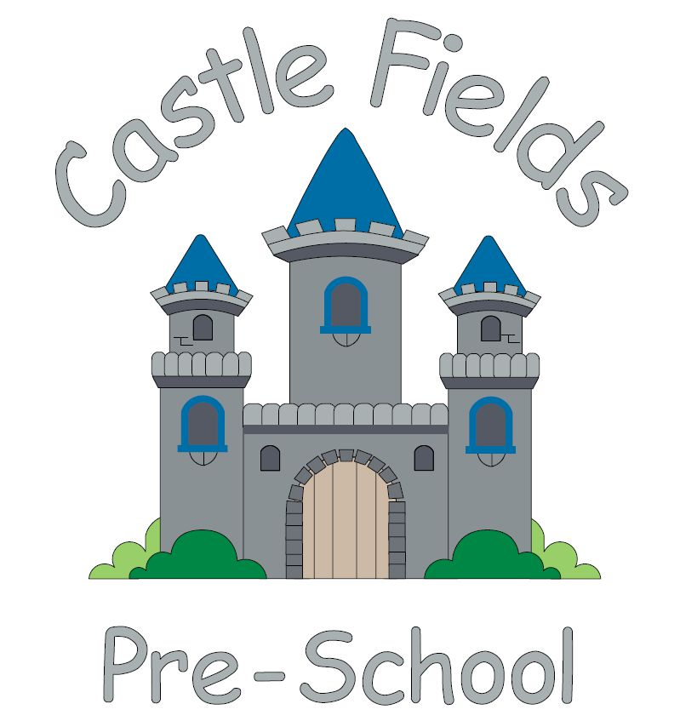

**5 principles**

The Castle Fields Pre-School team share these statements which summarise our values.

* Safeguarding

Learning in a safe, secure environment.

* Parent partnership

Welcoming families

as part of the Castle Fields team.

* Having fun

When children are playing, they are learning.

* Community

Our team welcome

and value every

family and child.

* Positive Role Models

Positive influences from interested people.

Castle Playing Fields, School Lane, Haverhill, Suffolk, CB9 9DE

Telephone: 01440 705800

Email: admin@castlefieldspreschool.co.uk

Website: wwww.castlefieldspreschool.co.uk

**Application Form**

Providing learning opportunities for 1-5 year olds in a caring, fun environment with an experienced, qualified Early Years team.

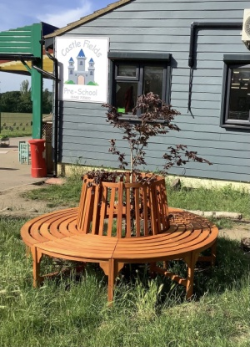

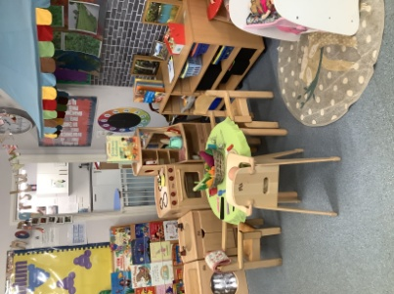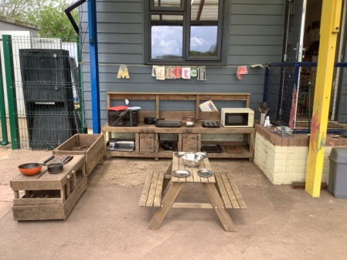

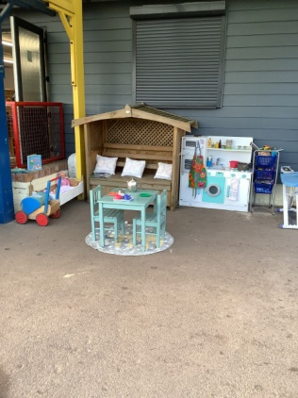

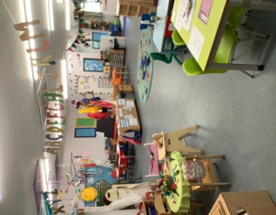

Name of child: Male  Female

Date of birth:

Main contact telephone number:

If you would like help completing this form, a member of staff will be very happy to assist you.

**Personal Details**

This data is collected according to our GDPR policy. For a copy of our policy, please speak to the office.

|  |  |
| --- | --- |
| Parent/Carer Details | Parent/Carer Details |
| Name: | Name: |
| Address: | Address: |
|  |  |
|  |  |
| Home Telephone: | Home Telephone: |
| Mobile Number: | Mobile Number: |
| Work Number: | Work Number: |
| Email: | Email: |
| NI number: | NI number: |
| Your date of birth: | Your date of birth: |
| Please state which address your child resides at. | |
| Please indicate your child’s first language and any other languages spoken. | |
| **Please provide proof of your Childs date of birth by presenting an original passport or birth certificate. Please refer to our admissions policy.** | |

**Ethnicity (please tick)**

|  |  |  |  |  |  |  |  |  |  |
| --- | --- | --- | --- | --- | --- | --- | --- | --- | --- |
| White British(weng) |  | White European (weur) |  | Indian (aind) |  | White & Black Caribbean (mwbc) |  | Chinese (coch) |  |
| White Irish  (wiri) |  | White/ black African (mwba) |  | Other Pakistani (aopk) |  | White & Asian (mwao) |  | Not given (refu) |  |
| Gypsy/Roma  (wrog/wror) |  | Other white British (wowb) |  | Bangladeshi  (aban) |  | Croatian (wcro) |  | Any other ethnic group (ooeg) |  |
| White other (wotw) |  | Other black  (botb) |  | Other Asian (aota) |  | Other mixed background (motm) |  | Information not yet obtained (nobt) |  |

**Collection Form**

**Collection of your child**

All mothers and **MOST** fathers have legal rights and responsibilities as a parent, known as Parental Responsibility. If no legal document is provided, we cannot deny access to either parent.

Please indicate who has parental responsibility for your child \_\_\_\_\_\_\_\_\_\_\_\_\_\_\_\_\_\_\_\_\_\_\_\_\_\_\_\_\_\_.

Security at Castle Fields Pre-School is paramount. If a parent is unable to collect your child, we will require additional information from you. Please speak to a member of staff if this situation arises.

It is really important for Castle Fields Pre-School to be able to contact you (or another named individual) in the event of an emergency whilst your child is at pre-school. We also require that where possible an additional name and telephone number is included in case you are not contactable (e.g., relative, friend or neighbour).

|  |  |
| --- | --- |
| Name: | Name: |
| Relationship to child: | Relationship to child: |
| Contact Number: | Contact Number: |

Security at Castle Fields Pre-School is paramount. As part of our safeguarding policy we ask that you provide a recent, unedited photo of any adult authorised to collect. If a parent is unable to collect, we will require information about who is collecting your child at the end of the pre-school session. We will only allow your child to leave our setting with a responsible adult aged over 18 years.

|  |  |
| --- | --- |
| Name of adult collecting |  |
| Contact Telephone No. |  |
| Password (if applicable) |  |
| Relationship to child |  |
|  | |
| Name of adult collecting |  |
| Contact Telephone No. |  |
| Password (if applicable) |  |
| Relationship to child |  |
|  | |
| Name of adult collecting |  |
| Contact Telephone No. |  |
| Password (if applicable) |  |
| Relationship to child |  |

**Medical Information**

***Do we have permission to seek medical attention in an emergency YES/NO (***delete as applicable)

|  |  |
| --- | --- |
| Child’s Doctor | Has your child been Immunised against?  (Please indicate **YES** or **NO**) |
| Name: | Diphtheria |
| Address: | Whooping Cough |
|  | Tetanus |
|  | Measles |
|  | HIBS |
|  | Any known allergies? (Please list) |
| Telephone Number: |

Does your child have any health issues or a diagnosed allergy that we need to be aware of? Please provide medical evidence. Please note any intolerances that your child may have.

**Please do not send any nut products to pre-school (i.e., peanut butter, Nutella).**

**We would ask that no food or drink (including sweets) are left in your child’s bag.**

Castle Fields Pre-School welcomes and values every family and child. Are there any individual learning needs or developmental concerns that you would like to discuss with our Special Educational Needs and Disabilities Co-ordinator (SENDCo)? Please detail below.

**Session requirements**

Please note this does not guarantee your child a place on these sessions. They are allocated according to our admissions policy. For a copy of our admissions policy, please speak to our office.

Any funded sessions may be taken between 9am to 12 noon (am session) and 12 noon to 3pm (pm session) Monday to Friday, term time only.

|  |  |  |  |  |
| --- | --- | --- | --- | --- |
| **Sessions (please select)** | **AM** | **PM** | **Funding entitlement** | **Code/ evidence** |
| **Monday** | [Grab your reader’s attention with a great quote from the document or use this space to emphasize a key point. To place this text box anywhere on the page, just drag it.]  [Grab your reader’s attention with a great quote from the document or use this space to emphasize a key point. To place this text box anywhere on the page, just drag it.]  [Grab your reader’s attention with a great quote from the document or use this space to emphasize a key point. To place this text box anywhere on the page, just drag it.]  [Grab your reader’s attention with a great quote from the document or use this space to emphasize a key point. To place this text box anywhere on the page, just drag it.]  [Grab your reader’s attention with a great quote from the document or use this space to emphasize a key point. To place this text box anywhere on the page, just drag it.]  [Grab your reader’s attention with a great quote from the document or use this space to emphasize a key point. To place this text box anywhere on the page, just drag it.]  [Grab your reader’s attention with a great quote from the document or use this space to emphasize a key point. To place this text box anywhere on the page, just drag it.]  [Grab your reader’s attention with a great quote from the document or use this space to emphasize a key point. To place this text box anywhere on the page, just drag it.]  [Grab your reader’s attention with a great quote from the document or use this space to emphasize a key point. To place this text box anywhere on the page, just drag it.]  [Grab your reader’s attention with a great quote from the document or use this space to emphasize a key point. To place this text box anywhere on the page, just drag it.] | | 2 year economic funding (golden ticket) |  |
| **Tuesday** | 2 year expanded entitlement (working eligibility) |  |
| **Wednesday** | 3-4 year old expanded entitlement (30 hour code) |  |
| **Thursday** | Privately funded | Charged at £18 per 3 hour session |
| **Friday** |  |  |

**Additional Information**

Castle Fields Pre-school currently use an online app to record your child’s development. The app is called Tapestry and you will be emailed a log in when your child starts with us. Policies and our GDPR (General Data Protection Regulation) information can be found in the documents section of Tapestry.

Does your child have any individual requirements, requests or needs that you would like to observe in the pre-school? (e.g.; religious observance, food, clothing etc). **YES/NO**

Is there any additional information that you feel we need to know in order to help us meet your child’s individual needs? **YES/NO**

How did you hear about us?

**An invoice of £10 is generated every term (September, January and April) for a voluntary consumables charge. Invoices will be made available on your online tapestry account.**

**Castle Fields Pre-School have a full range of policies to support our work with the children. These policies can be viewed at any time by enquiring at our office. These policies include Safeguarding, Equality and Diversity, Admissions, No Smoking, Use of Mobile Phones.**

* **Facebook- Castle Fields Pre-School**  105030175_144477947237481_7645954079901276961_n **Instagram- @castle\_fields\_preschool**

**Website- www.castlefieldspreschool.co.uk**

**Parental Permission**

If your child does not qualify for Early Years funding, an invoice will be raised. Our payments policy will be available on tapestry, however if you would like a paper copy, please speak to the office.

* **I agree** to the terms and conditions stipulated on the Castle Fields payments policy

Castle Fields staff will take photographs of your child that will be uploaded to Tapestry and may be used for displays. Sometimes children will be in the background of a photograph of another child.

* I **agree** to the use of electronic systems to record my child’s progress. Photo’s may capture other children’s images. **I agree not to share any of these images on social media.**

Castle Fields Pre-School have their own website and often use local media as an advertising tool.

* I **agree/disagree** to my child’s photo being used on the Castle Fields website, or being used by the local newspaper (including their website) for publicity.
* I **agree/disagree** to my child being used for Castle Fields Pre-School displays.

Sometimes we have face painting activities at pre-school. We understand that some children do have reactions to face paint so please could you give your consent to allow us to paint your child’s face if they wish.

* I **agree/disagree** to my child having their face painted

We believe that children should be protected against harmful rays of the sun. Please ensure your child has sun cream applied before the start of the session and brings a named hat. If your child is staying all day, please ensure a named bottle of sun cream is given to a member of staff.

* I **agree/disagree** to Castle Fields staff applying sun cream to my child, I have supplied a bottle of in date sun cream.

Each week we like to take advantage of our surrounding area and take the children for a walk to discover the outdoors. Our walks take place on different sessions each week to ensure inclusion.

* I **agree/disagree** to Castle Fields Pre-School taking my child on outings in the surrounding area.

Occasionally we will need to share information about your child’s progress and development with other professionals.

* I **agree/disagree** for Castle Fields Pre-School to share information with other professionals

In the event of a safeguarding concern, where we believe sharing information with a child’s family may cause further harm, we will refer to external agencies without seeking parental consent.

|  |  |
| --- | --- |
| Child’s full name: |  |
| Parent/Carer Signature: |  |
| Name (print): |  |
| Date: |  |