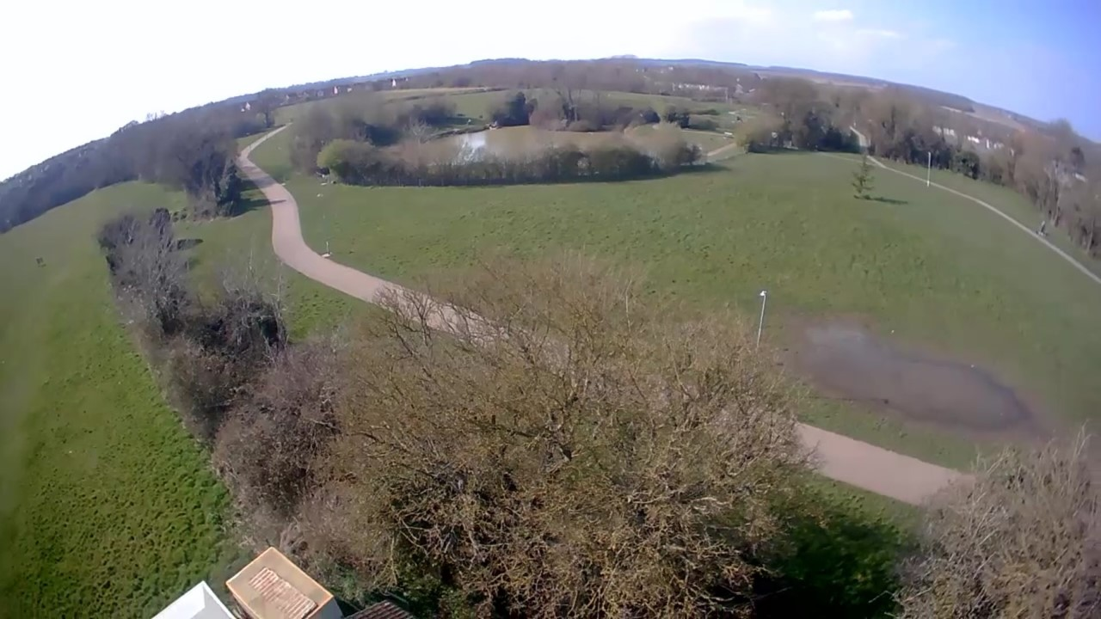

[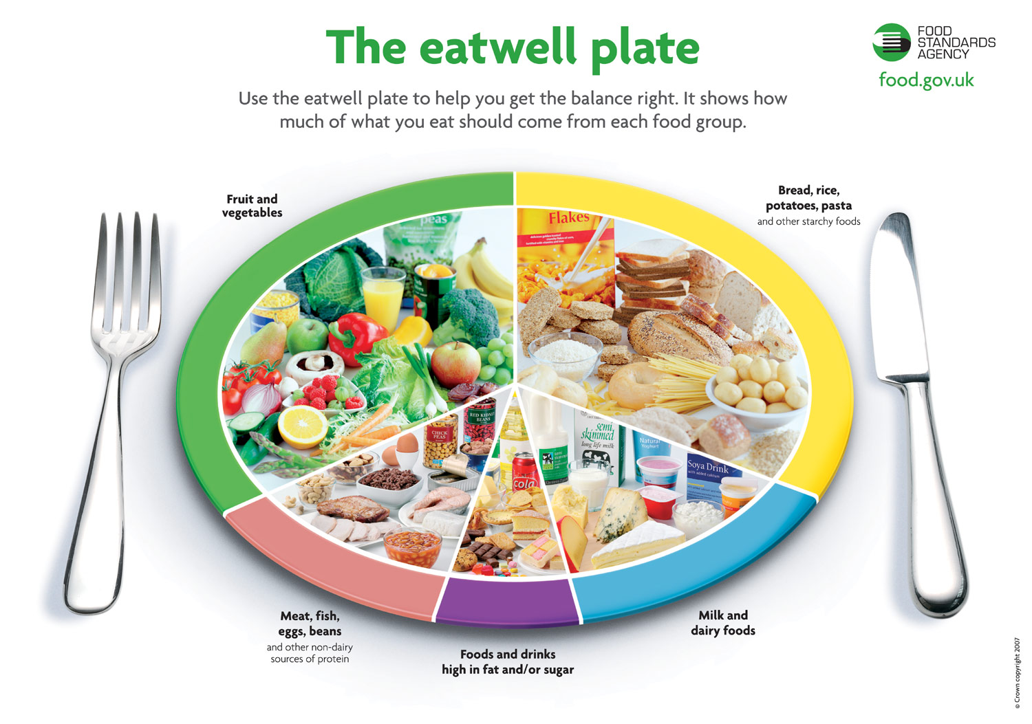](https://www.google.com/url?sa=i&rct=j&q=&esrc=s&source=images&cd=&cad=rja&uact=8&ved=2ahUKEwii466Ij7jdAhWqK8AKHRvFDBIQjRx6BAgBEAU&url=https://scottishrunningguide.com/running-advice/nutrition/nutrition-eat-well&psig=AOvVaw0KMQwXvdASUIqC-Lt7T6kf&ust=1536932802462664)

What is parental responsibility?

All mothers and MOST fathers have legal rights and responsibilities as a parent, known as Parental Responsibility. If no legal document is provided, we cannot deny access to either parent.

Social Media Sites

We would ask that you do not request members of staff to join your social media site. Staff are bound by their contracts of employment and are expressly asked not to accept requests. Castle Fields operate their own Facebook page and we would ask that you join to access further information. Find us at Castle Fields Pre-school.

What shall I put in my child’s lunchbox? (some suggestions…)

* Raisins
* Crackers
* Cheese
* Fruit
* Yoghurt
* Breadsticks

Please **DO NOT** put any nuts, peanuts or nut products (including Nutella) into your child’s lunch box.

Do you help with potty training?

When your child is ready to potty train, please discuss this with your child’s key person. We will always support you and your child during this time. Our toilets and sinks are at a height to support and develop your child’s independence.

What do I do if my child is sick?

If your child is sick or has diahorrea at school, we will always call you to collect them. If they are unwell at home, it is our policy that they do not return to school for 48 hours after the last bout of sickness or diahorrea.

Will you give my child medicine?

Castle Fields will only administer medication to your child if it has been prescribed by a doctor. If your child comes to school with medication, please ensure that it is clearly named and given to a member of staff at the start of the session. We will always ask that you complete an authorisation form. Please note that this includes asthma pumps and spacers.

Can anyone collect my child?

The safeguarding of your child is paramount to Castle Fields Pre-school. We will only allow your child to go home with their parent, unless you have spoken to a member of staff and given us details of the person collecting your child (must be 18 or over). We can operate a password system in emergencies.

Home visits

Part of our settling in process for your child includes a visit at home by their key person.

We are most definitely **not** inspecting your home!

[Grab your reader’s attention with a great quote from the document or use this space to emphasize a key point. To place this text box anywhere on the page, just drag it.]

‘**There is no such thing as bad weather, only bad clothing’**

Inside this leaflet you will find helpful

information about:

* Potty training
* If your child is sick
* Administering medicines
* Collection of your child
* Parental responsibility
* Social Media sites
* Lunchbox suggestions
* What to bring to pre-school
* What is a key person
* Safeguarding
* How to contact us
* Session fees/ times
* Other useful links

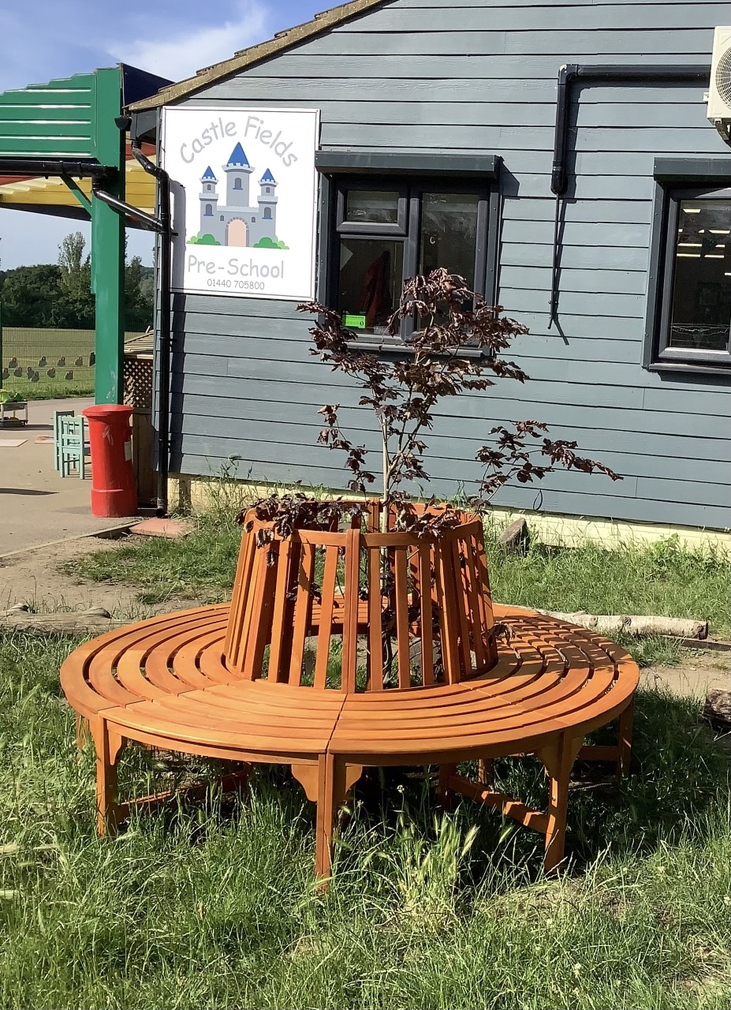

Things to bring to school

A change of clothes, including socks (please name all items).

Nappies, wet wipes and nappy sacks.

Coat, hat (winter or summer hat), mittens, wellie boots, waterproof clothing.

Please remember to dress for mess!

Nappy cream, suncream.

Soothers, comforter.

Ice pack in their lunch box (if staying for lunch).

You don’t need to bring food or drink with you. Water and milk are provided.

We do ask for a voluntary consumables charge of £10 per term.

Can my child bring toys to school?

Sometimes children may want to share one of their own toys, we will do our best to keep them safe. Sadly we can’t guarantee they won’t be lost or broken. So we recommend keeping precious toys at home.

What is a key person?

A key person will be allocated to your child as soon as they start at Castle Fields. They will come and introduce themselves to you and will be your first point of contact at Castle Fields. The whole team will be looking after your child, with the key person taking a special interest in their continued development.

What times do sessions start and how much do they cost?

Sessions are from 9am-midday (morning session) and midday-3pm (afternoon session). We are open for 38 weeks of the year. Our session fees are £18 per 3 hour session. A £10 voluntary consumable charge will be invoiced at the start of every term.

Upon enrolment you will have access to your child’s online learning journal 24/7

*(speak to a member of staff)*

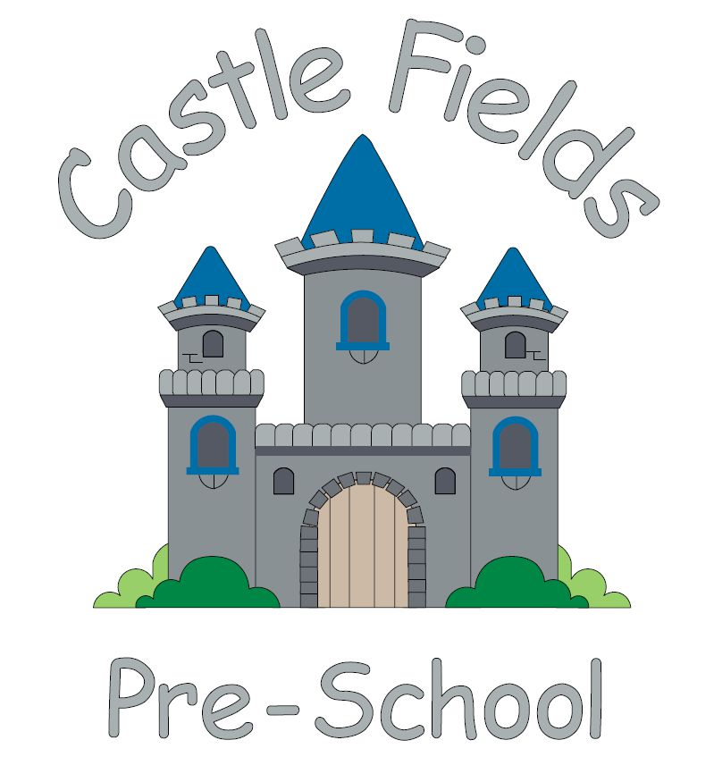

**Things you need to know**

**5 Principals**

**The Castle Fields team share these statements which summarise our values.**

**Safeguarding**

**Learning in a safe, secure environment.**

**Parent Partnership**

**Welcoming families as part of the Castle Fields team.**

**Having fun**

**When children are playing, they are learning.**

**Community**

**Our team welcome and value every family and child.**

**Positive Role Models**

**Positive influences from interested people.**

**Castle Fields Pre-school**

**We have lots of policies and procedure, should you wish to read any of them**

**do not hesitate to ask**

**Other Useful Links**

[www.nhs.uk/Livewell/Goodfood/Pages/eatwell-plate.aspx](http://www.nhs.uk/Livewell/Goodfood/Pages/eatwell-plate.aspx)

<https://assets.publishing.service.gov.uk/media/65aa5e42ed27ca001327b2c7/EYFS_statutory_framework_for_group_and_school_based_providers.pdf>

[www.gov.uk/government/organisations/ofsted](http://www.gov.uk/government/organisations/ofsted)

<https://infolink.suffolk.gov.uk/kb5/suffolk/infolink/results.page?ipsvmore=Childcare&qt=local+offer&sorttype=relevance>

<https://www.gov.uk/parental-rights-responsibilities>

[www.childcarechoices.gov.uk](http://www.childcarechoices.gov.uk)

<https://foundationyears.org.uk/files/2021/09/What-to-expect-in-the-EYFS-complete-FINAL-16.09-compressed.pdf>





Castle Fields Pre-school

Castle Playing Fields

School Lane

Haverhill

Suffolk CB9 9DE

Phone: (01440) 705800

Email: admin@castlefieldspreschool.co.uk

Website: www.castlefieldspreschool.co.uk

Facebook: Castle Fields Pre-School

Instagram: @castle_fields_preschool

TikTok: @castlefieldspreschool

[Grab your reader’s attention with a great quote from the document or use this space to emphasize a key point. To place this text box anywhere on the page, just drag it.]