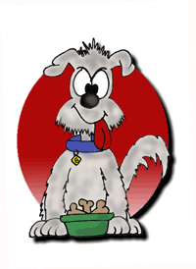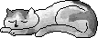

Dog Days & Cat Naps

5665 NW Beaver Drive Johnston, IA 50131
515-276-0086

Information and Release Form
Date: ______________
Owners Name: __________________________________________________
Address: _______________________City: _____________ State: ___ Zip: _____
Home Phone #: ___________________Emergency #: ____________________
Cell Phone #: ____________________Email address: ____________________
Pet’s Name: ______________________ Sex: ______ Spayed/Neutered (circle)
Breed: _____________________ Age: _________ Color: _______________
Does your dog - Please answer yes or no to the following:
Chew destructively: ____ Bite: ____ Climb fences: ____ Bark excessively: ____
Does your dog have any known allergies - check one: Yes_____ No_____
If yes please indicate what allergic to: ____________________________
Does your pet have any medical conditions – check one: Yes ______ No ______
If yes please indicate condition: _______________________________
Is your pet currently on medication – check one: Yes______ No ______
If yes please indicate when meds are given: ________________________
1. Owner will certify that their animal has not harmed or shown aggression or threatening behavior towards any person or other animals.
- I agree that my animal is current on the following vaccinations: Rabies, Bordetella, DHLP.
Current Veterinary _________________________
- I agree that my animal is at least 8 weeks of age.
- I agree that my animal has been spayed or neutered; this applies to all animals over 6 months of age.
- I agree and understand that my animal will have inherent risk, injury or disease exposure when dogs owned by different people are allowed to commingle.
- I certify that my animal is in good health and has not been exposed communicable diseases.
- I agree to pay in full Dog Days & Cat Naps for all incurred charges for my
animal.

I certify that I have read and understand the guidelines of Dog Days & Cat Naps.

Date: ______________________

Signature of Owner: _________________________________________

Prescreening/Temper test done by: _____
Toy aggressive Y____ N_____ Food aggression Y_____ N_____ Other aggressive behavior __________
Evolution results_______________________________________________________________________________

