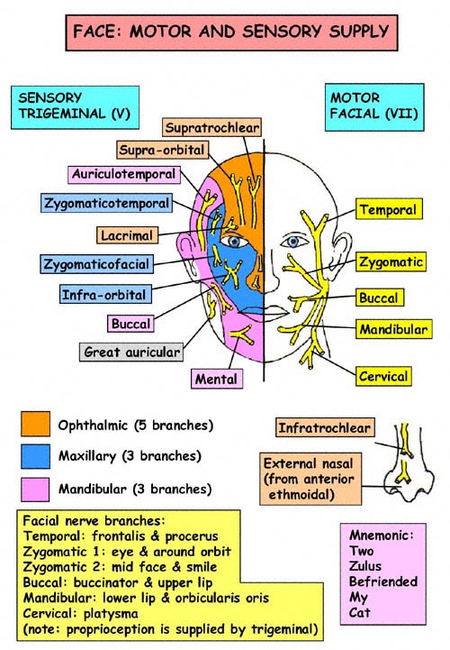
Hi guys,
There are a few
Things that I wanted
To review with you
And time ran short
On Wednesday. I wanted
To be sure to remind
You to review
Cutanesous sensation
Of the face and
The NECK!!!

A favorite question is… if you prick the skin
Overlying the thyroid
Cartilage what cutaneous
Nerve are you testing.

- Manibular brach of V
- Superior thyroid
- Transverse cervical
- Supraclavicular

Anwer next page.

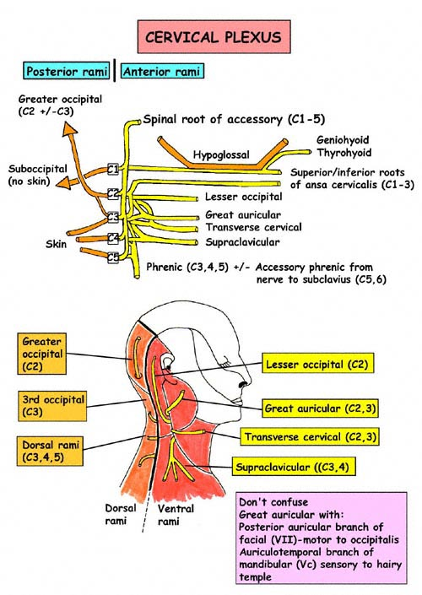
- The transverse cervical
Nerve innervates the
Region directly over
The thyroid cartilage!!

More… ok you twisted
My arm…

The primary vessel
Traversing the
Infratemporal fossa?

Easy one but it gave
Me an excuse to give
The next diagram to you.

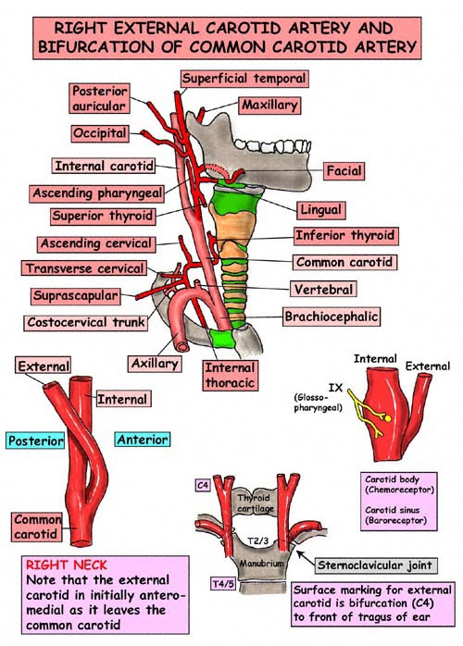

The maxillary artery… of course.

One they go like is…
What two veins
Joint for form the
External jugular
Vein…?

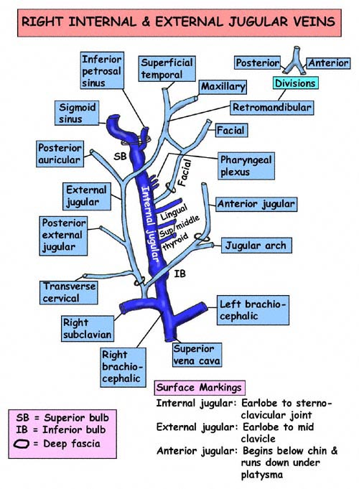
Posterior auricular &
Retromandibular.

Remember we have
An anterior jugular as well we sometimes
Forget that…

Ok a few more
And I’ll leave ya
Alone… to your studies…

What are the
Structures
That exit the
Jugular
Foramen…?

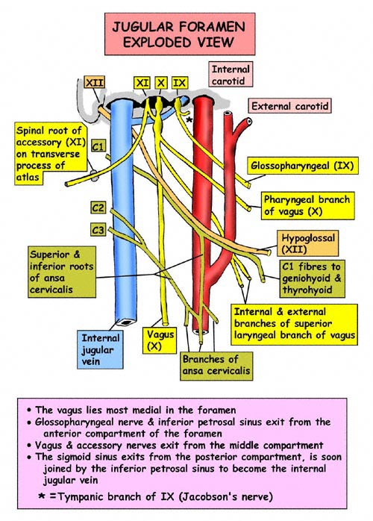

Here is one
Of the favorites.
You are operating on the parotid gland. Do you know what vascular and neurological structures you could injure and make your malpractice company very unhappy???

Next diagram..

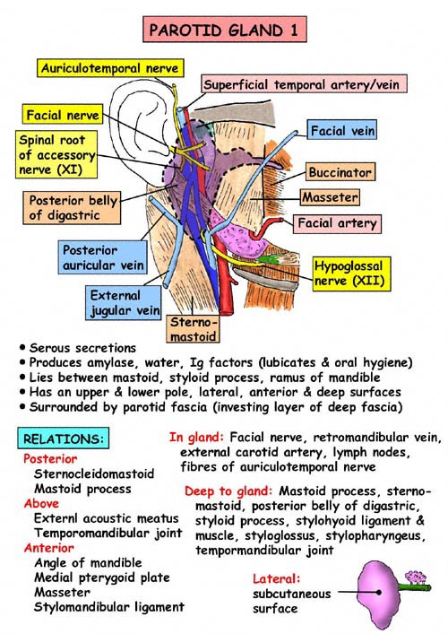
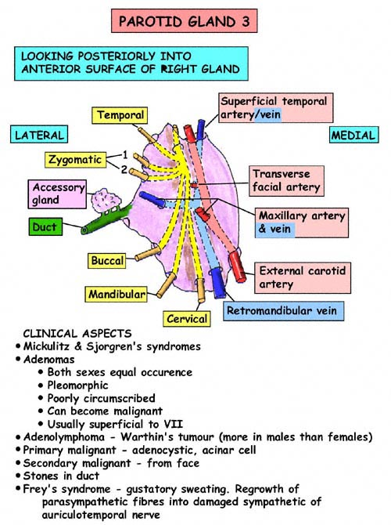

VII nerve is a favorite….

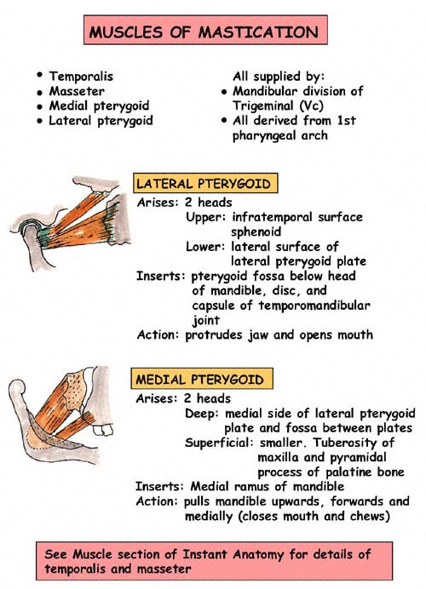

Keep the function
Of the pterygoids
Straight… those are “gimi” questions!
Which one retracts the
Jaw which one protrudes the jaw?

