Chadwell’s DNA Questions

1. Which of the following statements is FALSE?

a. Bacterial DNA normally exists in a negatively supercoiled form
b. DNA Gyrase is a type II topoisomerase
c. During the removal of supercoils by topoisomerases, no external supply of every is required
d. Positive supercoiling is beneficial to an organism, as it promotes DNA unwinding.
e. Type I topoisomerases work by introducing transient single-stranded breaks into supercoiled DNA.

2. All of the following statements about tRNAs are true EXCEPT:

a. tRNAs contain minor bases that are not found in other types of RNA molecules
b. A charged tRNA carries an amino acid attached at its 3’ end by means of an ester bond
c. The base pairing between the first base of the tRNA anticodon and the last base of the codon is not as specific as normal base pairing
d. All tRNAs form a “cloverleaf” secondary structure
e. With the exception of stop codons, all cells have an individual tRNA for each codon

3. Which of the following diagrams BEST represents a DNA replication fork as found in the cell?
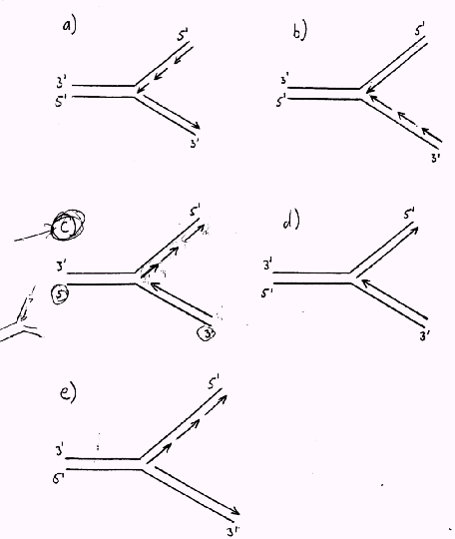
4. Which of the following statements about DNA polymerase I is FALSE?

a. It has a 5’ ➔ 3’ exonuclease activity, which has a proofreading function
b. It requires a DNA primer
c. It removes RNA primers and replaces them with DNA
d. It is a processive enzyme
e. It has 3 enzymatic activities on one protein

5. Which of the following statements about transcription in prokaryotes is FALSE?

a. Prokaryote promoters have a consensus sequence called the Pribnow box approximately 10 nucleotides before the start of transcription.
b. The first base incorporated into a growing RNA chain is usually A or G
c. Sigma factor is an absolute requirement for proper initiation of prokaryote RNA synthesis
d. Before an RNA transcript can be made, the DNA double helix must completely unwind.
e. RNA polymerase does not require a primer.

6. Which of the following statements about transcription in eukaryotes is FALSE?

a. It involves more than one RNA polymerase
b. It takes place in the cytosol
c. It does not require an RNA Primer
d. mRNA precursors are synthesized by RNA Polymerase III
e. Within a gene only one of the DNA strands is transcribed into RNA

7. Which of the following post-transcriptional processes occurs in BOTH prokaryotes and eukaryotes?

- Modification of certain bases in tRNAs
- Removal of introns from mRNA precursors
- Export of mRNA from the nucleus to the cytosol
- Addition of a poly A tail to the 3’ end of mRNAs
- Addition of a “cap” to the 5’ end of some mRNAs

8. Which of the following protein factors is involved in delivering aminoacyl-tRNAs to the prokaryote ribosome?

- IF-1
- EF-G
- EF-T
- EF-2
- RF-1

9. Consider a prokaryote ribosome having fmet-tRNA in its P site and a charged aminoacyl-tRNA in it’s A site. The ribosome is associated with a functional mRNA. Which of the following would you expect to be the next step of protein synthesis to occur?

- Ejection of the fmet-tRNA from the P site
- Formation of an initiation complex
- Termination of translation
- Peptide bond formation
- Translocation of the ribosome along the mRNA

10. Which of the following enzymes would NOT be required for the repair of DNA damaged by spontaneous deamination of a cytosine residue?

- DNA ligase
- DNA polymerase
- Uracil-DNA glycosylase
- Hypoxanthine-DNA glycosylase
- AP-endonuclease

11. Which of the following statements is FALSE?

- Many spontaneous mutations are caused by tautomeric shifts in the nucleotide bases.
- 5-bromouracil is a base analogue of cytosine
- Most carcinogens have also been shown to be mutagens
- X-rays and gamma rays can cause mutations by causing DNA strand breakage
- Nitrous acid induces mutations by causing deamination of bases

12. With the exception of one enzyme, all the enzymes below catalyze reactions that are reversible, but which go to completion in the cell, because pyrophosphate, one of the products, is hydrolyzed. Which enzyme is the exception?

- DNA polymerase I
- RNA polymerase
- Pyrophosphatase
- Aminoacyl-tRNA synthetase
- Fatty acyl-CoA synthetase

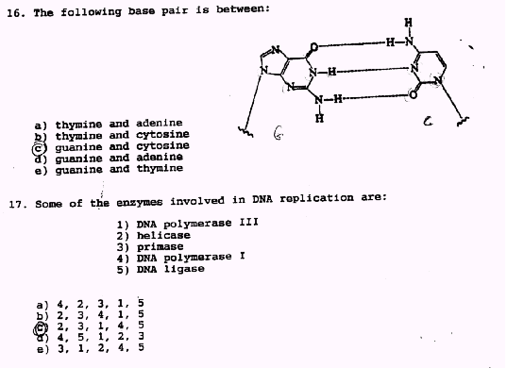
13. The following base pair is between:

- Thymine and adenine
- Thymine and cytosine
- Guanine and cytosine
- Guanine and adenine
- Guanine and thymine

14. Some of the enzymes involved in DNA replication are:

  - DNA polymerase III
  - Helicase
  - Primase
  - DNA polymerase I
  - DNA ligase

- 4, 2, 3, 1, 5
- 2, 3, 4, 1, 5
- 2, 3, 1, 4, 5
- 4, 5, 1, 2, 3
- 3, 1, 2, 4, 5

15. DNA polymerase I:

- is remarkably error free
- makes errors that it corrects after scanning completed sections of daughter DNA strands
- makes errors that are later corrected by DNA polymerase III
- makes errors that it corrects using its 3’-exonuclease activity
- makes errors that it corrects using its 5’-exonuclease activity

16. Transcription of the following sequence of a double-stranded DNA sequence occurs in the direction indicated by the arrow. What would be the base sequence of the mRNA produced?

3’…..CGCCGCAGCGCG…..5’
5’…..GCGGCGTCGCGC…..3’

- 5’…..CGCCGCAGCGCG…..3’
- 5’…..GCGGCGTCGCGC…..3’
- 5’…..GCGCGACGCCGC…..3’
- 5’…..CGCGCUGCGGCG…..3’
- 5’…..GCGGCGUCGCGC…..3’

17. All of the following statements on transcription are true EXCEPT:

- The position where transcription should start is denoted by a specific region of DNA called the promoter
- It is necessary for the whole of the DNA double helix to unwind before transcription can take place.
- In eukaryotes, the precursors of mRNAs are synthesized by RNA polymerase II.
- Termination of transcription is prokaryotes sometimes requires the participation of the rho factor
- Many eukaryotic RNAs contain extra RNA sequences called introns when they are first synthesized.

18. Which of the following statements about translation is FALSE?

- the information contained in mRNA is read in the 3’ to 5’ direction
- mRNA is normally translated by more than one ribosome at a time
- In prokaryotes, aminoacyl-tRNAs are carried to the ribosome by EF-Tu
- The termination codons are recognized by protein release factors
- Diphtheria toxin inhibits translation by inactivating EF-2

19. Which of the following antibiotics inhibits peptidyl transferase in prokaryotic ribosomes?

- streptomycin
- chloramphenicol
- rifamycin
- tetracyclines
- actinomycin D

20. Osteogenesis Imperfecta is a genetic disorder involving collagen biosynthesis and bone formation. A common cause of this condition is a mutation that causes a glycine residue in the collagen polypeptide to be replaced by another amino acid with a bulkier side chain. This disrupts the formation of a stable tropocollagen helix

Use the genetic code table below to determine which of the following mutational events leading to osteogenesis imperfecta could not be caused by a single base change.

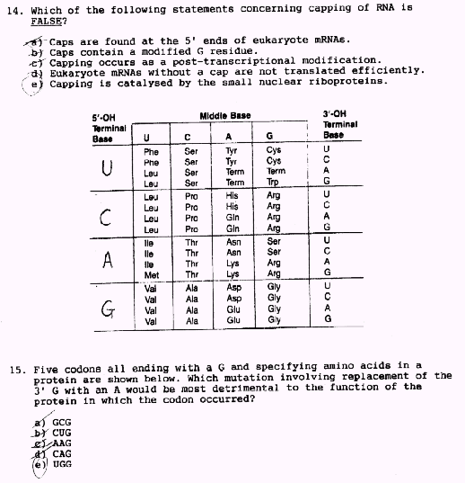
- gly ==> val
- gly ==> glu
- gly ==> ser
- gly ==> tyr
- gly ==> asp

21. Which of the following histones are components of the DNA nucleosome?

- histone 2A
- histone 2B
- histone 3
- histone 1
- a, b and c

For questions 22-25, make the BEST match between one of the choices in the list below and what is asked for in the question. Use each choice as often as is appropriate.

a. DNA
b. RNA
c. Both
d. Neither

22. In its double stranded conformation, it exists in the B-form

23. Normally exists as molecules with only one strand.

24. Can be hydrolyzed by dilute alkali

25. Contains adenine and uracil

26. Which of the following is only involved in the termination of transcription in prokaryotes?

- α-subunit of RNA polymerase
- β-subunit of RNA polymerase
- release factor
- sigma factor
- rho factor

27. All know DNA polymerases have the following in common EXCEPT:

- they require deoxynucleoside triphosphates as substrates
- They synthesize the new DNA chain in the 5’➔3” direction
- They have 5’→ 3’ exonuclease activity
- They require a primer
- They usually catalyze semi-conservative DNA replication

28. Which of the following is FALSE?

- In E. Coli, the RNA primers are removed by DNA Polymerase III
- Okazaki fragments are associated with the lagging DNA strand
- Helicases are required in order to unwind double-stranded DNA prior to its replication
- Eukaryote DNA is synthesized from multiple replicons
- The DNA template is read in the 3’ → 5’ direction

29. Which of the following statements about translation is FALSE?

- An mRNA can be read by more than one ribosome at a time
- Except for fmet-tRNAf, aminoacyl-tRNAs enter the ribosome at the A site
- In eukaryotes, diphtheria toxin acts by inactivating EF-2
- GTP is required at several stages of the translation process
- %s ribosomal RNA is a component of the small ribosomal subunit

30. With respect to the control of gene expression in the lactose operon of E. coli, which of the following statements is FALSE?

- The lac enzymes are not synthesized in the presence of glucose even if lactose is present
- The lac repressor protein binds to the operator sequence in the presence of allolactose
- The lac repressor protein is synthesized constitutively
- The lac operon synthesizes a polycistronic mRNA
- The operator sequence partially overlaps the promoter sequence
31. Which of the following codons acts as a termination signal during translation?

- UAG
- GAU
- AGU
- UCG
- AAU

For questions 32 to 36, make the BEST match between one of the choices listed below and what is asked for in the question. Use each choice as often as is appropriate.

- Normal DNA replication in prokaryotes
- DNA repair in prokaryotes
- Both
- Neither

32. Involves the participation of DNA Pol I

33. Involves the participation of DNA Pol III

34. Involves the participation of DNA ligase

35. Involves the participation of EF-Tu

36. Involves the participation of an RNA primer

37. Which of the following “reactions” describing routes of glycero-phospholipid synthesis in mammals in FALSE (i.e. does not occur)?

- DAG + CDP-ethanolamine =========> phosphatidyl ethanolamine
- Phosphatidyl ethanolamine + 3Me =====> phosphatidyl choline
- CDP-DAG + inositol ==============> phosphatidyl inositol
- CDP-choline + DAG ==============> phosphatidyl choline
- CDP-serine + DAG ===============> phosphatidyl serine

For questions 38-41, make the BEST match between one of the structures below and what is asked for in the question. Use each choice once, or not at all.

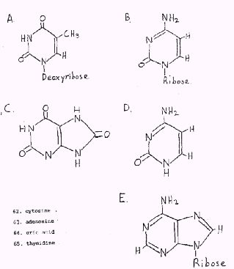

38. Cytosine
39. Adenosine
40. Uric Acid
41. Thymidine

For questions 42-45, make the BEST match between one of the structures below and what is asked for in the question. Use each choice once, or not at all.

- Pribnow sequence
- Attenuator sequence
- Sanger sequence
- Shine-Dalgarno sequence
- Hogness sequence

42. Found in eukaryote promoter regions
43. Involved in control of the trp operon
44. Helps to align prokaryote ribosomes properly with respect to the ribosome
45. Found in prokaryote promoter regions

For questions 46-50, make the BEST match between one of the structures below and what is asked for in the question. Use each choice as often as is appropriate.

- Translation in eukaryotes
- Translation in prokaryotes
- Both
- Neither

46. AUG acts as the initiation codon
47. Cylcohexamide inhibits peptidyl transferase
48. 70s ribosomes participate
49. A single methionine specific tRNA reads both initial and internal met codons
50. The information in the mRNA is read from the 3’→5’ direction

For questions 51-54, make the BEST match between one of the structures below and what is asked for in the question. Use each choice once, or not at all.

- rifamycin
- alpha-amanitin
- fluorouracil
- streptomycin
- acyclovir

51. Inhibits DNA synthesis by causing premature chain termination
52. Inhibitor of type II eukaryote RNA polymerase
53. Inhibits DNA synthesis by interfering with the synthesis of TMP
54. Inhibits initiation of transcription in prokaryotes.

55. Which of the following statements concerning DNA is TRUE?

- A G/C base pair has 2 hydrogen bonds
- Most of the DNA found in cells is in the A form
- DNA is easily degraded by dilute alkali treatment
- The DNA described by Watson & Crick has 10 bases/turn of the helix
- The absorption of UV light by double-stranded DNA decreases with the strands separate

56. In a strain of E. Coli carrying a temperature sensitive (conditional lethal) mutation inactivating the 3’→ 5’ exonuclease activity of its DNA Polymerase III. Which of the following is most likely to be TRUE?

- DNA would be made containing more errors than normal
- The DNA would not unwind properly
- DNA strands would be made containing short pieces of RNA
- There would be o DNA synthesis at all
- The 3’→5’ exonuclease of Pl I would compensate, so no change would be seen.

57. Which of the following statements concerning RNA synthesis in eukaryotes is FALSE?

- Eukaryote promoters contain a sequence called the Hogness box
- Eukaryote transcription occurs in the nucleus
- The DNA template is read in the 3’→5’ direction
- mRNA precursors are synthesized by RNA polymerase II.
- Eukaryote RNA polymerases have error checking capability.

58. Which of the following concerning tRNAs is FALSE?

- All tRNAs have a “cloverleaf” secondary structure
- Amino acids are attached to the 5’ end of tRNA molecules
- Some tRNAs are able to recognize more than one codon
- tRNAs contain unusual modified bases
- In fmet-RNA, the formyl group is added after the met is attached to the tRNA

59. Which of he following statements concerning capping of RNA is FALSE?

- Caps are found at the 5’ ends of eukaryote mRNAs
- Caps contain a modified G residue
- Capping occurs as a post-transcriptional modification
- Eukaryote mRNAs without a cap are not translated efficiently
- Capping is catalyzed by the small nuclear riboproteins

60. Five codons all ending with a G and specifying amino acids in a protein are show below. Which mutation involving replacement of the 3’ G with an A would e most detrimental to the function of the protein in which the codon occurred?

- GCG
- CUG
- AAG
- CAG
- UGG

61. Which of the following is involved in carrying charged aminoacyl-tRNAs to the A site of the prokaryote ribosomes?

- IF-2
- EF-G
- EF-Tu
- EF-2
- RF-1

62. Which of the following statements concerning translation is FALSE?

- Cells have two different tRNAs that recognize AUG codons
- Proteins are synthesized starting at their amino terminal ends
- UAA acts as a termination codon
- All eukaryote proteins start with formyl-methionine
- GTP is involved in several step during translation

63. Which of the following statements is FALSE?

- YACs are useful for cloning very large pieces of DNA
- Human growth hormone can be manufactured using recombinant DNA technology
- cDNA is made with the aid of reverse transcriptase
- Methylated restriction enzyme recognition sites are resistant to cleavage by that restriction enzyme
- The natural function lf restriction enzymes is to participate in bacterial DNA recombination

64. Which of the following interact directly with enhancer DNA sequences?

- TATA binding protein
- Basal factors
- Activator proteins
- Sigma factor
- Single strand binding proteins

65. Which of the following agents is most likely to cause a frameshift mutation in DNA?

- X-rays
- Acridine dyes
- 5-bromouracil
- UV light
- Alkylating agents

66. Which of the following properties of double stranded DNA are appreciably affected by its percentage GC content?

- its viscosity
- its density
- its molecular weight
- its Tm
- B & D

67. Which of the following statements is/are true?

- 61 codons code for amino acids
- The genetic code is non-overlapping
- Most amino acids have more than one codon
- Termination codons are recognized by protein releasing factors
- A & C

68. Which of the following antibiotics directly inhibits the process of translation in prokaryotes?

- oligomycin
- rifamycin
- antimycin A
- streptomycin
- B & D

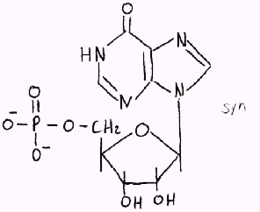
69. Which of the following statements concerning the molecule shown above is/are TRUE?

- It contains a Purine base.
- It is a nucleoside 5’ monophosphate
- It contains an N-glycosidic bond
- It is a common component of RNA
- A, B & C
Answer Key

1 D 55 D
2 E 56 A
3 C 57 E
4 A 58 B
5 D 59 E
6 B 60 E
7 A 61 C
8 C 62 D
9 D 63 E
10 D 64 C
11 B 65 B
12 C 66 E
13 C 67 D
14 C 68 D
15 D 69 E
16 E
17 B
18 A
19 B
20 D
21 E
22 A
23 B
24 B
25 B
26 E
27 C
28 A
29 E
30 B
31 A
32 C
33 A
34 C
35 D
36 A
37 E
38 D
39 E
40 C
41 A
42 E
43 B
44 D
45 A
46 C
47 A
48 B
49 D or A
50 D
51 E
52 B
53 C
54 A

