Cushing’s Syndrome

 | DST |  | ACTH | Adrenal Glands
 | Low | High | ACTH | Adrenal Glands
Primary Pituitary Adenoma | (-) | (+) | ↑ | BOTH hyperplastic
Ectopic ACTH | (-) | (-) | ↑ | BOTH hyperplastic
Primary Adrenal Adenoma | (-) | (-) | ↓ | Affected Adrenal Enlarged  Contralateral Atrophic
Exogenous Cortisol | (-) | (-) | ↓ | Both atrophic

Hyperaldosteronism

 | Primary | Secondary
HTN | (+) | (-)
Na | ↑ | Normal
K | ↓ | ↓
Renin | ↓ | ↑
Alkalosis | (+) | (+)

Adrenal Insufficiency

 | Primary | Secondary
ACTH | ↑ | ↓
Cortisol | ↓ | ↓

MEN Syndrome

Type I (3 P’s) | Type IIa (2 mph) | Type IIb
Pituitary | Medullary | Mucosa
Pancreas | Pheochromocytoma | Medullary Carcinoma
Parathyroid | Hyperparathyroidism | Pheochromocytoma

PHAEochromocytoma (Symptoms)

Palpitations
Hypertension/Headache
Anxiety
Episodic Diaphoresis

Causes of Hypertension (Think Chaps)

Cushing’s
Hyperaldosteronism
Aortic Stenosis/Coarcation of the Aorta
Pheochromocytoma
Stenosis of Renal arteries
1) Young Fibromuscular dysplasia
2) Middle Age Atherosclerosis
Hypercalcemia

Will lead to:
Bones, Stones, Moans, Groans

Caused by: (Chimpanzees)
Calcium Supplements
Hyperparathyroidism (primary)
Iatrogenic
Metastasis, Multiple Myeloma
Pagets Disease
Addison’s Disease
Neoplasms
Zollinger-Ellison Syndrome
Excess Vit A
Excess Vit D
Sarcoidosis

Tumors Metastasizing to Bone

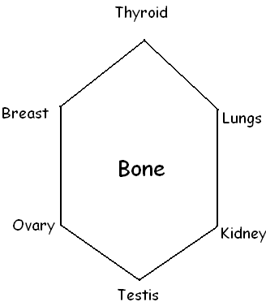

Hypothyroidism

Primary | Secondary | Tertiary
Hashimoto’s | Sheehan Syndrome | Hypothalamus disorder
Lymphocytic | Pituitary disorder
Subacute thyroiditis
Surgery
Iodine Deficiency
Postpartum thyroiditis
- Usually self-limiting
- Treat with steroids early

