RMMS Band Shirt Order Form 2023-2024

Student Name______________________ Parent Name ________________________

The RMMS band program is continuing the tradition of using Polo shirts for all band performances.
All new band students will need a polo. Returning students can use their previous one if it fits. Please order a new one if needed. Additional shirts can be purchased. Please include the total number of sizes on the order lines below. This form is due no later than Friday, September 1.

Payments:
Payments upfront and attached to this form are appreciated. Payment plans available and can be arranged with Mrs. Newland.
- Make checks payable to CSD and write student’s name on the memo line.
- For cash, exact change is appreciated.
- There are no digital options for payments currently.
- Please send cash or check in an envelope with the student’s name on it. This form can be added to the inside of the envelope or stapled to the outside.
- Receipts will be given back to student after payment is received, please allow a day.

All sizes need to be collected by September 1.
Final payments will need to be turned in by October 1 or when shirts arrive.

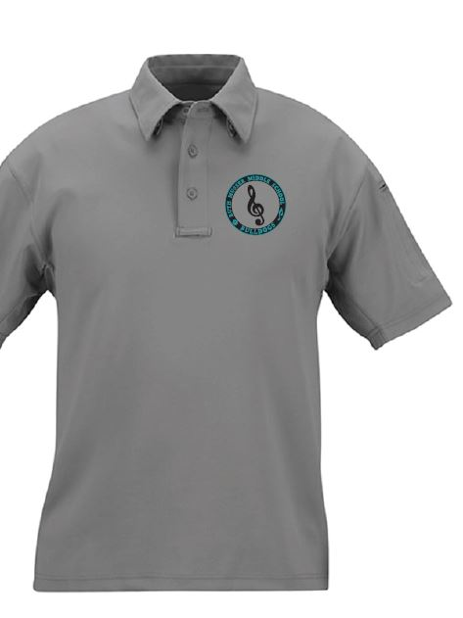
The sizes run long on this brand; there are a couple extras purchased to be able to swap sizes if needed.

Polo shirt $30 each
_____Youth Medium
_____Youth Large
_____Adult Small
_____Adult Medium
_____Adult Large
_____Adult X Large
_____Adult XX Large ($32)

________Total for Polo Shirt

Returning Students:
- I have my Polo from last year and as of this week it fits.
- I need to swap my shirt for a different size.
- I will purchase a new shirt.
- Parent Signature___________________________

Total Amount Due $_________________

