- 5:45 pm meet at the arena. Students bring instruments with them.
- Meet at the Northwest Entrance and check in with Mrs. Newland.
- 6:00 we will enter the arena.
  - Parents will enter through the Northwest Entrance and go to seats.
  - Performers will enter through the loading dock go to green room to drop off instrument cases. We will warm up together.
  - Right before show time, we will use the 102 staircase to come up main level and head to the stage.
- Perform National Anthem on the stage.
- 7:00 the game starts
- We will play at 1st intermission (time is based on game clock)
  - “Low Town Anthem” smash up
- Return to the green room and store instruments. (Via 102 staircase)
- Enjoy the game performers with parents. (single riders with Newland)
- At the end of the game, students will meet at section 102 to go back to the green room for instrument pick up. Parents will wait for their child to meet outside at the Northwest Entrance to leave the arena. Students will be exiting from the loading dock area and will meet you there. Mrs. Newland will sign each student out as they leave with their parent. Percussion students will load items into Mrs. Newland’s car before they are dismissed. Single Rider students can meet their parent at the curb for pickup.

Entrance: drop off or parking
Northwest entrance (gate) we will be entering the arena. Parking Lot F is across from that entrance and will cost $10. Drop off is on Ontario Center drive, you will not need to pay to drop off or pick up.

To wear:
Students will wear band polos with long blue or black pants. Long sleeves underneath is ok. The arena is cold, so students should bring a sweatshirt with them. Jerseys and hoodies can be put on after the performances.
Instruments:
Students will be responsible for all their own equipment. Storage location will be shown on arrival. Percussion will be responsible to get equipment loaded back in Mrs. Newland’s car, BEFORE they are dismissed.
Dismissal:
1. All students will be dismissed that end of the game, after instruments are collected from storage. Mrs. Newland will sign out matched student with parent at the Northwest entrance/exit.
Note, only the timeline above shows when the storage room will be accessed.
2. Single Rider Students will be dismissed at the curb to their waiting parent in the car.

Entrance, Drop off and Pick up at the Northwest corner
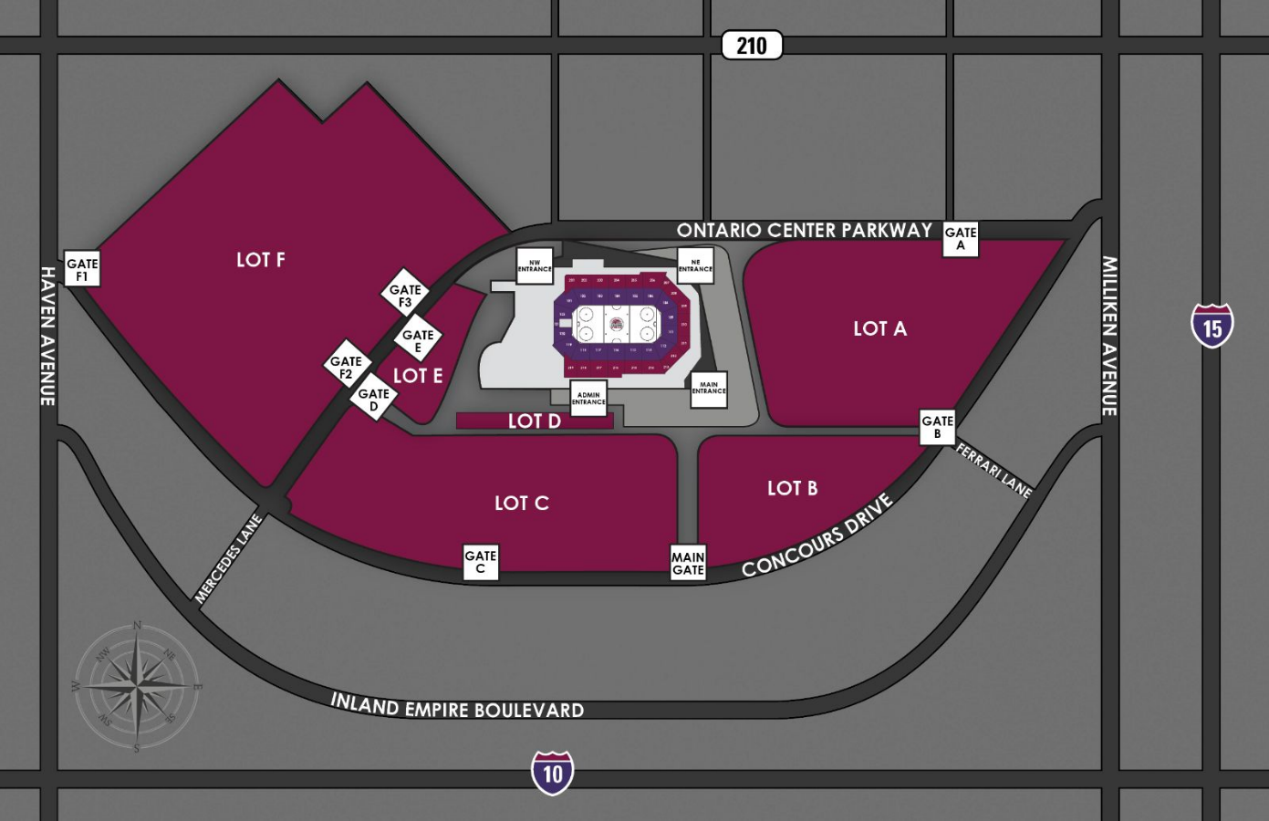
Meet at northwest entrance
Parking Here
Staircase to the green room outside of section 102.
North

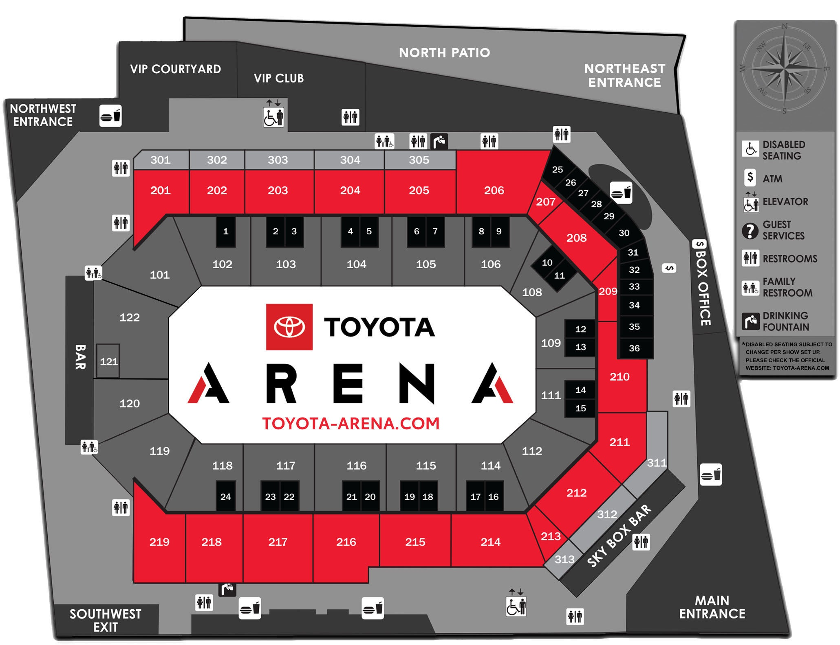
Seats
sections 116-118 216-218

