**Salvation of the Saviors**

**(53_series 369)**

**Project 369 –The Idea…**

***If you have an apple and I have an apple,***

***and if we exchange these apples,***

***then you and I each have one apple.***

***But if you have an idea and I have an idea***

***and we exchange the ideas, then each of us***

***will have two ideas…***

All people, at different periods of their existence, aim at different goals. For some of them, the peak of their dreams is the conquest of space, for others - the conquest of power, while some crave fame and wealth. There are those who prefer **SIMPLE PLEASURES** of life, such as food, rest and love, enjoying the moments without deep thought and experiencing pleasures that are not available to those inclined to intellectual hobbies. A person on the path to his dream derives joy from both the process itself and the results achieved.

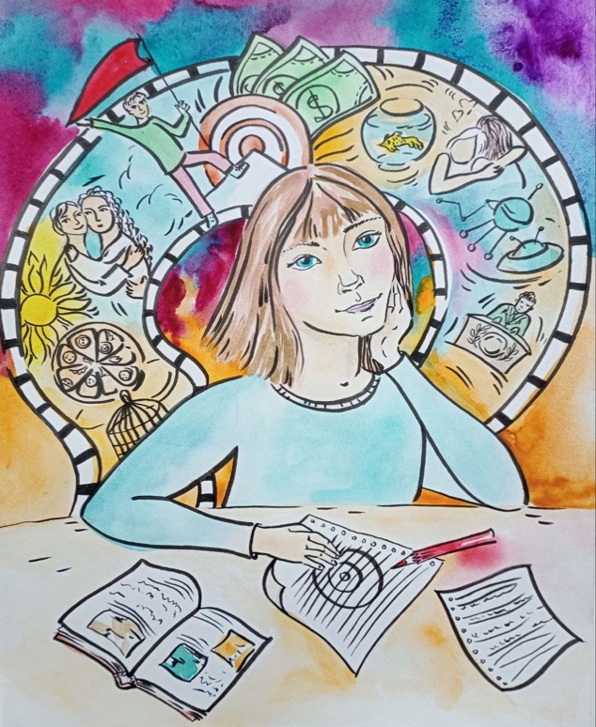Interests that bring pleasure to educated and thoughtful people often **SEEM BORING** or incomprehensible to the less thoughtful people. And what inspires admiration of the latter may not be to the liking of the former. Everyone strives for different things in life, be they great or small, important or routine. The most important thing is that these aspirations are **DEEPLY CONNECTED** with our nature. But when it comes to the ultimate goal of existence, what exactly do you want to get? Fame, power, wealth, material goods or pleasures that are unlikely to fill your life with true meaning. The value of pleasure is determined **NOT BY ITS SOURCE**, but by the depth of experiences that it awakens within you. It is like warmth in the house: it does not matter whether wood or coal burns in your fireplace, the main thing is that it is warm. The same is with pleasure: the main thing is that it **IS SINCERE** and pervades your entire being.

Nowadays the question of the meaning of life leaves many people untouched. You should not think that your coming into this world is justified only by the opportunity to build a house, raise children or plant trees. After all, over time, children will leave this world, houses will fall down, and trees will die. Leo Tolstoy emphasized in his "Confession" - *"... today or tomorrow, illnesses, death will come (and have already come) to our loved ones, to me, and nothing but stench and worms will remain. My works, whatever they may be, will all be forgotten - sooner or later, and I will not be there. So why bother?”* The answer to the question seems impossible.

Most people **DO NOT ASK** themselves the question "what is the meaning of life?” I emphasize, not of one’s life, but the meaning of life itself... In chess, to make the right move, you must consider the entire board. Likewise, in order to understand the **MEANING OF LIFE**, you must mentally penetrate every corner of the universe, not limiting yourself to our physical world. From this global view, the main thing should be extracted. As an example of such understanding you can take Religion. It points to the existence of an **INEXPLAINABLE ALMIGHTY** force that gave birth to everything that exists, including the world and man - God. According to an ancient prophecy, when a person dies, his 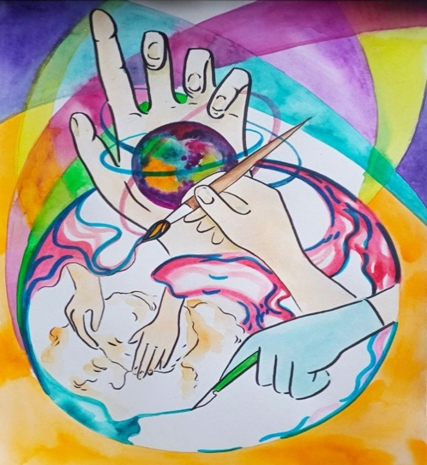body returns to the earth from which it came, confirming the idea that "... ***from dust we arose and to dust we shall return."*** The understanding of morality is based on the idea that after death, souls go either to eternal happiness in the heavenly abodes **FOR OBEDIENCE** to God's laws, or to endless torment in the underworld **FOR VIOLATION OF THEM.** Consequently, the pinnacle and meaning of human existence are associated with the liberation of the soul from sins and the pursuit of heavenly perfection. In this context, the concepts of "good" and "evil" are defined through their influence on the achievement of the highest goal - ***good is seen as everything that contributes to salvation, and evil is an obstacle on this path.***

On the other hand, the atheistic view claims that there is only **ONE REALITY** - the material world that we perceive through our senses. According to this opinion, the world **DOES NOT HAVE** a creator and exists on its own infinitely. In the atheistic perspective, the concept of God remains impossible without the assumption of the existence of the Creator of the universe. It is believed that only that which has the beginning can have a Creator, and that which exists eternally **DOES NOT REQUIRE** creation. In the context of historical events, the actions carried out by the Inquisition, such as the execution of heretics by burning or torture, were justified by the **DESIRE to SAVE** their souls, just as surgery is recognized as a good thing for its ability to save lives. This is seen as an analogy between the physical saving of the body by the surgeon and the spiritual salvation by the Inquisitor, despite the apparent cruelty of the methods, reflecting the clarity and unambiguity of the moral judgments of the time, free from doubts and double interpretations.

If the idea of ​​a deity is rejected, then the existence begins to seem like a product of a **RANDOM COMBINATION** of natural forces. In such a context, everything we know about ourselves - our thoughts, feelings, and even self-awareness - are nothing more than **SIDE EFFECTS** of complex physical and chemical processes. Without belief in a higher power - the concept of sin loses its foundation, becoming as abstract as a mistake in the face of fictional elves[1]. In a world where there is **NO BELIEF** in an afterlife or in a dualistic division between **HEAVEN AND HELL**, human existence begins to seem like a short-lived journey from existence to non-existence, where the only tangible goal is the pursuit of earthly pleasures. In this perspective, the definition of what is considered good or bad depends entirely on their ability to achieve what they desire. Thus, the view of what gives true meaning to life varies depending on each person’s beliefs, implying the **NEED FOR FAITH** in the truth of the chosen point of view***. People are divided into those who believe in the divine presence and those who deny its existence***. Such a diversity of views gives rise to the belief among believers that their understanding of the truth is the **ONLY CORRECT** one, and all alternative opinions can be classified as erroneous or even as manifestations of Satanism. An example of such an attitude is the criticism of the religious rites of the South American Indians by Christians, while they **DO NOT PAY** attention to their own rites and vices. The question of belief or disbelief in God becomes a personal choice for everyone, where some identify themselves as **HAVING FAITH**, while others describe their position as **LACK OF FAITH**. In any case, both directions rely on faith, whether in confirmation or denial of the divine.

There is no need to look for any arguments that can convince you of the correctness of any side. Just categorically refuse to take into account arguments coming from both atheistic and religious beliefs. And you have a reason for this - the path of knowledge, which I hope you **HAVE** **CHOSEN LONG AGO -** Knowledge of the truth in the ongoing. In particular - I do not like to consider religious issues, because admitting the truth of their assumptions, we come to the contradiction ... - where the faith of some - inevitably sends others to hell, if we assume their paradise is real. But I understand the main thing perfectly - we were all "made" as we are today - purposefully - for more than two thousand years and how this was done - I wrote in detail in my books. I know that many people, nevertheless, are burdened by the **SEARCH FOR THE MEANING OF EXISTENCE** nowadays. In this context, they should look at the world differently, imagining it as a single whole, like a chessboard, and try to identify the main goal - that which **WILL GIVE MEANING TO LIFE**. But they face a problem: even such an approach does not bring the expected results. The obstacle is **NOT IN THE IMPOSSIBILITY** of their personal understanding or knowledge, as one might assume, but in the **FUNDAMENTAL ERROR** embedded in the very question - about the meaning of life. And do not consider this as a lesson - it is a statement of what is happening.

The Universe consists of various elements and events, each with a **UNIQUE SET** of characteristics, including but not limited to size, shape, weight, energy and other aspects. But it is important to understand that the modern physical picture of the world resembles not even a patchwork quilt, but a **HEAP OF INCOMPATIBLE PIECES**. Not explained ***(or explained incorrectly):***

- absolute motion and absolute energy;

- mechanisms of gravity and repulsion;

- the structure and solid-state rotation of spiral galaxies;

- the source of thermal energy of the Sun, cycles of solar activity,

-differential rotation of the Sun, Jupiter, Saturn and Earth;

- movement of the Moon, Earth and other planets;

- tides, tidal and seasonal currents and winds, including monsoons;

- free fall of bodies and oscillations of pendulums, increase in the energy of freely falling bodies and the source of this energy;

- the origin and structure of nucleons and their unification into three-dimensional systems - atoms, molecules and substances; chemical properties of atoms, molecules and substances;

- heat, light and other waves; polarization and other properties of waves;

- physical properties of atoms, molecules and substances, including hardness, elasticity, heat capacity, thermal conductivity, thermal expansion, states of aggregation of matter, anisotropy and magnetism of crystals, attraction and repulsion of permanent magnets;

- the nature of electric current, thermal and magnetic effects of current, resistance and superconductivity of conductors, electromagnetic induction;

- causes of radiation and decay of atoms;

- long-term conservation of atomic energy in atoms and its mechanical nature; etc., etc. In order to comprehend the environment, it is necessary to **HAVE THE POSSIBILITY** to identify these features. Without certain attributes, an object or phenomenon **CANNOT** be tangible, understood or recognized as real. The importance of knowledge lies in the ability to give objects and phenomena the **STATUS OF REALITY** through their parameters. This rule applies to everything from the smallest particles to cosmic galaxies, and extends to everything from microbes to humans, each of which has **ITS OWN** set of properties.

Man's attempts to systematize knowledge are faced with the imposs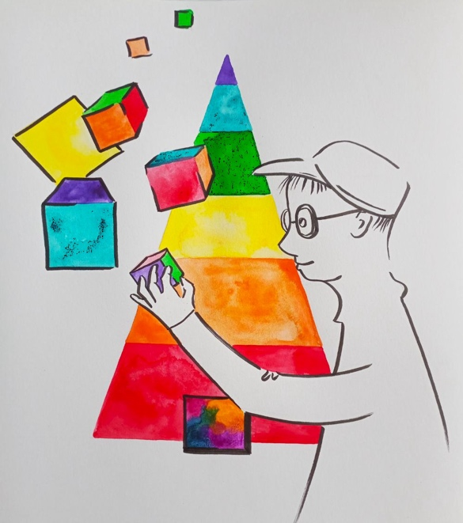ibility of fully encompassing and understanding the world that surpasses any notions of size and nature, rushing into infinite space. This **INTANGIBLE INFINITY** does not fit into the framework of the existing, not because of its absent reality, but because it is beyond the boundaries of the concept of "being", **HAVING NO** definite forms or properties. Describing its nature in words turns out to be impossible, because infinity initially goes beyond any definitions. The question of infinite space has always been a complex problem. Its nature can be felt, but it **DOES NOT FIT** into clear definitions or boundaries. Any attempt to limit it led to an imbalance. It was impossible to reject its reality, but it was also impossible to fully reveal or define it. As a result, humanity found a **CERTAIN COMPROMISE.** Aristotle took the first step towards this by introducing the concept of ***"potential infinity***". He claimed that it was impossible to understand **ACTUAL INFINITY,** considering it to be virtually unreal. According to ancient teachings, the concept of infinity was associated with the image of a balloon, the walls of which can stretch infinitely, but still remain within the framework of a finite object. This is similar to the principle of a natural series of numbers, where the last digit **DOES NOT EXIST**, but the entire series is perceived as finite. The idea of ​​absolute infinity was excluded by the ancients from the realm of the real, based on the assumption of its impossibility.

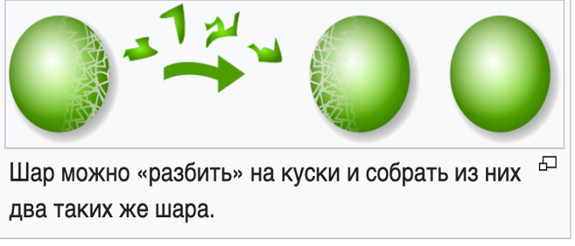In the field of mathematics, set theory developed on the basis of the concepts of infinity and the contradictions within this discipline. Einstein emphasized that although mathematical statements can reflect reality, they

can also **NOT DO SO**. At the dawn of the 20th century, two scientists from Poland showed that it was possible to divide an object into parts in such a way that an identical object could be assembled from these fragments, and then they showed that an infinite number of identical objects could be created from these parts, thus confirming the Banach-Tarski[2]theorem. Although this seems illogical, it has been **STRICTLY PROVEN** in terms of mathematics.

The time far beyond our ancestors keep stories about how Epimenides, an ancient sage[3], questioned his honesty by declaring that he was lying, which caused a wave of doubt in his words. This intrigue became fateful for Diodorus Cronus, who, in pursuit of the solution, refused to eat and died of starvation, never having found the solution. A similar fate befell Philetus of Cos, exhausted by the attempts to understand this mystery, as evidenced by the inscription on his tomb, stating that the paradox took his life. The last century saw Gödel's discovery that the world is awash with paradoxes and contradictions, emphasizing that they are an **ESSENTIAL PART** of existence. Zeno's paradoxes (involving the contradiction between the data of experience and their mental analysis) in the fifth century demonstrated the intertwining of motion and rest, raising questions about the nature of time and space. Bertrand Russell (who contributed to mathematical logic, the history of philosophy, and the influence of knowledge) emphasized that such paradoxes touch upon the foundations of many theories of infinity, time, and space, **EXERTING INFLUENCE** over our understanding of the world from ancient to modern times.

Paradoxes surround us. If we imagine water that can talk, and when it lies, it freezes, what should happen to it if it says: ***"I'm going to freeze now."*** If it **DIDN'T FREEZE**, then it lied, and it should freeze from lying. If it freezes, then it told the truth and it **DOESN'T FREEZE** from the truth. So what should happen to the talking water that freezes from lying and said "I'm going to freeze"?

If the world consists of an infinite number of quantities, if numbers are infinite both in increase - there is no last largest number, and in decrease, no matter how much you divide a digit, you can never divide it to zero, and then the world **CAN BE NUMBERED**. Pythagoras said that the world is based on number, and to know the world means to know number. In the information age, the correctness of Pythagoras's thought is especially evident. **THE WORLD IS A DIGIT.** With the help of digits, you can describe the parameters of a system, a finite quantity. But it is impossible to operate with infinity using numbers. You can write on paper or a screen "1∞ + 1∞ = 2∞". Formally, this equation is true, but in fact **IT IS A CHIMERA**. It has no place in reality, because there is only one infinity. There is simply no room for the second.

Between everything that exists in the Universe - from the smallest neutrino particles to huge galaxies, from sounds to stones, and even between a person and the objects of his environment, there is a relationship of great significance. The importance of these connections is emphasized by the fact that there are boundaries between these elements. These boundaries can be as transparent as a diamond, or blurred like fog, can shroud in mystery, like black holes and singularity points. Understanding the essence of any object or phenomenon without defining these boundaries **BECOMES IMPOSSIBLE**. Although the human mind has the ability to separate and comprehend various objects and phenomena, the concept of infinity remains beyond it, since it encompasses everything that exists **WITHOUT EXCEPTION.**

Our mind is capable of processing only measurable quantities, be they stable or rapidly changing, while small details are ignored, depending on the brain genotype that we have today (also divided into many sub-genotypes of a specific brain genotype). Anything that is beyond our understanding and measurement, such as infinity, **REMAINS BEYOND** our perception. Our desire to understand infinity actually **LEADS** **US** further from its **TRUE UNDERSTANDING**. Thus, we limit ourselves to only what is within the area of ​​our understanding and mental coverage, filtering out **THE ENTIRE EXTRA.** In exploring the meaning of life, we may come across analogies similar to the search for the optimal move in chess or the encounter between a powerful projectile and an impenetrable defense, which emphasizes the **COMPLEXITY AND MULTIFACETED NATURE** of our search. Analyzing the armor and the projectile separately, the Mind works without difficulty. However, when trying to compare them together, obstacles arise. This is because if the armor is penetrated by the projectile, it is no longer considered absolutely resistant, and if this does not happen, then the projectile has not fulfilled its function. Therefore, if the armor and the projectile really correspond to the supposed characteristics, their interaction **BECOMES MEANINGLESS**. Sometimes, the absence of an answer may indicate that the question itself is meaningless. The mind is trapped between infinite walls, where complete 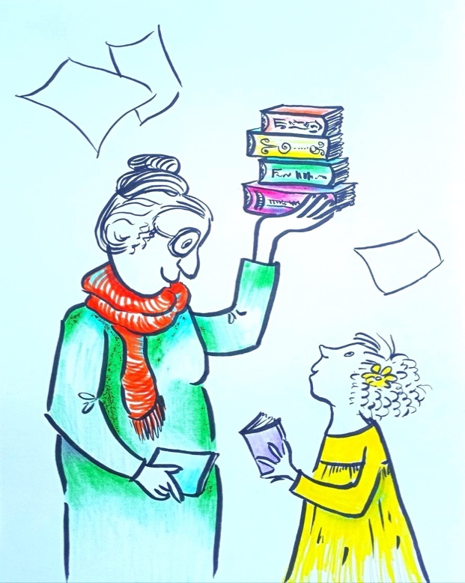**UNDERSTANDING IS UNATTAINABLE** due to the inconsistency of concepts. The search for the meaning of life does not require accepting other people's ideas on faith; it is important to have **ONE'S OWN UNDERSTANDING** and knowledge. Understanding infinity, like trying to overcome impenetrable walls, seems impossible, even if the efforts are directed at punching tunnels for as long as necessary. The search for the meaning of life goes beyond a simple final goal, coming from a vast range of possibilities. Some people find comfort in the idea that life in a global sense **HAS NO** purpose, and this allows them to continue their daily life, focusing on current affairs, until the **INEVITABLE END** comes.

Personally, I cannot agree with such a view, as if I were a passenger on a ship that is going down, and instead of looking for a save, I decorate my cabin, waiting for the end. Deep down, I reject such a passive position and continue my search for answers to the main question about the meaning of our existence and about extending it to the maximum (which today is defined up to 136 years - but this is for today ...) and in the maximum activity of this existence - calling it the idea **GLOBAL OF WHICH** there is no other in our world - ***to Conquer death and Overcome old age.***

It is impossible to find the universal meaning of life in the whole Universe. However, the main goal plays a decisive role in the search for the meaning and I have found it. This main goal was found and specified when a huge amount of information was taken into account and comprehended; surpassing what was based on the limited data. It is this approach, based on the **MAXIMUM AMOUNT** of the available information that forms the highest goal, which becomes the ***"meaning of life".*** The path of life itself determines the limits of available information, while questions about what happens after death remain unanswered, especially in our days. The beliefs of various religions offer the idea that the existence of a person in the form of a spiritual entity continues in an alternative dimension after he leaves this world. There is no irrefutable evidence about the fate of a human entity after it leaves this world. On the one hand, **THERE ARE NO** guarantees that the individuality of a person will be completely absorbed by a vacuum. On the other hand, there is no certainty about the possibility of continuing its existence in an alternative reality or space. Moreover, the so-called "reincarnation of Entities has been stopped" for known reasons, and on the other hand, it is **EXTREMELY DIFFICULT** to understand the prospects of the Entity for "integration into the future". Personally, I refuse to take any assumptions on faith, preferring to rely on clear and irrefutable data, which exist for the past reincarnation, but not yet for "integration". One of the arguments for this is the complete uncertainty regarding what awaits us **EXACTLY TODAY** (at the present time) beyond the threshold of death. My own Entity (or to be more precise and correct - the Brain) can either disappear into absolute emptiness or find a way of existence that we **CANNO**T understand or explain today.

Our existence on Earth in the present body is **NOT** **ETERNAL** and, sooner or later, will end, leaving behind only **UNMOVING REMAINS**, which will either be buried or turned to ashes. And of course - the opportunity to decide for myself when the end of my path will come, refusing to follow the outdated views on the duration of human life, described in ancient scriptures, is **VERY VALUABLE**. It is impossible to predict the moment of farewell to the world, but I believe that it will be right to "step away" when you feel that your time has come. Life in the world where **THERE IS NOTHING SURPRISING** seems meaningless to me, and I am ready to give it up as soon as I feel that the time has come. For now, I am happy with every moment, while I am still full of energy, but I am ready to accept the end if the moment of inevitable changes comes or I get tired of the daily routine.

But let's return to our reasoning and reality. The question of whether it is possible to pray and exercise at the same time has **DIFFERENT ANSWERS**, depending on how it is presented. An athlete, engaging in vigorous actions such as running, jumping and waving his arms, will most likely confirm that prayer is possible at such moments. But if you ask a priest whether it is appropriate to engage in physical activity during prayer, the answer, most likely, **BE NEGATIVE**. Thus, the point is not in the action, but **IN WHAT WAY** the question is asked. Likewise, people's attitudes towards the topics of life and death vary greatly depending on the wording of the question. For example, many people may disagree with a direct question about the desire for immortality.

In the community where the cult of death is exalted, members of the society blindly follow ingrained norms **WITHOUT STOPPING** to reflect on their meaning. This practice is reminiscent of the ancient Aztecs, for whom child sacrifice to the Sun was commonplace, and reflected their indifference to the concept of death. Whatever society considers normal is **IMPASSIVELY ACCEPTED** without questioning what death really is. Perhaps it is time to question the firmness of these beliefs, to expose their absurdity, by drawing an analogy with the passengers on a sinking ship who do not look for the ways for saving, preferring to remain in their cabins. Imagine yourself in a situation with difficult choice: it is cozy and bright around you, but this place promises only death, while in the cool and windy beyond safety **LIES** **the** **POSSIBILITY** of being saved. Perhaps in the open space you can build a life raft, or spot an island to which you can swim. Which path seems more appealing to you? Let us recall the story of the prince of an ancient kingdom who, faced with a similar dilemma between the safety of the palace with its fatal end and the unknown beyond its walls in search of saving, He **CHOSE THE LATTER**. ***This prince later became known as the Buddha***. This reminds us of the universal truth that life inevitably approaches its end, and each of us is faced with a choice: to wait for the end in passivity or to actively seek a way out. Strangely, but most of us prefer to remain in the comfort of our "cabin", resigned to the expectation of death, perhaps because we **PUT BARRIERS** to our thoughts about ***conquering death.*** Overcoming difficulties becomes easier when you think about the choice between dying by your own decision or under the influence of others. After all, **NO ONE WANTS** to leave this world, submitting to the will of another. And even believers in life after death **WILL NOT** object to the idea of ​​​​going there when they feel ready. Otherwise, people **WOULD NOT HAVE PUT IN** so much effort to avoid sudden death or interference, such as at the hands of a murderer. Thus, the desire to avoid death, whether by accident or by the actions of others, highlights that statements about the desire to end one’s life **AT ONE’S OWN FREE WILL** are often the result of spontaneous emotion, indifference, or habit. The deeply ingrained belief in the inevitability of death often leads to passivity. In a world where opposing views on this concept can send a person to see a mental health professional, skepticism about this belief raises suspicion and can potentially lead to consultation with a psychiatrist. Such beliefs have their origins in ancient religious views that divine will **DETERMINES the LIMITS** of life and death, setting the maximum age of man at 120 years, and this order is indisputable. The point is that human frailty cannot defy divine decree. In ancient times, when religious views dominated society, ideas about immortality **DID NOT FIND** grounds for discussion, since any attempts to think about **VICTORY OVER DEATH** were considered a crime against divine laws, which could lead to the most serious consequences. These circumstances restrained any desire to set tasks that contradicted established dogmas. At present, many people still recognize death as inevitable, but they **NO LONGER FIND** explanations for their conviction, taking it for granted, without additional thought.

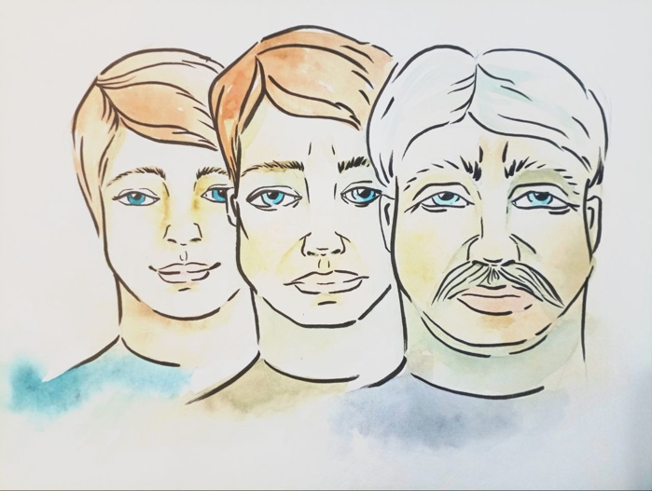Centuries of religious dominance have created beliefs that **HAVE BECOME UNTOUCHABLE** and are not subject to reflection or debate. These beliefs are powerful to such a point that they are difficult to put into words. We stand before their absolute truth in silence, realizing that any attempt to give them a voice only desecrates their purity. Those who hear these statements will inevitably experience mixed feelings: from anxiety and surprise to fear and discomfort. Although we **CANNOT** fully justify our belief in the inevitability of death, this does **NOT UNDERMINE** our confidence in its inevitability. After all, aging and death are an inevitable part of life, caused by the cessation of cell division and, as a result, the inability to renew tissue. If our brain **DID NOT STOP** controlling all the cells of our entire body at a certain point of time, aging and death would be unknown to us. The vital resources and energy to support this process are available in abundance within the body itself. However, due to the “mechanism” “built into” the brain, expressed mainly as the brain’s genotype, which limits cells division, the cells **CANNOT** use these resources effectively. This “mechanism” is the cause of aging and death. Considering a person before this limiting mechanism is activated, he can be compared to the car whose worn-out parts are regularly replaced, ensuring its smooth operation. However, after this timer is turned on, the situation changes: a person begins to resemble the car which worn-out parts have stopped being replaced, that leads to his gradual deterioration. At first, the car **CAN** still **FUNCTION,** despite creaking, sagging and tilting, but over time, due to the breakdown of important parts, it finally breaks down. Just as **REPLACING OLD** components with new ones in a falling apart car can turn it into a **NEW VEHICLE**, ***activating by the Brain (and only by the Brain) the cells division in an elderly person with failing eyesight and atrophied organs can make him young and healthy.*** As divisible cells change into indivisible cells, people experience aging, wrinkles, stooped posture, age-related diseases, and physical weakness. Death comes when the key organs stop working properly and **LOSE CONTROL** of the Brain completely.

The behavior of the European pearl mussel[4] is unique: its larval development is interconnected with the life of the salmon on which they parasitize. If signs of aging are detected in their host, these larvae **SECRETE A SPECIAL SUBSTANCE** that delays aging and initiates rejuvenation in the fish. This process transforms the old fish into a creature that not only looks younger, but also has increased strength and vitality compared to its peers, **NOT INFECTED** by larvae. This information makes you think about the possibilities of biology in the context of the fight against age-related changes and diseases, including cancer, but on one condition - understanding what our Brain is?

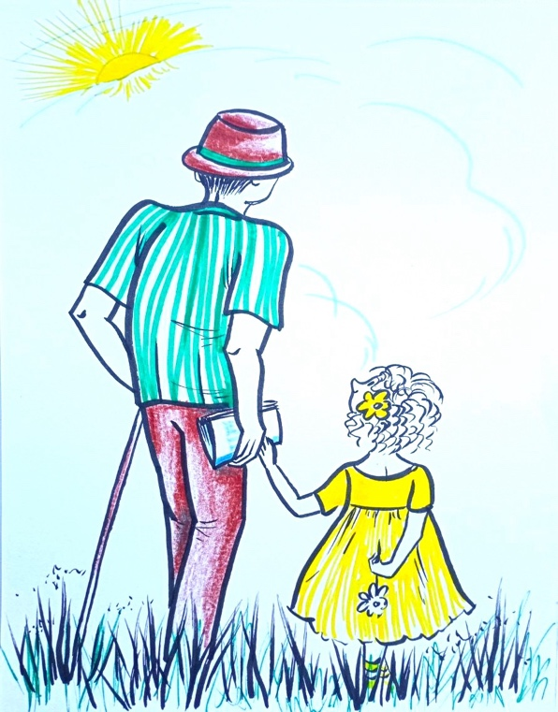You were informed of your inevitable fate, but it **DID NOT** **TOUCH** your feelings deeply. Your loved ones were informed that the disease will inevitably lead to death, but you remain unflappable, focusing on everyday activities such as work, shopping and improving your life. On the other hand, imagine a world where medical treatment eliminates all pain. In such a context, the awareness of the approaching death would cause **INEVITABLE ANXIETY**, making the search for a way to escape the main task. In this struggle for survival, all other desires and aspirations retreat, giving way to the urgent need to save life. Imagine a situation where you find out that your cells are **NO LONGER CAPABLE** of dividing, or this moment is just around the corner, which is more serious than a diagnosed cancer. How would your close friends, your family react to this? Probably, many of them would think that **DEEP DESPAIR** made you lose touch with reality. Your loved ones would begin to urge you to act wisely. They would try to convince you that in the moments when death seems inevitable, it is worth distracting yourself from everyday worries and concentrating on fighting it. After all, only those who **DO NOT GIVE UP** without a fight have a chance to overcome the inevitable, directing their energy and time to resistance. Once cells become cancerous (and they become cancerous when they lose control of the Brain), the chances of survival can vary, reaching in some stages from minimal to almost absolute chances of death. At the moment when cells are no longer capable of dividing, the probability of survival drops to zero, indicating the inevitability of death. It is known that there are no cases in which a person with such a change in cells would escape the **AGING PROCESS** and eventual death. Imagine that you were able to accept this sad news. You decided to share with your family, friends and acquaintances your decision to use the remaining time and energy **TO FIGHT** death. You emphasized that in the face of inevitable death, it is important to put aside everyday worries and concentrate on overcoming death. Success often comes to those who **ACTIVELY FIGHT**, especially against the inevitability of the end. Such a fight can become the **MAIN PURPOSE of LIFE** at certain moments. People around you, especially friends and family, may **NOT UNDERSTAND** your new outlook on life, assuming that you have strayed from the usual path or even joined an unusual community (or, in common parlance, a cult, although few understand what a cult is). They might suggest that you reconsider your beliefs, claiming that most people choose **NOT TO PAY** attention to these aspects of life and **NOT to WASTE** time on them. In an attempt to console you, they would remind you that **AGING AND DEATH** are parts of the natural course of life, urging you to accept them **AS INEVITABLE**. People often face a lack of understanding of the importance of actively responding to health threats, including cancer. Many would feel relieved to learn that the **TRUE DANGER** is not the disease itself, but in the inevitability of the end. After all, it is preferable to accept it as the inevitable than to live in fear of what **COULD HAVE BEEN** avoided. Despite this, the prevailing view is that one should distract oneself from potential dangers and ignore them, which raises questions about the correctness of this approach.

Regarding using the time, there is an advice to work, earn money, and organize one's life, rather than pursue meaningless questions and answers. This is seen as a way to make the rest of one's life **MORE MEANINGFUL**, allowing people to enjoy the fruits of their work in anticipation of the inevitable. Many people wonder why it is necessary to **STUBBORNLY RESIST** the inevitability of death when there are so many other challenges around, including economic difficulties, daily chores, the need for rest and entertainment, not to mention global problems such as wars, diseases, and the everyday standard of living. In this context, the desire of some people **to FIND A WAY** to avoid death is seen by many as strange, and sometimes such people are considered to be cultists or madmen. Comparing the situation with the passengers who, faced with the danger of the sinking ship, prefer to tidy up their cabins instead of looking for the ways to save themselves **LOOKS ABSURD**. This view underlines the hopelessness of those who choose to ignore serious challenges, preferring to **DO ROUTINE** and wait for the inevitable. Some realize that the absence of death will lead to a critical population of the Earth, the depletion of its resources and unprecedented pollution. This group of people, concerned about the future of the planet and humanity, is ready to make personal sacrifices in order to prevent an ecological crisis and problems of overpopulation. While others believe that the process of aging and the inevitability of death **GIVE LIFE** its true value, making each moment especially meaningful and joyful, despite the potential insincerity of statements about the charms of aging, loss of health and turning to dust after death. When discussing the problem of overpopulation, one should not limit oneself to the fight against the inevitability of death. Why **NOT STOP** treating heart disease or cancer? After all, the recovery of patients **ALSO CONTRIBUTES** to the increase in the population. After all, if we stop treating them, life on Earth, by this logic, should become easier. Imagine that you are asking the person fighting cancer why he decides to fight death by using your arguments against his fight for life. Why are you seeking a solution to one life-threatening problem while other equally important issues are ignored? Consider yourself in the situation of **EXTREME DANGER** and ask yourself what motivates you to seek a way out. Before I give you an answer to your question***, I invite you to reflect on it yourself.*** Many people find comparison disappointing, while others find comparison unacceptable. I wonder why such a comparison is considered unacceptable, since in both cases death is caused by the cells change, although one process occurs faster than the other. Why does death caused by one type of cell change cause you to fear and fight for life, while another process leading to the same result you ignore and feel no fear of it? In times past, the average human life span was **NOT EXCEEDING 40** years, often due to cardiovascular problems that at that time seemed inevitable due to some unknown causes. The perception of death, caused by sudden changes at the cellular level, could have changed dramatically if it had been viewed **AS A DISEASE**, rather than as part of the natural order. Thus, our attitude to the problem is largely determined not by its nature, but by **THAT WAY** it is presented, which in a way is a manipulation of our perception. Death remains a mysterious process that still takes the lives of many people today. Its nature is shrouded in mystery, although it seems obvious to many people. Often people refuse to accept that **THERE MAY BE NOTHING** natural about death, just as there is nothing natural about diseases such as cancer or tuberculosis. This attitude is surprising, because usually we expect an adequate response from a person to threats. For example, in case of fire, people are expected to find escape, but **NOT to GO ON** with their normal activities, ignoring the danger. When in the situation like a fire, a father goes on watching television, and a mother is putting the children to bed despite the fire, this clearly indicates a **MISPERCEPTION OF THE SITUATION**. Ignoring important aspects of death is similar to this illogical behavior.

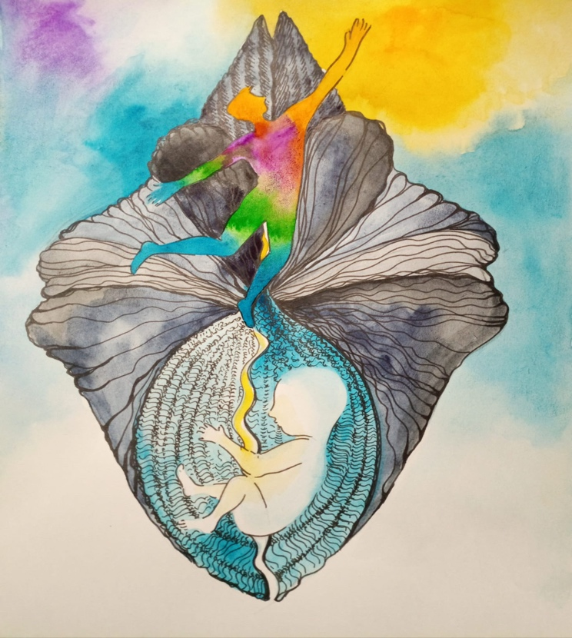 People gain the true meaning of their existence through real experiences, abandoning illusory aspirations. Solving the tasks and problems that life poses to a person raises him to a **HIGHER** level of development, opening up the access to unexplored areas of knowledge and setting new, more significant goals for him. This constant forward movement allows a person to encounter endless horizons of possibilities. Ultimately, all people face the **INEVITABILITY of DEATH**, which makes the desire to overcome it an absolutely priority mission for humanity, in the broadest sense of the word. Recognizing the victory over death as the supreme goal gives life the **HIGHEST MEANING**, based on the concrete realities, and not on assumptions. When the task is solved, a person will rise to a new height, from which **NEW HORIZONS** will open up to him. He will embrace a new volume of information and derive a **NEW MAIN GOAL.** ***But while we are all mortal, we cannot have a greater task than* OVERCOMING DEATH *and one of the components of this task is Victory over aging.***

If the main goal of mortal life is victory over death, then the meaning of life has been found. It is derived not from assumptions and suppositions, but from undoubted and reliable facts. It is **IMPOSSIBLE to THINK** of anything higher than this goal, if only because to achieve any goal **YOU** need **TO BE ALIVE.**

**P.S.**

The main difference between a realistically feasible proposal and a simple dream is the readiness and ability to **TURN WHAT IS PLANNED** into reality, including the stages of planning and mobilizing the necessary resources. While fantasy remains an **UNREACHABLE IDEALIZATION**, the intended goal turns into a **SPECIFIC IDEA** only then ***when realism is mixed with the dream in the form of a clear plan of action***. Only the combination of a dream with the way to implement it can give birth to the real idea.

A dream without a specific method simply becomes an impossible wish. I have created a complete plan, covering everything from start to finish, in order to implement the initial stage of my goal **– “*defeating old age".*** In this process, I have developed a clear strategy and a deep understanding of the necessary steps. In the following articles of the ***"...Project 369 series”***, I will try to describe in detail how you can successfully achieve the planned results, and I strongly recommend reading them to those who agree with the information presented above in this article.

***Dream + method = Idea.***

***Dream - method = fantasy.***

**F. Shkrudnev**

**05. 03. 2025**

1. Elves (German: Elfe - English: elf) are a magical people in Germanic-Scandinavian and Celtic folklore.
2. The Banach–Tarski paradox (also called the doubling ball paradox and the Hausdorff–Banach–Tarski paradox) is a theorem in set theory stating that a three-dimensional ball is equally composed of two copies of itself.
3. **Эпименид** (Epimenides), в Древней Греции полулегендарный мудрец, прорицатель и поэт, родом с острова Крит. Будучи ребёнком, пас овец, задремал в пещере и проспал 57 (или 40) лет.
4. The European pearl oyster is a bivalve mollusk. It has an elongated brown shell with a slightly protruding crown and a thick layer of nacre that has a pinkish tint. This is the pearl oyster - the "mother" of Russian pearls, one of the few freshwater pearl-bearing mollusks.