SMCC **Christian Education Ministries**

July 2025 Issue – Page 1

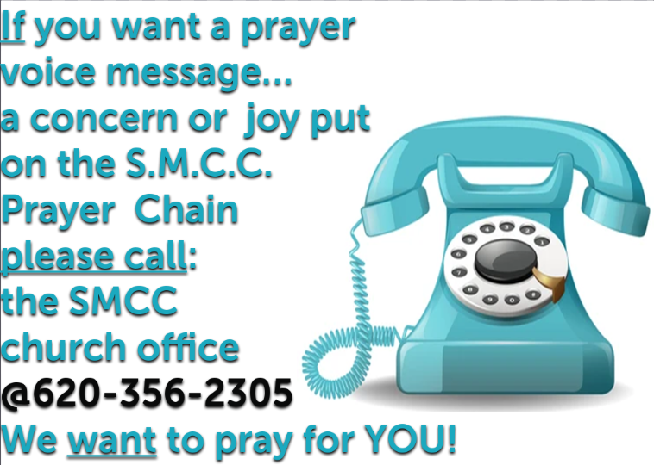  

 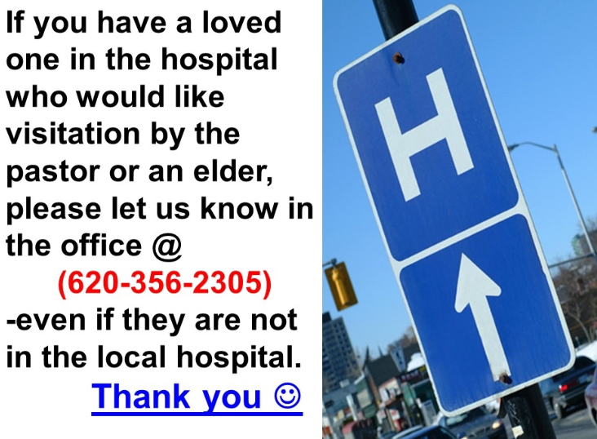 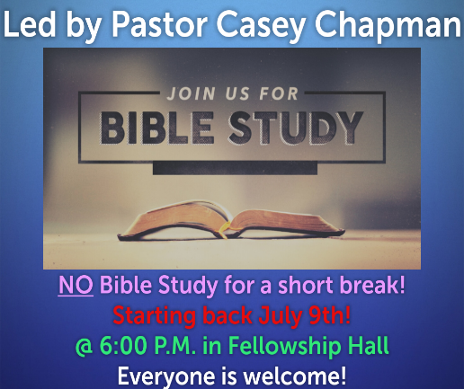

 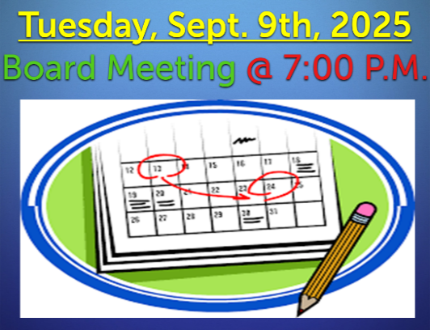 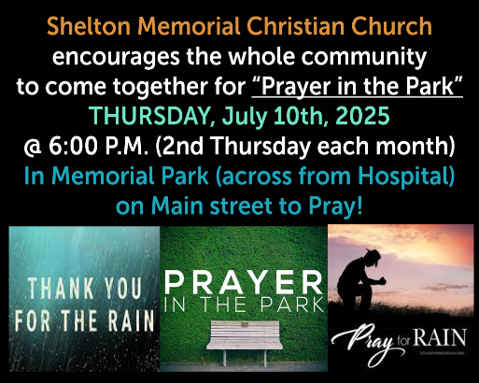

 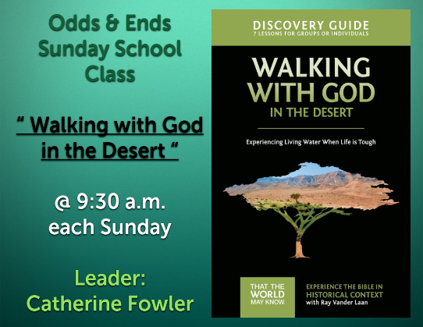 

 **SMCC Preschool**

Where Children love to Learn, and Learn with Love!

Miss Elizabeth and students are all on Summer Break! We look forward to another school year of new faces and a few old ones. We still have just a couple spots open out of our 36 spots available.

If you have a child who will be 4 by Aug. 31st and are interested, please give us a call.

***Thank you and have a nice day!***

***Kelly Rae :)***

**Kelly Rae Howard / Christian Education Director of Youth & Children  
Shelton Memorial Christian Church / 316 N. Main St. / P.O. Box 402  
Ulysses, Kansas 67880-0402  
620-356-2305 office / 620-353-8798 cell**

SMCC **Christian Education Ministries**

July 2025 Issue – Page 2

**  **

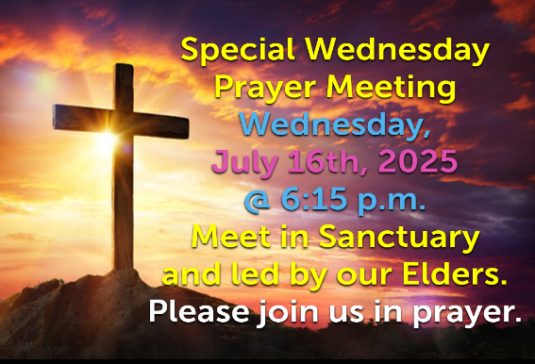 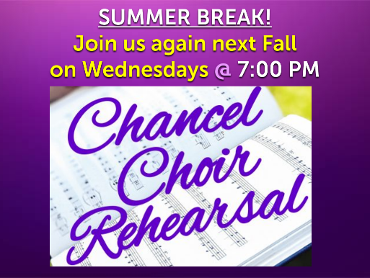 

|  |  |  |  |  |  |  |
| --- | --- | --- | --- | --- | --- | --- |
| |  | | --- | |  | |  |  |  |  |  |
|  |  |  |  |  |  |
|  |  |  |  |  |  |
|  |  |  |  |  |  |
|  |  |  |  |  |  |
|  |  |  |  |  |  |
|  |  |  |  |  |  |
|  |  |  |  |  |  |
|  |  |  |  |  |  |
|  |  |  |  |  |  |
|  |  |  |  |  |  |
|  |  |  |  |  |  |
|  |  |  |  |  |  |
|  |  |  |  |  |  |
|  |  |  |  |  |  |
|  |  |  |  |  |  |
|  |  |  |  |  |  |
|  | **ENROLLMENT FORM** | | | | |
|  |  |  |  |  |  |
|  | **Family Name______________________________________________________** | | | |  |
|  |  |  |  |  | **AGE** |
|  | **Adults -** |  |  | **Kids -** |  |
|  | **Adults -** |  |  | **Kids -** |  |
|  |  |  |  | **Kids -** |  |
|  |  |  |  | **Kids -** |  |
|  |  |  |  | **Kids -** |  |
|  | **Nursery Available 6:30 - 8:30 p.m.** |  |  | **Child -** |  |
| **?** | **Any special needs or dietary/allergies we need to be aware of ?** | | | |  |
|  |  |  |  |  |  |
|  | **Mailing Address: _____________________________________________________** | | | | |
|  | **___________________________________________________________________** | | | | |
|  |  |  |  |  |  |
|  | **Telephone No:_____________________________________________________** | | | | |
|  |  |  |  |  |  |
|  | **E-Mail address: ___________________________________________________________** | | | | |
|  |  |  |  |  |  |
|  | **Do you have a home church? _______________________________________________________** | | | |  |
|  | **Please know you are always welcome at Shelton Memorial Christian Church.** | | | | |
|  | **Sunday School @ 9:30 a.m. / Worship Service @ 10:30 a.m.** | | | |  |
|  | **Nursery provided every Sunday morning from 9:30 - 11:30 a.m.** | | | |  |
|  |  |  |  |  |  |