SMCC **Christian Education Ministries**

August 2025 Issue – Page 1

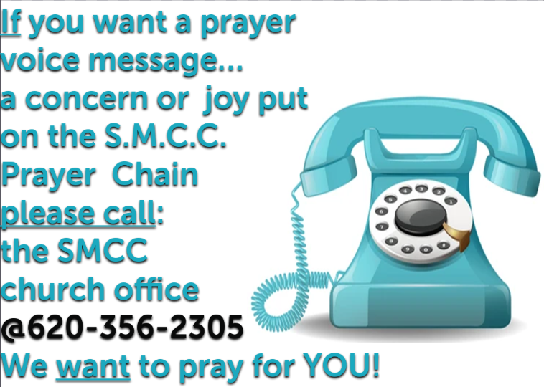  

  

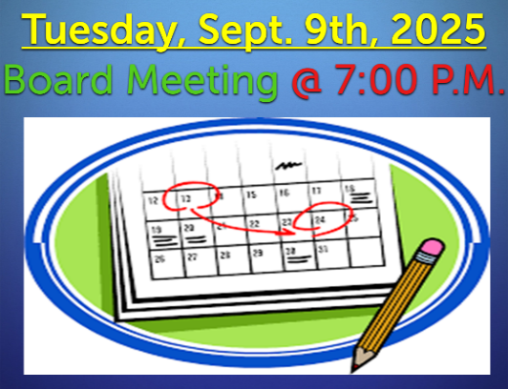  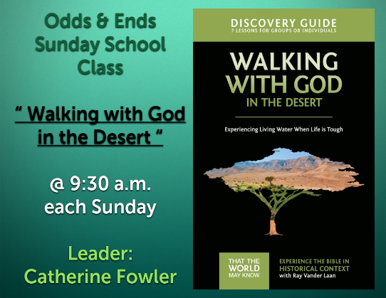

 **SMCC Preschool**

Where Children love to Learn, and Learn with Love!

Miss Elizabeth and her students will be returning after Labor Day! We look forward to another school year of new faces and a few old ones. We still have just a couple spots open out of our 36 spots available. If you have a child who will be 4 by Aug. 31st and are interested in our older class that prepares for Kindergarten, please give us a call. Meet -N-Greet will be Aug. 26th.

***Thank you and have a nice day!***

***Kelly Rae :)***

**Kelly Rae Howard / Christian Education Director of Youth & Children  
Shelton Memorial Christian Church / 316 N. Main St. / P.O. Box 402  
Ulysses, Kansas 67880-0402  
620-356-2305 office / 620-353-8798 cell**

SMCC **Christian Education Ministries**

August 2025 Issue – Page 2

 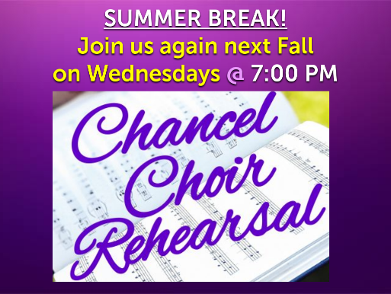 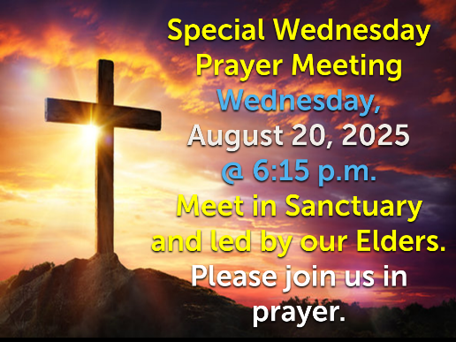

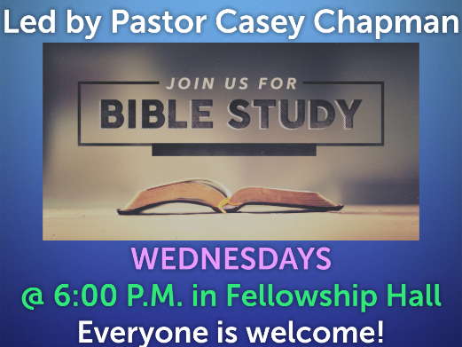 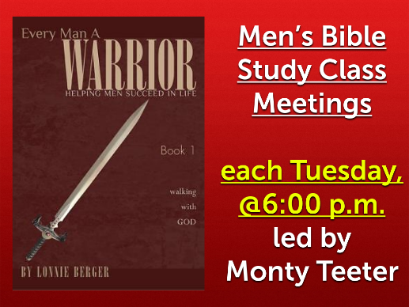 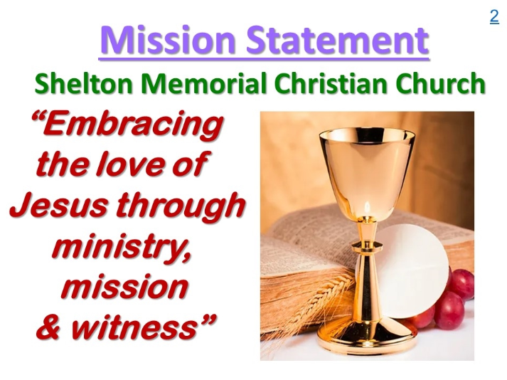

**“CAMP CHAOS” WAS A HUGE SUCCESS! We served over 70 people and over 25 families this week!**

***THANK YOU* to all of the volunteers, helpers, kitchen staff, leaders, registration and Pastor!**

