 SMCC Christian Education Ministries
August 2026 Issue – Page 1



 SMCC Preschool Where Children love to Learn, and Learn with Love!
SUMMER IS ALMOST OVER!
Miss Jess will be getting the classroom ready in August.
We will have our Teacher Meet – n – Greet on
Wednesday, August 26th from 3:00 – 7:00 P.M.
ALL Paperwork is required to be turned in by Aug. 19th.
First Days of Preschool are either
Wednesday Sept 9th -or- Thursday Sept. 10th!
If you have any questions, please feel free to reach out to
Jess @ 620-453-0716
or Kelly Rae @ 620-353-8798

New SMCC Preschool HOURS
3 & 4 YEAR OLD CLASSES / (Mon & Wed) or (Tue & Th) 9:00 – 11:00 A.M.
4 & 5 YEAR OLD CLASS / 4 DAYS A WEEK – (Mon, Tues, Wed & Thurs) 12:30 – 3:30 P.M.
SMCC Christian Education Ministries
August 2026 Issue – Page 2


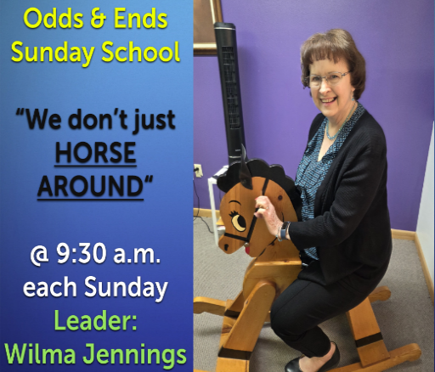
From the desk of Kelly Rae On my mind, in my heart and ready to share!

Calming My Back-to-School Mama's Heart by Karen Ehman

"Then He went down with them and came to Nazareth and was obedient to them. His mother kept all these things in her heart. And Jesus increased in wisdom and stature, and in favor with God and with people." Luke 2:51-52 (HCSB)


Neatly lined notebook paper. Sharpened number two pencils. A brand-new box of brightly-colored crayons. A sturdy lunch box ready for the first PB&J of the year. Permission slips. Sports schedules. Class lists. So many details and so much stuff! This time of year, shopping for 3-ring binders can seem almost like a 3-ring circus. Gone are the lazy days of summer. The fall school routine brings new courses, loads of homework and many extra curricular activities.
While the arrival of a new school year brings a fresh start - and soon the change of seasons - it can also bring a lot of worry to a mama's heart. Our thoughts turn toward our children's interaction with others. We wonder how our timid child will fare in a brand-new classroom, when most of his friends are in another class. We fret about our prank-pulling middle schooler, earnestly hoping he doesn't make a habit of getting called to the principal's office. We fear for our high school student, worried they will hang around the wrong crowd. We stress over academic concerns. Will our struggling first grader ever make progress in her reading? Will math ever click with our fifth grader who gets hives when she sees a story problem? Will our high schooler get into his hoped-for university? Besides relational and academic matters, we also long for kids who are spiritually and physically healthy and strong. If left unchecked, our thoughts and concerns as mothers can wreak havoc on our hearts as we allow the tentacles of worry to choke out our joy.
We find an antidote to worry in the gospel of Luke and the story of Mary and Jesus. Luke 2 mentions four areas Jesus grew in as a young boy: "And Jesus increased in wisdom and stature, and in favor with God and with people." Our Lord grew wiser each year. He physically grew. His relationship with His heavenly Father continually strengthened. Jesus even gained favor with people here on earth who saw Him day to day. And how I love the simple sentence that precedes this: "His mother kept all these things in her heart."
When Mary was mothering Jesus, she tucked thoughts of her son safely in her heart. Some Bible translations say she "treasured" them. Others use the word "cherished." The original Greek word meant, "to keep safe or hold fast." In none of these descriptions do we see Mary fretting and fussing, worried and anxious, disquieted and unsettled. She pondered about her son and his growth, but she didn't allow her mama heart to become rattled.
This fall, let's turn our anxious thoughts into treasured prayers, kept safe and held fast by our loving Father - the one who knows our hearts and loves our children even more than we do. When a concern pops up in our mind, let's drop to our knees and carry that concern to God. When we start to fear for our child's future, let's petition the only one who knows exactly what the future holds. When we turn our worries into our prayers, we create space in our hearts to treasure and cherish the sweet moments with our kids. These paper-and-pencil school days won't last forever. Let's delight in all that God is teaching our kids, whether it's how to read, how to forge friendships or how to solidify their walk with Him. And realize they aren't the only ones being taught; we moms are learning a life-long lesson in trusting and treasuring, knowing God is always in control.
Father, please help me this year to turn my worries into prayers, knowing You are in control. Allow me to treasure each moment with my children as they grow in wisdom and stature and in favor with others and also with You. In Jesus' Name, Amen.

