 SMCC Christian Education Ministries
September 2026 Issue – Page 1

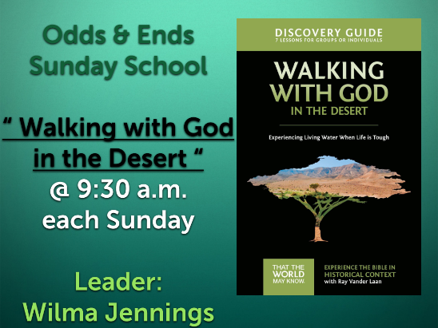
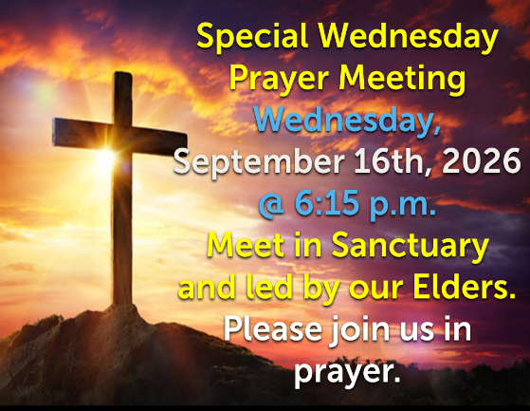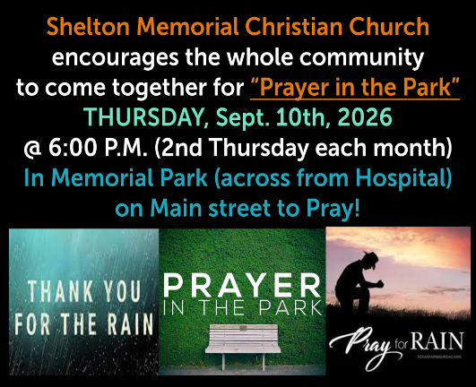
 SMCC Preschool Where Children love to Learn, and Learn with Love!
September is here! We are getting closer to starting our first day here at SMCC. I am getting very excited for my very first official school year. I have been working very closely with Kelly Rae on getting all the children ready for their first day! We were able to do an open house and meet most of the children and their parents. The children enjoyed being able to play in the classroom, and the most popular center was our new light table! It was so nice to meet new children and see their personality.
This month I plan on working with the children on hanging up their backpack, being able to identify their first letter of their name for the three year olds, and identifying their name with the four year olds. We will be talking about the routine during their day, how to wash their hands and how to blow their nose, also emotions and manners. A lot of this month we will be working on establishing boundaries and rules. We will also work on introducing different nursery rhymes and songs!
They will be able to play with different centers we have set up in the preschool! We will be exploring different sensory play tubs. They will be able to play with dyed pasta, and beans. They will be able to play with homemade play-dough at our playdough center, this will help build their fine motor skills so that it will be easier to hold pencils. Our dramatic center is set up, with some different pairs of shoes, hats, and clothes. A writing center is set up, and our book center is set up as well. All of these centers are so important in helping children develop.
I am so excited for this school year and what God has planned for myself and these children. I can’t wait to see all of the children and their smiling faces! It is going to be a great school year. If you have any questions, please feel free to contact me on my email or cell phone!

Jessica Malone
Preschool Teacher/Director
Email: jkmalone10@gmail.com Phone :620-453-0716
New SMCC Preschool HOURS
3 & 4 YEAR OLD CLASSES / (Mon & Wed) or (Tue & Th) 9:00 – 11:00 A.M.
4 & 5 YEAR OLD CLASS / 4 DAYS A WEEK – (Mon, Tues, Wed & Thurs) 12:30 – 3:30 P.M.
SMCC Christian Education Ministries
September 2026 Issue – Page 2
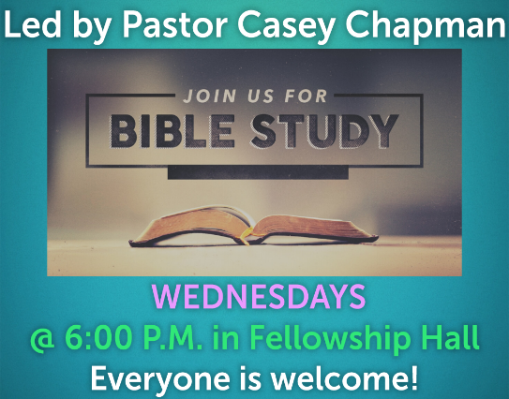

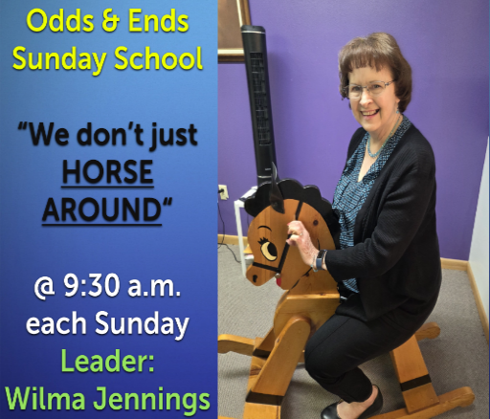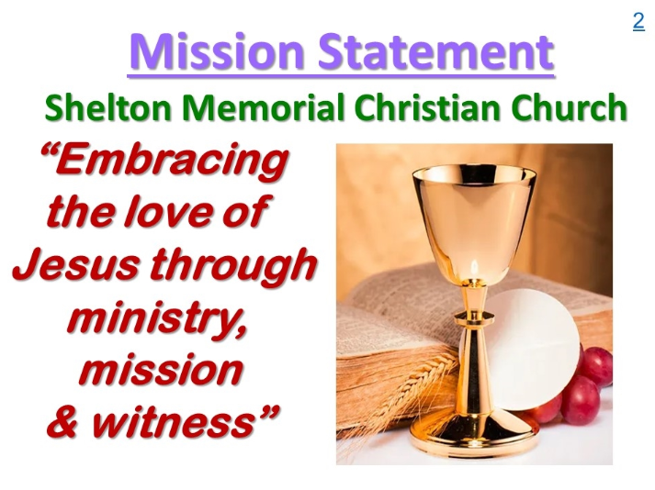
From the desk of Kelly Rae On my mind, in my heart and ready to share!

Autumn’s Palette by Shari Johnson Psalm 147

There’s always a reason to Praise! There are few things more beautiful than the changing of the leaves in the Autumn of West Virginia. A wonderful reminder that there is always beauty in our lives no matter what season we’re in.
Orange – the color of Gratitude ¹ Praise ye the Lord: for it is good to sing praises unto our God; for it is pleasant; and praise is comely. Orange is an autumn staple in our décor throughout the fall holidays. What are you thankful for in this season of your life? Season could be age, or it could be a specific life event that you’re going through.
Brown – the color of stability. Like to trees of the forest, seasons come and seasons go, and many of them are filled with the trials of life. But through them all God is always faithful! The Psalmist mentions a few seasons in this Psalm that we are now in or have been at some point in our life. As church Homecoming approaches, think about the many people who have had a season in our church. Perhaps they’re still here, or have been long gone. Name them, and pray for them in the coming days. More importantly, Invite them! ² The Lord doth build up Jerusalem: he gathereth together the outcasts of Israel. someone not always welcome in their community or family ³ He healeth the broken in heart, and bindeth up their wounds… we all know someone with a broken heart.
Yellow – the color of the stars. Too many in the Heavens to number, yet our Father has named them all. Isn’t it awesome that even though we sometimes forget a name for a season, God never does! Someone may have walked away from Victory Baptist Church, and walked away from God, but He still remembers their name and desires their fellowship. So should we! ⁴ He telleth the number of the stars; he calleth them all by their names.
Green – the color of forever. ⁵ Great is our Lord, and of great power: his understanding is infinite. Not only does the Lord not forget who we are, He doesn’t remember who we were! Now that is a reason to praise Him every day.
Gray – the color of rain. During the fall and winter seasons, the dismal gray of the sky and forest can weaken the human spirit. It’s easy to fall into depression and discouragement. But along with the gray overcast skies, usually comes an abundance of rain or snow. Again… not what we’re necessarily fond of. But what a sad spring it would be, if the ground wasn’t strengthened by that moisture. ⁶ The Lord lifteth up the meek: he casteth the wicked down to the ground. ⁷ Sing unto the Lord with thanksgiving; sing praise upon the harp unto our God: ⁸ Who covereth the heaven with clouds, who prepareth rain for the earth, who maketh grass to grow upon the mountains. ⁹ He giveth to the beast his food, and to the young ravens which cry.
Red – the color of Redemption. ¹⁰ He delighteth not in the strength of the horse: he taketh not pleasure in the legs of a man. ¹¹ The Lord taketh pleasure in them that fear him, in those that hope in his mercy.
Red seems to make its way into every season in some form or another; from pinks of Easter to the Holly berries of Christmas. Every season of the life of a child of God has been covered by the blood. God’s not impressed with our strength, for it’s nothing in comparison to His, but He is impressed with the humility of a child of God who depends on Him and has hope in His mercy.
If you read on in this Psalm you can prepare your heart for winter too! But for today let praise Him for the goodness of Fall. ¹² Praise the Lord, O Jerusalem; praise thy God, O Zion.¹³ For he hath strengthened the bars of thy gates; he hath blessed thy children within thee. ¹⁴ He maketh peace in thy borders, and filleth thee with the finest of the wheat. ¹⁵ He sendeth forth his commandment upon earth: his word runneth very swiftly. ¹⁶ He giveth snow like wool: he scattereth the hoarfrost like ashes. ¹⁷ He casteth forth his ice like morsels: who can stand before his cold? ¹⁸ He sendeth out his word, and melteth them: he causeth his wind to blow, not dealt so with any nation: and as for his judgments, they have not known them. Praise ye the Lord.and the waters flow. ¹⁹ He sheweth his word unto Jacob, his statutes and his judgments unto Israel. ²⁰ He hath not dealt so with any nation: and as for his judgments, they have not known them. Praise ye the Lord.

