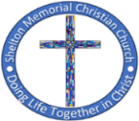
SHELTON MEMORIAL CHRISTIAN CHURCH
316 N. Main Street P.O. Box 402
Ulysses, KS 67880
620-356-2305—E-mail smcc1oms@gmail.com

Website www.smcculysses.com

August 2026

OUR PURPOSE:

“Embracing the love of Jesus through ministry, mission & witness”
“A Time to Study”
by: Pastor Casey Chapman

It is time to sharpen the pencils, pack the bookbags, and open our hearts to timeless wisdom. The season of rest is over as our young adults and children return to college or grade school. It is also time for us, as Christians, to return to the study of God’s Word.

Psalm 119:105
“Thy word is a lamp unto my feet, and a light unto my path.” (KJV)

It is time for us to fill our oil lamps and flasks as we wait for the groom to arrive. Matthew 25:1-10 (KJV) says, “¹Then shall the kingdom of heaven be likened unto ten virgins, which took their lamps, and went forth to meet the bridegroom. ² And five of them were wise, and five were foolish. ³ They that were foolish took their lamps, and took no oil with them: ⁴ But the wise took oil in their vessels with their lamps. ⁵ While the bridegroom tarried, they all slumbered and slept. ⁶ And at midnight there was a cry made, Behold, the bridegroom cometh; go ye out to meet him. ⁷ Then all those virgins arose, and trimmed their lamps. ⁸ And the foolish said unto the wise, Give us of your oil; for our lamps are gone out. ⁹ But the wise answered, saying, Not so; lest there be not enough for us and you: but go ye rather to them that sell, and buy for yourselves. ¹⁰ And while they went to buy, the bridegroom came; and they that were ready went in with him to the marriage: and the door was shut.”
God’s Word, the Bible, lights our way. We live in a dark and confusing world, filled with distractions and people claiming to be wise but are fools. How can we find our way through the darkness without a light? Even your pastor can be fallible. How do you know the truth is being preached without having God’s Word stored up inside of you? Store up the Word so that you may be ready at all times for the groom to come. Have your lamps full of oil to give light to your family and the ministry that God has put you in for we are all ministers of God’s Word.
The Apostle Paul, having just encountered the Lord Jesus on the Road to Damascus retreated for three years and devoted himself to the study of the Word. There is a time of rest and there is a time of study. A time of planting and a time of harvesting. We must be willing to move through life according to God’s rhythms, for if we grow content in one season, another is neglected. That neglect results in stagnant faith which hinders our walk with God and the blessings He so desires to give to His children.
Be good stewards of the Word of God that the saints have carefully passed down from times and time ago, and that the Holy Spirit testifies to our spirit today of its Truth. Fill your oil lamps so that you will be prepared for all things as we patiently await our Savior’s return for His bride.
---------------------------------------------------------------------------------------------------------------------------------------------------
ANOTHER SUCCESS FOR FAMILY VBS
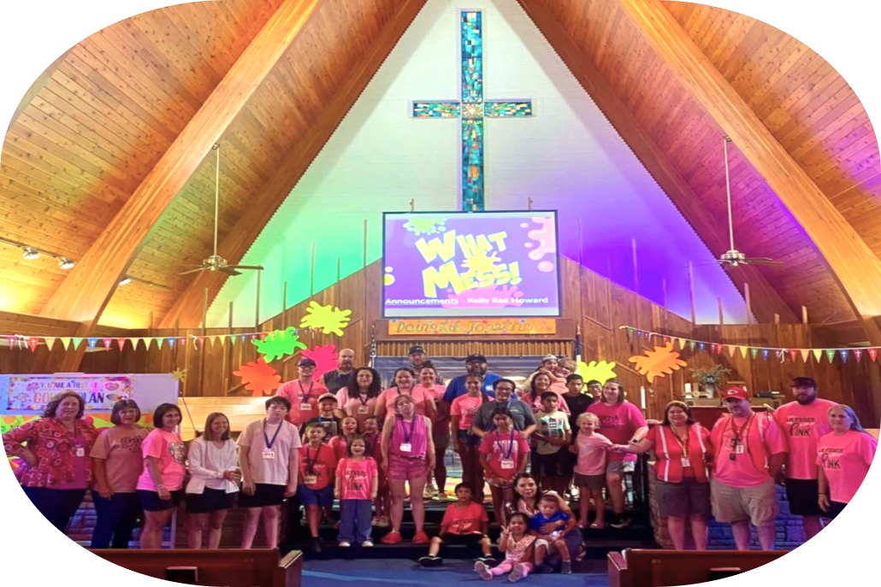

AUGUST BIRTHDAYS/*ANNIVERSARIES
04 – Callahan Dawson---1 year old
05 – Rod Nordyke
05 – Gaige McGaughey
05 – *Wally & Marcia Raines
06 – Bryson Stejskal
07 – Kyler Smyth
09 – Shelley Phelps
10 – Collin Wilson
10 – Rhonda Anderson
10 – Russell Wells
11 – *Larry & Thelma Bortz
11 – Craig Bohl
11 – Jace Smyth
11 – Leilani Anderson---1 year old
15 – Trip Hull
15 – Kelin Smyth
18 – Allison Raines
18 – Daisy Mae Smyth---1 year old
19 – Brian Gustin
20 – Robyn Nordyke
20 – *Gary & Donna Covey
22 – Brittany Raines
23 – Rhonda Brady
25 – Linda Post
25 – Kelsey Nordyke
28 – Marcia Raines
If your special day has been missed, please contact the church office. 620-356-2305
-----------------------------------------------------------------------------------Scheduled to Serve in AUGUST:
Elders: Monty Teeter, Wally Raines

Deacons: Bruce Howard, Robyn Nordyke
Marcia Raines, Justin Howard

Communion: Kim Klein/Kelly Rae Howard

Worship Leaders:
02: Monty Teeter 23: Robyn Nordyke
09: Justin Howard 30: Tamra Rundell
16: Thelma Bortz
Children’s Moments:
02: Kelly Howard 23: Marcia Raines
09: Jeri Lynn Wells 30: Robyn Nordyke

16: Jean Teeter
Greeters: Deacons for the month
Questions?? CALL or email:
Pastor Casey 620-356-2305(W) 814-573-8148 (C) pastorcaseychapman@gmail.com
Rhonda @ 620-356-2305 (W) 620-952-0589 (C) smcc1oms@gmail.com or rhondaanderson615@gmail.com

Kelly Rae @ 620-356-2305 (W) 620-353-8798 (C) smcc2ce@gmail.com or kellyraehoward1961@gmail.com

General Offering to SMCC thru July
$117,419.12
Thank you, God, for the generosity of this Community of Believers and may their love for you and each other be an inspiration to reach out to those who are in need of knowing You and believing in your love, peace and grace.

SMCC cares about you! You are loved and prayed for when you’re here and when you’re NOT here. AND YOU ARE MISSED!!!!! Remember, this is your home away from home!

REMINDER
If you have a loved one in the hospital, please let the church office staff know (620-356-2305).

If there is someone who is not on the prayer list but needs to be, please let the office staff know. We do want to pray for those in immediate need!! So, keep us updated, PLEASE. Rhonda

Known Prayer Concerns & Joys:
Chris & Gina Banuelos (Oregon fires), Carolyn Dunn, Chris Madrigal, Raymond Howell (surgery Aug. 4), Chandler (3-yr old in Ohio), Friend of Trace Phelps - London Gonzales (13-yr old w/Cancer), Tim Dennett (cancer), April Dennett, Kayla Smyth, June Mason, William Malone, Cheryl Moyer, Cherri Chapman, Steve Alford, Mary Fowler, Jessica Reese & son Ransom, Donna Ward, Danny & Pam Watson, Jeff Watson, Zach Irvin, Jerald & Sharon Phelps, Brad Bevan, Randy Dawson (Jordan’s F-I-L), Sharlene Harding, Robert Moore, Kai (friend of Gina Banuelos’ family), Bruce Limper, Marla Young (Lana’s cousin), Martie Floyd, Donna Hooton, Linda Hickman, Catherine Fowler, Jolene Turner, Kinsey Cook, Adam Heinrichs, Luke Ruiz & Roman Ruiz (Violet’s brothers).
Prayers for those who have recently lost loved ones!
Pray for our Armed Forces: Damon Haney, Wes Wilkening, Caden Beims, Maison Wiginton, Dylan Carroll, Canyon Collum, Adam Lambing, Corey Ungles, Lacy Rundell ========================================Regular Monthly Schedule

Sunday 9:30 A.M. – Christian Ed. Classes Odds & Ends –‘Walking with God in the Desert’

10:30 A.M. – Worship Service

CAN ALSO VIEW ONLINE

FACEBOOK & YouTube

1st Sunday 9:00 A.M. – Elder’s Meeting

Wednesday 6:00 P.M. – Bible Study

3rd Wed. 6:15 P.M. – Special Wednesday

Prayer Meeting in sanctuary w/Elders- Join us!!!

---------------------------------------------------------------

Monthly Schedule for AUGUST 2026

Aug. 2– 9:00 A.M. Elder Meeting
9:30 A.M. Odds & Ends Sunday School
10:30 A.M. Worship Service
Message by Pastor Casey Chapman
Aug. 3– 5:30 P.M. Anniversary Comm. Meeting
Aug. 5– 6:00 P.M. Bible Study
Aug. 8– Young adults Picnic @ Pastor Casey’s
Aug. 12– 6:00 P.M. Bible Study
Aug. 13– 6:00 P.M. Prayers for Rain in the Park
across from the hospital
Aug. 16– 9:30 A.M. Odds & Ends Sunday School
10:30 A.M. Worship Service
Message by Pastor Casey Chapman
Aug. 19– 6:15 P.M. Prayers in Sanctuary w/Elders
NO Bible Study
Aug. 23– 9:30 A.M. Odds & Ends Sunday School
10:30 A.M. Worship Service
Message by Pastor Casey Chapman
Aug. 26– 6:00 P.M. Bible Study
Aug. 30– 9:30 A.M. Odds & Ends Sunday School
10:30 A.M. Worship Service

