SMCC Christian Education Ministries
January 2026 Issue – Page 1
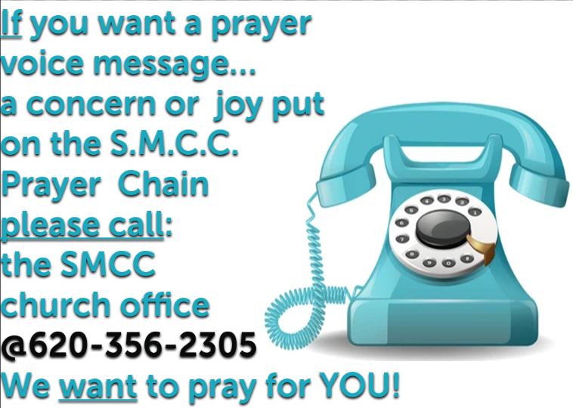

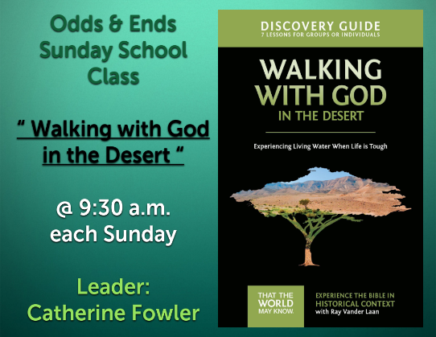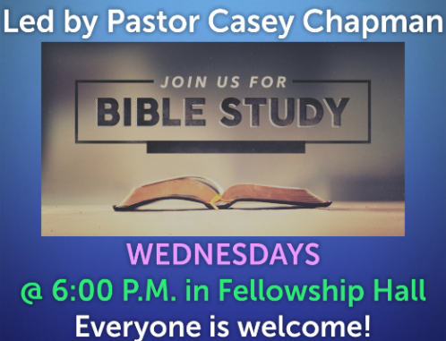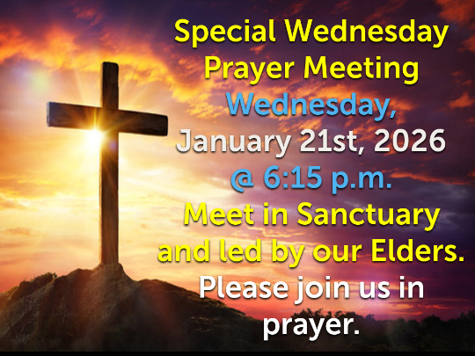
 SMCC Preschool
Where Children love to Learn, and Learn with Love!
As most of you have already heard, unfortunately Miss Elizabeth had to step down from her position due to health reasons. As part of the Christian Education Committee, we have decided to accept applications for a new Preschool Director/Teacher. The deadline is January 15th, 2026.

Mrs. Robyn Nordyke has agreed to be our long-term sub starting in January 2026 until we find a replacement.
Our goal is for the new teacher to work with Robyn closely for a few months to provide a smooth and seamless transition for all the kids as well as their families. We will make that announcement as soon as we can.

Just a reminder that we follow the USD #214 Calendar as much as possible.
Our 3-year old classes will start back on Tues. Jan. 6th and Wed. Jan 7th depending on which class you attend.
Our 4-year old program wills start back on Tues. Jan. 6th. NO CLASSES ON MONDAY, JAN. 4TH, 2026.

Please spread the word about our search for the right Teacher, and pray for the process to be successful in our candidate we choose. We know that God has a plan for us, and we are trying to be patient in that process.
The SMCC Preschool Committee consists of Marcia Raines, Jan Goehring and Kelly Rae Howard.

Please let us know if you have any further questions.

Thank you and have a nice day. Kelly Rae
@ 620-356-2305 office or 620-353-8798 cell SMCC Preschool HOURS
3 & 4 YEAR OLD CLASSES / (Mon & Wed) or (Tue & Th) 9:00 – 11:00 A.M.
4 & 5 YEAR OLD CLASS / 4 DAYS A WEEK – (Mon, Tues, Wed & Thurs) 12:00 – 3:00 P.M.
SMCC Christian Education Ministries
January 2026 Issue – Page 2


From the desk of Kelly Rae On my mind, in my heart and ready to share!


9 New Year’s Resolutions from the Bible
"Commit to the Lord whatever you do, and your plans will succeed" (Proverbs 16:3).
Setting goals for self-improvement each year is a personal process, the results of which we don't always care to share. While telling your spouse that you plan to clean out the basement by February holds you accountable, it also makes you feel even lazier if March rolls around and it's still a mess. Having a partner who knows your new year's resolutions can be both a blessing and a curse, unless that partner is God. Talking to Him about your goals will give you peace of mind and an opportunity to ask for wisdom (whether your plan is in your best interests and others') and guidance (how to reach your goal). This year, consider these Bible verses and have peace in knowing that if it is God's will for your resolution to be fulfilled, He will enable you to accomplish it.
1. Teach with intelligence. "Have nothing to do with foolish, ignorant controversies; you know that they breed quarrels. And the Lord's servant must not be quarrelsome but kind to everyone, able to teach, patiently enduring evil, correcting his opponents with gentleness" (2 Timothy 2:23-24).
2. Pray for guidance. "If any of you lacks wisdom, let him ask God, who gives generously to all without reproach, and it will be given him" (James 1:5).
3. Forgive those who have hurt you. "Bear with each other and forgive whatever grievances you may have against one another. Forgive as the Lord forgave you" (Colossians 3:13).
4. Take care of yourself. "Do you not know that your body is a temple of the Holy Spirit, who is in you, whom you have received from God? You are not your own; you were bought at a price. Therefore honor God with your body" (1 Corinthians 19:20).
5. Love others. "The most important one, answered Jesus, "is this: ‘Hear, O Israel, the Lord our God, the Lord is one. Love the Lord your God with all your heart and with all your soul and with all your mind and with all your strength.' The second is this: ‘Love your neighbor as yourself.' There is no commandment greater than these."
6. Be a role model. "Show yourself in all respects to be a model of good works, and in your teaching show integrity, dignity" (Titus 2:7).
7. Don't be discouraged by failures. "Have I not commanded you? Be strong and courageous. Do not be frightened, and do not be dismayed, for the Lord your God is with you wherever you go" (Joshua 1:9).
8. Value your friendships. "Two are better than one, because they have a good reward for their toil. For if they fall, one will lift up his fellow. But woe to him who is alone when he falls and has not another to lift him up! Again, if two lie together, they keep warm, but how can one keep warm alone?" (Ecclesiastes 4:9-11)
9. Help those in need. "Then the king will say to those at his right hand, ‘Come, you that are blessed by my Father, inherit the kingdom prepared for you from the foundation of the world; for I was hungry and you gave me food, I was thirsty and you gave me something to drink, I was a stranger and you welcomed me, I was naked and you gave me clothing, I was sick and you took care of me, I was in prison and you visited me.' Then the righteous will answer him, ‘Lord, when was it that we saw you hungry and gave you food, or thirsty and gave you something to drink? And when was it that we saw you a stranger and welcomed you, or naked and gave you clothing? And when was it that we saw you sick or in prison and visited you?' And the king will answer them, ‘Truly I tell you, just as you did it to one of the least of these who are members of my family, you did it to me'" (Matthew 25:34-40).

