SHELTON MEMORIAL CHRISTIAN CHURCH

316 N. Main Street P.O. Box 402

Ulysses, KS 67880

620-356-2305—E-mail [smcc1@pld.com](mailto:smcc1@pld.com)

Website www.smcculysses.com

**September 2025_____________________________________________________**

**OUR PURPOSE:**

***“Embracing the love of Jesus through ministry, mission & witness”***

“Sports Training”

by: Pastor Casey Chapman

With school back in swing so comes high school sports. Parents, family, and friends are cheering their loved ones on to victory. The band can be heard playing the fight song after every score. The cheerleaders are firing up the crowds to cheer for the Tigers. Student athletes are preparing persistently for the upcoming season and for the next game. Many have brought their bodies under “self-control” so that they can make their desired weight class or so that they can be even more athletic and improve their performance at the next event.

This is the perfect moment to remember that you CAN do it! Even more importantly, know that if you can do it in this physical world, then you can also develop the discipline of self-control in the spiritual world too. The Apostle Paul wrote this important teaching in the New Testament book of 1st Corinthians, chapter 9:24-27:

*Don’t you know that the runners in a stadium all race, but only one receives the prize? Run in such a way to win the prize. Now everyone who competes exercises self-control in everything. However, they do it to receive a crown that will fade away, but we [do it to receive] a crown that will never fade away. Therefore I do not run like one who runs aimlessly or box like one beating the air. Instead, I discipline my body and bring it under strict control, so that after preaching to others, I myself will not be disqualified,* (HCSB).

As you commit yourself to discipline in every earthly thing, also devote yourself with the same tenacity to spiritual victory. We are all running a race, whether student or elder. The race that we run is a life-long, spiritual marathon, and to all who finish it the prize of eternal life will be their reward. Therefore, I urge you to train for the race by reading the Bible. Run the race by living the Bible, and win the race by looking to the Coach and Author of the Bible, Jesus Christ. Keep focused on Him. Keep your faith in Him and He will see you over the finish line.

______________________________________________________________________________

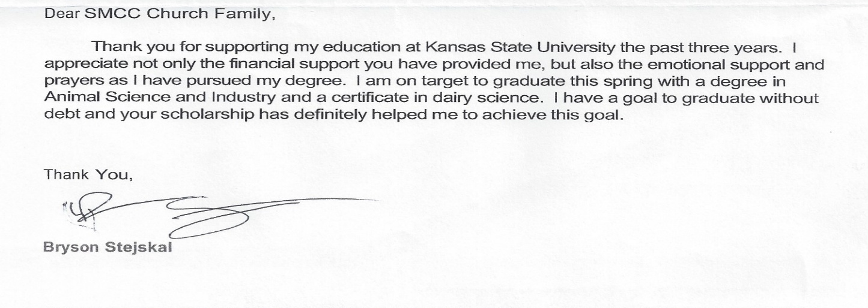

SEPTEMBER BIRTHDAYS**/*ANNIVERSARIES**

01 – Janice Smith

02 – Cherri Chapman

03 – **\*Kyle & Violet Smyth**

03 – Korina Ford

06 – Sandy Howard

07 – Reagan Gray

08 – Addie Harrold

09 – Carol Rider

11 – Carolyn Dunn

11 – Juan Anguiano

13 – Pam Gindlesberger

13 – Trace Phelps

13 – Jeff Watson

14 – Leona Smyth

17 – Axton Pantoja

20 – Kelly Rae Howard

20 – Ron Stewart

20 – **\*Stan & Leona Smyth**

21 – Jan Goehring

22 – Melanie Hill

23 – Paige Crombie

23 – Barbara Trotman

23 – Aubree Bohl

25 – Justin Anderson

If your special day has been missed, please contact the church office. 620-356-2305

-----------------------------------------------------------------------------------***Scheduled to Serve in September*:**

**Elders:** Justin Anderson, Wilma Jennings

**Deacons:** Jason Phelps, Robyn Nordyke

Kelly Howard, Justin Howard

**Communion:** Kim Klein/Kelly Rae Howard

**Worship Leaders**:

07: Thelma Bortz 21: Tamra Rundell

14: ???????????? 28: ?????????????

**Greeters:** Deacons for the month

**Questions?? CALL or email:**

Pastor Casey 620-356-2305(W) [smcc@pld.com](mailto:smcc@pld.com)

(C) 814-573-8148 pastorcaseychapman@gmail.com

Rhonda @ 620-356-2305(W) smcc1@pld.com

Rhonda @ 620-952-0589 (C) redhb@pld.com

Kelly Rae @ 620-356-2305 (W) [smcc2@pld.com](mailto:smcc2@pld.com)

Kelly Rae @ 620-353-8798 (C) [bkhoward@pld.com](mailto:bkhoward@pld.com)

SMCC cares about you! You are loved and prayed for when you’re here and when you’re NOT here. AND YOU ARE MISSED!!!!! Remember, this is your home away from home!

**General Offering to SMCC thru August 24th**

**$129,018.37**

**Thank you, God, for the generosity of this**

**Community of Believers and may their love for you and each other be an inspiration to reach out to those who are in need of knowing You and believing in your love, peace and grace.**

**REMINDER**

If you have a loved one in the hospital, please let the church office staff know (620-356-2305).

*If there is someone who is not on the prayer list but needs to be, please let the office staff know. We do want to pray for those in immediate need!! So, keep us updated, PLEASE. Rhonda*

**Known Prayer Concerns & Joys:**

Helen Finch (Thelma’s sister), Pastor Casey, Carol Tyler, Sharlene Harding, Catherine Fowler, Titus Smith, Miles Trost, Larry Daniels, Gary McCarty (Robert’s BIL), Kasich Smyth, Lovella Dennett, Don Dennett (stroke), Margo Kohl, Linda Kepley, Roman Ruiz (Violet Smyth’s brother), Terra Gamble, Jose Mota, (relative of Violet Smyth’s sister), Robert Annis, Justin Brickman (Leona’s cousin), Kayla Smyth, Linda Gross (Spencer’s friend), Jerald & Sharon Phelps, Greg McHenry, Brad Bevan, Ron Limper, Bob & Lorine Myers.

*Prayers for those who have recently lost loved ones!*

**Pray for our Armed Forces:** Caden Beims,Dylan Carroll,Maison Wiginton, Canyon Collum,Adam Lambing, Corey Ungles, Lacy Rundell.

========================================**Regular Monthly Schedule**

**Sunday 9:30 A.M. –** Christian Ed. Classes ***Odds & Ends* –‘Walking with God in the Desert’**

**10:30 A.M. –** Worship Service

**LIVE ON FACEBOOK**

***1st Sunday* 9:00 A.M.** – Elder’s Meeting

**Wednesday 7:00 P.M. – Choir Practice** begins 17th

***3rd Wed*.**  **6:15 P.M.** – Special Wednesday

Prayer Meeting in sanctuary w/Elders- Join us!!!

========================================

**Monthly Schedule for SEPTEMBER 2025**

**Sep. 1st –OFFICE CLOSED FOR LABOR DAY**

**Sep. 2nd – 6:00 P.M. ‘**Every Man a Warrior**’**

**Sep. 3rd – 6:00 P.M.** Bible Study w/Pastor

**Sep. 3rd & 4th PRESCHOOL BEGINS**

**Sep. 7th** **– 9:00 A.M. Elder Meeting**

**9:30 A.M.** Odds & Ends S.S.

**10:30 A.M.** Worship Service

Message by Pastor Casey Chapman

**Sep. 8th – 6:30 P.M. Salad Supper** sponsored

by CWF – Bring your favorite salad & a friend

**Sep. 9th – 6:00 P.M. ‘**Every Man a Warrior**’**

**7:00 P.M. Board meeting**

**Sep. 10th** **–**  **9:00 A.M. CWF Meeting**

**6:00 P.M.** Bible Study w/Pastor

**Sep. 11th – 6:00 P.M.** Pray for Rain at Memorial

Park – canceled for Pioneer meetings

**Sep. 14th –10:30 A.M.** Worship Service

Message by Pastor Casey Chapman

**Sep. 16th – 6:00 P.M. ‘**Every Man a Warrior**’**

**Sep. 17th –** **6:15 P.M.** Prayers with elders in

the Sanctuary – All are welcome

**7:00 P.M. Choir Practice Begins**

**Sep. 21st –****10:30 A.M.** Worship Service

Message by Pastor Casey Chapman

**Sep. 23rd – 6:00 P.M. ‘**Every Man a Warrior**’**

**Sep. 24th – 6:00 P.M.** Bible Study w/Pastor

**7:00 P.M.** Choir Practice

**Sep. 28th –10:30 A.M.** Worship Service

Message by Pastor Casey Chapman

**Sep. 30th – 6:00 P.M. ‘**Every Man a Warrior**’**