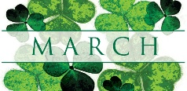SMCC Christian Education Ministries
March 2026 Issue – Page 1
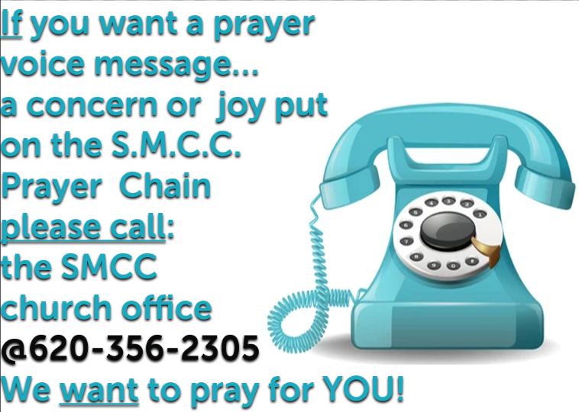
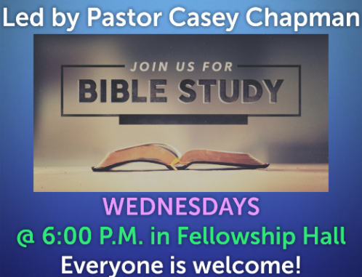
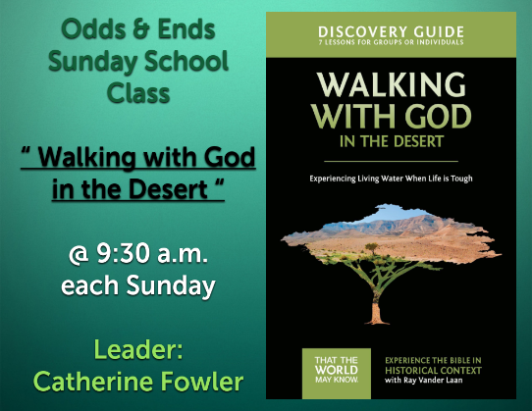
 SMCC Preschool Where Children love to Learn, and Learn with Love!
Hello,
February flew by with Valentine Parties that included a snowball fight (with cotton balls), cup stacking, valentines and candy cookies. We are looking forward to March and learning about spring, wind and air, and how seeds grow.
The 4 year-old class continues to learn how to write their first name and numbers to 5.
Budding artists have been painting at the easel helping the children develop creativity, imagination and improving hand-eye coordination and fine motor control, all needed later on in school.
With warm winter weather, we’ve had fun times outside on tricycles, scooters, and flying turtles.
We are thankful for the monetary donation to SMCC Preschool. We have purchased balls, paint, paint brushes, building toys, stringing beads, unifix cubes, and other educational materials to encourage learning.
Please let us know of any problems or concerns. We are enjoying your children!

Thank you for trusting us with your children.
Miss Robyn @ 620-353-7825
Miss Jess @ 620-453-0716 SMCC Preschool HOURS
3 & 4 YEAR OLD CLASSES / (Mon & Wed) or (Tue & Th) 9:00 – 11:00 A.M.
4 & 5 YEAR OLD CLASS / 4 DAYS A WEEK – (Mon, Tues, Wed & Thurs) 12:00 – 3:00 P.M.

SMCC Christian Education Ministries
March 2026 Issue – Page 2
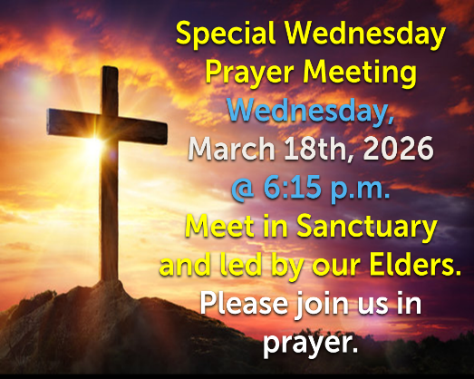

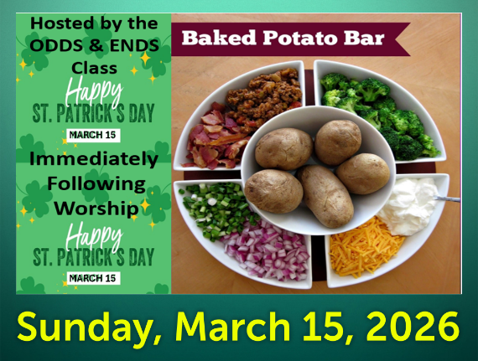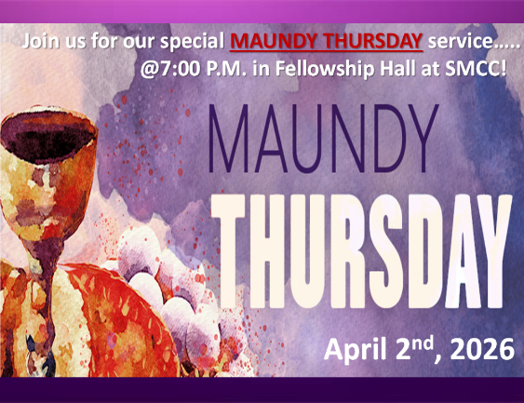

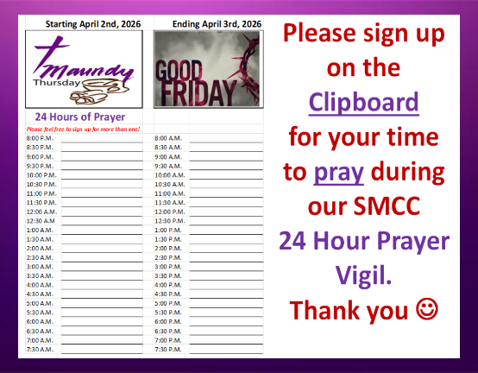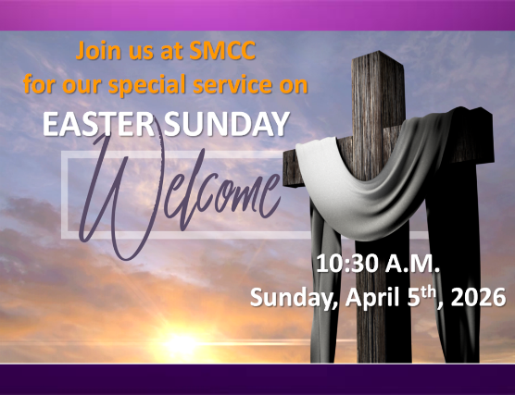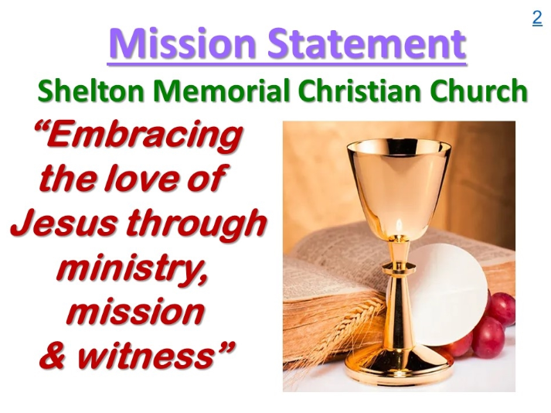
From the desk of Kelly Rae On my mind, in my heart and ready to share!

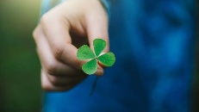
8 Things You Probably Didn’t Know About St. Patrick by Jessica Toomer
On St. Patrick’s Day, Ireland’s most famous saint inspires many to wear green, march in parades and hunt for shamrocks but do you know the legend behind the holiday? Here are 8 St. Patrick facts you probably didn’t know about the saint and why he is celebrated around the world.
1. The Patron Saint of Ireland wasn’t Irish. St. Patrick, the apostle of Ireland, was actually born in, what was then, Old Kilpatrick, Scotland.
2. St. Patrick was once enslaved. When he was fourteen, Patrick was captured during a raiding party and taken to Ireland as a slave to tend and herd sheep. He managed to escape at age 20 after he dreamt God told him to leave Ireland by going to the coast. He was able to persuade a group of sailors to bring him back to Britain where he reunited with his family.
3. St. Patrick was led by vision. Patrick had many dreams that spurred his decisions in life. In one dream, he heard the people of Ireland, who practiced paganism at the time, calling out for him to walk among them. He began his priesthood studies shortly after having that vision.
4. St. Patrick brought Christianity to Ireland. Though Ireland was made up of mostly Druids and pagans when Patrick first came to the country, he was able to convert entire kingdoms to Christianity over the four decades he spent there.
5. St. Patrick is associated with the shamrock. The shamrock is a symbol we often associate with St. Patrick’s Day and many mistake it as the symbol of Ireland but it’s really connected to St. Patrick, who used the clover to explain the concept of the Trinity to non-believers.
6. St. Patrick is not associated with the color green—but blue! Though you might get a pinch if you’re not wearing the country’s signature green, the color used to represent the famous saint is actually blue. Several pieces of art depicting the saint show Patrick sporting blue vestments. King Henry VIII once used a blue flag with an Irish harp to represent Ireland and even now, blue can be found on country flags, coats-of-arms and sports jerseys.
7. St. Patrick’s life is steeped in various legends. There are quite a few legends surrounding the popular saint, including one that claimed Patrick was able to drive all the snakes out of Ireland. Though it’s true that the reptiles don’t inhabit the island, this is probably due to the cool climate, not St. Patrick. Scholars believe the term “snakes” in ancient texts may refer to pagan ritual beliefs and practices, not the animals themselves.
8. St. Patrick’s real name wasn’t Patrick. Though much about Patrick’s life is speculation, we’re pretty sure his real name wasn’t Patrick. According to Irish legend, his birth name was actually Maewyn Succat, or in Latin, Magonus Succetus. He took on the name of Patrick when he became a priest.

