SMCC **Christian Education Ministries**

October 2025 Issue – Page 1

  

 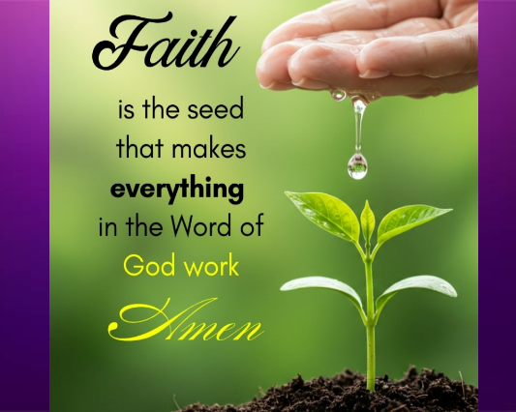 

 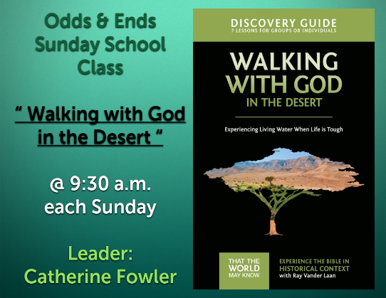 

 **SMCC Preschool**

Where Children love to Learn, and Learn with Love!

**Hello Preschool Families!**

**October is such a fun month at preschool! Full of learning, cooler weather, pumpkins, and of course, Halloween! The kids have been busy practicing their letters, numbers, and fine motor skills while also exploring the themes of fall. We’re so proud of the progress they are making each day.**

🍂**Halloween Parties**🎃

**We are excited to announce our classroom Halloween parties! This is always such a fun time for the children, and we can’t wait to see their costumes and share some festive fun together.**

**•Monday/Wednesday 3–4 Class: Party on Wednesday, October 29th**

**•Tuesday/Thursday 3–4 Class & Monday–Thursday AND 4–5 Class: Party on Thursday, October 30th**

**During our parties, we’ll enjoy special snacks, games, and a chance to celebrate together. A sign-up sheet for party supplies will be available at the door. If you’d like to contribute, please take a look and sign up. Thank you in advance for helping make our celebration a success!**

**Thank you for being such a wonderful part of our preschool family.**

**We can’t wait to celebrate this season with your kiddos!**

Elizabeth Masson 📞 620-575-4754 **NEW SMCC Preschool HOURS**

**3 & 4 YEAR OLD CLASSES /** (Mon & Wed) or (Tue & Th)  **9:00 – 11:00 A.M.**

**4 & 5 YEAR OLD CLASS /** 4 DAYS A WEEK – (Mon, Tues, Wed & Thurs)  **12:00 – 3:00 P.M.**

SMCC **Christian Education Ministries**

October 2025 Issue – Page 2

 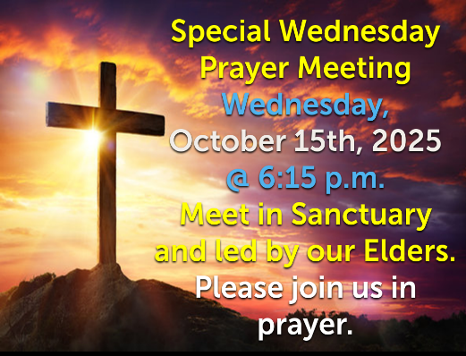 

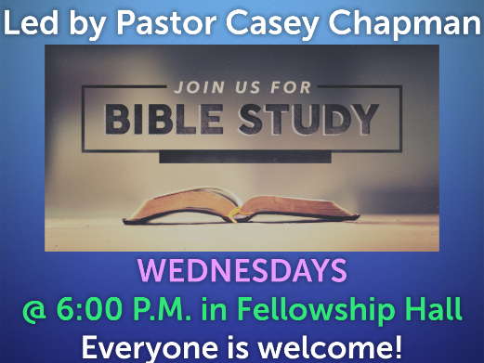 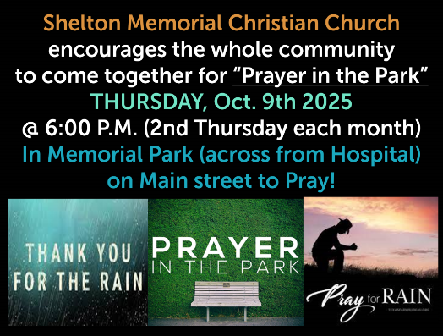 

**  **

From the desk of **Kelly Rae** ☺

On my mind, in my heart and ready to share!

**A Prayer for Autumn Days By Joyce Rupp**

**God of the seasons, there is a time for everything; there is a time for dying and a time for rising. We need courage to enter into the transformation process.**

**God of autumn, the trees are saying goodbye to their green, letting go of what has been. We, too, have our moments of surrender, with all their insecurity and risk. Help us to let go when we need to do so.**

**God of fallen leaves lying in colored patterns on the ground, our lives have their own patterns. As we see the patterns of our own growth, may we learn from them.**

**God of misty days and harvest moon nights, there is always the dimension of mystery and wonder in our lives. We always need to recognize your power-filled presence. May we gain strength from this.**

**God of harvest wagons and fields of ripened grain, many gifts of growth lie within the season of our surrender. We must wait for harvest in faith and hope. Grant us patience when we do not see the blessings.**

**God of geese going south for another season, your wisdom enables us to know what needs to be left behind and what needs to be carried into the future. We yearn for insight and vision.**

**God of flowers touched with frost and windows wearing white designs, may your love keep our hearts from growing cold in the empty seasons.**

**God of life, you believe in us, you enrich us, you entrust us with the freedom to choose life.  
For all this, we are grateful. Amen.**