SMCC Christian Education Ministries
February 2026 Issue – Page 1
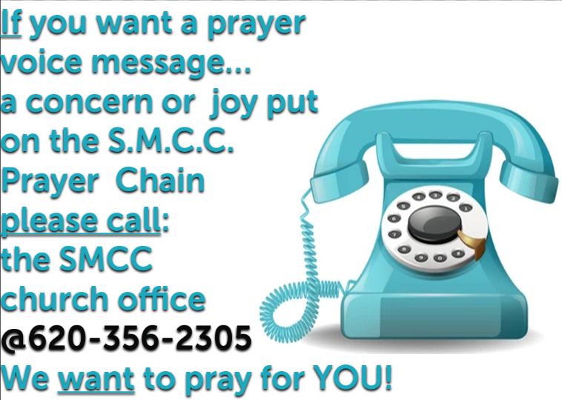

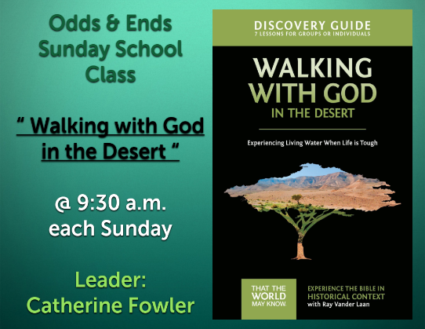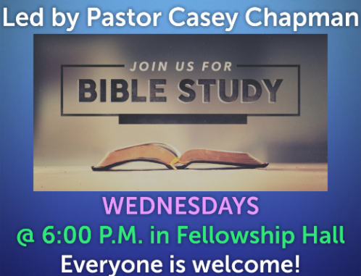
 SMCC Preschool Where Children love to Learn, and Learn with Love!
Hello,
I am Robyn Nordyke, your child’s preschool teacher at Shelton Memorial Christian Church. I have been a teacher in the USD 214 system for many years as a first grade teacher, a developmental kindergarten teacher and a kindergarten teacher. I have been substituting in the Ulysses schools since my retirement from USD 214. I also owned and operated Robyn’s Nest Preschool for twelve years while my girls were preschool age.
I am still getting organized and figuring out how best to organize the day. I hope your child is enjoying preschool. I know a change in teachers may have been an adjustment. The children are settling into a routine. Hours for the 3 Year-old class are 9-11:00AM, Monday and Wednesday and 9-11:00 Tuesday and Thursday. Hours for the 4 Year-old class are 12-3:00 PM, Monday through Thursday.
I appreciate promptness and doors will open 10 minutes early each day. I plan to be at the door each day. It is good to drop your child off at the door or if your child is still having difficulty with that bring them inside the door, tell them goodbye and leave. The crying most usually stops right after you leave.
I will send out February snack calendars this week. I will coordinate your child’s snack day on or close to their birthday. Summer birthdays will be scheduled in April and May depending on the number of birthdays. Please send just something to eat on your child’s snack day. Do not send drinks. We will drink water so there is less sugar and you can save some money. Drinks are okay to send on your child’s birthday snack day.
I will plan to post pictures of preschool activities occasionally in a group text so you can see the children at work.
It is helpful if your child does not bring toys to school or if they must, they know the toys must stay in their backpacks.
Please let me know of any problems or concerns. I am enjoying your children.
Thank you for trusting me with your child.
Robyn @ 620-353-7825 SMCC Preschool HOURS
3 & 4 YEAR OLD CLASSES / (Mon & Wed) or (Tue & Th) 9:00 – 11:00 A.M.
4 & 5 YEAR OLD CLASS / 4 DAYS A WEEK – (Mon, Tues, Wed & Thurs) 12:00 – 3:00 P.M.
SMCC Christian Education Ministries
February 2026 Issue – Page 2
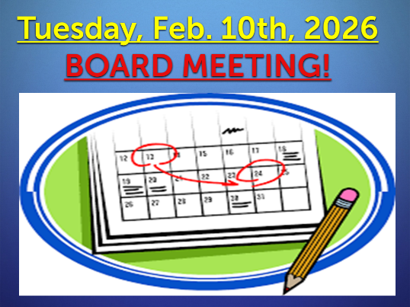
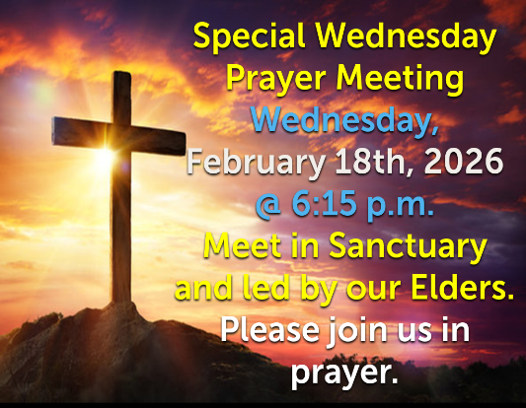
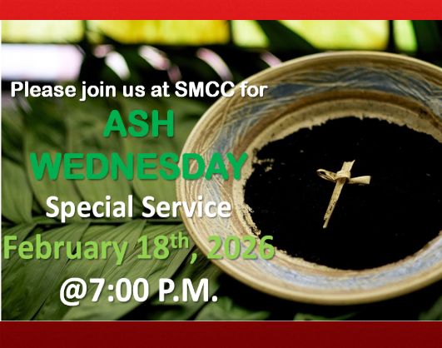
From the desk of Kelly Rae On my mind, in my heart and ready to share!

A Marriage Prayer by julia-attaway
I pray this prayer when things are going well, and when they are rough.

Today, Andrew and I celebrate our 20th wedding anniversary. I’m happy, though we happen to be in the midst of one of those bumpy patches that plague almost every marriage.
I woke up, made coffee and sat down to pray. I pried out the words I’ve used almost daily for two decades: Lord, thank you for my husband. Pause. Teach me to love him.
I pray this prayer when things are going well, and when they are rough. For if there’s one thing marriage has taught me, it’s that I’m only ever beginning to learn what it means to love my husband.
Love is easy when it’s a warm and fuzzy sentiment. Love is hard when I see my husband’s flaws clearly, or when he lets me down, or when we disagree on how to parent a difficult child. Love requires the rock-solid belief that God has given me Andrew for our mutual benefit, even when I am blind to the good in it (at the moment).
Marriage is about drawing closer to God through each and every blessing and conflict and disappointment. And it’s about closing my daily prayer for my spouse with lines like these:
Dear Lord, bless Andrew in whatever ways you see he needs. Grant him the grace to grow nearer to you through me… and despite me. You know him better than I do, Lord. Teach me to love him as you do.

