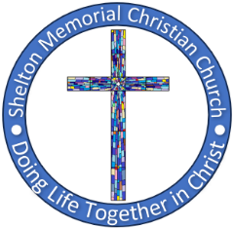SHELTON MEMORIAL CHRISTIAN CHURCH

316 N. Main Street P.O. Box 402

Ulysses, KS 67880

620-356-2305—E-mail [smcc1@pld.com](mailto:smcc1@pld.com)

Website www.smcculysses.com

**July 2025_ _______________________________________________________**

**OUR PURPOSE:**

***“Embracing the love of Jesus through ministry, mission & witness”***

“Three Points of Contact!”

by: Pastor Casey Chapman

I have just returned to my office from visiting a member of our church, and as I sit at my desk I am reminded that the Body of Christ is a family. June, July, and August are all months where families get together for graduations, weddings, reunions, and vacations.

As we kick off July, our first sermon will be from Matthew 7:24-27 which talks about building on solid ground versus building on sand. This sermon will give us some context as we continue through studying the early church in the book of Acts. We will be learning about having three points of contact in our faith. The first point is with Jesus. The second point of contact is with His Word, and the third point of contact is with His Body, the church, the family of God.

Maintaining relationships in the Body of Christ is important for us to climb the mountain of faith until one day we reach its summit, our sanctification when we enter the gates of Heaven. As a former High Adventure Director for the Boy Scouts of America, when you are climbing, you always maintain three points of contact with the cliff. Only when you are secure in those three points can you reach your free hand to climb higher. If you do not have those points of contact, even missing just one, you are likely to fall.

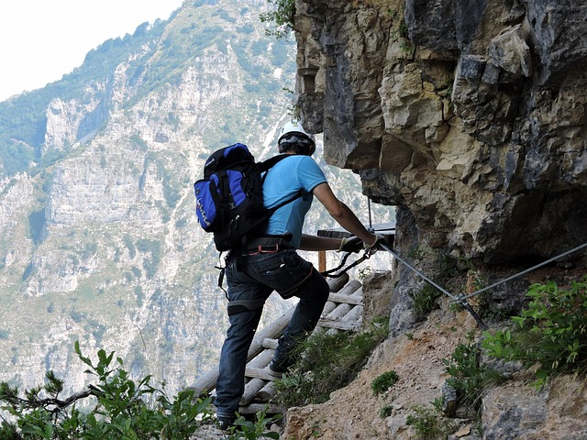

Christianity is a journey that takes the narrow way through all sorts of terrain. There are valleys to go through and mountains to climb. Jesus must be our first point of contact or we cannot make it through the simplest of challenges along the way. His Word is our guardrail that keeps us from crashing over the edge, and His Body is our encouragement to lift us up when we feel that we cannot go on this path of life anymore and we want to throw in the towel.

If you ever find yourself wanting to give up, come on over. Sit on my porch with me. Let’s talk things through. Let’s pray together. Let’s cry with one another. Let’s laugh aloud together. We are family in Christ. It is the superior family for it is made by the Blood of Jesus and held together by His pains. No more are we Chapmans and ____________ (insert your last name). We are Christians. **“There is neither Jew nor Greek, there is neither slave nor free, there is no male and female, for you are all one in Christ Jesus,” Galatians 3:28, ESV.**

JULY BIRTHDAYS**/*ANNIVERSARIES**

01 – Donna Covey

03 – Carlotta Barnes

05 – Kim McGaughey

06 – **\*Gary & Sherie Riley**

07 – Zak Anderson

10 – Shalesa Aldrich

11 – **\*Rod & Robyn Nordyke**

14 – **\*Robert & Carol Annis**

14 – **\*Jay & Donna McGaughey**

15 – **\*Homer & Carlotta Barnes**

21 – Katie McElroy

25 – **Craig & Aubree Bohl**

29 – Dylan Sena

29 – Cary Henderson

If your special day has been missed, please contact the church office. 620-356-2305

-----------------------------------------------------------------------------------***Scheduled to Serve in July*:**

**Elders:** Wally Raines, Monty Teeter

**Deacons:** Randy Klein, Brett Lysinger

Jeri Lynn Wells, Zane Anderson

**Communion:** Kim Klein/Kelly Rae Howard

**Worship Leaders**:

06: Kelly Howard 20: Thelma Bortz

13: Jean Teeter 29: Tamra Rundell

**Greeters:** Deacons for the month

**Questions?? CALL or email:**

Pastor Casey 620-356-2305(W) [smcc@pld.com](mailto:smcc@pld.com)

(C) 814-573-8148 pastorcaseychapman@gmail.com

Rhonda @ 620-356-2305(W) smcc1@pld.com

Rhonda @ 620-952-0589 (C) redhb@pld.com

Kelly Rae @ 620-356-2305 (W) [smcc2@pld.com](mailto:smcc2@pld.com)

Kelly Rae @ 620-353-8798 (C) [bkhoward@pld.com](mailto:bkhoward@pld.com)

SMCC cares about you! You are loved and prayed for when you’re here and when you’re NOT here. AND YOU ARE MISSED!!!!! Remember, this is your home away from home!

**General Offering to SMCC thru June**

**$ 97,278.26**

**Thank you, God, for the generosity of this**

**Community of Believers and may their love for you and each other be an inspiration to reach out to those who are in need of knowing You and believing in your love, peace and grace.**

*If there is someone who is not on the prayer list but needs to be, please let the office staff know. We do want to pray for those in immediate need!! So, keep us updated, PLEASE. Rhonda*

**REMINDER**

If you have a loved one in the hospital, please let the church office staff know (620-356-2305).

**Known Prayer Concerns & Joys:**

Gary McCarty, Cheryl Moyer, Sandy Howard (foot fracture), Kelin Smyth, Kasich Smyth, John Nichol, Larry Daniels, Glenda Randall, Helen Finch (Thelma’s sister), Lovella Dennett, Don & Sherry Dennett, April Dennett, Elizabeth Masson (jaw surgery), Sherry Whitehead, Janet Stewart, Margo Kohl, Linda Kepley, Roman Ruiz (Violet Smyth’s brother), T.J. Gamble, Terra Gamble, Jose Mota, (relative of Violet Smyth’s sister), Tammie Hensley, Robert Annis, Justin Brickman (Leona’s cousin), Kayla Smyth, Linda Gross (Spencer’s friend), Nancy Grace, Jerald & Sharon Phelps, Sherie Riley, Evelina Velasquez (cancer), Greg McHenry, Brad Bevan, Ron Limper, Bob & Lorine Myers, Bob Moore, Sara Watson, June Mason.

*Prayers for those who have recently lost loved ones!*

**Pray for our Armed Forces:** Dylan Carroll,Canyon Collum,Adam Lambing, Corey Ungles, Lacy Rundell.

========================================

**Regular Monthly Schedule**

**Sunday 9:30 A.M. –** Christian Ed. Classes ***Odds & Ends* –‘Walking with God in the Desert’**

**10:30 A.M. –** Worship Service

**LIVE ON FACEBOOK**

***1st Sunday* 9:00 A.M.** – Elder’s Meeting **Tuesday** **6:00 P.M. –** Every Man a Warrior

starts up July 8

**Wednesday 6:00 P.M.** –Bible Study w/Pastor

***3rd Wed*.**  **6:15 P.M.** – Special Wednesday

Prayer Meeting in sanctuary w/Elders- Join us!!!

========================================

**Monthly Schedule for JULY 2025**

**July 6th** **– 9:00 A.M. Elder Meeting**

**10:30 A.M.** Worship Service

Message by Pastor Casey Chapman

**July 8th – 6:00 P.M. ‘**Every Man a Warrior**’**

**July 9th – 6:00 P.M.** Bible Study begins

**July 10th – 6:00 P.M.** Pray for Rain at Memorial

Park across from the hospital

**July 13th –10:30 A.M.** Worship Service

Message by Pastor Casey Chapman

**July 16th – 6:15 P.M.** Prayers with Elders in

the Sanctuary – All are welcome

**July 20th –****10:30 A.M.** Worship Service

Message by Pastor Casey Chapman

Elder quarterly meeting after Worship

**July 26th – 8:00 A.M. NOODLEMAKING**

**July 27th –10:30 A.M.** Worship Service

Message by Pastor Casey Chapman

**July 30th – NO Bible Study**

**JULY 28TH – 31ST**

