SHELTON MEMORIAL CHRISTIAN CHURCH

316 N. Main Street P.O. Box 402

Ulysses, KS 67880

620-356-2305—E-mail [smcc1@pld.com](mailto:smcc1@pld.com)

Website www.smcculysses.com

**January 2025_______________________________________________________**

**OUR PURPOSE:**

***“Embracing the love of Jesus through ministry, mission & witness”***

“Caution: Wisdom. Handle with Care.”

by: Pastor Casey Chapman

I would say that a good Christian seeks wisdom from God. It is one of the many reasons one studies the Word of God. The Bible encourages the believer to pursue wisdom. King Solomon writes in Proverbs 1:7 that “[t]he fear of the LORD is the beginning of knowledge; fools despise wisdom and discipline,” (HCSB).

Yet despite this, Solomon also writes in Ecclesiastes 1:17-18 that “wisdom and knowledge [are] madness and folly; I learned that [they are also] a pursuit of the wind. **For with much wisdom is much sorrow; as knowledge increases, grief increases**,” (emphasis added). This truth written by Solomon took me back.

The saying “ignorance is bliss” has a certain truth to it in light of Ecclesiastes 1:18. Despite this, God has not called us to be ignorant. He has not appointed us to turn a blind eye and a deaf ear. Jesus tells us in Matthew 10:16 to “be wise as serpents and innocent as doves,” (ESVS). Now we are not to be serpents, but we are to be as wise as they in order to avoid their schemes.

As we grow in our walk with God and our knowledge of Him increases, we will become even more aware of the evil and injustices of this world. We will have grief at what we see taking place, but this will cause us all the more to pursue after God’s ways. To seek justice and peace. To show God’s love, and above all, to live for Christ.

Infant Holy, Infant Lowly

Infant holy, infant lowly, for his bed a cattle stall; oxen lowing, little knowing, Christ the babe is Lord of all. Swiftly winging angels singing, bells are ringing, tidings bringing: Christ the babe is Lord of all, Christ the babe is Lord of all.

Flocks were sleeping, shepherds keeping vigil till the morning new, saw the glory, heard the story – tidings of a gospel true. Thus rejoicing, free from sorrow, praises voicing, greet the morrow: Christ the babe was born for you,

Christ the babe was born for you!

~~~~~~~~~~~~~~~~~~~~~~~~~~~~~~~

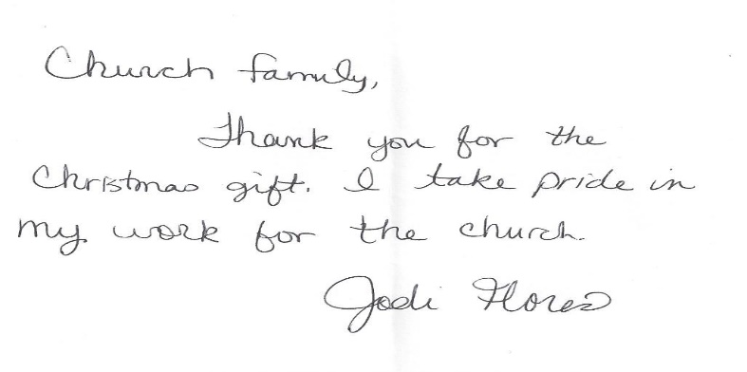

JANUARY BIRTHDAYS**/*ANNIVERSARIES**

01 – Carol Annis

02 – Brett Lysinger

04 – Matt Tarbet

05 – Angela Anderson

06 – Alisha Beims

07 – Wilma Jennings

08 – Larry Bortz

08 – Linda Watson

09 – Lana Anderson

09 – Lilly Bowman

11 – Robert Annis

12 – Justin Ford

15 – Justin Howard

15 – Chloe Tarbet

17 – \***Brian & Marcia Gustin**

18 – Jo Tarbet

19 – Matt Harrold

20 – Olivia Tarbet

26 – Meyer Ater

27 – Andrew Gindlesberger

27 – Gary Howard

28 – Parker Ater

30 – Emely Tarbet

30 – Gary Riley

If your special day has been missed, please contact the church office. 620-356-2305

-----------------------------------------------------------------------------------

***Scheduled to Serve in January*:**

**Elders:** Kim Klein, Mark McGaughey

**Deacons:** Brett Lysinger, Zane Anderson

Randy Klein, Jeri Lynn Wells

**Deacon Ass’t:**

**Communion:** Kim Klein/Kelly Rae Howard

**Worship Leaders**:

05: Thelma Bortz 19: ???????????

12: ???????????? 26: Tamra Rundell

**Greeters:** Deacons for the month

**Questions?? CALL or email:**

Pastor Casey 620-356-2305(W) [smcc@pld.com](mailto:smcc@pld.com)

(C) 814-573-8148 pastorcaseychapman@gmail.com

Rhonda @ 620-356-2305(W) smcc1@pld.com

Rhonda @ 620-952-0589 (C) redhb@pld.com

Kelly Rae @ 620-356-2305 (W) [smcc2@pld.com](mailto:smcc2@pld.com)

Kelly Rae @ 620-353-8798 (C) [bkhoward@pld.com](mailto:bkhoward@pld.com)

SMCC cares about you! You are loved and prayed for when you’re here and when you’re NOT here. AND YOU ARE MISSED!!!!! Remember, this is your home away from home!

**General Offering to SMCC thru December**

**$ 207,193.81**

**Thank you, God, for the generosity of this**

**Community of Believers and may their love for you and each other be an inspiration to reach out to those who are in need of knowing You and believing in your love, peace and grace.**

*If there is someone who is not on the prayer list but needs to be, please let the office staff know. We do want to pray for those in immediate need!! So, keep us updated, PLEASE. Rhonda*

**REMINDER**

If you have a loved one in the hospital, please let the church office staff know (620-356-2305).

**Known Prayer Concerns & Joys:**

Bill Patton, Rebecca Giesbrecht, Jerald & Sharon Phelps, Kim McGaughey (knee), Jamie Clodfelter, Jay Coleman (lungs), Harriet Arnett (Lovella’s friend), Raul Velasquez (cancer), Kim Klein, Linda Kepley, Baby Owen Heinrichs (respiratory), Sherry Whitehead (Wilma’s niece -cancer), Rudy Perez, Mary Fowler, Janet Stewart, Tammie Hensley, Sherie Riley, Carol Rider, Don Dennett, Evelina Velasquez (cancer), Adam Heinrichs, Leona Smyth, Greg McHenry (Linda Post’s brother), Meredith Drees (friend of Lana Anderson), Larry Daniels, Brad Bevan, Nancy Grace, Ron Limper, Catherine Fowler, Bob & Lorine Myers, Dave Taylor (friend of Monty), Linda Metcalf, Norma McCauley, Bob Moore, Sara Watson, Kasich Smyth, June Mason, Titus Smith.

Prayers for those who have recently lost loved ones!

**Pray for our Armed Forces:** Maison Wiginton,Dylan Carroll,Canyon Collum,Adam Lambing, Corey Ungles, Lacy Rundell.

========================================

**Regular Monthly Schedule**

**Sunday 9:30 A.M. –** Christian Ed Classes

***Odds & Ends* – “Isaiah”**

**10:30 A.M. –** Worship Service

**LIVE ON FACEBOOK**

***1st Sunday* 9:00 A.M.** – Elder’s Meeting

**Monday 6:00 P.M. –** Bible Study

**Tuesday 6:30 P.M. –** Men’s Study Group

**“Every Man a Warrior”**

**Wednesday 7:00 P.M. – Choir Practice**

***3rd Wed*.**  **6:15 P.M.** – Special Wednesday

Prayer Meeting with Elders in the Sanctuary

========================================

**Monthly Schedule for JANUARY 2025**

**Jan. 1st – NEW YEARS DAY –** Office Closed

**Jan. 5th – 9:00 A.M. Elder Meeting**

**10:30 A.M.** Worship Service

**Jan. 6th – 6:00 P.M.** Bible Study led by Pastor

**Jan. 7th** **– Preschool Resumes**

**Jan. 8th – No Chancel Choir**

**Jan. 9th – 6:00 P.M.** Prayer and thanks for

Rain/Snow - in Memorial Park across

Main St. from the hospital.

**Jan. 12th –10:30 A.M.** Worship Service

Message by Pastor Casey Chapman

NEED HELP TO TAKE DOWN DECORATIONS

**Jan. 14th – 7:00 P.M.** Board Meeting

**Jan. 15th** **–**  **6:15 P.M.** Prayer Mtg in Sanctuary

led by the Elders

**Jan. 19th** **–10:30 A.M.** Worship Service

Message by Pastor Casey Chapman

**Jan. 20th – 4:00 P.M.** Worship Meeting

**Jan. 26th –10:30 A.M.** Worship Service

Message by Pastor Casey Chapman