SMCC Christian Education Ministries
April 2026 Issue – Page 1
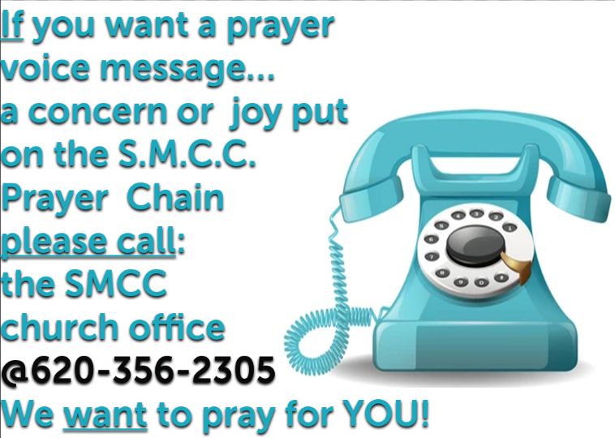
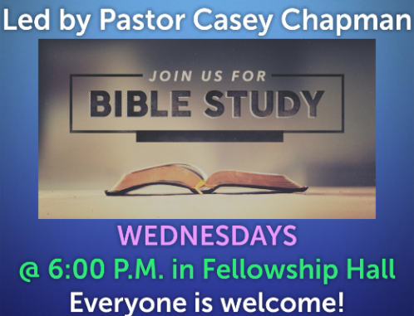
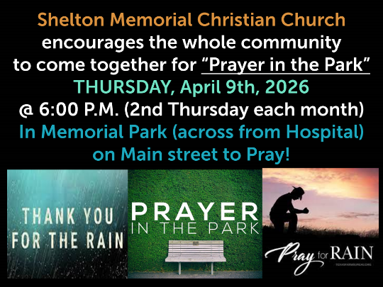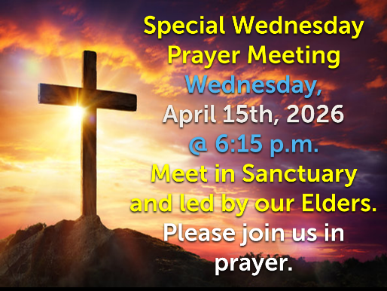
 SMCC Preschool Where Children love to Learn, and Learn with Love!
Hello,
March has flown by with Spring break for a week. The children have enjoyed their time off.
We got back to school with bright and shining faces! We have also been working on knowing what Spring is, why we have it, and how it works. We also have been exploring with Magnifying Glasses, and learning some spring time songs! We are so excited for our Easter egg hunts and teaching them the real reason why we celebrate Easter! We are continuing to play outside with tricycles, hot wheels, scooters, flying turtles, and balls. Thank you for sharing your children with us!
Please do not hesitate to call or ask questions.
Jessica Malone (620) 453-0716

COMING IN APRIL!
- Monalisa Portraits will be taking pictures on Tuesday, April 7th for both M/W 3-year-old class & the afternoon 4-year-old class, and then again on Wednesday, April 8th for the T/TH 3-year-old class.
- Parent/Teacher Conferences will be held on Friday, April 10th and Friday, April 17th. We will have a sign-up sheet for time slots on those 2 days!

SMCC Preschool HOURS
3 & 4 YEAR OLD CLASSES / (Mon & Wed) or (Tue & Th) 9:00 – 11:00 A.M.
4 & 5 YEAR OLD CLASS / 4 DAYS A WEEK – (Mon, Tues, Wed & Thurs) 12:00 – 3:00 P.M.
SMCC Christian Education Ministries
April 2026 Issue – Page 2
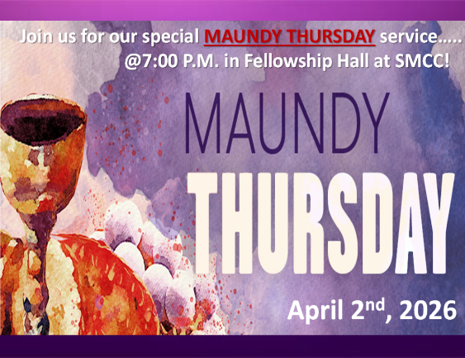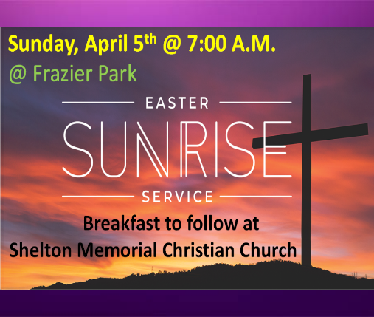

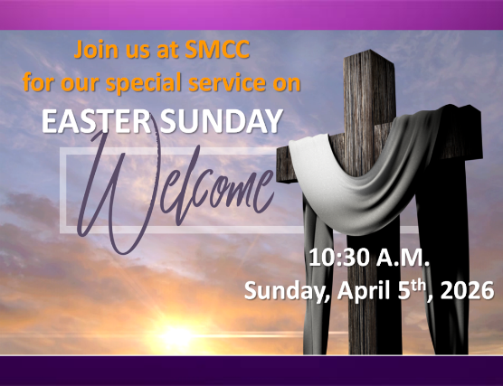
From the desk of Kelly Rae On my mind, in my heart and ready to share!

There's a New World Coming
Why is it so important to believe in the resurrection of Jesus? Because we who believe it and confess Him as Lord will be raised too! by Jill Briscoe | JBU Founder

“Listen’ he said, ‘we’re going up to Jerusalem, where the Son of Man will be betrayed to the leading priests and the teachers of religious law. They will sentence him to die. Then they will hand him over to the Romans to be mocked, flogged with a whip, and crucified. But on the third day he will be raised from the dead.” (Matthew 20:18-19 NLT)
With the benefit of two thousand years of hindsight, we understand there could be no Easter morning without a Good Friday. However, as far as the disciples of Jesus were concerned, on that Friday after the crucifixion, the Cross was the end of all their highest hopes and most daring dreams.
Jesus had certainly done His best to prepare His followers for the Cross, for on three occasions he had told them that He would die, but also that He would rise again. The first occasion was after Peter’s confession of faith (Matt. 16:21). The second was after Jesus was transfigured (Matt. 17:22-23). The third was as He and His disciples were going to Jerusalem for the last time. Jesus spoke of Himself, saying, “They will hand him over to the Romans to be mocked, flogged with a whip, and crucified. But on the third day he will be raised from the dead” (Matt. 20:19). It seems strange that not one of the disciples remembered the momentous promise that Jesus would rise again.
Why is it so important to believe in Jesus’ resurrection? Because we who believe it and confess Him as Lord will be raised too! By far the biggest problem in life is death. But for the believer, the stone has been rolled away from the tomb of death. It’s empty! Death for the Christian is the gateway into life. Christ has gone before to tell us there is a new world ahead of us, and those of us who believe can face the grave with utmost confidence in that promise.
PRAYER: Lord, thank You for Your tremendous sacrifice, and for showing me that God’s power is endless. He can and will raise people to life after death. Give me opportunities to encourage others with this wonderful truth! Amen.

