SMCC **Christian Education Ministries**

September 2025 Issue – Page 1

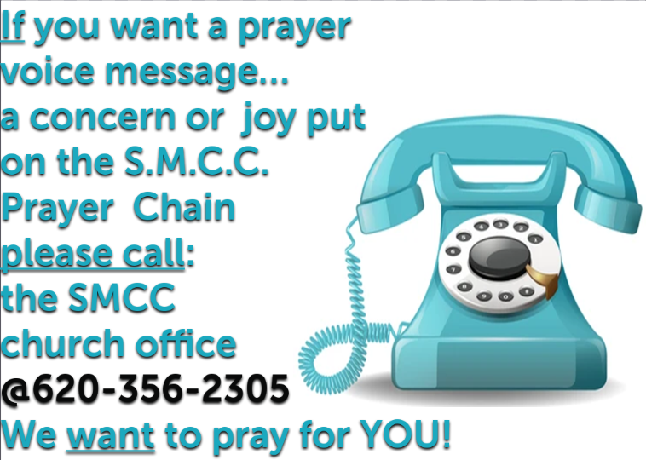  

 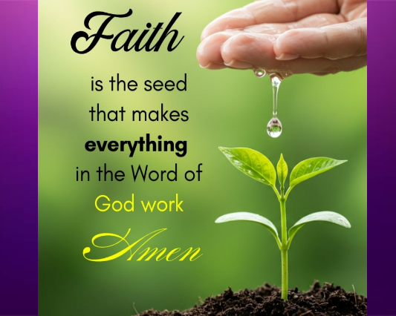 

  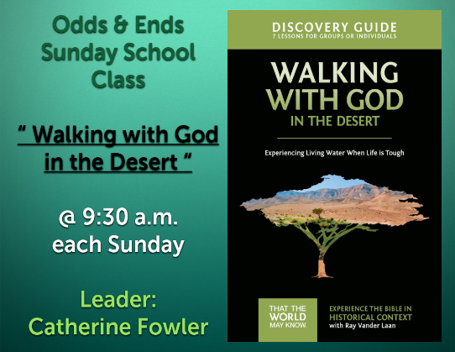

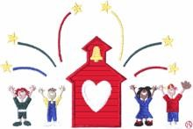 **SMCC Preschool**

Where Children love to Learn, and Learn with Love!

🎉✏️ It’s back to school time! Parents, grandparents, and kiddos are getting ready, and so are we! I’m SO excited to kick off my second year at SMCC. Honestly, I feel so blessed to be part of this amazing place. 💛

Last year was filled with lots of learning, laughter, and love for all of our little ones, and I can’t wait to see what fun adventures this year brings. 🖍️📚

If you ever have questions (big or small), I’m just a call or text away. Here’s to another awesome year together. Let’s make it the best one yet! 🚀✨

Elizabeth Masson 📞 620-575-4754 **NEW SMCC Preschool HOURS**

**3 & 4 YEAR OLD CLASSES /** 4 DAYS A WEEK – (Mon & Wed) or (Tue & Th)

**9:00 – 11:00 A.M.**

**4 & 5 YEAR OLD CLASS /** 4 DAYS A WEEK – (Mon, Tues, Wed & Thurs)

**12:00 – 3:00 P.M.**

SMCC **Christian Education Ministries**

September 2025 Issue – Page 2

**  **

  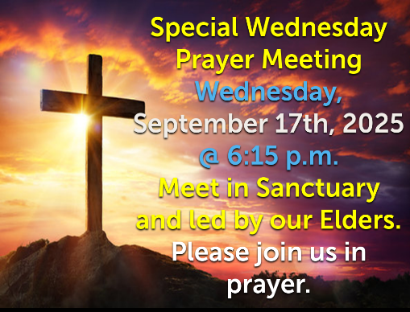

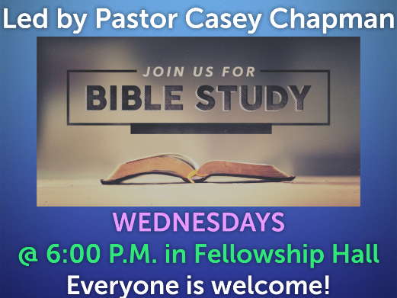 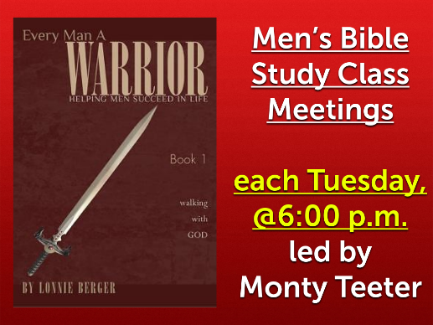 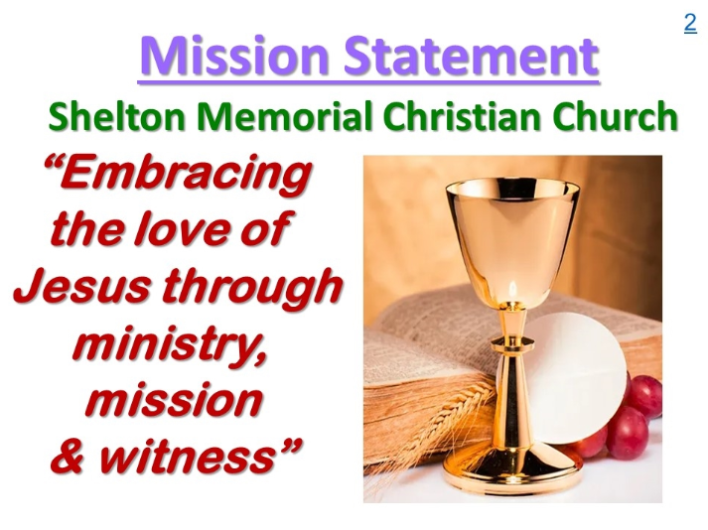

**Back to School Devotional for Children**

**School can be scary, you are learning new things and becoming familiar with new ideas. God wants us to be full of wisdom. Do you know what wisdom means? Wisdom is having quality in what you know, it is having the best of the best knowledge. Let’s see what the Bible says about wisdom.**

***Let the wise hear and increase in learning, and the one who understands obtain guidance, to understand a proverb and a saying, the words of the wise and their riddles. The fear of the Lord is the beginning of knowledge; fools despise wisdom and instruction. (Proverbs 1:5-7)***

**Let’s break this down, the first sentence is explaining that we should increase what we are learning, we should ask God for more wisdom and more guidance so that we can understand.**

**The second sentence says, “the fear of the LORD is the beginning of knowledge.” Do you think this means that we should be scared of God? Of course we should not be scared of God, what this sentence means is that we should honor God. Those who honor God have wisdom, but those who do not choose to honor God are fools.**

**We should always desire to learn and grow in wisdom, but above all of our classes and above all of our studies, we should desire to learn who God is first! Keep your Bible in your backpack at school so that you can always take it out and study God’s Word so that you can grow in wisdom.**

***Prayer: Dear God, thank you that we get to go back to school and be filled with knowledge and wisdom. We pray that our hearts can always be yours, and as we learn our reading and math, let us also learn to study your Word. We love you and we honor you! Amen.***