
SHELTON MEMORIAL CHRISTIAN CHURCH
316 N. Main Street P.O. Box 402
Ulysses, KS 67880
620-356-2305—E-mail smcc1@pld.com

Website www.smcculysses.com

February 2026 ____________________________________________________

OUR PURPOSE:

“Embracing the love of Jesus through ministry, mission & witness”

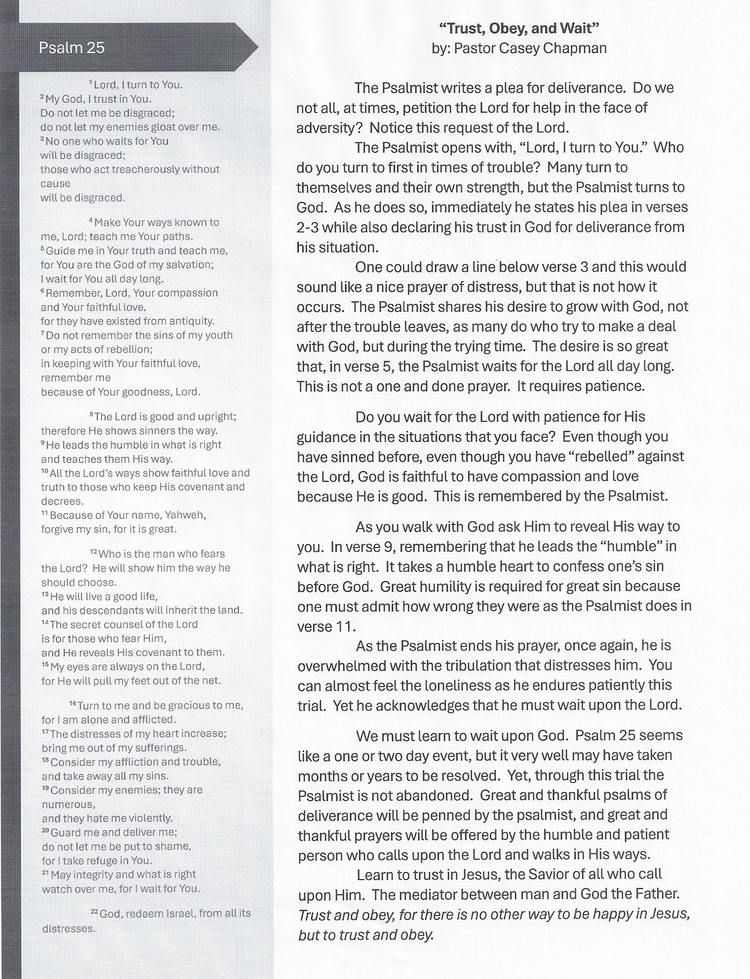

FEBRUARY BIRTHDAYS/*ANNIVERSARIES
01 – Deanna Hull
02 – Alexandria Alcala
04 – Josh Hickman
05 – Chase Phelps
07 – Jordan (Howard) Dawson
10 – Hunter Dawson
10 – Mark Goehring
14 – Jason Rundell
16 – Spencer Chapman
18 – Jean Teeter
18 – Stacy Figgins
20 – Dustin Covey
20 – Josh Flores
20 – Kenzi Sena
23 – Januea Sena

If your special day has been missed, please contact the church office. 620-356-2305
-----------------------------------------------------------------------------------Scheduled to Serve in February:

Elders: Monty Teeter, Jason Phelps

Deacons: Kelly Howard, Justin Howard
Bruce Howard, Robyn Nordyke

Communion: Kim Klein/Kelly Rae Howard

Worship Leaders:
01: Robyn Nordyke 15: Kelly Howard
08: Thelma Bortz 22: Tamra Rundell

Greeters: Deacons for the month
Questions?? CALL or email:
Pastor Casey 620-356-2305(W) 814-573-8148 (C) pastorcaseychapman@gmail.com
Rhonda @ 620-356-2305 (W) 620-952-0589 (C) smcc1oms@gmail.com or redhb@pld.com
Kelly Rae @ 620-356-2305 (W) 620-353-8798 (C) smcc2ce@gmail.com or kellyraehoward1961@gmail.com

SMCC cares about you! You are loved and prayed for when you’re here and when you’re NOT here. AND YOU ARE MISSED!!!!! Remember, this is your home away from home!

General Offering to SMCC thru January
$ 16,435.36
Thank you, God, for the generosity of this
Community of Believers and may their love for you and each other be an inspiration to reach out to those who are in need of knowing You and believing in your love, peace and grace.

REMINDER
If you have a loved one in the hospital, please let the church office staff know (620-356-2305).
If there is someone who is not on the prayer list but needs to be, please let the office staff know. We do want to pray for those in immediate need!! So, keep us updated, PLEASE. Rhonda

Known Prayer Concerns & Joys:
Lea Daniels, Linda Hickman, Carol Tyler, David Steen (heart issue), Catherine Fowler, Karen Wilkerson, Jeff Watson, Raymond Howell, Larry Velasquez, Tammy Steen (heart issue), Gary McCarty (Carol Annis’ brother), Terry Anderson, Marty Floyd, Tim Dennett & wife, Jolene Turner, Kinsey (Lana’s g-daughter), Pauline Wilkerson, Randy Fisher, Betty Wilkerson, Easton Millar (5-yr old w/brain tumors), Temeshia Walls (Kayla’s friend), Nichole Smyth, Adam Heinrichs, Michelle (friend of Kim McG), Luke Ruiz (Violet’s brother), Bob Myers, Bob Cubbage (Cancer), Sharlene Harding, David Harding, Titus Smith, Kasich Smyth, Roman Ruiz (Violet’s brother), Justin Brickman (Leona’s cousin), Kayla Smyth, Jerald & Sharon Phelps.
Prayers for those who have recently lost loved ones!
Pray for our Armed Forces: Caden Beims, Maison Wiginton, Dylan Carroll, Canyon Collum, Adam Lambing, Corey Ungles, Lacy Rundell ========================================Regular Monthly Schedule

Sunday 9:30 A.M. – Christian Ed. Classes Odds & Ends –‘Walking with God in the Desert’

10:30 A.M. – Worship Service

LIVE ON FACEBOOK

1st Sunday 9:00 A.M. – Elder’s Meeting

Wednesday 7:00 P.M. – Choir Practice

3rd Wed. 6:15 P.M. – Special Wednesday

Prayer Meeting in sanctuary w/Elders- Join us!!!

---------------------------------------------------------------

Monthly Schedule for FEBRUARY 2026
Feb. 1– 9:00 A.M. Elder Meeting
9:30 A.M. Odds & Ends Sunday School
10:30 A.M. Worship Service
Message by Pastor Casey Chapman
Elder qtrly meeting after service
Feb. 2– 6:00 P.M. ‘Every Man a Warrior’
Feb. 4– 6:00 P.M. Bible Study w/Pastor
7:00 P.M. Choir Practice
Feb. 8– 9:30 A.M. Odds & Ends Sunday School
10:30 A.M. Worship Service
Message by Pastor Casey Chapman
Feb. 9– 5:30 pm to 7:30 pm UMA Soup Supper
Feb. 10– 7:00 P.M. Board Meeting
Feb. 11– 9:00 A.M. CWF Meeting
6:00 P.M. Bible Study w/Pastor
7:00 P.M. Choir Practice
Feb. 12– 6:00 P.M. Prayers in Memorial Park
across from the Hospital
Feb. 15– 9:30 A.M. Odds & Ends Sunday School
10:30 A.M. Worship Service
Feb. 16– NO PRESCHOOL
Feb. 18– 6:15 P.M. Prayers with elders in
the Sanctuary – All are welcome
7:00 P.M. Ash Wednesday Service
NO CHOIR PRACTICE
Feb. 22– 9:30 A.M. Odds & Ends Sunday School
10:30 A.M. Worship Service
Feb. 25– 6:00 P.M. Bible Study w/Pastor
7:00 P.M. Choir Practice

