 SMCC Christian Education Ministries
October 2026 Issue – Page 1
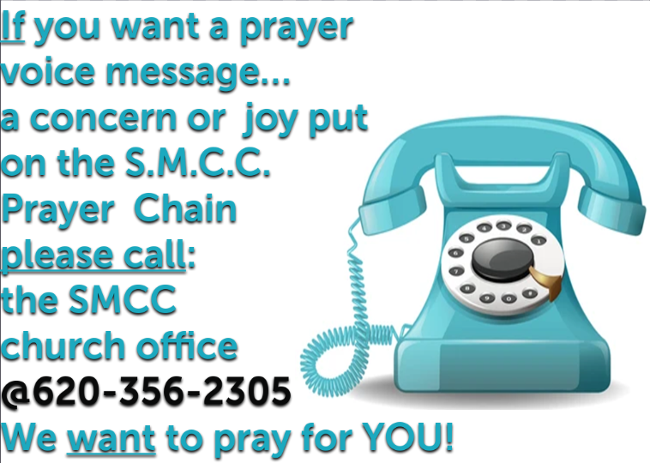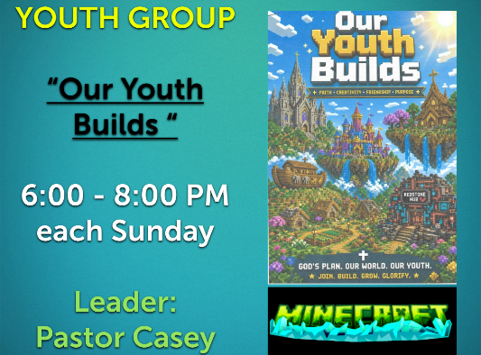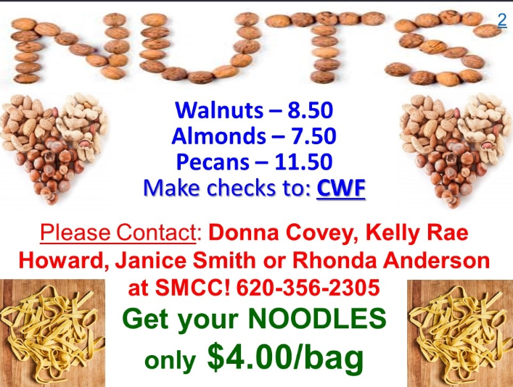
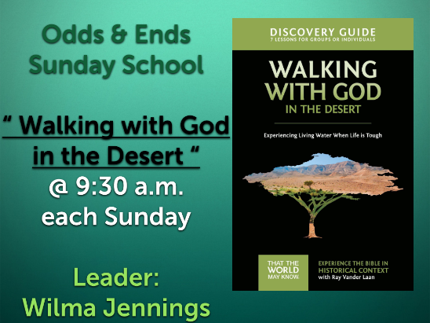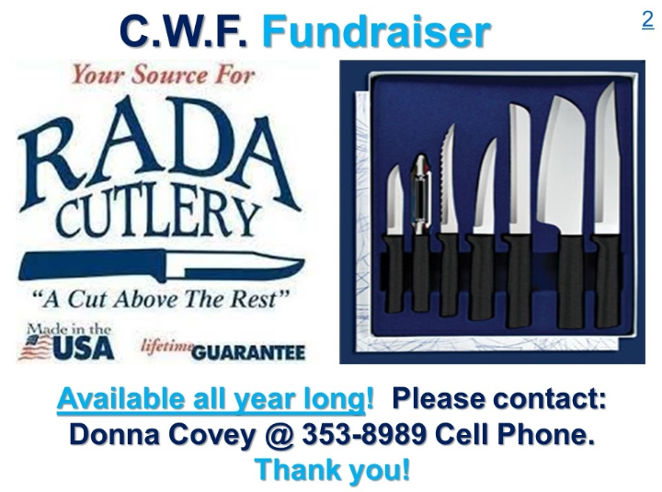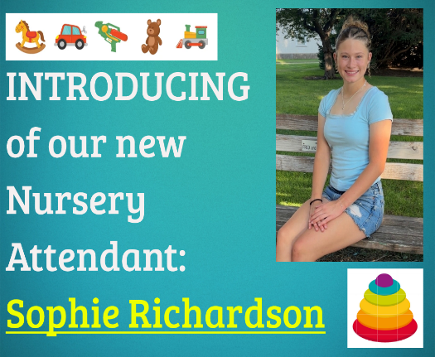
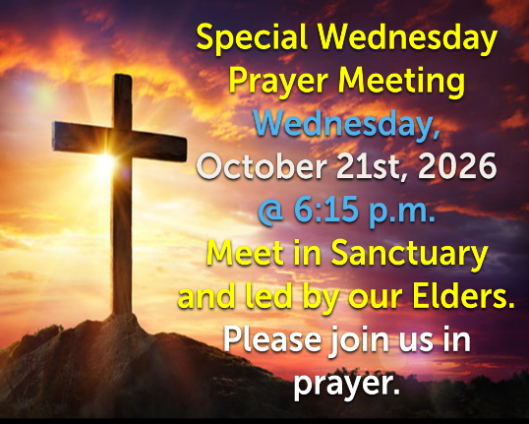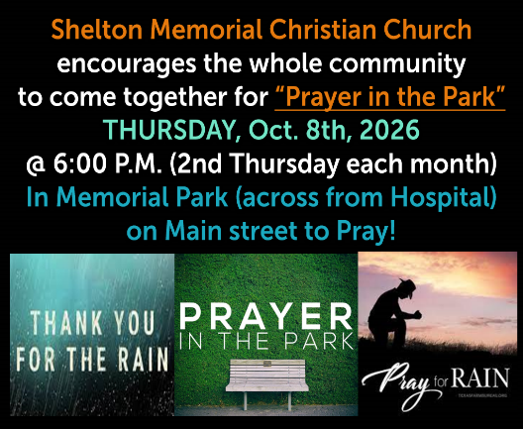
 SMCC Preschool Where Children love to Learn, and Learn with Love!
October is here! We will be talking about all things fall, we will be talking about fire safety, and first responders and what they do, why leaves change color, why it gets colder outside, & spiders and bats! The letters M, & N will also be taught. We have only been in school for two weeks! Routines are getting established, kids are getting better at hanging up their back pack and finding their names to put on the table. They have loved playing in the rice, learning new nursery rhymes, and learning a few finger plays. I focused mainly on the letter A. The sound it makes, and what words start with the letter A. We are still working on straightening our hand muscles, so we have not worked on writing letter A, but we plan to soon! We have learned to glue, and used scissors a couple of times in the four year old class, and how to use glue in the 3 year old classes. We have also painted with water colors and the proper way to do that so your colors don’t get mixed up! We had a day in the four year old class where we talked about apples, how they grow, and all the different kinds of apples there are! We taste tested green and red and I had the children tell me what their favorite kind was! It was about half and half! We also painted with apples, and made caramel apples out of paper! The four year olds have been great at doing show and tell! It’s so neat to see them get brave enough to share something near and dear to them in front of the whole class! It has been very busy, but also a whole lot of fun! If you have any questions, please feel free to reach out to me!
Thank you!

Jessica Malone
Preschool Teacher/Director
Email: jkmalone10@gmail.com Phone :620-453-0716
New SMCC Preschool HOURS
3 & 4 YEAR OLD CLASSES / (Mon & Wed) or (Tue & Th) 9:00 – 11:00 A.M.
4 & 5 YEAR OLD CLASS / 4 DAYS A WEEK – (Mon, Tues, Wed & Thurs) 12:30 – 3:30 P.M.
 SMCC Christian Education Ministries
October 2026 Issue – Page 2
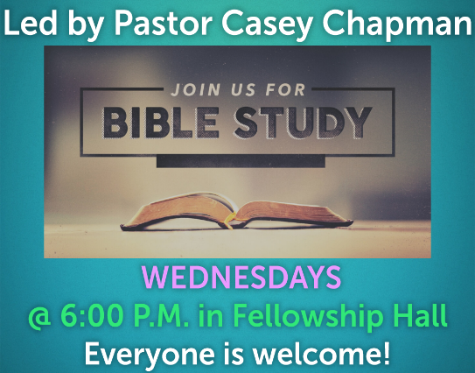

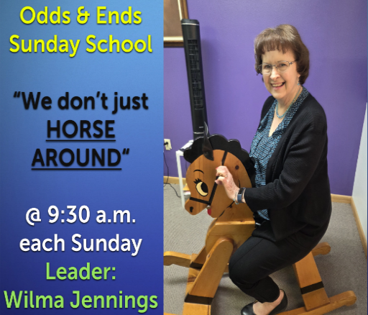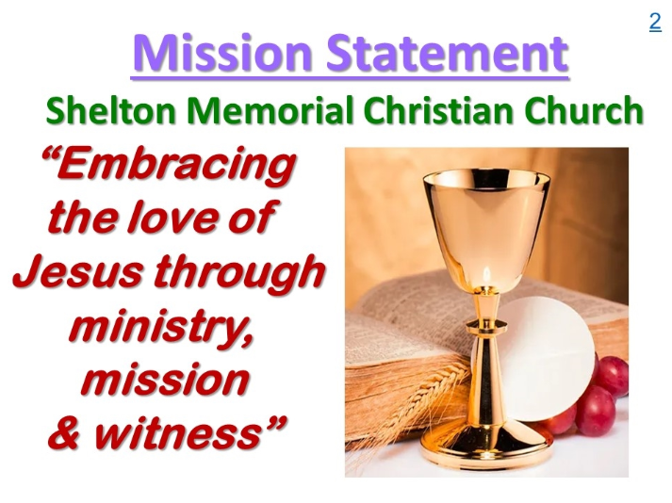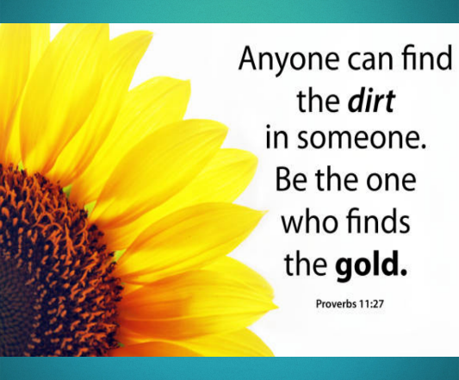
From the desk of Kelly Rae On my mind, in my heart and ready to share!

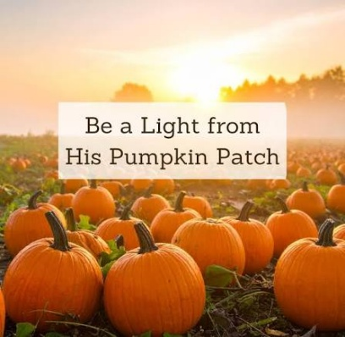
You Are God's Pumpkin This devotional was written by Kelly McFadden
God has united you with Christ Jesus. For our benefit God made him to be wisdom itself. Christ made us right with God; he made us pure and holy, and he freed us from sin. Therefore, as the Scriptures say, "If you boast,
boast only about the Lord." —1 Corinthians 1:30-31 (NLT)

For most of the country, the crisp cool air of autumn is upon us. A sure sign of autumn is that Christmas decorations are popping up everywhere in retail stores. Halloween costumes and disguises are selling out in stores as trick-or-treaters are ready to take over the streets. A popular symbol of both harvest time and Halloween is the pumpkin. I was thinking recently that being a Christian is a lot like being a pumpkin. Perhaps you are visualizing this orange, round vegetable and wondering how you could ever be compared to one of these squashes! Simply put, like a child chooses a pumpkin to carve and mold an image upon, so God carves and molds His own unique design in you.
The Scriptures tell us that the Lord chooses us. He lifts us up and washes the dirt from our skin. Then he opens us, connecting deep inside to scoop out all the slimy, yucky stuff, including seeds of doubt, spite, lies, and fear. Then He carves a new creation, and makes our faces shine by putting His light inside for all to see.
Sometimes I feel like I don't want my light to shine because I am ashamed of a thought or action or pattern in my life. I try to hide the light Christ has put in me, and blend in with the crowd. What I forget is that when God carved me, created me, and gave me His Son, I no longer had to count on my own strength. I can count on the Lord's. It is He who washes me clean; it is He who gives me a spirit of strength and perseverance; it is He who makes me pure; it is He who frees me from sin; and it is He who gives me hope. When I realize that my part of the equation is to rely on His strength and power, then I can do as Scriptures say, and shine His light through the power of the Holy Spirit.
What starts as an everyday squash turns into a lantern of light. What starts as an everyday person turns into a beacon of hope for all to see. Through our union with Christ, we are given the light and wisdom of the Holy Spirit who enters and dwells in our lives. It is He who picked you out and carved you just the way He wants you. So make sure you keep your lantern lit for all to see.
GOING DEEPER:
1. What sins are in your life that you need to release and allow the Lord to scoop out for you?
2. Each time you see a pumpkin this autumn, think through why it is so important for you to be a vessel of light representing our Lord.
FURTHER READING: Psalms 19:7-10; Colossians 2:3

