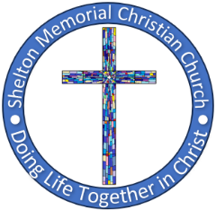SHELTON MEMORIAL CHRISTIAN CHURCH

316 N. Main Street P.O. Box 402

Ulysses, KS 67880

620-356-2305—E-mail [smcc1@pld.com](mailto:smcc1@pld.com)

Website www.smcculysses.com

**October 2025_____________________________________________________**

**OUR PURPOSE:**

***“Embracing the love of Jesus through ministry, mission & witness”***

“Should I Get Baptized Again if I was Baptized as a Baby?”

by: Pastor Casey Chapman

The question “should I get baptized if I was baptized as a baby” recently began to circulate in my mind as we have been studying the New Testament Church on Sunday mornings in the book of Acts. Have you ever had this question or similar questions like, “can I get rebaptized with my children?” Or how about after a period of straying from the faith, “Can I be rebaptized to recommit my life to Christ?” You are not alone in these and similar questions. No matter what pastor you ask, you are probably going to get different answers.

I once had a couple tell me this story that happened to them on their trip to the Holy Land when they got to visit the Jordan River. Their pastor, who was leading their group, was baptizing people in the same spot that Jesus was baptized. They went forward to be baptized, but he rebuked them saying that you can only be baptized once, and they had already been baptized.” It really bothered them.

In Acts 19:1-7 we see the first and only time that people were baptized twice.

***19****While Apollos was in Corinth, Paul traveled through the interior regions and came to Ephesus. He found some disciples****2****and asked them, “Did you receive the Holy Spirit when you believed?”*

*“No,” they told him, “we haven’t even heard that there is a Holy Spirit.”*

***3****“Then what baptism were you baptized with?” he asked them.*

*“With John’s baptism,” they replied.*

***4****Paul said, “John baptized with a baptism of repentance, telling the people that they should believe in the One who would come after him, that is, in Jesus.”*

***5****When they heard this, they were baptized in the name of the Lord Jesus.*

***6****And when Paul had laid his hands on them, the Holy Spirit came on them, and they began to speak in other languages and to prophesy.*

***7****Now there were about 12 men in all.*[1]

Apollos was a God-fearing man who had previously encouraged these people of Ephesus. He was bold and used the Scriptures. The problem was the New Testament was not written yet. As a matter-of-fact, Apollos did not know who Jesus was nor of His resurrection. That is why the people at Ephesus did not have the Holy Spirit, and is also why they had only been baptized by John’s baptism according to verse three.

This would be very similar to infant, or baby baptism. When an infant is baptized, they receive the Baptism of John which cannot save, nor impart the Holy Spirit. That is why when we grow and begin to understand, we decide or choose to follow Jesus. Babies are covered by what is known as the Age of Accountability which is God’s great grace upon them. While this topic is lengthy, in short, if a baby or child passes during this age they are with Christ. My intent is to convey to the person who believes that baptism alone saves, it is not baptism that saves but Jesus Christ alone. Baptism is often the first step in following the teachings of Jesus.

For their lack of knowing Christ, Paul tells them of Jesus and His Gospel. In verse five, the people believe and are rebaptized. After this, the Holy Spirit comes upon them.

So, should a person baptized as a baby be rebaptized? I would say yes! Can a person who is rededicating their life to Christ be rebaptized? I would also say yes. Why not? Does it encourage them and the body? Yes. Is it forbidden by the Scriptures? No. Then by all means be baptized. Can parents get baptized with their children, even if they already were baptized? Again, why not, for does it not encourage the family to greater intimacy with each other and God?

Baptism should never be discouraged, but encouraged to those who believe in God, for only through Christ can we come before the Father, and only with Christ can we start following His way.

It is clear, other than this example, because of Apollo’s lack of understanding, unbelievers are never baptized in the Bible. Confess the name of Jesus and you are immediately saved. Then, start living your life obediently. The first step… Be baptized. It is how Jesus started His ministry. It is how we ought to start our new Life in Him… by following His way.

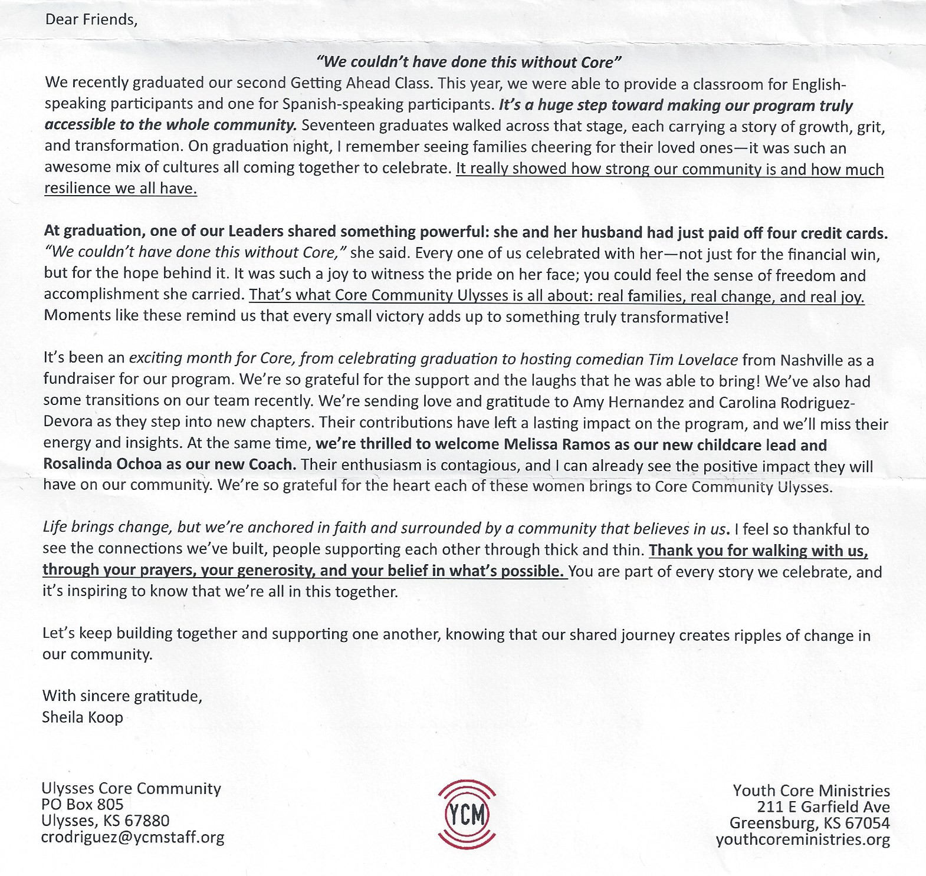

OCTOBER BIRTHDAYS**/*ANNIVERSARIES**

01 – Nathan Walters

02 – Thelma Bortz

08 – **\*Andrew & Val Gindlesberger**

13 – Bruce Howard

15 – **\*Monty & Jean Teeter**

16 – **\*Randy & Kim Klein**

18 – Mark McGaughey

19 – Randy Klein

19 – Zane Anderson

24 – Richard Jennings

24 – Rebecca Ames

26 – Don Dunn

26 – **\*Don & Carolyn Dunn**

29 – C.J. Raines

If your special day has been missed, please contact the church office. 620-356-2305

***Scheduled to Serve in October*:**

**Elders:** Tamra Rundell, Vacancy shared by:

Wilma, Justin A.,????????????

**Deacons:** Jeri Lynn Wells, Zane Anderson

Randy Klein, Brett Lysinger

**Communion:** Kim Klein/Kelly Rae Howard

**Worship Leaders**:

05: Robyn Nordyke 19: Monty Teeter

12: Kelly Howard 26: Tamra Rundell

**Greeters:** Deacons for the month

**Questions?? CALL or email:**

Pastor Casey 620-356-2305(W) [smcc@pld.com](mailto:smcc@pld.com)

(C) 814-573-8148 pastorcaseychapman@gmail.com

Rhonda @ 620-356-2305(W) smcc1@pld.com

Rhonda @ 620-952-0589 (C) redhb@pld.com

Kelly Rae @ 620-356-2305 (W) [smcc2@pld.com](mailto:smcc2@pld.com)

Kelly Rae @ 620-353-8798 (C) [bkhoward@pld.com](mailto:bkhoward@pld.com)

SMCC cares about you! You are loved and prayed for when you’re here and when you’re NOT here. AND YOU ARE MISSED!!!!! Remember, this is your home away from home!

**General Offering to SMCC thru September**

**$150,506.78**

**Thank you, God, for the generosity of this**

**Community of Believers and may their love for you and each other be an inspiration to reach out to those who are in need of knowing You and believing in your love, peace and grace.**

**REMINDER**

If you have a loved one in the hospital, please let the church office staff know (620-356-2305).

*October 31st is Halloween. SMCC is a part of the Trick or Treat Trail again this year!!*

*Drop by to see who is handing out goodies!!*

*4 to 6 pm on Main Street*

*If there is someone who is not on the prayer list but needs to be, please let the office staff know. We do want to pray for those in immediate need!! So, keep us updated, PLEASE. Rhonda*

**Known Prayer Concerns & Joys:**

Michelle (friend of Kim McG), Dewey Middleton, Tammy Steen (heart issues), Mike McGillivray, Cameron Mastin (cousin of Jace Smyth), Earl Teeter, Luke Ruiz (Violet’s brother), Bob Myers, Marty Floyd (friend of the Petersons), Easton Millar (5-yr old w/brain tumors – friend of Gina Banuelos), Bob Cubbage (Cancer), Sharlene Harding, Ron DeGarmo, Terry Winkleman, Helen Finch (Thelma’s sister), Carol Tyler, Catherine Fowler, Titus Smith, Miles Trost, Larry Daniels, Gary McCarty (Robert’s BIL), Kasich Smyth, Lovella Dennett, Don Dennett (stroke), Margo Kohl, Linda Kepley, Roman Ruiz (Violet’s brother), Terra Gamble, Jose Mota (relative of Violet Smyth’s sister), Justin Brickman (Leona’s cousin), Kayla Smyth, Linda Gross (Spencer’s friend), Jerald & Sharon Phelps, Greg McHenry, Brad Bevan, Ron Limper.

*Prayers for those who have recently lost loved ones!*

**Pray for our Armed Forces:** Caden Beims,Dylan Carroll,Maison Wiginton, Canyon Collum,Adam Lambing, Corey Ungles, Lacy Rundell.

========================================**Regular Monthly Schedule**

**Sunday 9:30 A.M. –** Christian Ed. Classes ***Odds & Ends* –‘Walking with God in the Desert’**

**10:30 A.M. –** Worship Service

**LIVE ON FACEBOOK**

***1st Sunday* 9:00 A.M.** – Elder’s Meeting

**Wednesday 7:00 P.M.** – Choir Practice

***3rd Wed*.**  **6:15 P.M.** – Special Wednesday

Prayer Meeting in the sanctuary w/Elders- Join us!

========================================

**Monthly Schedule for OCTOBER 2025**

**Oct. 1st – 6:00 P.M.** Bible Study w/Pastor

**7:00 P.M.** Choir Practice

**Oct. 5th – 9:00 A.M. Elder Meeting**

**9:30 A.M.** Odds & Ends S.S.

**10:30 A.M.** Worship Service

Message by Pastor Casey Chapman

**Oct. 6th – 6:00 P.M.** Every Man a Warrior

**Oct. 8th – 6:00 P.M.** Bible Study w/Pastor

**7:00 P.M.** Chancel Choir Practice

**Oct. 9th** **– 6:00 P.M.** Prayers at Memorial Park

**Oct. 12th –** **9:30 A.M.** Odds & Ends S.S.

**10:30 A.M.** Worship Service

Message by Pastor Casey Chapman

**Oct. 14th – 7:00 P.M. Board meeting**

**Oct. 15th** **–**  **9:00 A.M. CWF Meeting**

**6:15 P.M.** Prayers with elders in

the Sanctuary – All are welcome

**Oct. 19th –10:30 A.M.** Worship Service

Message by Pastor Casey Chapman

**Congregational Meeting after Worship**

**Oct. 22nd – 6:00 P.M.** Bible Study w/Pastor

**7:00 P.M.** Choir Practice

**Oct. 26th** **–10:30 A.M.** Worship Service

Message by Pastor Casey Chapman

**4:00 P.M.** Pastor Casey worship

service at Care Home

**Oct. 31st – 4:00 to 6:00 p.m.** Trick or Treat Trail

1. Acts 19:1-7, HCSB.