Homeschooling Rescue & Recreation Program

“Homeschooler R&R Program”

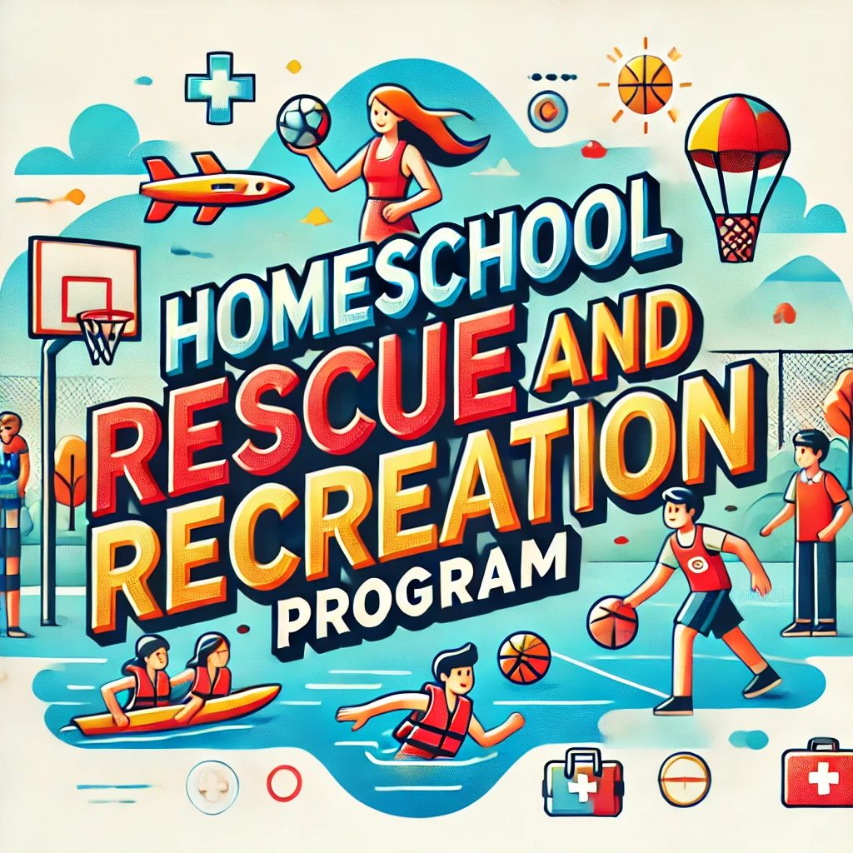

-Courses provide CEU credits-

### **Week 1: Babysitting Basics & CPRO Introduction**

**Main Goal:** Develop core babysitting skills and introduce advanced CPR concepts for professional rescuers.

* **Day 1 (3 hours)**:
  + **Babysitting Basics** (3 hours):
    - Responsibilities, communication with parents, safety, and injury prevention.
    - Discuss common emergencies in babysitting and how to manage them.
* **Day 2 (2 hours)**:
  + **Babysitting Essentials** (2 hours):
    - Infant and toddler care (feeding, diapering, napping).
    - Introduction to behavior management and emergency protocols.
* **Day 3 (3 hours)**:
  + **Babysitting Emergency Response** (2 hours):
    - Role-playing scenarios for managing injuries and illnesses.
  + **CPRO Introduction** (1 hour):
    - Overview of CPR for Professional Rescuers, discussing the differences from standard CPR.
* **Day 4 (2 hours)**:
  + **CPRO Basics** (2 hours):
    - Basic life support (BLS) introduction.
    - Role of a professional rescuer, legal considerations, and team-based response.
* **Day 5 (3 hours)**:
  + **CPR for Professional Rescuers** (3 hours):
    - Adult and child CPR introduction.
    - Airway management and checking for breathing and pulse.

### **Week 2: Advanced CPR for the Professional Rescuer**

**Main Goal:** Focus on in-depth CPR skills required for professional rescuers.

* **Day 6 (3 hours)**:
  + **CPR for Infants and Children** (3 hours):
    - 2-person CPR techniques for infants and children.
    - Using rescue breathing and pulse checks for infants and children.
* **Day 7 (2 hours)**:
  + **CPR/AED Integration** (2 hours):
    - Using an AED in an emergency for adults and children.
    - Team CPR with AED and oxygen administration.
* **Day 8 (3 hours)**:
  + **CPR Scenarios** (3 hours):
    - Hands-on practice in simulated emergency scenarios (cardiac arrest, drowning, etc.).
    - Rescue breathing and bag-valve-mask (BVM) techniques.
* **Day 9 (2 hours)**:
  + **First Aid Integration** (2 hours):
    - Administering advanced first aid in emergencies (bleeding control, fractures, spinal injuries).
    - Connecting first aid with CPR response.
* **Day 10 (3 hours)**:
  + **Advanced Airway Management** (3 hours):
    - Airway obstruction, conscious choking, and unconscious choking techniques.

### **Week 3: Emergency Preparedness Focus**

**Main Goal:** Build comprehensive emergency preparedness skills and integrate them with professional rescuer responses.

* **Day 11 (3 hours)**:
  + **Introduction to Emergency Preparedness** (3 hours):
    - Types of emergencies (natural disasters, medical, fire, chemical incidents).
    - Discuss how professional rescuers prepare and respond.
* **Day 12 (2 hours)**:
  + **Emergency Action Plans** (2 hours):
    - Creating emergency action plans for families and groups.
    - Assembling and maintaining emergency supply kits.
* **Day 13 (3 hours)**:
  + **Evacuation Drills & Scenarios** (3 hours):
    - Evacuation procedures and drills for different types of emergencies (fire, floods).
    - Applying professional rescuer techniques in high-stress situations.
* **Day 14 (2 hours)**:
  + **First Aid for Natural Disasters** (2 hours):
    - Treating injuries during natural disasters (fractures, bleeding, burns).
    - Role of a professional rescuer in providing care until help arrives.
* **Day 15 (3 hours)**:
  + **Scenario Day** (3 hours):
    - Simulated emergencies combining evacuation, first aid, and CPR skills.

### **Week 4: Integration of Skills & Certification Prep**

**Main Goal:** Apply all skills learned in simulated real-world scenarios and prepare for certification assessments.

* **Day 16 (3 hours)**:
  + **Babysitting Practice with CPR Integration** (3 hours):
    - Advanced babysitting scenarios where students respond to common emergencies, integrating CPR and first aid knowledge.
* **Day 17 (2 hours)**:
  + **CPRO Advanced Practice** (2 hours):
    - Scenario-based training with 2-rescuer and team CPR, including AED use.
* **Day 18 (3 hours)**:
  + **Emergency Preparedness Simulation** (3 hours):
    - Simulating full-scale emergencies (medical, fire, chemical) where CPR and emergency preparedness plans are implemented.
* **Day 19 (2 hours)**:
  + **Skills Review and Practice** (2 hours):
    - Review all key skills: CPR, AED, choking response, first aid, and emergency preparedness.
* **Day 20 (3 hours)**:
  + **Certification Day** (3 hours):
    - Final assessment and practical evaluation for **CPR for Professional Rescuers**, babysitting, and emergency preparedness.
    - Completion of Red Cross certification requirements.

### **Summary of Time Allocation:**

* **Babysitting:** 10 hours
* **CPRO (CPR for Professional Rescuers):** 15 hours (Certification focus)
* **Emergency Preparedness:** 10 hours

By the end of this month-long curriculum, participants will be equipped with advanced CPR skills required for professional rescuers, babysitting knowledge, and comprehensive emergency preparedness, ready to obtain certifications in all areas through the **American Red Cross**.