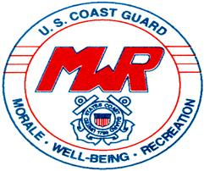

Emergency Action Plan # 2

Multiple Lifeguards On Duty

|  |
| --- |
| * 1st Lifeguard recognizes the victim * Activates the EAP/hits the pool alarm on the wall behind Guard Station #1 * Three loud whistles/loud-oral announcement. |



|  |
| --- |
| * Lifeguard # 1 Assess the Situation, Gets the Equipment Needed, and Performs the Rescue * Lifeguard # 2 Clears the pool and assists Lifeguard #1 with additional support. * Gear Issue Staff calls 9-1-1 immediately, stays on with them until **THEY** hang up. Assists lifeguard staff when/as needed. * Additional Gear Issue Staff performs crowd control (Parent/Child/Etc…) and secures the area. * Additional Gear Issue Staff waits for EMS to Arrives and Escorts them to the Victim’s Location. |



|  |
| --- |
| Lifeguards # 1 & # 2 continues to administer care until EMS personnel arrive and take over. |



|  |
| --- |
| After EMS personnel arrive and take over, the lifeguards interview any witnesses and **individually** fill out an incident report form. |



|  |
| --- |
| Call José immediately at (401) 663-6105 |