**Proposed Pay Structures for The Director of Aquatic Strategy Role**

To meet the organization’s needs while ensuring flexibility and measurable results, I propose the following pay structures. These options are adaptable to fit the scope of work, whether as a full-time, hybrid, or project-based position, and are designed to produce immediate, high-impact outcomes.

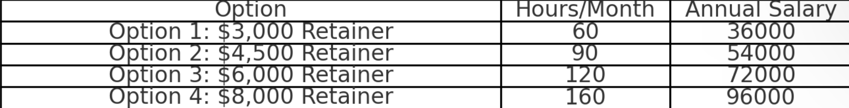

**Option 1: $3,000 Monthly Retainer hybrid remote 50-50**

* Scope:
  + Perform efficiency audits of operations (aquatics and other areas).
  + Identify 1-2 high-impact revenue-generating opportunities per quarter (e.g., program diversification, space optimization, vendor partnerships).
  + Provide detailed implementation plans with timelines and deliverables.
* Hours:
  + 60 hours/month:
    - 30 in-person hours: Observing operations, meeting with staff, and presenting findings.
    - 30 remote hours: Developing strategies, reports, and communication.

**Option 2: $4,500 Monthly Retainer hybrid remote 50-50**

* Scope:
  + Comprehensive analysis of multiple departments for efficiency improvements.
  + Develop and implement 2-3 new revenue-generating ideas per quarter (e.g., corporate partnerships, class package deals, or facility rentals).
  + Assist with marketing strategies for new programs.
* Hours:
  + 90 hours/month:
  + 45 in-person hours: Observing, meeting stakeholders, and tracking progress.
  + 45 remote hours: Planning, reporting, and coordinating new initiatives.

**Option 3: $6,000 Monthly Retainer hybrid remote 50-50**

* Scope:
  + Holistic review of facility operations for cross-departmental efficiency gains.
  + Design and implement 3-4 significant revenue-generating initiatives per quarter (e.g., innovative programming, cross-promotional partnerships with local businesses, or subscription services).
  + Conduct staff training on efficiency strategies and new revenue opportunities.
* Hours:
  + 120 hours/month:
  + 60 in-person hours: Engaging with staff, running pilot programs, and ensuring implementation.
  + 60 remote hours: Developing strategies, marketing plans, and progress tracking.

**Option 4: Full-Time Hybrid Role ($8,000 Monthly Retainer) Scope:**

* + Serve as a Strategic Revenue and Efficiency Consultant.
  + Oversee efficiency improvements across all departments.
  + Implement and manage 5+ revenue-generating programs annually.
  + Act as a long-term strategic partner, ensuring sustainable growth.
* Hours:
  + 160 hours/month:
  + 80 in-person hours: Overseeing operations, managing initiatives, and staff engagement.
  + 80 remote hours: Long-term strategic planning, reporting, and marketing.

**Option 5: Hybrid Remote: Hourly with Minimum Hours Per Month;**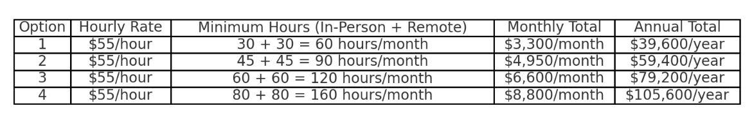

**Achievable Outcomes for Each Option**

* Option 1: $3,000 Monthly Retainer
  + Reduce swim school scheduling conflicts by 20% within the first 3 months.
  + Increase swim school capacity utilization by 10% annually.
  + Generate $10,000+ annually in new revenue streams through streamlined operations and pricing adjustments.
* Option 2: $4,500 Monthly Retainer
  + Decrease staff turnover by 15% within 6 months through improved scheduling and incentives.
  + Achieve 90% enrollment in swim school programs by balancing group and private lesson offerings.
  + Generate $20,000+ annually by implementing targeted marketing and new program structures.
* Option 3: $6,000 Monthly Retainer
  + Increase private lesson bookings by 25% within the first year by optimizing scheduling and marketing.
  + Reduce scheduling inefficiencies in group lessons by 30%, improving overall satisfaction and retention.
  + Achieve $30,000+ annually in new revenue through adaptive programs and local partnerships.
* Option 4: $8,000 Monthly Retainer
  + Achieve 95% enrollment capacity year-round across all swim school tiers.
  + Reduce staff overtime costs by 20% annually by improving efficiency in staffing and scheduling.
  + Generate $50,000+ annually by launching 5+ new revenue-generating programs, such as corporate partnerships and seasonal offerings.
* Option 5: Hourly Hybrid Model
  + Deliver measurable improvements in registration workflows, reducing errors by 25% in the first quarter.
  + Enhance staff onboarding processes, cutting training time by 30%.
  + Support ongoing operational challenges with flexible, high-impact solutions tailored to immediate needs.

**What I Can Offer**

As The Director of Aquatic Strategy, I bring a comprehensive skill set and proven strategies that can elevate the Greenwich YMCA’s aquatic program to new heights in a short period. Here’s what I can deliver:

1. Retention of Full-Time Employees

* Streamline Day-to-Day Tasks: Eliminate repetitive and time-consuming activities by implementing efficient workflows and digital solutions, freeing staff to focus on high-impact responsibilities.
* Create Clear Role Definitions: Provide staff with defined tasks and achievable goals to reduce burnout and increase job satisfaction.
* Foster a Positive Work Environment: Establish recognition and incentive programs that reward contributions and build morale, leading to higher retention rates.

2. Significant Revenue Growth Through Training Programs

* Expand Community Training Services: Offer lifeguard, CPR, first aid, and specialty certifications to increase participation and generate revenue in the tens of thousands, if not hundreds of thousands, annually.
* Corporate and School Partnerships: Develop training agreements with local businesses and schools to maximize facility utilization and revenue potential.
* Innovative Training Formats: Introduce flexible training models, such as hybrid classes or on-demand certifications, to attract a wider audience.

3. Building High-Performing Teams

* Recruitment and Mentorship: Attract top talent through targeted recruitment campaigns and build sustainable teams by providing professional development and mentorship opportunities.
* Cross-Training Programs: Ensure staff are equipped with diverse skill sets, increasing flexibility and resilience in operations.
* Leadership Development: Identify and cultivate future leaders within the team, ensuring long-term stability and growth.

4. Operational Efficiency

* Streamline Swim School Operations: Simplify registration processes, balance class schedules, and optimize staffing to eliminate inefficiencies.
* Maximize Facility Usage: Increase enrollment and revenue by ensuring every lane, pool hour, and staff shift is utilized effectively.
* Reduce Overhead Costs: Implement systems to track and control expenses, such as staffing and program supplies, without compromising quality.

5. Program Growth and Innovation

* Launch New Programs: Introduce adaptive swim classes, leadership development for teens, or family-focused aquatic events to broaden community engagement.
* Data-Driven Decisions: Use analytics to identify trends, measure success, and continuously refine offerings.
* Market Expansion: Build partnerships with neighboring communities and organizations to grow program reach and participation.

6. Sustainability and Longevity

* Develop Self-Sustaining Teams: Build teams and workflows that continue to thrive independently, ensuring long-term operational success.
* Create Repeatable Systems: Implement scalable strategies that can be adapted for future growth and program expansion.
* Long-Term Revenue Stability: Establish programs and partnerships that provide consistent, recurring income streams to support the YMCA’s mission.

My goal is not just to solve immediate challenges but to create a foundation for lasting success that positions the Greenwich YMCA as a leader in aquatic programming.

Best regards,

Evie Gindi

Phone: 203-514-7870