wa
Wolfe Property Management
Seasonal Property Care — Scottsdale Pricing Model
Service Season: May – September 2026
Our pricing reflects the realities of Scottsdale's premium market, the specialized expertise required for
desert property care, and our commitment to proactive protection—not reactive check-ins. All prices are
seasonal rates covering the typical 5-month summer period.
Core Service Plans
Service Plan
Seasonal Rate
$1,250
What's Included
Monthly Inspection
One comprehensive inspection per month (5
total), detailed photo reports, emergency
response, vendor coordination
Bi-Weekly Inspection
Weekly Inspection
$2,100
$3,750
Two inspections per month (10 total),
enhanced monitoring, detailed reports, priority
emergency response, vendor coordination
Weekly inspections (20+ total), maximum
oversight, comprehensive reporting,
immediate issue detection, priority vendor
coordination
Note: All plans include initial walkthrough, closing inspection, emergency response capability, and full photo
documentation.
Property Size Adjustments
Base pricing applies to properties up to 3,500 sq ft. Larger estates require additional inspection time
and oversight:
Property Size
Additional Fee
+$250 per season
+$500 per season
Custom quote
3,501 – 5,000 sq ft
5,001 – 7,500 sq ft
7,501+ sq ft
Premium Add-On Services
Service
Price
Best For
Pre-Return Ready Package
$395
Owners wanting home ready &
comfortable on arrival
Monsoon Storm Response Plan
$575
$425
Properties exposed to wind,
drainage risks, or mature trees
HVAC Summer Survival Monitoring
Older systems or high cooling
demands


Insurance Walkthrough Support
Luxury Home Discretion Tier
$350
When incident requires insurance
claim
+35%
High-value properties requiring
enhanced privacy
À La Carte Services
Service
Price
Additional mid-season inspection (one-time)
Emergency callout (unscheduled visit)
$175
$225
Vendor supervision (per hour, 2-hour minimum)
Mail/package retrieval and forwarding (per occurrence)
Vehicle start and operation (per visit)
$85/hour
$45 + shipping
$65
Our Pricing Philosophy
Premium market, premium service. Scottsdale's seasonal homeowners expect—and deserve—
exceptional care. Our pricing reflects:
•
Specialized expertise: Understanding desert climate challenges, high-end home systems, and
Scottsdale's unique property dynamics
•
Proactive oversight: Not just checking boxes—actively preventing problems before they
escalate
•
•
•
Professional standards: Trained staff, comprehensive insurance, meticulous documentation
Accountability: Your home is our responsibility—we take that seriously
Peace of mind: You shouldn't worry about your home while you're away
We're not the cheapest option in the Valley—and we don't try to be. We're the option for homeowners
who understand that protecting a significant investment requires genuine expertise and vigilant care.
Payment Terms
•
•
•
•
50% deposit due upon contract signing
50% balance due before service begins (typically early May)
Premium add-ons billed separately when activated
À la carte services invoiced monthly based on usage
Accepted payment methods: ACH transfer (preferred), check, major credit cards (3% processing fee
applies)
Cancellation & Refund Policy
•
•
•
•
Cancellation more than 30 days before service start: Full refund minus $200 administrative fee
Cancellation 15-30 days before service start: 50% refund
Cancellation less than 15 days before service start: No refund
Early return during active service: Pro-rated refund for uncompleted months (minimum 2 months
charged)
Questions About Pricing or Services?
Contact Wolfe Property Management for a customized quote
tailored to your property's specific needs.
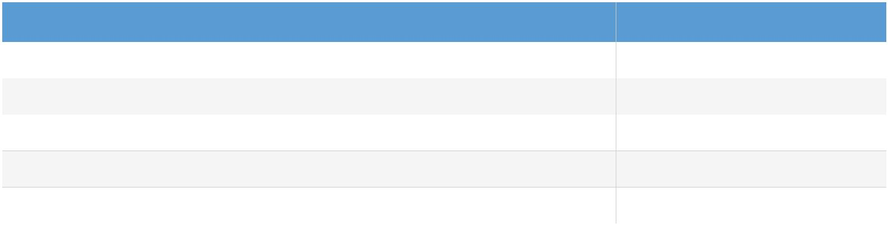

Premium Protection. Proactive Care. Complete Peace of Mind.

