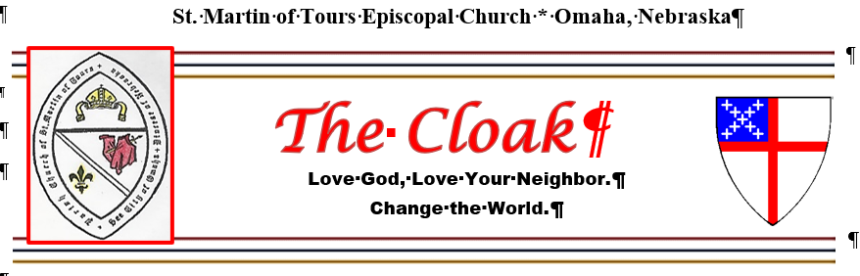
December 2025
Greetings,
Almighty God, give us grace to cast away the works of darkness, and put on the armor of light, now in the time of this mortal life in which your Son Jesus Christ came to visit us in great humility; that in the last day, when he shall come again in his glorious majesty to judge both the living and the dead, we may rise to the life immortal; through him who lives and reigns with you and the Holy Spirit, one God, now and for ever. Amen.
The Collect for the First Sunday of Advent
Blessings to you in the New Year! No, I am not rushing our holiday season. Not at all. I am wishing you a Blessed Liturgical New Year! Advent is about to begin, and that marks the beginning of our new church year! The First Sunday in Advent begins on November 30th, and it will be the Year of Matthew
Since the Synoptic Gospels (Matthew, Mark, and Luke) report many of the same episodes in Jesus’ life, one would expect much similarity in their accounts. But, not so! There is much that is unique about Matthew.
Matthew’s gospel tells the story of the manifestation of God to the gentiles represented by the Magi. After the visit, an angel appeared to Joseph in a dream instructing him to take the Mary and the infant Jesus to escape King Herod’s intent to kill the child. This highlights the divine protection and guidance of the migrant Holy Family.
December is a busy month in the church and in the secular world. My prayer for all of you is that you may find some peace and serenity during the seasons of Advent and Christmas.
Love God, love your neighbor, change the world,
Mother Kim
Prayer Requests * Prayer Chain
The Prayer List will be sent electronically weekly, along with an electronic copy of the bulletin and weekly notices. If you have new names to add, please notify Deacon Mark Kowalski at kowalskimjk@gmail.com or Mtr. Kim Roberts at bkeroberts@msn.com, or call the church phone at 402-733-8815. On Sundays, if you have someone for the Prayers of the People, please let Deacon Mark know before the service begins.

St. Mart’s News and Announcements

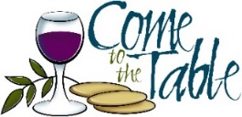
All are welcome. All worshipping at St. Martin of Tours who seek God and are drawn to Christ are welcome to receive Holy Communion at God’s table. If you prefer to receive a blessing, please fold your arms across your chest.
The Vestry of St. Martin of Tours will meet on Sunday, December 14th following Second Table.


Please know that Mother Kim or Deacon Mark will never text or email you asking for “a favor” or “gift cards”! These are scammers posing as church leaders, and unfortunately, they are very common. If you receive a text, block the number. If it’s an email, please report it as a scam You can usually spot it by checking the phone number or the full email address. If you are ever in doubt, please contact Mtr. Kim.
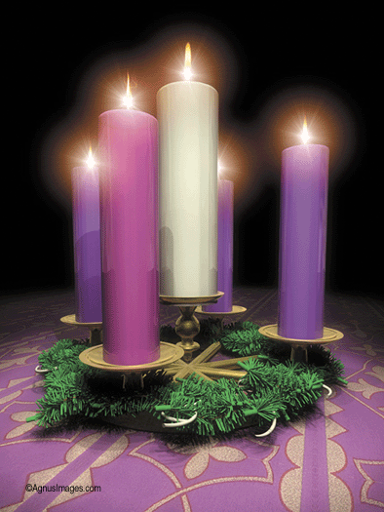
ADVENT
Advent is a season observed as a time of waiting and preparation for both the celebration of Jesus’ birth at Christmas and the return of Christ at the Second Coming. It begins on the fourth Sunday before Christmas. Advent is the beginning of the liturgical year. This year Advent begins on Sunday, November 30th.
This Photo by Unknown Author is licensed under CC BY-NC-ND
History Cabinet - The Advent/Christmas cabinet theme is “All about Angels”. Judy, Jimmy, and Jen are seeking help with collecting angels for the display. Please bring an angel—no bigger than 12 inches—to share. Include your name with it so they can be returned to the rightful owners.

THE GREENING OF THE CHURCH
Sunday, December 21st (Advent IV) will be the date the church will be decorated for Christmas following the service. All are invited to help with this project. When finished, we will have a Second Table party. Please bring a favorite Christmas treat to share.

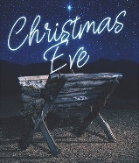
CHRISTMAS EVE
St, Martins will celebrate the great Feast of the Nativity of Our Lord Jesus Christ on Tuesday, December 24th at 6:30 pm.

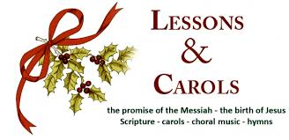
LESSONS & CAROLS
Lessons & Carols and Holy Eucharist will be offered on Sunday, December 28th at the 10 am service.

EPIPHANY
The Epiphany celebrates the manifestation of Christ to the Gentiles as represented by the Magi. The service will be transferred to Sunday, January 4, 2026.

Thank You
St. Martin of Tours church has had a busy and productive year so far—thanks to all of you. We continue to provide the Episcopal presence in South Omaha. But of course, we can always do more. Please consider inviting a friend to worship with us. Please prayerfully consider your pledge to St. Martins and what it means to do God’s work in this community. Most especially, thank you for your faithful witness.

St. Martin of Tours Episcopal Church Contacts
- The Rt. Rev. J. Scott Barker, Diocesan Bishop of Nebraska
- Rev. Kim Roberts, Rector bkeroberts@msn.com
- Rev. Mark Kowalski, Deacon kowalskimjk@gmail.com
- Ann Chambers, Parish Administrator, Music Director achambers1954@gmail.com
- Jim Murphy, Senior Warden
- Conner Mowery, Junior Warden
- Beth Mincer, Treasurer
- Office Hours: Wednesday and Friday: 9 am - Noon
- Web site: https://stmartinomaha.org
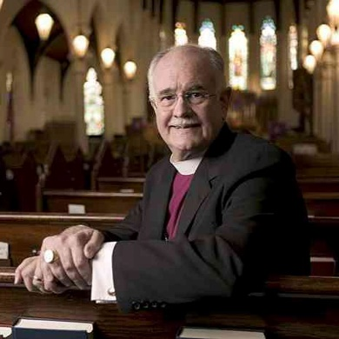
We bid prayers for The Rt. Rev. Joseph Goodwin Burnett, who died Friday, November 14, 2025, and for his family in their grief.
Bishop Burnett’s funeral will be held here at Trinity on Friday, January 9, 2026 at 10:30 AM. Please keep Joe and his family in your prayers.May he rest in peace and rise in glory.

December - Family and Friends Month

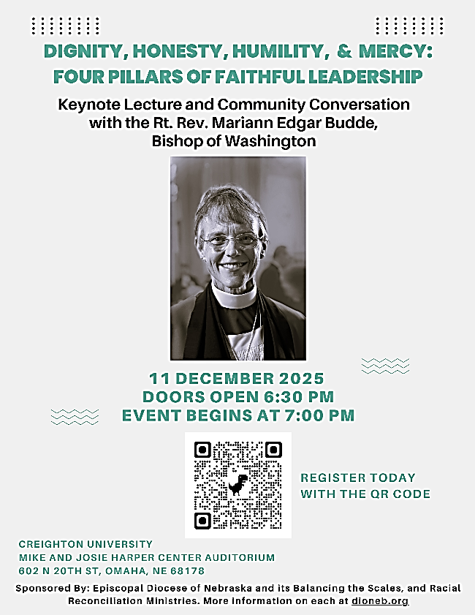
The Right Reverend Mariann Edgar Budde, Bishop of Washington (DC) will be speaking Thursday, December 11th at Creighton University’s Harper Auditorium, hosted by the Episcopal Diocese of Nebraska. Doors open at 6:30 pm.
Register Free. Register. https://alliance.wufoo.com/forms/z1l1khtr0q7tx97/

