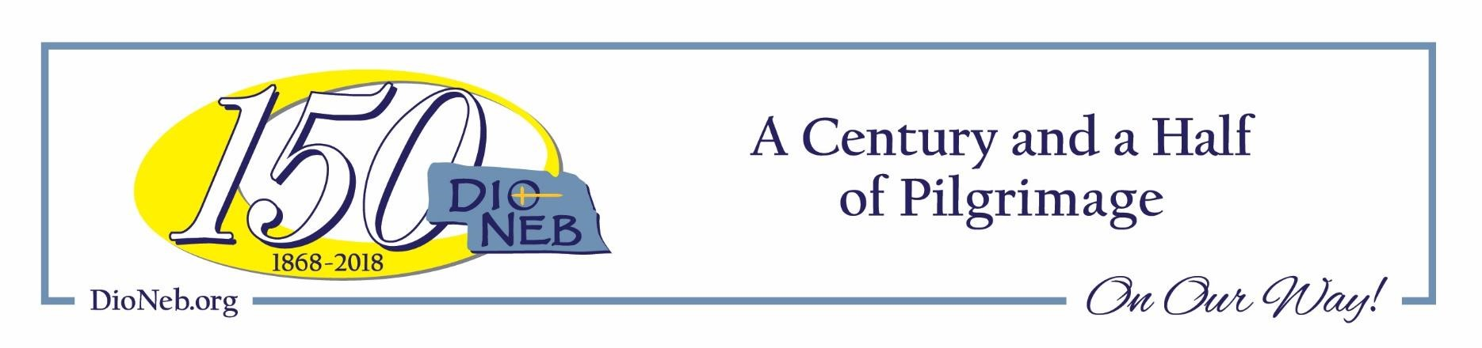
ST MARTIN OF TOURS EPISCOPAL CHURCH
24TH & J Street, Omaha, Nebraska
Diocese of Nebraska

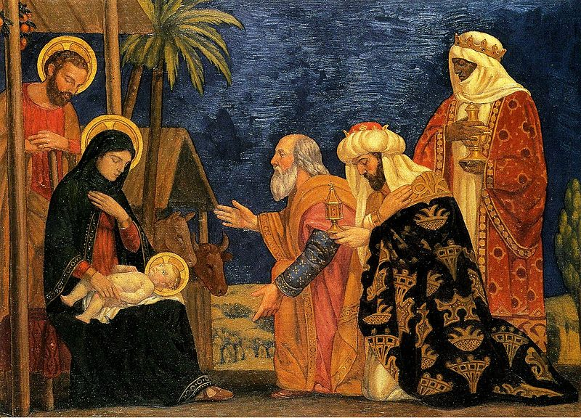

The Epiphany
January 8, 2023

THE HOLY EUCHARIST
Please stand or kneel as you are able and desire to do so.
Voluntary March of the Kings
Opening Hymn 127
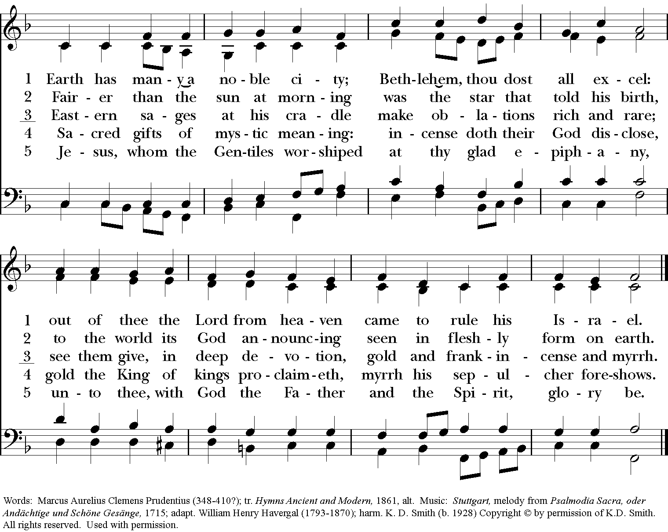
The Word of God
Opening Acclamation BCP page 355
Celebrant Blessed be God: Father, Son, and Holy Spirit.
People And blessed be God’s kingdom, now and for ever. Amen.
Almighty God, to you all hearts are open, all desires known, and from you no secrets are hid: Cleanse the thoughts of our hearts by the inspiration of your Holy Spirit, that we may perfectly love you, and worthily magnify your holy Name; through Christ our Lord. Amen.
Hymn of Praise S-280 Canticle 20
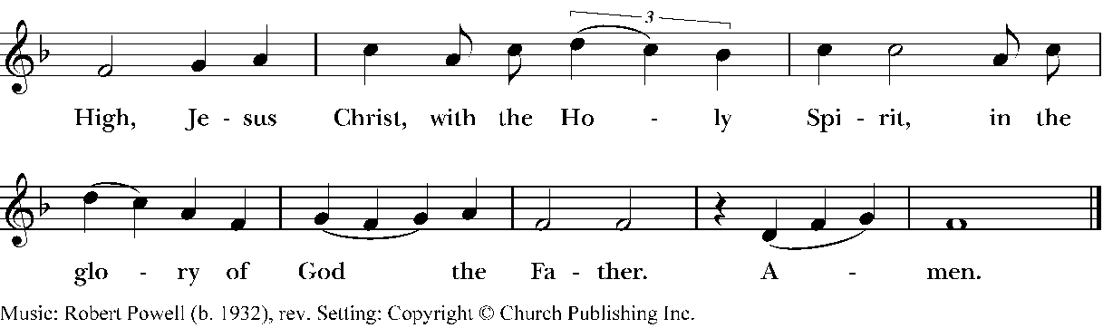
The Collect of the Day
Celebrant: The Lord be with you.
People: And also with you.
Celebrant: Let us pray.
O God, by the leading of a star you manifested your only Son to the peoples of the earth: Lead us, who know you now by faith, to your presence, where we may see your glory face to face; through Jesus Christ our Lord, who lives and reigns with you and the Holy Spirit, one God, now and for ever. Amen.

The Lessons

First Lesson Isaiah 60:1-6
Arise, shine; for your light has come, and the glory of the Lord has risen upon you. For darkness shall
cover the earth, and thick darkness the peoples; but the Lord will arise upon you, and his glory will
appear over you. Nations shall come to your light, and kings to the brightness of your dawn. Lift up
your eyes and look around; they all gather together, they come to you; your sons shall come from far
away, and your daughters shall be carried on their nurses' arms.
Then you shall see and be radiant; your heart shall thrill and rejoice, because the abundance of the sea shall be brought to you, the wealth of the nations shall come to you. A multitude of camels shall cover you, the young camels of Midian and Ephah; all those from Sheba shall come. They shall bring gold and frankincense, and shall proclaim the praise of the Lord.

The Word of the Lord.
People: Thanks be to God.

The Psalm 72:1-7Deus, judicium

1 Give the King your jus-tice, O /God, *and your righteousness to the King's/ Son; || 2 That he may rule your people /right-eou-sly *and the poor with /jus-tice;

3 That the mountains may bring prosperity to the / peo-ple, *and the little hills bring /right-eous-ness.|| 4 He shall defend the needy among the / peo-ple; *he shall rescue the poor and crush the op / pres-sor.

5 He shall live as long as the sun and moon en/dure, *from one generation to an/o-ther.|| 6 He shall come down like rain upon the mown / field, *like showers that water the / earth.

Last half of the Chant
7 In his time shall the righteous/ flour -ish; *there shall be abundance of peace till the moon shall be no/ more.

Second Lesson Ephesians 3:1-12
This is the reason that I Paul am a prisoner for Christ Jesus for the sake of you Gentiles-- for surely you have already heard of the commission of God's grace that was given me for you, and how the mystery was made known to me by revelation, as I wrote above in a few words, a reading of which will enable you to perceive my understanding of the mystery of Christ. In former generations this mystery was not made known to humankind, as it has now been revealed to his holy apostles and prophets by the Spirit: that is, the Gentiles have become fellow heirs, members of the same body, and sharers in the promise in Christ Jesus through the gospel. Of this gospel I have become a servant according to the gift of God's grace that was given me by the working of his power. Although I am the very least of all the saints, this grace was given to me to bring to the Gentiles the news of the boundless riches of Christ, and to make everyone see what is the plan of the mystery hidden for ages in God who created all things; so that through the church the wisdom of God in its rich variety might now be made known to the rulers and authorities in the heavenly places. This was in accordance with the eternal purpose that he has carried out in Christ Jesus our Lord, in whom we have access to God in boldness and confidence through faith in him.

The Word of the Lord.
People: Thanks be to God.

Sequence Hymn LEVAS 24

The Holy Gospel
Then, all standing, the Deacon or a Priest reads the Gospel, first saying
The Holy Gospel of our Lord Jesus Christ according to Matthew. Matthew 2: 1-12
In the time of King Herod, after Jesus was born in Bethlehem of Judea, wise men from the East came to Jerusalem, asking, "Where is the child who has been born king of the Jews? For we observed his star at its rising, and have come to pay him homage."
When King Herod heard this, he was frightened, and all Jerusalem with him; and calling together all the chief priests and scribes of the people, he inquired of them where the Messiah was to be born. They told him, "In Bethlehem of Judea; for so it has been written by the prophet: `And you, Bethlehem, in the land of Judah,
are by no means least among the rulers of Judah; for from you shall come a ruler who is to shepherd my people Israel.'"
Then Herod secretly called for the wise men and learned from them the exact time when the star had appeared. Then he sent them to Bethlehem, saying, "Go and search diligently for the child; and when you have found him, bring me word so that I may also go and pay him homage." When they had heard the king, they set out; and there, ahead of them, went the star that they had seen at its rising, until it stopped over the place where the child was. When they saw that the star had stopped, they were overwhelmed with joy. On entering the house, they saw the child with Mary his mother; and they knelt down and paid him homage. Then, opening their treasure chests, they offered him gifts of gold, frankincense, and myrrh. And having been warned in a dream not to return to Herod, they left for their own country by another road.

Gospeler : The Gospel of the Lord.
People: Praise to you, Lord Christ.

The Sermon

  - The Nicene Creed (please stand as you are able)
We believe in one God, the Father, the Almighty, maker of heaven and earth, of all that is, seen and unseen. We believe in one Lord, Jesus Christ, the only Son of God, eternally begotten of the Father, God from God, Light from Light, true God from true God, begotten, not made, of one being with the Father. Through him all things were made. For us and for our salvation he came down from heaven: by the power of the Holy Spirit he became incarnate from the Virgin Mary and was made man. For our sake he was crucified under Pontius Pilate; he suffered death and was buried. On the third day he rose again in accordance with the Scriptures; he ascended into heaven and is seated at the right hand of the Father. He will come again in glory to judge the living and the dead, and his kingdom will have no end. We believe in the Holy Spirit, the Lord, the giver of life, who proceeds from the Father and the Son. With the Father and the Son he is worshiped and glorified. He has spoken through the Prophets. We believe in one holy catholic and apostolic Church. We acknowledge one baptism for the forgiveness of sins. We look for the resurrection of the dead, and the life of the world to come. Amen.

Prayers of the People Form IV
Let us pray for the Church and for the world.
Grant, Almighty God, that all who confess your Name may be united in your truth, live together in your love, and reveal your glory in the world.
Silence
Lord, in your mercy. Hear our prayer.
Guide the people of this land, and of all the nations, in the ways of justice and peace; that we may honor one another and serve the common good.
Silence
Lord, in your mercy. Hear our prayer.

Give us all a reverence for the earth as your own creation, that we may use its resources rightly in the service of others and to your honor and glory.
Silence
Lord, in your mercy. Hear our prayer.
Bless all whose lives are closely linked with ours, and grant that we may serve Christ in them, and love one another as he loves us.
Silence
Lord, in your mercy. Hear our prayer.
Comfort and heal all those who suffer in body, mind, or spirit; give them courage and hope in their troubles, and bring them the joy of your salvation.
Silence
Lord, in your mercy. Hear our prayer.
We commend to your mercy all who have died, that your will for them may be fulfilled; and we pray that we may share with all your saints in your eternal kingdom.
Silence
Lord, in your mercy. Hear our prayer.
The Celebrant adds a concluding Collect.
Confession of Sin (kneeling)
Let us confess our sins against God and our neighbor.
The Minister and People, then together say
Most merciful God, we confess that we have sinned against you in thought, word, and deed, by what we have done, and by what we have left undone. We have not loved you with our whole heart; we have not loved our neighbors as ourselves. We are truly sorry and we humbly repent. For the sake of your Son Jesus Christ, have mercy on us and forgive us; that we may delight in your will, and walk in your ways, to the glory of your Name. Amen.
The Priest stands and says

Almighty God have mercy on you, forgive you all your sins through our Lord Jesus Christ, strengthen you in all goodness, and by the power of the Holy Spirit keep you in eternal life. Amen.

The Peace
The peace of the Lord be always with you.
People : And also with you.
The Ministers and People may greet one another in the name of the Lord.
Announcements and Offertory Sentence

Offertory Hymn 128

The people stand while the offerings are presented and placed on the Altar.

The Holy Communion
The Great Thanksgiving Eucharistic Prayer B (BCP page 367)
Celebrant The Lord be with you.
People And also with you. Celebrant Lift up your hearts. People We lift them to the Lord. Celebrant Let us give thanks unto our Lord God. People It is right to give him thanks and praise.
It is right, and a good and joyful thing, always and everywhere to give thanks to you, Father Almighty, Creator of heaven and earth.

Here a Proper Preface is sung or said on all Sundays, and on other occasions as appointed.

Therefore we praise you, joining our voices with Angels and Archangels and with all the company of heaven, who for ever sing this hymn to proclaim the glory of your Name:

Sanctus S-125

The people stand or kneel. Then the Celebrant continues
We give thanks to you, O God, for the goodness and love which you have made known to us in creation; in the calling of Israel to be your people; in your Word spoken through the prophets; and above all in the Word made flesh, Jesus, your Son. For in these last days you sent him to be incarnate from the Virgin Mary, to be the Savior and Redeemer of the world.

In him, you have delivered us from evil, and made us worthy to stand before you. In him, you have brought us out of error into truth, out of sin into righteousness, out of death into life.

On the night before he died for us, our Lord Jesus Christ took bread; and when he had given thanks to you, he broke it, and gave it to his disciples, and said, “Take, eat: This is my Body, which is given for you. Do this for the remembrance of me.”

After supper he took the cup of wine; and when he had given thanks, he gave it to them, and said, “Drink this, all of you: This is my Blood of the new Covenant, which is shed for you and for many for the forgiveness of sins. Whenever you drink it, do this for the remembrance of me.”

Therefore, according to his command, O Father,
Celebrant and People
We remember his death,
We proclaim his resurrection,
We await his coming in glory;
The Celebrant continues
And we offer our sacrifice of praise and thanksgiving to you, O Lord of all; presenting to you, from your creation, this bread and this wine. We pray you, gracious God, to send your Holy Spirit upon these gifts that they may be the Sacrament of the Body of Christ and his Blood of the new Covenant.

Unite us to your Son in his sacrifice, that we may be acceptable through him, being sanctified by the Holy Spirit. In the fullness of time, put all things in subjection under your Christ, and bring us to that heavenly country where, with St. Martin of Tours and all your saints, we may enter the everlasting heritage of your sons and daughters; through Jesus Christ our Lord, the firstborn of all creation, the head of the Church, and the author of our salvation.

By him, and with him, and in him, in the unity of the Holy Spirit all honor and glory is yours, Almighty Father, now and for ever. Amen.

And now, as our Savior as our Savior Christ has taught us, has taught us, we are bold to say,

The Lord’s Prayer
Our Father who art in heaven, hallowed be thy name. Thy kingdom come, thy will be done, on earth as it is in heaven. Give us this day our daily bread. And forgive us our trespasses, as we forgive those who trespass against us. And lead us not into temptation but deliver us from evil. For thine is the kingdom, and the power and the glory forever and ever. Amen.

The Breaking of the Bread
The Celebrant breaks the consecrated Bread.
S-154 Fraction Anthem: Christ out Passover

Facing the people, the Celebrant says the following Invitation
The Gifts of God for the People of God. Take them in remembrance that Christ died for you, and feed on him in your hearts by faith, with thanksgiving.
The Communion of the People
Spiritual Communion Celebrant and People say together

In Union, dear Lord, with the faithful at every altar of your Church where your blessed Body and Blood are being offered to God, I desire to offer you praise and thanksgiving. I believe that you are truly present in the Holy Sacrament. And since I cannot now receive you sacramentally, I beseech you to come spiritually into my heart. I unite myself to you and embrace you with all the affections of my soul. Let me never be separated from you. Let me live and die in your love. Amen.

Communion Hymn 312
Post Communion Prayer

Let us pray. Celebrant and People
Almighty and ever living God, we thank you for feeding us with the spiritual food of the most precious Body and Blood of your Son our Savior Jesus Christ; and for assuring us in these holy mysteries that we are living members of the Body of your Son, and heirs of your eternal kingdom. And now, Father, send us out to do the work you have given us to do, to love and serve you as faithful witnesses of Christ our Lord. To him, to you, and to the Holy Spirit, be honor and glory, now and for ever. Amen.
The Blessing

Closing Hymn 109
The Dismissal
Go in Peace to Love and Serve the Lord.
People: Thanks be to God.

Voluntary In Dulci Jubilo - With Joyful Hearts Aglow

SJMP Buxtehude

The worship ends. The service begins.

