

**St Martin of Tours Episcopal Church**24th & J Street, Omaha, NE 68107The Diocese of Nebraska



**Holy Cross Day (transferred)**

**September 14, 2025**

**The Holy Eucharist***Please stand as you are able. Book of Common Prayer Page 355*

**Voluntary  *Hymns of Joy by J. William Greene from SJMP***

# **The Word of God**

**Hymn H-473 Lift high the cross**

*Celebrant:* Blessed be God: Father, Son, and Holy Spirit. **+**  
**People: And blessed be God’s kingdom, now and for ever. Amen.***Celebrant:* Almighty God, to you all hearts are open, all desires known, and from you no secrets are hid: Cleanse the thoughts of our hearts by the inspiration of your Holy Spirit, that we may perfectly love you, and worthily magnify your holy Name; through Christ our Lord. **Amen.**

**Song of Praise S-280*,*** Canticle 20 Glory to God *Gloria in excelsis*

**The Collect of the Day**

*Celebran*t: The Lord be with you.

**People And also with you.**

*Celebrant* Let us pray.

Almighty God, whose Son our Savior Jesus Christ was lifted high upon the cross that he might draw the whole world to himself: Mercifully grant that we, who glory in the mystery of our redemption, may have grace to take up our cross and follow him; who lives and reigns with you and the Holy Spirit, one God, in glory everlasting. **Amen.**

**The Lessons**

### **The First Lesson** **Isaiah 45:21-25**

### Declare and present your case; let them take counsel together! Who told this long ago? Who declared it of old? Was it not I, the Lord? There is no other god besides me, a righteous God and a Saviour; there is no one besides me. Turn to me and be saved, all the ends of the earth! For I am God, and there is no other. By myself I have sworn, from my mouth has gone forth in righteousness a word that shall not return: “To me every knee shall bow, every tongue shall swear.” Only in the Lord, it shall be said of me, are righteousness and strength; all who were incensed against him shall come to him and be ashamed. In the Lord all the offspring of Israel shall triumph and glory.

### *Reader:* The Word of the Lord **People: Thanks be to God**

**The Psalm Psalm 98 or 98:1-4 *Cantate Domino***

**1 Sing to the Lord a new/ song, *for he has done marvelous /things.||2 With his right hand and his holy /arm *has he won for himself the /victory.  
  
3 The Lord has made known his /victory; *his righteousness has he openly shown in the sight of the /nations.||4 He remembers his mercy and faithfulness to the house of /Israel, *and all the ends of the earth have seen the victory of our/ God.  
  
5 Shout with joy to the Lord, all you/ lands; *lift up your voice, rejoice, and /sing.||6 Sing to the Lord with the /harp, *with the harp and the voice of /song.**

### **7 With trumpets and the sound of the /horn *shout with joy before the King, the /Lord.||8 Let the sea make a noise and all that is /in it, *the lands and those who dwell /therein.**

### **9 Let the rivers clap their /hands, *and let the hills ring out with joy before the Lord, when he comes to judge the /earth.||10 In righteousness shall he judge the /world *and the peoples with /equity.**

### **The Second Lesson** **Galatians 6:14-18**

### May I never boast of anything except the cross of our Lord Jesus Christ, by which the world has been crucified to me, and I to the world. For neither circumcision nor uncircumcision is anything; but a new creation is everything! As for those who will follow this rule-- peace be upon them, and mercy, and upon the Israel of God. From now on, let no one make trouble for me; for I carry the marks of Jesus branded on my body.

### May the grace of our Lord Jesus Christ be with your spirit, brothers and sisters. Amen.

### *Reader:* The Word of the Lord **People: Thanks be to God**

### **Hymn H-441 In the cross of Christ I glory Verses 1-3**

### **The Holy Gospel** *Then, all standing, the Deacon or a Priest reads the Gospel, first saying* The Holy Gospel of our Lord Jesus Christ according to John. + **John 12:31-36a** **People: Glory to you, Lord Christ.**

### Jesus said, “Now is the judgment of this world; now the ruler of this world will be driven out. And I, when I am lifted up from the earth, will draw all people to myself.” He said this to indicate the kind of death he was to die. The crowd answered him, “We have heard from the law that the Messiah remains forever. How can you say that the Son of Man must be lifted up? Who is this Son of Man?” Jesus said to them, “The light is with you for a little longer. Walk while you have the light, so that the darkness may not overtake you. If you walk in the darkness, you do not know where you are going. While you have the light, believe in the light, so that you may become children of light.

### The Gospel of the Lord **People: Praise to you, Lord Christ.**

**Hymn H-441 In the cross of Christ I glory Verses 4-5**

**The Sermon**

**The Nicene Creed***(stand as you are able)***We believe in one God, the Father, the Almighty, maker of heaven and earth, of all that is, seen and unseen. We believe in one Lord, Jesus Christ, the only Son of God, eternally begotten of the Father, God from God, Light from Light, true God from true God, begotten, not made, of one being with the Father. Through him all things were made.**

**For us and for our salvation he came down from heaven: by the power of the Holy Spirit, he became incarnate from the Virgin Mary, and was made man.**

**For our sake he was crucified under Pontius Pilate; he suffered death and was buried. On the third day he rose again in accordance with the Scriptures; he ascended into heaven and is seated at the right hand of the Father.**

**He will come again in glory to judge the living and the dead, and his kingdom will have no end. We believe in the Holy Spirit, the Lord, the giver of life, who proceeds from the Father and the Son. With the Father and the Son he is worshiped and glorified. He has spoken through the Prophets. We believe in one holy catholic and apostolic Church. We acknowledge one baptism for the forgiveness of sins. We look for the resurrection of the dead, +and the life of the world to come. Amen.**

**Prayers of the People Form IV**

Let us pray for the Church and for the world.

Grant, Almighty God, that all who confess your Name may be united in your truth, live together in your love, and reveal your glory in the world.   
*Silence* Lord, in your mercy  
**Hear our prayer.**

Guide the people of this land, and of all the nations, in the ways of justice and peace; that we may honor one another and serve the common good.   
*Silence* Lord, in your mercy   
**Hear our prayer.**

Give us all a reverence for the earth as your own creation, that we may use its resources rightly in the service of others and to your honor and glory.   
*Silence* Lord, in your mercy   
**Hear our prayer.**

Bless all whose lives are closely linked with ours, and grant that we may serve Christ in them, and love one another as he loves us.   
*Silence* Lord, in your mercy   
**Hear our prayer.**

Comfort and heal all those who suffer in body, mind, or spirit; give them courage and hope in their troubles, and bring them the joy of your salvation.   
*Silence* Lord, in your mercy   
**Hear our prayer.**

We commend to your mercy all who have died, that your will for them may be fulfilled; and we pray that we may share with all your saints in your eternal kingdom.   
*Silence* Lord, in your mercy   
**Hear our prayer.**

*The Celebrant adds a concluding Collect.***People:Amen.**

**Confession of Sin** *(kneeling)*

Let us confess our sins against God and our neighbor. *Silence may be kept. The Minister and People, then together say.*

**Most merciful God, we confess that we have sinned against you in thought, word, and deed, by what we have done, and by what we have left undone. We have not loved you with our whole heart; we have not loved our neighbors as ourselves. We are truly sorry and we humbly repent. For the sake of your Son Jesus Christ, have mercy on us and forgive us; that we may delight in your will, and walk in your ways, to the glory of your Name. Amen.**

*The Priest alone stands and says.*Almighty God have mercy on you, forgive you all your sins **+**through our Lord Jesus Christ, strengthen you in all goodness, and by the power of the Holy Spirit keep you in eternal life. **Amen.**

**The Peace**  *All stand as able* The peace of the Lord be always with you.**People: And also with you.**

*The Ministers and People may greet one another in the name of the Lord.*

**Announcements and Offertory Sentence***Celebrant:* Walk in love as Christ loves us and gave himself for us, an offering and sacrifice to God.

**Offertory Anthem Christ Be With Me by Hal Hopson**

**The Holy Communion**

**The Great Thanksgiving** *Eucharistic Prayer C BCP page 369*

*Celebrant:* The Lord be with you.  
**People: And also with you.**  
*Celebrant:* Lift up your hearts.  
**People: We lift them to the Lord.**  
*Celebrant:* Let us give thanks to the Lord our God.  
**People: It is right to give him thanks and praise.**

*Then, facing the Holy Table, the Celebrant proceeds*

God of all power, Ruler of the Universe, you are worthy of glory and praise.  
**Glory to you for ever and ever.**   
  
At your command all things came to be: the vast expanse of interstellar space, galaxies, suns, the planets in their courses, and this fragile earth, our island home.   
**By your will they were created and have their being**.

From the primal elements you brought forth the human race, and blessed us with memory, reason, and skill. You made us the rulers of creation. But we turned against you, and betrayed your trust; and we turned against one another.   
**Have mercy, Lord, for we are sinners in your sight**.

Again and again, you called us to return. Through prophets and sages you revealed your righteous Law. And in the fullness of time you sent your only Son, born of a woman, to fulfill your Law, to open for us the way of freedom and peace.   
**By his blood, he reconciled us. By his wounds, we are healed.**

And therefore we praise you, joining with the heavenly chorus, with prophets, apostles, and martyrs, and with all those in every generation who have looked to you in hope, to proclaim with them your glory, in their unending hymn:

**S-125 Holy, Holy, Holy Lord**

*Celebrant and People*



*The people stand or kneel.*

*The Celebrant continues*

And so, Father, we who have been redeemed by him, and made a new people by water and the Spirit, now bring before you these gifts. Sanctify them by your Holy Spirit to be the Body and Blood of Jesus Christ our Lord.

On the night he was betrayed he took bread, said the blessing, broke the bread, and gave it to his friends, and said, “Take, eat: This is my Body, which is given for you. Do this for the remembrance of me.”

After supper, he took the cup of wine, gave thanks, and said, “Drink this, all of you: This is my Blood of the new Covenant, which is shed for you and for many for the forgiveness of sins. Whenever you drink it, do this for the remembrance of me.”

Remembering now his work of redemption, and offering to you this sacrifice of thanksgiving,

*Celebrant and People*

**We celebrate his death and resurrection,   
as we await the day of his coming.**

Lord God of our Fathers and Mothers; God of Abraham, Isaac, and Jacob, Sarah, Rebecca, Leah, and Rachel; God and Father of our Lord Jesus Christ: Open our eyes to see your hand at work in the world about us. Deliver us from the presumption of coming to this Table for solace only, and not for strength; for pardon only, and not for renewal. Let the grace of this Holy Communion make us one body, one spirit in Christ, that we may worthily serve the world in his name

**Risen Lord, be known to us in the breaking of the Bread.**

Accept these prayers and praises, Father, through Jesus Christ our great High Priest, to whom, with you and the Holy Spirit, your Church gives honor, glory, and worship, from generation to generation. **AMEN.**

And now, as our Savior Christ hath taught us, we are bold to say,

**The Lord’s Prayer**

*People and Celebrant*

**Our Father who art in heaven, hallowed be thy name. Thy kingdom come, thy will be done, on earth as it is in heaven. Give us this day our daily bread. And forgive us our trespasses, as we forgive those who trespass against us. And lead us not into temptation but deliver us from evil. For thine is the kingdom, and the power and the glory forever and ever. Amen.**

**The Breaking of the Bread**

Celebrant: Alleluia. Christ our Passover is sacrificed for us.  
**People: Therefore, let us keep the feast. Alleluia.**

The Gifts of God for the People of God. Take them in remembrance that Christ died for you, and feed on him in your hearts by faith, with thanksgiving.

**The Communion of the People** *All who seek God and are drawn to Christ are welcome to receive communion.*

**Hymn H-321 My God, thy table now is spread**

**Post Communion Prayer**

*Celebrant:* Let us pray.

**Almighty and everliving God, we thank you for feeding us with the spiritual food of the most precious Body and Blood of your Son our Savior Jesus Christ; and for assuring us in these holy mysteries that we are living members of the Body of your Son, and heirs of your eternal kingdom. And now, Father, send us out to do the work you have given us to do, to love and serve you as faithful witnesses of Christ our Lord. To him, to you, and to the Holy Spirit, be honor and glory, now and forever. Amen**

**The Blessing+**

**Hymn JS 730 Go make a difference**

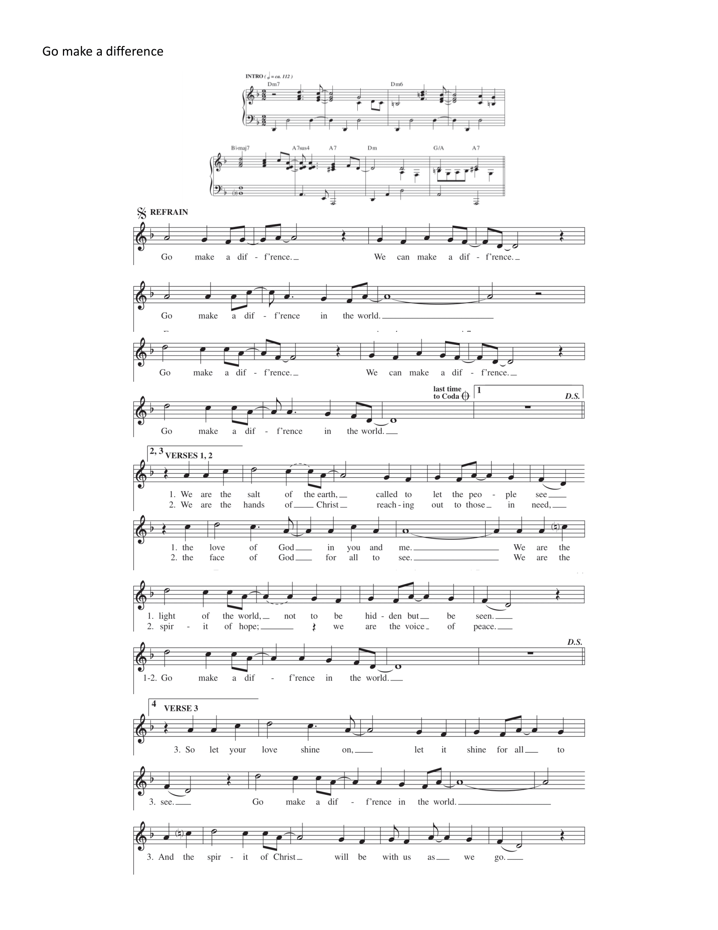

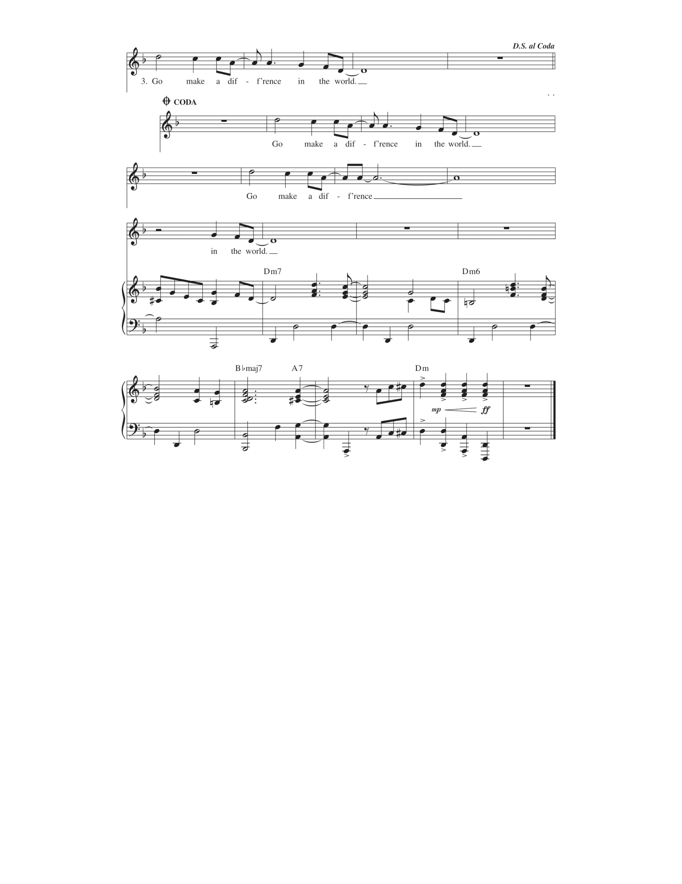

**The Dismissal** Go in peace to love and serve the Lord.

**People: Thanks be to God**

**Voluntary  *Hymns of Joy by J. William Greene from SJMP***