=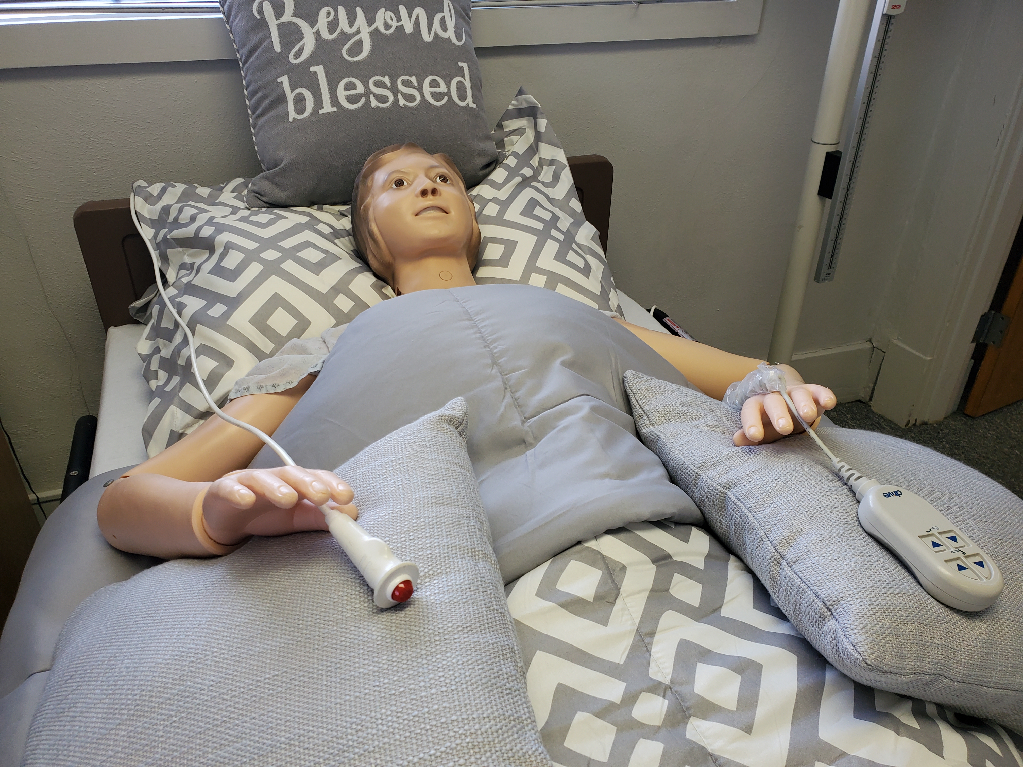  Faith Nurse Aide Training Program  State Approved  Ohio Department of Health Nurse Aide Training Certification Program https://odh.ohio.gov/know-our-programs/nurse-aide-training-and-competency-evaluation-program-natcep/resources  Nurse Aide State Test  The D&S Diversified Technologies LLP State Examination Nurse Aide exam and skills test fee is $104, i.e., log into to https://www.hdmaster.com/testing/ cnatesting/ohio/OH_STNA_Home.htm  You may qualify for VA benefits eligibility reimbursement for approved licensing and certification test. | Vision  Our vision is to embrace the pursuit of excellence both inside and outside the classroom.  Mission  Encourage critical thinking and emphasize the learning process using creativity.  Prepare caring and committed individuals to receive a Certified Nursing Assistant (CNA) certificate and,  Prepare each candidate for the D&S Diversified Technologies LLP State Exam Nursing Assistant (STNA) test.  Fee  The Nurse Aide Course fee is $680.00 per student and includes  Personal protection equipment (PPE),  Nurse Aide textbook/workbook/practice quizzes, and  One scrub set. Course fees are non-refundable.  YOU WILL NEED A BACKGROUND CHECK (BCI), 2-STEP TB, SOCIAL SECURITY AND I.D. | Nurse Aide Workshops  Workshop Written Exam - Faith NATP offers an 8-hour nurse aide written exam prep workshop which includes 200-question exam review. The fee is $200.00 per student. An additional fee is $28.00 for the cost of the Nurse Aide textbook.  Workshop Skills Practice - Faith NATP offers an 8-hour nurse aide skills prep workshop fee at $200.00 per student which includes review of 16 skills and personal protection equipment (PPE). The student will need to download the D&S Nurse Aide Mock Skills Handbook located at https://www.hdmaster.com/testing/cnatesting/ohio/OH_STNA_Home.htm.  2-Week State Approved, 80 Hours  Classes Are Forming Now  Class Schedule is Monday - Friday  8 am – 4:30 pm  Evening and Weekend Class May Be Available
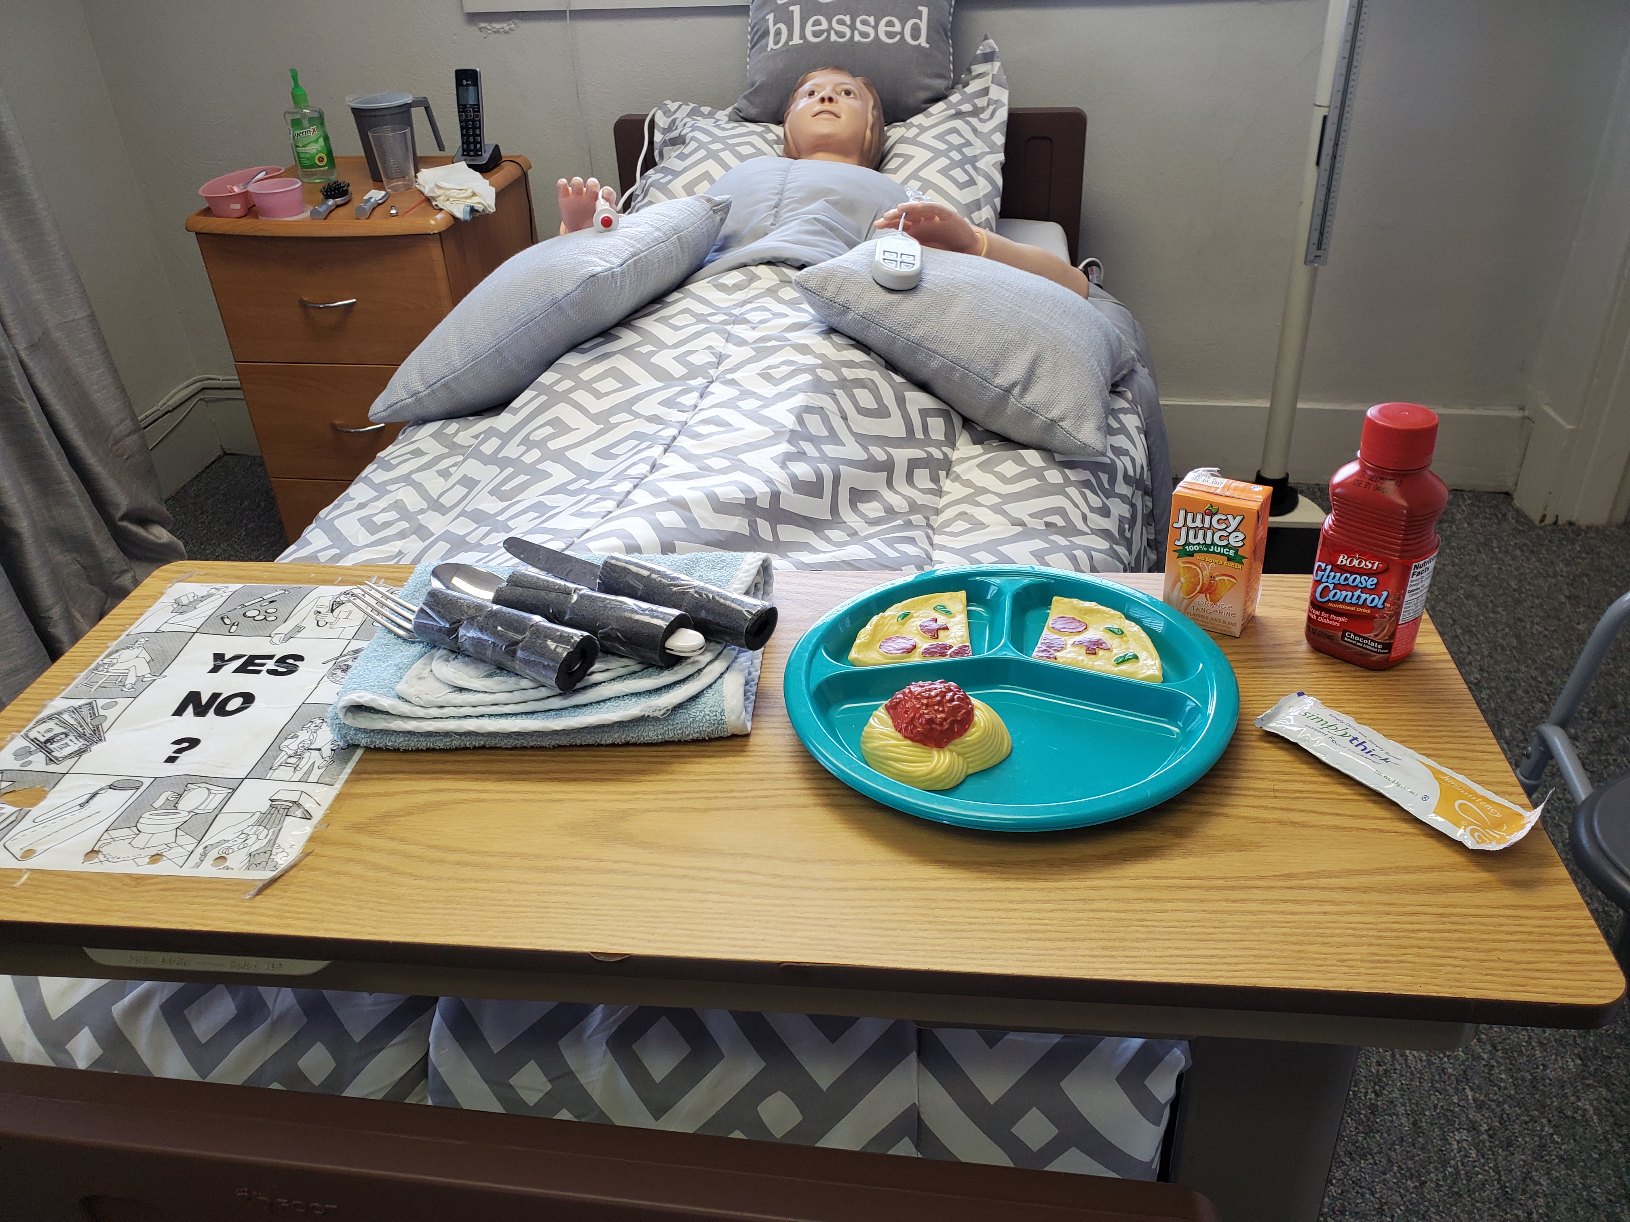  - Classroom Setting!  - Hands-on Lab!  - Translation Available for English-as-second Language Students!  (I.e. French, Spanish)   | Faith Nurse Aide Training Program  Is Unique by having professional, caring, and helpful program instructors  Contact Us  Vivian Jackson MSNed, RN  Program Coordinator  Faith Nurse Aide Training Program  115 Linwood St, Suite 22  Dayton, OH 45405  Phone: 937-854-1953  Email Address  faithnurseaidetrainingprogram@gmail.com  Website  https://faithnurseaidetrainingprogram.website​ | Faith Nurse Aide Training Program  115 Linwood St, Suite 22  Dayton, OH 45405  Phone: 937-854-1953

