Tom’s Landscaping Guide: Treating Gall Wasp Infestation & Proper Pruning Techniques
At Tom’s Landscaping, we understand how frustrating Gall Wasp infestations can be for homeowners and garden enthusiasts. These pests commonly affect citrus trees, causing deformities, reducing fruit yield, and weakening overall plant health. This guide explains how to identify, treat, and manage gall wasp infestations—along with safe and effective pruning practices.

What is Gall Wasp?
Gall wasps are small insects that lay eggs in the soft new growth of citrus trees. As the larvae develop, they cause swelling (galls) in the stems. These galls disrupt nutrient flow, weaken branches, and can significantly reduce fruit production if left untreated.
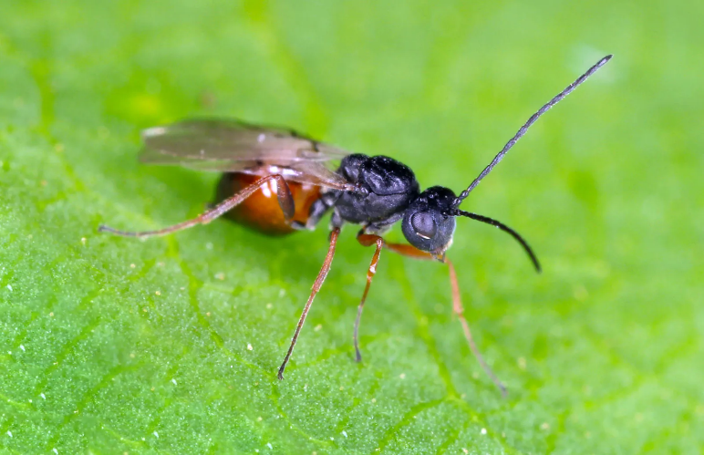

Identifying an Infestation
Look for the following signs:
- Swollen, lumpy growths on stems and branches
- Distorted or stunted new growth
- Reduced flowering or fruiting
- Cracked bark on older galls (a sign that wasps have already emerged)
Early detection is key to controlling the spread.
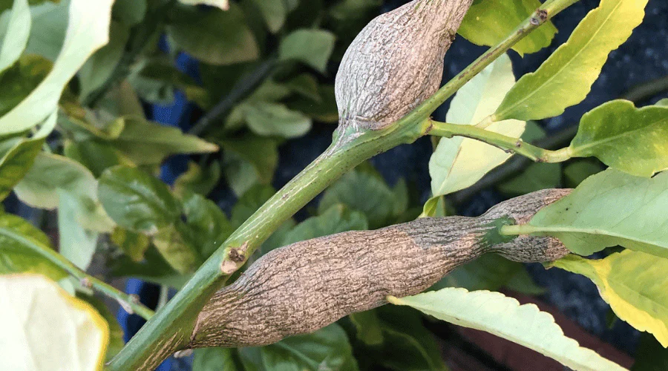

When to Act
Timing is critical when managing gall wasp:
- Best pruning period: Late winter to early spring (before adult wasps emerge)
- Avoid pruning during peak emergence: Typically Spring to early summer
Pruning too late can worsen the infestation by spreading the pests.

How to Treat Gall Wasp Infestation

1. Pruning Infected Branches
This is the most effective control method.
Step-by-step pruning guide:
- Inspect the tree carefully and identify all galls
- Trace the affected branch back to healthy wood
- Cut at least 10–15 cm below the gall to ensure all larvae are removed
- Use clean, sharp pruning tools to make precise cuts
- Sterilise tools between cuts using methylated spirits or disinfectant to prevent spread
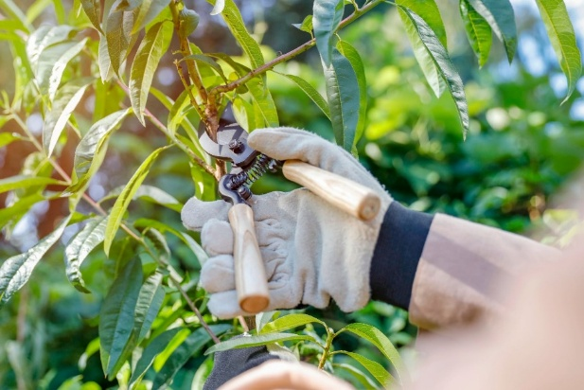

2. Disposal of Infected Material
Proper disposal is essential:
- Do NOT compost infected branches
- Seal cuttings in a plastic bag and dispose of them in general waste
- Alternatively, solarise the material by leaving it in a sealed bag in the sun for several weeks

3. Preventative Care
- Maintain tree health with proper watering and fertilization
- Avoid excessive nitrogen fertilizers, which promote soft growth attractive to wasps
- Monitor trees regularly during growing seasons

4. Protective Options
- Apply eco-friendly barrier treatments (like kaolin clay) during egg-laying periods
- Consider netting young trees to reduce exposure

Important Pruning Tips from Tom’s Landscaping
- Focus on shaping the tree to improve airflow and sunlight penetration
- Always prune during dry weather to reduce disease risk
- Wear protective gloves and eye protection

When to Call the Professionals
If your tree is heavily infested or difficult to manage safely, Tom’s Landscaping offers professional pruning and pest management services. Our team ensures effective treatment while maintaining the long-term health and structure of your citrus trees.

Final Thoughts
Gall wasp infestations can be controlled with timely action and proper care. Regular inspection, correct pruning techniques, and responsible disposal are the most reliable ways to protect your citrus trees.
If you need expert assistance, Tom’s Landscaping is here to help keep your garden thriving year-round.

