TEXAS COMPLIANCE SOLUTIONS
Stage Explanation

Residential
- Stage 1 Inspection (Pre-const.: Rough Plumbing)
- Set back verification OR form board survey
- Address board with permit posted
- T-Pole
- Trash receptacle installed. Either haul in dumpster OR plywood-built dumpster
- Construction driveway consistent of gravel and a culvert if needed to keep contractor vehicles off the road and to provide safe access onto the property
- Port-A-Potty on site. 1 per house being remodeled/built unless 2 houses are consecutively next to each other by same builder
- Erosion control as required.
- Plumbing rough. This is to include a head test on the sewer and a pressure test on the water line. Water can be tested on the city pressure or by air. If by air the pressure gauge needs to stay on the water line till time of the inspection.

- Stage 2 Inspection (Pre-Pour)
- Foundation pre-pour. This includes Piers as well as Foundation
- If brace wall plan calls for Simpson Straps (i.e. STHD, LSTHD) to be embedded into the concrete, then this needs to be done at this stage
- UFER needs to be installed per the 2017 NEC section 250.52(A)(3)

- Stage 3 Inspection (Trade Roughs)
- Electrical rough
- Plumbing top out
- Framing
- Brace wall plan. If brace wall plan calls for Simpson Tension Ties (i.e. HTT4 or HTT5) to be embedded into the concrete, then this needs to be done at this stage
- HVAC
- Partial energy code. We will check window and doors to see if they comply with your ResCheck. U-Factor as well as SHGC. Mastic in HVAC registers.

- Stage 4 Inspection (Energy Code/Pre-Cover)
- ResCheck compliance. We will recheck windows and doors as well as R-value on all insulation.

- Stage 5 Inspection (Final)
- Final/CO. This is where everything must be done and able to occupy right away. Smoke detectors in each bedroom, all windows must raise and lower with ease, automatic garage door must have anti-crush, address must be posted on house or at mailbox, yard must be graded to drain, if yard is not sodded then there needs to grass present or erosion control established. Stage 5 means if a green tag is issued the inspector can walk out and someone can move in.

- Simple Inspection (Electric Pole, Gas Meter etc.)
- T-Pole if not part of Stage 1. Panel should have a weatherproof cover as well as GFCI plugs. Also, must be braced against the swag.
- Gas Meter. Lines must be aired up and gauge should be left on till time of inspection
- Flatwork. All flatwork will be inspected whether new or re-model.
- Simple Inspections can include anything that is not a Stage inspection.
- Gas Meter. Lines must be aired up and gauge should be left on till time of inspection
- Flatwork. All flatwork will be inspected whether new or re-model.
- Simple Inspections can include anything that is not a Stage inspection.

STHD-LSTHD

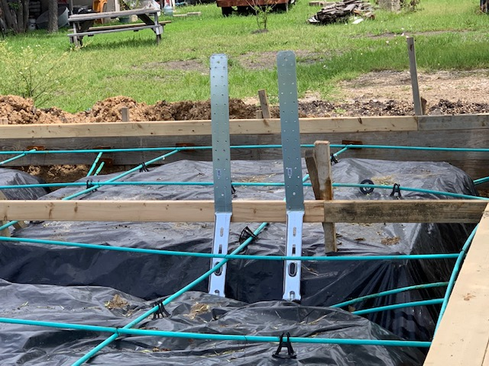
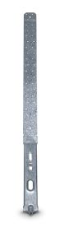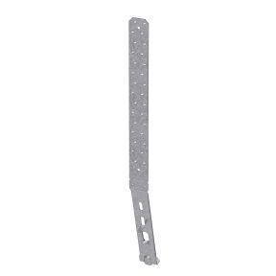

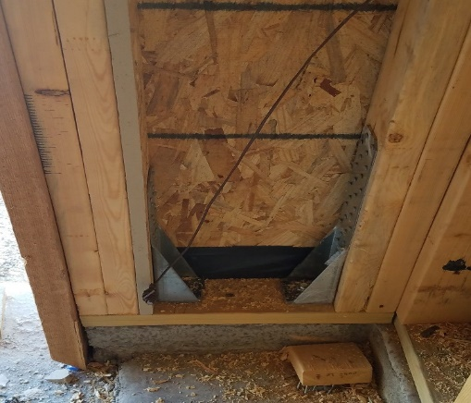
HTT4 & HTT5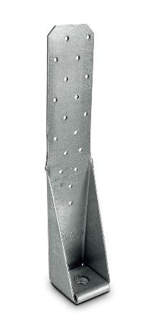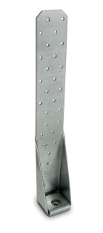

MSTC
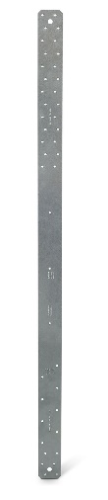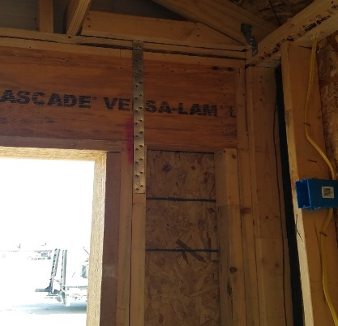

Sign Board
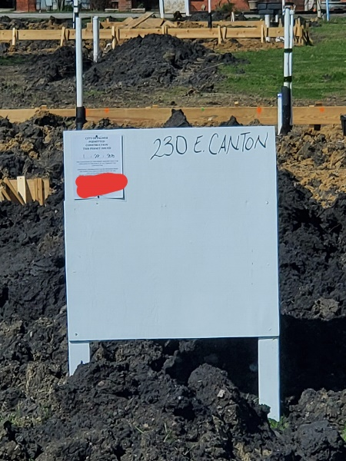
T-Pole
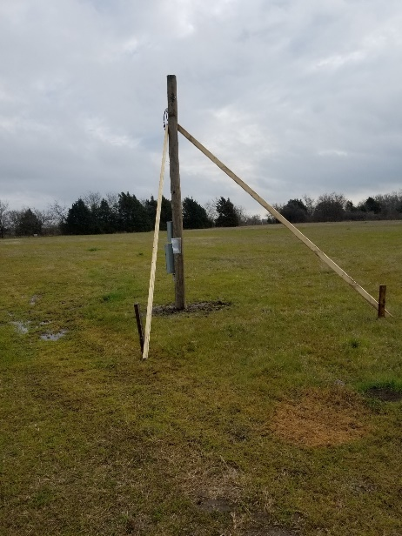

UFER
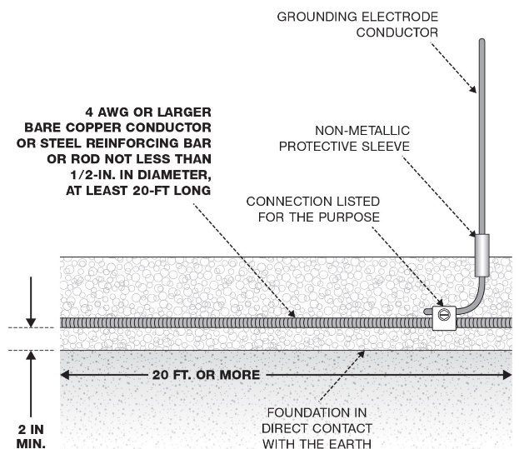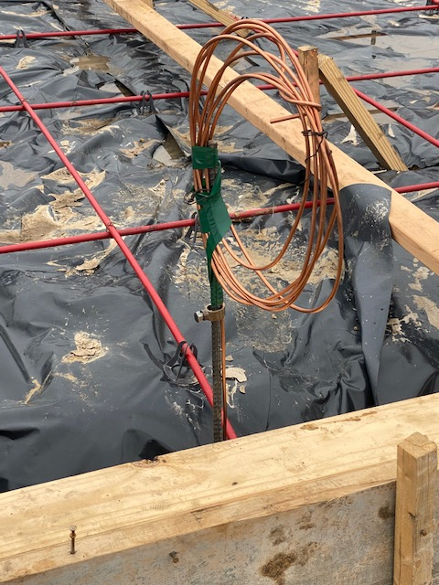

ResCheck

