**South Australian Waterfowl Club   
Please state on Entry Form which club your exhibitor fee has been paid towards.**

|  |  |  |  |
| --- | --- | --- | --- |
| Class No | Pen No | Breed Description | Entry Fee |
|  |  |  |  |
|  |  |  |  |
|  |  |  |  |
|  |  |  |  |
|  |  |  |  |
|  |  |  |  |
|  |  |  |  |
|  |  |  |  |
|  |  |  |  |
|  |  |  |  |
|  |  |  |  |
|  |  |  |  |
|  |  |  |  |
|  |  |  |  |
|  |  |  |  |
|  |  |  |  |
|  |  |  |  |
|  |  |  |  |
|  |  |  |  |
|  |  |  |  |
|  |  |  |  |
|  |  |  |  |
|  |  |  |  |
|  |  |  |  |
|  |  |  |  |
|  |  |  |  |
|  |  |  |  |
|  |  |  |  |
|  |  |  |  |
|  |  |  |  |
|  |  |  |  |
|  |  |  |  |
|  |  | SAPA Exhibitor Fee (must be paid to either SAWC or GDPFA) | $ |
|  |  | Entry Fee’s | $ |
|  |  | Membership | $ |
|  |  | Donation | $ |
|  |  | Total Amount Due | $ |

Membership: Adults $15, Family $20 (2 Adults & 3 Children under 16yrs old on the day of the show), Juniors $5  
Entry Fee: Members $2, Juniors $1, Non-Members $3, Junior Non-Member $2

**EFT Payments with Entries: - Name as Reference  
Account Name: South Australian Waterfowl Club Inc.  
Bsb: 105-014 Acc No: 08 355 2440**

Name: Phone Number:

Email:

**RULES & REGULATIONS**

1) – All diseased or infested birds will be removed from the Pavilion.

2) – All Junior exhibitors are required to pen their own birds.

3) – Junior exhibitors must be 16 years & under on the day of the show.

4) – All birds must be penned by 9:55am on the day of the show.

5) – The convenor reserves the right to reduce entries if there are insufficient pens.

6) – The Judges decision is final.

7) – All Judging will be done in accordance with the Australian Poultry Standard.

8) – No birds are to be removed from the shed until after both clubs have finished their presentations.

***A Big Thankyou to our following Sponsors:***



***Glen Bubner***

***Doug Costello***

***Fix Family***

***Quinton Family***

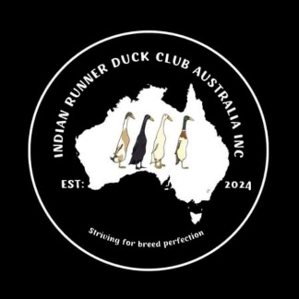***Stringer Family***

***Hall Family***

***Jenny Colley***

***S. & L. Greenslade***

