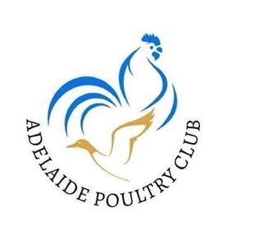
SATURDAY 27th JUNE 2026
SAPA HEADQUARTERS
6 ACRYLON ROAD, SALISBURY

Entries close MONDAY 15th June with the Show Convenor -
Show Convener: Judy Kearney
Email : sbred@bigpond.com
Phone: 0410548843
No Late entries will be accepted
Entry fees
$2.00 per bird
Juniors $1.00 per bird

Membership: Family $25 Single $15 Junior $5
Must be a member to exhibit

PENNING TIMES: 4pm. to 7pm. Friday 27th June
7am. to 9am. Saturday 28th June

BREAKFAST, MORNING TEA & LUNCH CATERED BY ALLGAME CLUB

Judge: Nick Fenaughty

Champion Bird of Show $100 plus SAPA rosette

Reserve Champion Bird of Show $50

Champion Junior Reserve Champion Junior

Champion & Reserve Champion ribbons & Prizes
Best of Breed awards, Rare breed awards.

APC Awards of Show:
Rhode Island Red
Sussex
Mediterranean

SAPA Most Successful exhibitor award rosette supplied by SAPA

RULES & REGULATIONS
- – All diseased or infested birds will be removed from the Pavilion.

- – All Junior exhibitors are required to pen their own birds.

- – Junior exhibitors must be 16 years & under on as of the 31st October 2026

- – All birds must be penned by 9am on the day of the show.

- – The convenor reserves the right to reduce entries if there are insufficient pens.

- – The Judges decision is final.

- – All Judging will be done in accordance with the Australian Poultry Standard.

- All breeds/varieties eligible for the Rare Breed prizes are marked with a *

- No birds are to be removed from the shed until after all 3 clubs have finished their presentations.

A BIG THANK YOU TO ALL SPONSORS

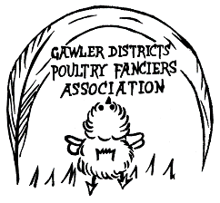
J & K Kearney Noble Family Dennis Hart
Charles Staker Jenny Colley Acre-Liva
Rex & Leah Liebelt Kinster Poultry

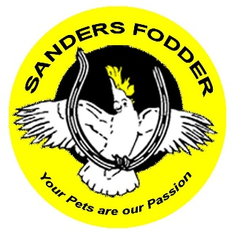
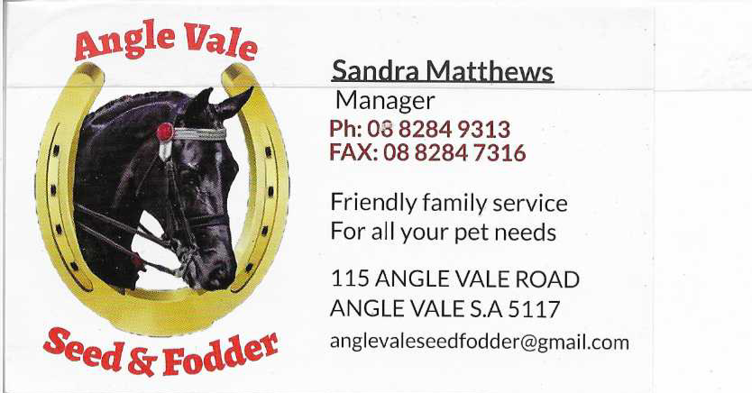

Left blank for you to add your name here if you would like to donate…….
South Australian Poultry Association – SAPA Rosette

CLASSES

STANDARD HEAVY BREEDS

 | Cock | Hen | Cockerel | Pullet
AUSTRALORP BLACK | 1 | 2 | 3 | 4
AUSTRALORP AOC | 5 | 6 | 7 | 8
AUST LANGSHAN BLACK | 9 | 10 | 11 | 12
AUST LANGSHAN BLUE | 13 | 14 | 15 | 16
*AUST LANGSHAN WHITE | 17 | 18 | 19 | 20
*BARNAVELDER Any Colour | 21 | 22 | 23 | 24
*BRAHMA Any Colour | 25 | 26 | 27 | 28
*COCHIN AC | 29 | 30 | 31 | 32
*DORKING AC | 33 | 34 | 35 | 36
*FAVEROLLE AC | 37 | 38 | 39 | 40
*FRIZZLE | 41 | 42 | 43 | 44
*NEW HAMPSHIRE | 45 | 46 | 47 | 48
ORPINGTON Black | 49 | 50 | 51 | 52
ORPINGTON Buff | 53 | 54 | 55 | 56
ORPINGTON AOC | 57 | 58 | 59 | 60
PLYMOUTH ROCK Dark Barred | 61 | 62 | 63 | 64
*PLYMOUTH ROCK AOC | 65 | 66 | 67 | 68
RHODE ISLAND Red | 69 | 70 | 71 | 72
*RHODE ISLAND White | 73 | 74 | 75 | 76
SUSSEX Light | 77 | 78 | 79 | 80
*SUSSEX AOC | 81 | 82 | 83 | 84

STANDARD LIGHT BREEDS

 | Cock | Hen | Cockerel | Pullet
ANCONA | 97 | 98 | 99 | 100
*ANDALUSIAN | 101 | 102 | 103 | 104
*ARACUANA AC | 105 | 106 | 107 | 108
*CAMPINE AC | 109 | 110 | 111 | 112
HAMBURG Black | 113 | 114 | 115 | 116
HAMBURG Silver Spangled | 117 | 118 | 119 | 120
*HAMBURG AOC | 121 | 122 | 123 | 124
LEGHORN Black | 125 | 126 | 127 | 128
LEGHORN Brown | 129 | 130 | 131 | 132
LEGHORN White | 133 | 134 | 135 | 136
*LEGHORN AOC | 137 | 138 | 139 | 140
*MINORCA Any Colour | 141 | 142 | 143 | 144
POLISH Any Colour | 145 | 146 | 147 | 148
SILKIE Black | 149 | 150 | 151 | 152
SILKIE White | 153 | 154 | 155 | 156
SILKIE AOC | 157 | 158 | 159 | 160
*SPANISH Any Colour | 161 | 162 | 163 | 164
*WELSUMMER | 165 | 166 | 167 | 168
*VORWERK | 169 | 170 | 171 | 172
AOV | 173 | 174 | 175 | 176

BANTAM HEAVY BREEDS
 | Cock | Hen | Cockerel | Pullet
AUSTRALORP Black | 255 | 256 | 257 | 258
*AUSTRALORP AOC | 259 | 260 | 261 | 262
AUST LANGSHAN BLACK | 263 | 264 | 265 | 266
AUST LANGSHAN BLUE | 267 | 268 | 269 | 270
*AUST LANGSHAN WHITE | 271 | 272 | 273 | 274
*BARNAVELDER AC | 275 | 276 | 277 | 278
*FRIZZLE White | 279 | 280 | 281 | 282
*FRIZZLE Buff or Red | 283 | 284 | 285 | 286
*FRIZZLE AOC | 287 | 288 | 289 | 290
*ORPINGTON AC | 291 | 292 | 293 | 294
PLYMOUTH ROCK Dark Barred | 295 | 296 | 297 | 298
PLYMOUTH ROCK AOC | 299 | 300 | 301 | 302
RHODE ISLAND Red | 303 | 304 | 305 | 306
*RHODE ISLAND White | 307 | 308 | 309 | 310
SUSSEX Light | 311 | 312 | 313 | 314
SUSSEX AOC | 315 | 316 | 317 | 318

BANTAM LIGHT BREEDS
 | Cock | Hen | Cockerel | Pullet
ANCONA | 335 | 336 | 337 | 338
ANDALUSIAN | 339 | 340 | 341 | 342
*ARACAUNA AC | 343 | 344 | 345 | 346
*HAMBURG AC | 347 | 348 | 349 | 350
LEGHORN Black | 351 | 352 | 353 | 354
LEGHORN Blue | 355 | 356 | 357 | 358
LEGHORN White | 359 | 360 | 361 | 362
*LEGHORN AOC | 363 | 364 | 365 | 366
*MINORCA AC | 367 | 368 | 369 | 370
*POLISH White Crested Black/Blue | 371 | 372 | 373 | 374
*POLISH AOC | 375 | 376 | 377 | 378
*SPANISH AC | 379 | 380 | 381 | 382
AOV | 383 | 384 | 385 | 386

TRUE BANTAMS
BELGIAN BANTAMS | Cock | Hen | Cockerel | Pullet
Barbu d' Anvers AC | 387 | 388 | 389 | 390
Barbu d' Uccle Millefleur | 391 | 392 | 393 | 394
Barbu d' Uccle Black/Blue | 395 | 396 | 397 | 398
Barbu d' Uccle Mottled | 399 | 400 | 401 | 402
Barbu d' Uccle AOC | 403 | 404 | 405 | 406
*Barbu d’ Watermael | 407 | 408 | 409 | 410
JAPANESE Black Tail White | 411 | 412 | 413 | 414
JAPANESE White | 415 | 416 | 417 | 418
JAPANESE Birchen/Grey | 419 | 420 | 421 | 422
*JAPANESE AOC | 423 | 424 | 425 | 426
PEKIN Black | 427 | 428 | 429 | 430
PEKIN Cuckoo | 431 | 432 | 433 | 434
PEKIN White | 435 | 436 | 437 | 438
PEKIN AOC | 439 | 440 | 441 | 442
ROSECOMB Black | 443 | 444 | 445 | 446
ROSECOMB AOC | 447 | 448 | 449 | 450
*SEBRIGHT Gold | 451 | 452 | 453 | 454
*SEBRIGHT Silver | 455 | 456 | 457 | 458
*DUTCH Red or Yellow | 459 | 460 | 461 | 462

WATERFOWL

 | Drake | Duck | Y Drake | Y Duck
*AYLESBURY | 565 | 566 | 567 | 568
AUSTRALIAN CALL White | 569 | 570 | 571 | 572
AUSTRALIAN CALL AOC | 573 | 574 | 575 | 576
CAMPBELL AC | 577 | 578 | 579 | 580
*CAYUGA | 581 | 582 | 583 | 584
*CRESTED | 585 | 586 | 587 | 588
*ELIZABETH | 589 | 590 | 591 | 592
INDIAN RUNNER White | 593 | 594 | 595 | 596
INDIAN RUNNER AOC | 597 | 598 | 599 | 600
MALLARD Normal | 601 | 602 | 603 | 604
MALLARD White | 605 | 606 | 607 | 608
MALLARD AOC | 609 | 610 | 611 | 612
MUSCOVY White | 613 | 614 | 615 | 616
MUSCOVY Black & White | 617 | 618 | 619 | 620
MUSCOVY AOC | 621 | 622 | 623 | 624
*ORPINGTON | 624 | 626 | 627 | 628
PEKIN | 629 | 630 | 631 | 632
ROUEN | 633 | 634 | 635 | 636
*SILVER APPLEYARD | 637 | 638 | 639 | 640
*SILVER APPLEYARD Bantam | 641 | 642 | 643 | 644
*SAXONY | 645 | 646 | 647 | 648
*SAXONY Bantam | 649 | 650 | 651 | 652
*AOV | 653 | 654 | 655 | 656

GEESE
 | Gander | Goose
TOULOUSE | 657 | 658
CHINESE | 659 | 660
EMBDEN | 661 | 662
AOV | 663 | 664
FIELD & GAME
 | Male | Female
TURKEY Any Variety | 665 | 666
GUINEA FOWL Any Colour | 667 | 668
Jungle Fowl | 669 | 670

JUNIOR SECTION
PRIZE SCHEDULE
- Champion Junior Fowl - Reserve Junior Fowl
- Champion Junior Waterfowl - Reserve Junior Waterfowl
Champion Junior Exhibit
Reserve Champion Junior Exhibit

APC Annual SHOW 2026

ENTRY FORM

Entries to be emailed to Judy Kearney sbred@bigpond.com

Phone 0410548843

Class | Description | Pen. | Fee
 |  | Entries
 |  | Donation
 |  | Membership
 |  | Real Property | $5
 |  | Total

Adelaide Poultry Association BSB 105108 Account 394061740

Name: .
Address: .
Phone: .
Email: .
I the undersigned declare that I will adhere to the rules and regulations of the show, and all my exhibits will be disease and parasite free on the day of the event. I also understand that the association is not responsible for any loss or damage to my birds.
Sign: .

