2020-2021  Review of Past Tuition  - Do you currently have a tuition schedule that is labeled 2020-2021?  - If so, this schedule was for the school year of 2020-2021  - Effective August 16th, 2021we will proceed to a new school year 2021-2022 tuition see below.  2021-2022  Current Tuition  - Welcome & Thank You to all our new and current families.  - We have had a minimal rate increase for the upcoming school year. We have had an exciting summer with several playground updates, new playground equipment, a new trike path and much more for you and your family to enjoy!  - If your bank gives the option to send bill pay and you are interested in setting up an account, please follow these steps:  - Mail to Hugs-n-Hearts ELC 8989 Antares Avenue, Columbus OH 43240.  - If an account number is requested, please use your last name & allow 7 to 9 lead days for processing.  - Please adjust your bill pay to reflect the current rates as needed.  - Tuition is due on the first day of the week your child attends.  - Payments received after your child’s first day of attendance (weekly) will be assessed a $30.00 late fee. Late fee will accrue weekly until account is current.  - Cancellation of enrollment requires a two week notice in writing.  To request a tuition statement please email Mr. Tim at hnhbusinessdept@gmail.com  Or call 614-540-2276.  Thank you! | Hi there.  Here’s everything you need to know about your tuition. | Additional Notes:  - Public Kindergarten and School-age part-time additional fees:  - Breaks/days off/ (enrolled children) + $30.00 a day  - Un-enrolled children (providing space) + $70.00 a day  - Am only adding a PM return from school + $25.00  - PM only adding AM = $15.00 Day  - Summer tuition for School-age and kindergarten will follow the tuition schedule posted prior to the start of summer.  Sibling Discount  Families enrolled full-time 4-5 days schedule and have 2 or more children enrolled in a Toddler, Preschool and or Kindergarten may apply a $10.00 weekly discount.  Part-time enrollment (2-3 Day) does not apply
 | Late pick up fee  Hugs-n-Hearts late pick-ups are monitored and will be submitted for review. If needed, a late fee may apply. We appreciate, if you feel you are delayed in picking up on time, please call. |  | 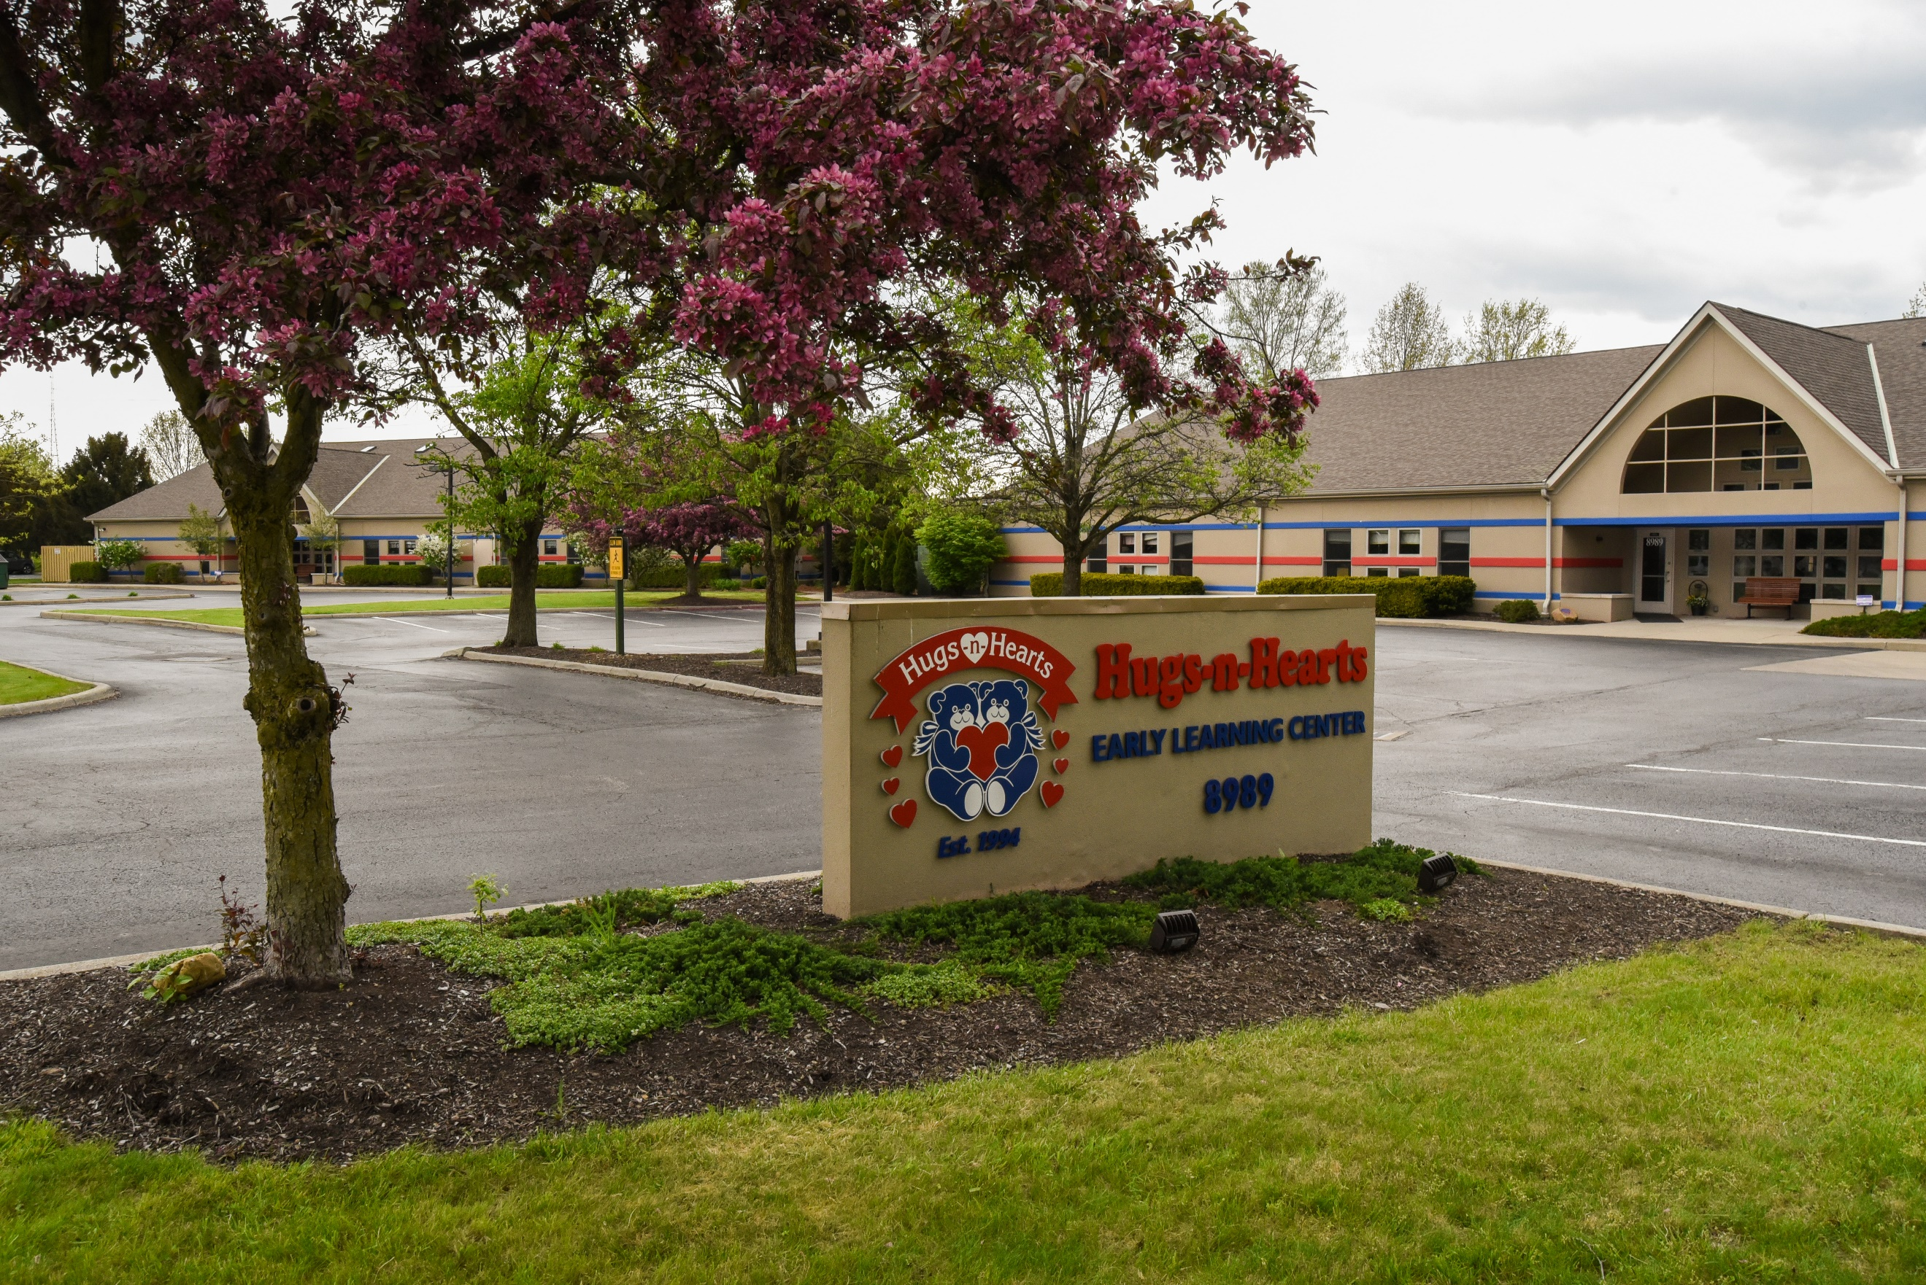

We are looking forward to a great 2021-2022 school year!

We are looking forward to a great school year!

