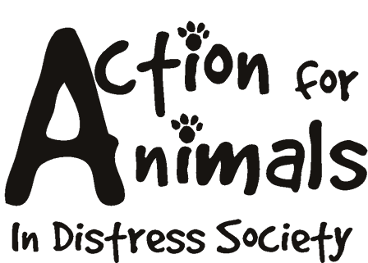



Name: __________________________________________________Date___________________
Address: ________________________________________________________________________
City: _________________________________ Postal Code: _______________________________
Phone (day): _____________________________ Phone (evening): _____________________________
Fax: ____________________________________ Email: ____________________________________
Best time to be reached: _____________ Best method: _____________________
Age: ______________

Do you… Rent ______ Own ______
Do you plan to de claw the cat __________________ Have you ever had a cat de clawed?
Explain: _________________________________________________________________________
Are you planning on moving in the next year? If yes, what will you do with your cat? ________________ _____________________________________________________________________________________
Where will this cat be kept (day/night)? _________________________________________________
How many hours a day will the cat be without human companionship? ___________
If you were out of town who would care for this cat? ________________________
Do you have children? __________ If yes, ages: ___________________________
Would this be your children’s first experience with a cat? _____________________
Does anyone in your household suffer from allergies? ________________________
Do you have other animals? ____
If yes, please list: ______________________________________________________________________
Have you ever surrendered an animal to a shelter? If so, please explain the circumstances:_____________
_____________________________________________________________________________________
Have you ever had an animal euthanized? If so, please explain: __________________________________ _____________________________________________________________________________________
_____________________________________________________________________________________
Why do you want to adopt a cat? __________________________________________________________ __________________________________________________________________________________________________________________________________________________________________________
Do you understand that this cat needs an annual vet visit? ______________________
Who will be responsible for the care and cost of this cat? _____________________
Will you allow the cat to go outside? Why or why not: ______________________________________
_____________________________________________________________________________________
Are you over eighteen years of age? ______
If not, a parent/guardian will have to fill out an application and agree to be the primary caregiver of any cat you may adopt.
By signing below you agree that all information on this application is true and complete and that you fully understand all the questions. You further understand that any falsified information will terminate the adoption process. You authorize the release of any records relating to the above information. Action For Animals In Distress Society reserves the right to refuse any application they deem unsatisfactory. The completion of this form does not guarantee that you will be able to adopt a cat.

Signature: _____________________________ Date: ____/____/____

Please note that you will be contacted within 7 days to discuss your application.

All of our animals are spayed or neutered prior to adoption.

Action For Animals In Distress Society
http://www.actionforanimals.net
Box 652, 4974 Kingsway
Burnaby V5H 4M9
Phone: 604 724-7652

Staff Use:

Date received: _____/_____/______
Declined: ______ Accepted: ______
Reasons/comments:
__________________________________________________________________
__________________________________________________________________
__________________________________________________________________
__________________________________________________________________

