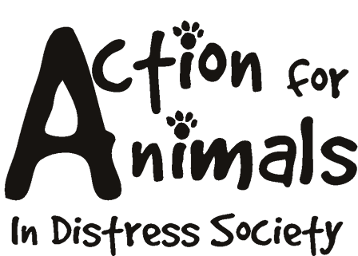



Name: __________________________________________________Date___________________
Address: ________________________________________________________________________
City: _________________________________ Postal Code: _______________________________
Phone (day): _____________________________ Phone (evening): _____________________________
Fax: ____________________________________ Email: ____________________________________
Best time to be reached: _____________ Best method: _____________________
Age: ______________

Do you plan to breed? ______
Explain: _________________________________________________________________________
Do you… Rent ______ Own ______
Are you planning on moving in the next year? If yes, what will you do with your dog?________________
_____________________________________________________________________________________
Where will this dog be kept (day/night)? _________________________________________________
Would the dog be left unattended in your yard? ___________________________
If yes, for what period of time? _______________________________________
How many hours a day will the dog be without human companionship? __________
What exercise will be provided? __________________________________________________________ _____________________________________________________________________________________
If you were out of town who would care for this dog? ________________________
Do you have children? __________ If yes, ages: ___________________________
Would this be your children’s first experience with a dog? _____________________
Does anyone in your household suffer from allergies? ________________________
Do you have other animals? ____________________ If yes, please list:___________________________ __________________________________________________________________________________________________________________________________________________________________________
Have you ever surrendered an animal to a shelter? If so, please explain the circumstances:_____________
_____________________________________________________________________________________
Have you ever had an animal euthanized? If so, please explain: __________________________________ _____________________________________________________________________________________
Why do you want to adopt a dog? _________________________________________________________ _____________________________________________________________________________________
Do you understand that this dog needs an annual vet visit? _____________________
Who will be responsible for the care and cost of this dog? ____________________
Are you over eighteen years of age? ______ If not, a parent/guardian will have to fill out an application and agree to be the primary caregiver of any dog you may adopt.

By signing below you agree that all information on this application is true and complete and that you fully understand all the questions. You further understand that any falsified information will terminate the adoption process. You authorize the release of any records relating to the above information. Action For Animals In Distress Society reserves the right to refuse any application they deem unsatisfactory. The completion of this form does not guarantee that you will be able to adopt a dog.

Signature: _____________________________ Date: ____/____/____

Please note that you will be contacted within 7 days to discuss your application.

All of our animals are spayed or neutered prior to adoption.

Action For Animals In Distress Society
http://www.actionforanimals.net
Box 652, 4974 Kingsway
Burnaby V5H 4M9
Phone: 604 724-7652

Staff Use:

Date received: _____/_____/______
Declined: ______ Accepted: ______
Reasons/comments:
__________________________________________________________________
__________________________________________________________________
__________________________________________________________________
__________________________________________________________________

__________________________________________________________________

