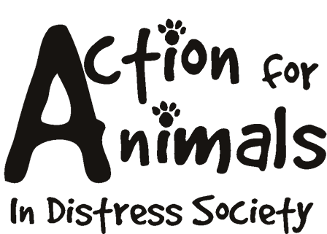


Please use this form if you wish to make a one time donation. Please print this form, fill it out and return it, along with payment to:

Action For Animals In Distress Society
http://www.actionforanimals.net
Box 652, 4974 Kingsway
Burnaby V5H 4M9
Phone: 604 724-7652

If you wish to make a pre-authorized monthly or annual donation, please visit our Sponsoring Page.

First Name: _____________________________________ Last Name: __________________________________________
Address:____________________________________________________________________________________________
City/Town: _____________________________ Prov/State/County: ___________________ Country: _________________
Postal/Zip Code: _______________ Telephone: ____________________ e-mail:______________ ____________________

Enclosed is my donation of:

 CDN $10.00
 CDN $20.00
 CDN $50.00
 CDN $75.00
 CDN $100.00
 CDN Other Amount $ _______

If you prefer to pay by credit card, you can access the PayPal secure server through our website at: http://www.actionforanimals.net/donations.html

Registered Charity #892546300 RR0001
Please do not send cash through the mail.

