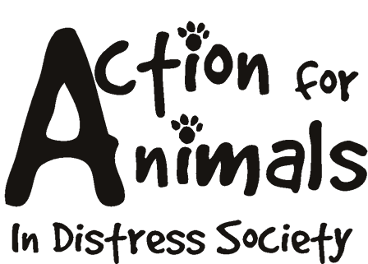


Please complete this form, and return it to:

Action For Animals In Distress Society
http://www.actionforanimals.net
Box 652, 4974 Kingsway
Burnaby V5H 4M9
Phone: 604 724-7652

Name: __________________________________________________________________
Address: ________________________________________________________________
City: _________________________________ Postal Code: _______________________
Phone (day): ____________________ Phone (evening): __________________________
Fax: ________________________ Email: _____________________________________

Do you have a particular animal you would like to sponsor? If so, please tell us.

________________________________________________________________________

Enclosed is my sponsor fee:

 CDN $25.00 monthly contribution
 CDN $_____monthly contribution
 CDN $225.00 annual contribution
 CDN $______annual contribution

If you prefer to pay by credit card, you can access the PayPal secure server through our website at: http://www.actionforanimals.net/donations.html or you can open a subscription using PayPal through our page at: http://www.actionforanimals.net/sponsor.shtml and clicking the Subscription button.

Registered Charity #892546300 RR0001
Please do not send cash through the mail.

