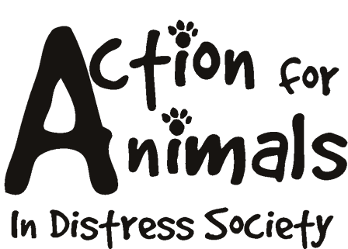


Please complete this form, and return it to:

Action For Animals In Distress Society
http://www.actionforanimals.net
Box 652, 4974 Kingsway
Burnaby V5H 4M9
Phone: 604 724-7652
Name: _____________________________________________________________________________________
Address: ____________________________________________________________________________________
City: __________________________________________ Postal Code: _________________________________
Phone (day): ____________________________________ Phone (evening): ______________________________
Fax: _________________________ Email: _____________________________________
Age: _______________________
Best time to be reached: _________________ Best method: ________________________

Personal Information: Please complete ALL questions

Do you work? _______ Full Time ______ Part Time ______ Do you have pets at present? _______
If so what and how many? _________________________________________________________
Have you worked with animals previously? If so what experience do you have (when and where)? ____________________________________________________________________________________________________
____________________________________________________________________________________________________
What type of animals are you prepared to work with, if and when necessary? ______________________________________
____________________________________________________________________________________________________
What animals, if any, are you not willing to work with? _______________________________________________________
Would you be available to pet sit / dog walk? _______________________________________________________________
Are you available to assist at fundraisers and special events, etc? ________________________________________________
What volunteering have you done previously? _______________________________________________________________
____________________________________________________________________________________________________
Tell us more about yourself: _____________________________________________________________________________
____________________________________________________________________________________________________
Hobbies, Interests? ____________________________________________________________________________________
Skills: ______________________________________________________________________________________________
References: __________________________________________________________________________________________
____________________________________________________________________________________________________
Additional Comments: __________________________________________________________________________________

