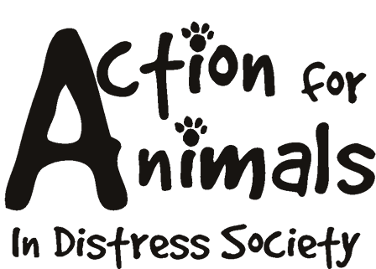



***Please attach any/all medical records to this form

Name: __________________________________________________Date___________________
Address: ________________________________________________________________________
City: _________________________________ Postal Code: _______________________________
Phone (day): _____________________________ Phone (evening): _____________________________
Fax: ____________________________________ Email: ____________________________________
Best time to be reached: _____________ Best method: _____________________

Please answer these questions as honestly as possible as it will help assist us in determining the future needs and eventual placement of this animal.

Dogs’ Name: ________________________________________________________
Age/DOB: ______________________ Approximate Weight: __________________
Sex: ______ Spayed or Neutered? ______ Breed: ___________________________
Colour/Description: ___________________________________________________
Tattoo #: ______________________ Microchip #: __________________________
Current Veterinarian: ______________________ Phone Number: ______________
Date of vaccinations;
Rabies: ______________________ Distemper: ____________________
Other: ____________________________
Does this dog have any medical problems or injuries? If so, please explain: ________________________ _______________________________________________________________________________________________________________________________________________________________________________________________________________________________________________________________
Is this dog taking any medications? ______________________________________
Are you this dogs’ first owner? If not, explain: _____________________________ __________________________________________________________________________________________________________________________________________________________________________
Does this cat get along with…
Other dogs ______ Cats ______ Small Children ______ Other? ______
How would you describe the dogs’ personality? ______________________________________________ _______________________________________________________________________________________________________________________________________________________________________________________________________________________________________________________________
Please explain, in detail, why you want to surrender this dog to Action For Animals In Distress Society: _________________________________________________________________________________________________________________________________________________________________________________________________________________________________________________________________________________________________________________________________________________________________________________________________________________________________________
Dogs’ current diet: ___________________________________________________ _____________________________________________________________________________________
Any other information: ____________________________________________________________________________________________________________________________________________________________________________________________________________________________________________________________________________________________________________________________________________________

By signing below you agree that all information on this application is true and complete and that you fully understand all the questions.You further understand that any falsified information will terminate the adoption process. You authorize the release of any records relating to the above information. Action For Animals In Distress Society reserves the right to refuse any application they deem unsatisfactory. The completion of this form does not guarantee that you will be able to adopt a dog.

Signature: _____________________________ Date: ____/____/____

Please note that you will be contacted within 7 days to discuss your application.

Action For Animals In Distress Society
http://www.actionforanimals.net
Box 652, 4974 Kingsway
Burnaby V5H 4M9
Phone: 604 724-7652

Staff Use:

Date received: _____/_____/______
Declined: ______ Accepted: ______
Reasons/comments:
__________________________________________________________________
__________________________________________________________________
__________________________________________________________________
__________________________________________________________________

