[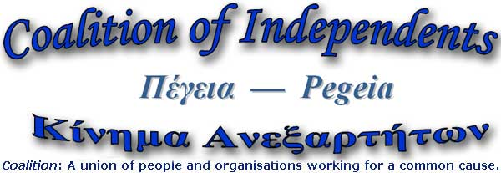](http://www.facebook.com/editevent.php?picture&eid=123473909132&created&new&m=1)

**info@pegeiacoalition.org www.pegeiacoalition.org**

***Voting Rights for Non-Cypriot EU Residents of Cyprus***

***NEXT ELECTIONS: END OF MAY 2024 (for Local Elections and EU Parliament)***

**EU citizens resident in Cyprus are eligible to vote and to stand as candidates in Municipal and European Parliament elections. They must register on two, separate electoral rolls (one for Municipal & one for EU Parliamentary elections).** Voter registration forms for both electoral rolls can be found at District Offices & Citizen Advice Bureaus. They can also be obtained from Pegeia Coalition.

Please share this information with neighbours, friends & contacts in Cyprus.

**How to register to vote in Municipal Elections**

1. Complete the form, “Application for Registration in the Special Electoral List for European Community Electors (Article 8 Municipal and Community Elections (Citizens of other Member States) Law of 2004)” [a photocopy is fine].  
2. Photocopy proof of EU citizenship, including ID with a photograph

(e.g., passport).   
3. Photocopy proof of residence for at least six months in Cyprus *or* in an EU Member State (e.g., Immigration “yellow” slip).   
4. Take above to **Citizen Advice Bureaus** or **District Offices**.

Voting application forms are available at all **District Offices** and **Citizen Advice Bureaus in Cyprus**. **Paphos Citizen’s Advice office** is **No. 62 Eleftheriou Venezelous St**. (same street as Butcher Boy). Citizen’s Advice Bureaus are open from 8am to 5pm, very user-friendly. The **Paphos District Office** (near the Municipal Market in the old town) is open 8am to 1pm; enter by the door closest to the Post Office. The office for elections is on the left, “ΔΙΑΒΑΤΗΡΙΑ/ ΕΚΛΟΓΕΣ” (Passports/ Elections).

Or email Pegeia Coalition: info@pegeiacoalition.org

You will be given a stamped receipt for registering on the electoral lists. Please retain this until you collect your voting book **(for local elections only),** whichwill be sent to you, care of the Koinotarchis/Mukhtar or the Municipal Office in your community.

You will need to pick this up personally. **Don’t expect them to call you! This voting book must be presented when you vote in local elections.**