Climbing is FUN!

Today we’re going to climb on walls at a climbing gym. There are some important rules.

No screaming • No running •No throwing • Follow Directions

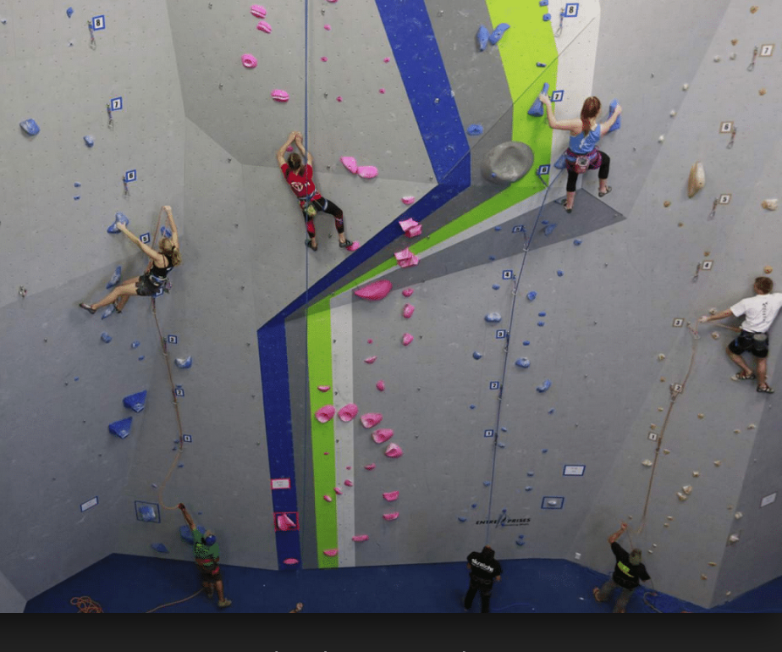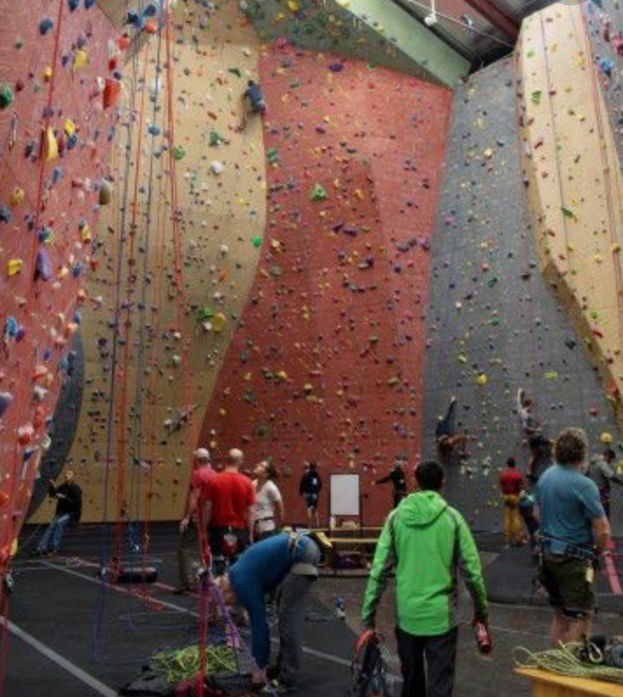

If you don’t want to wear climbing equipment, you can climb a small wall.

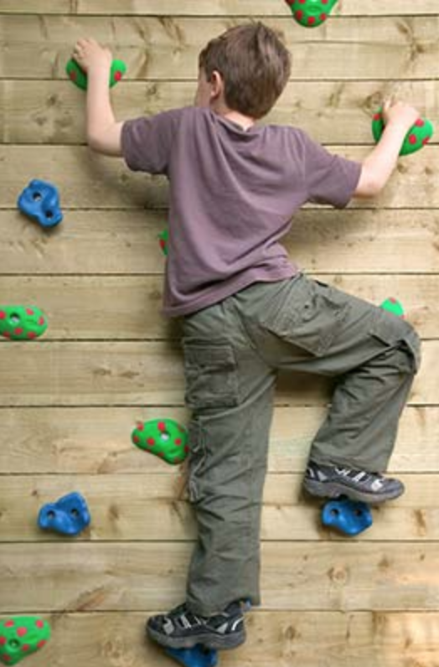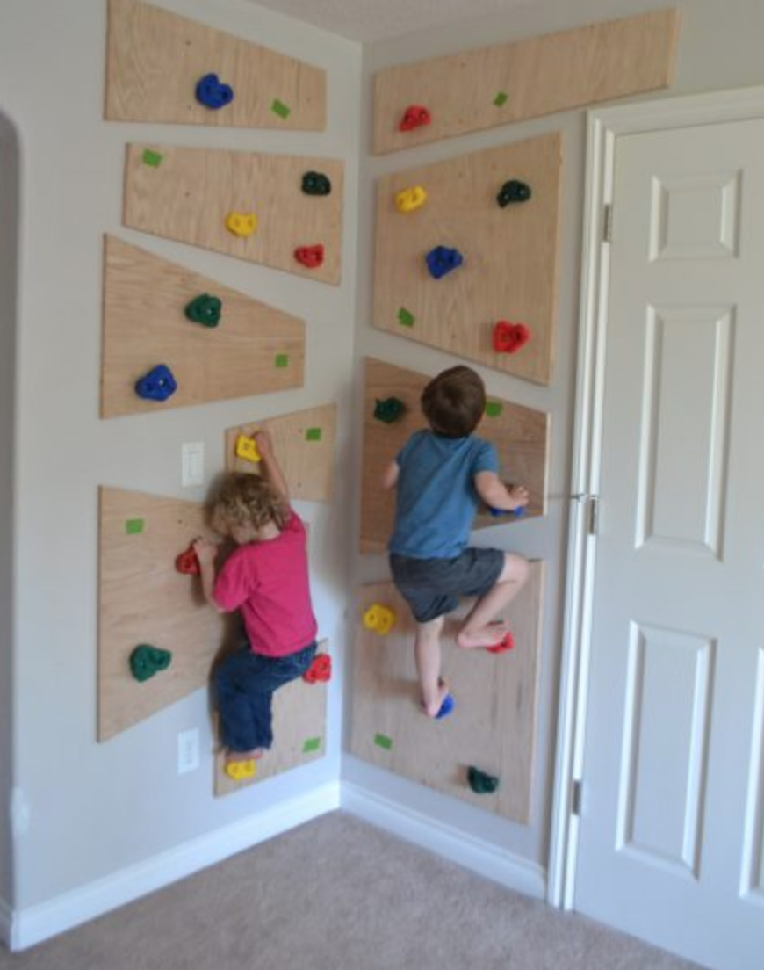

If you want to climb a big wall, you will have to wear a harness and use a rope.
You may need to wear a helmet too.

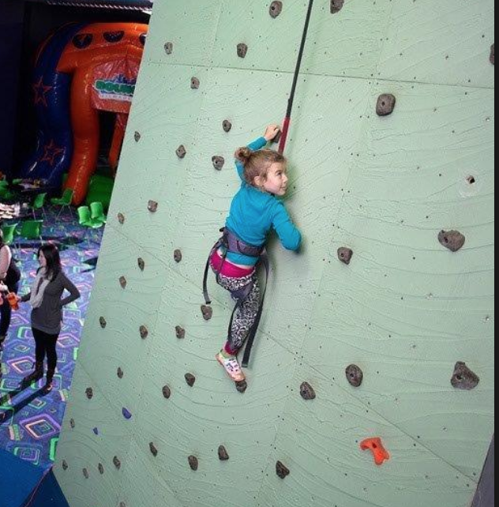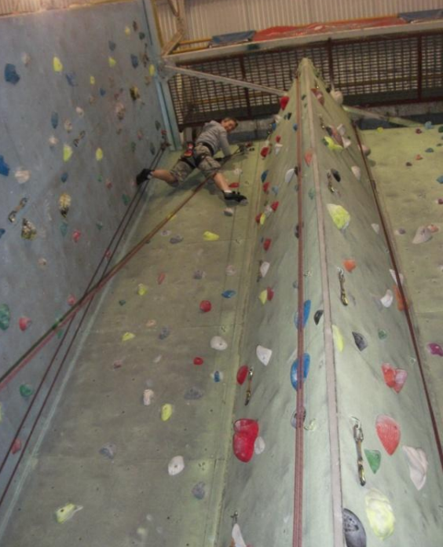

Disclaimer

Do NOT use this handout as a substitute for professional rock climbing instruction or for safety advice.

Rock climbing involves many risks and you should always seek professional assistance when attempting to learn to rock climb or to teach or take children rock climbing.

This handout is copyright of Kids Connect Us™. Do not alter, sell, or otherwise share this handout without written permission from Kids Connect Us™.

This handout was created for use as a social story for young children new to rock climbing, and for individuals with Autism.

Thank You!

Let’s Get Ready to Climb!

There are two kinds of harnesses. One goes over your shoulders. The other is more like a belt. Both have loops for your legs. The rope will keep you safe so you will not fall.

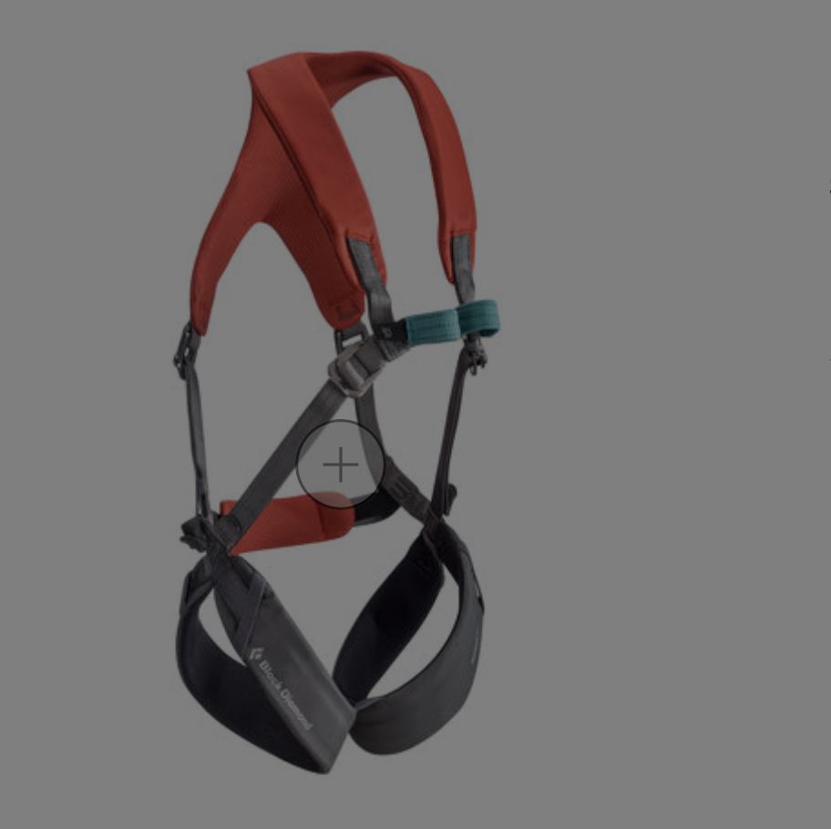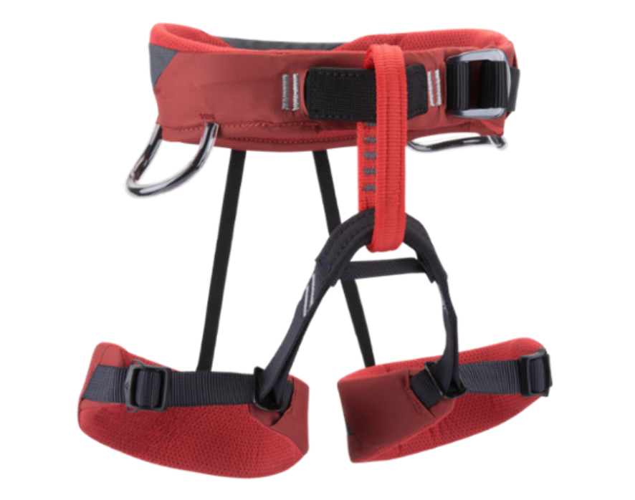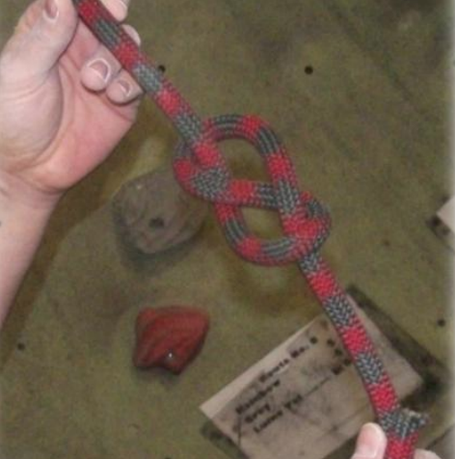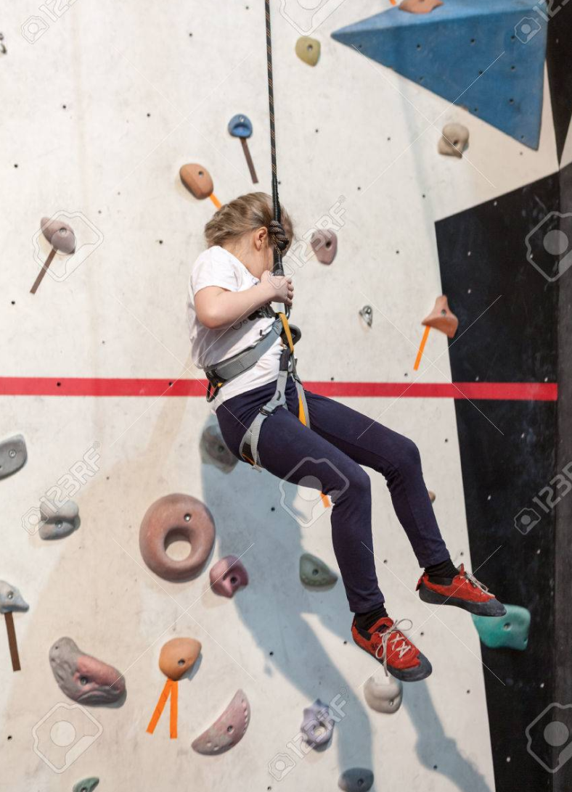

A helmet can protect your head but might make it harder to see where you are going and can get in the way sometimes. Special climbing shoes will help your feet stay where you put them.

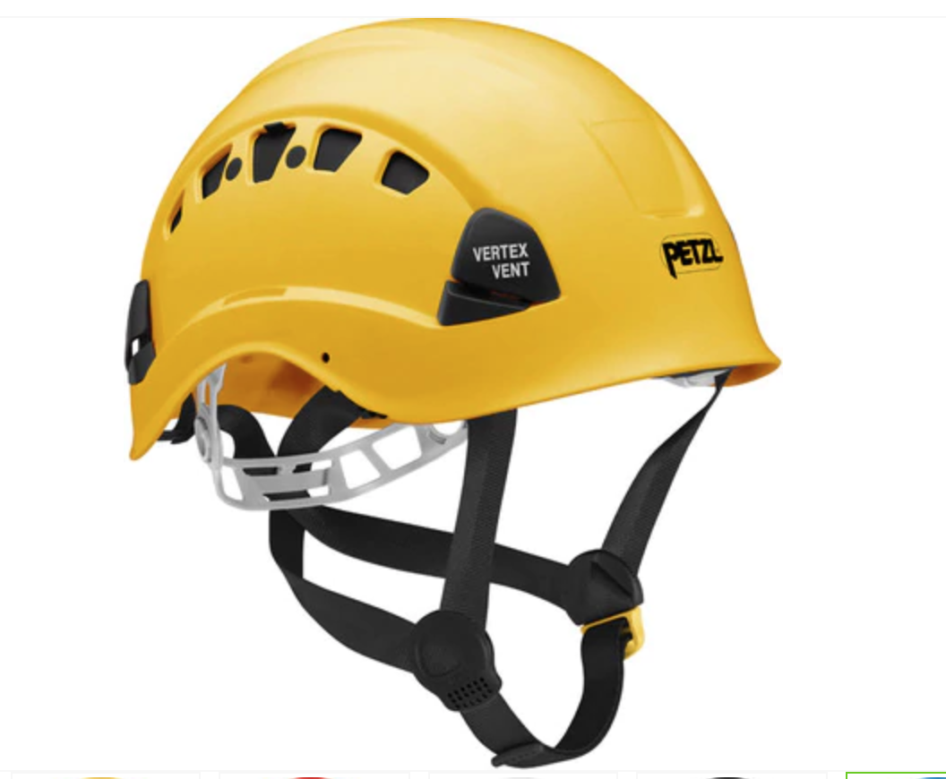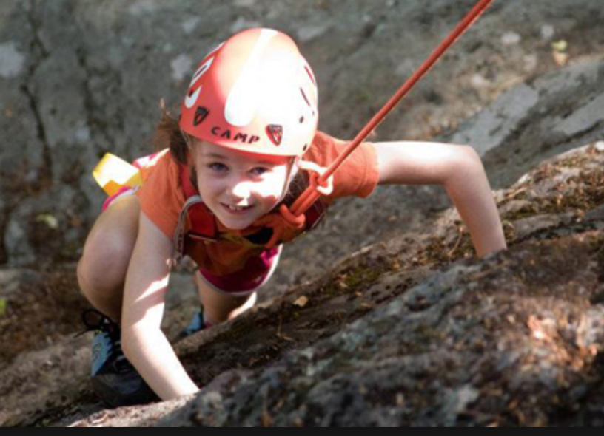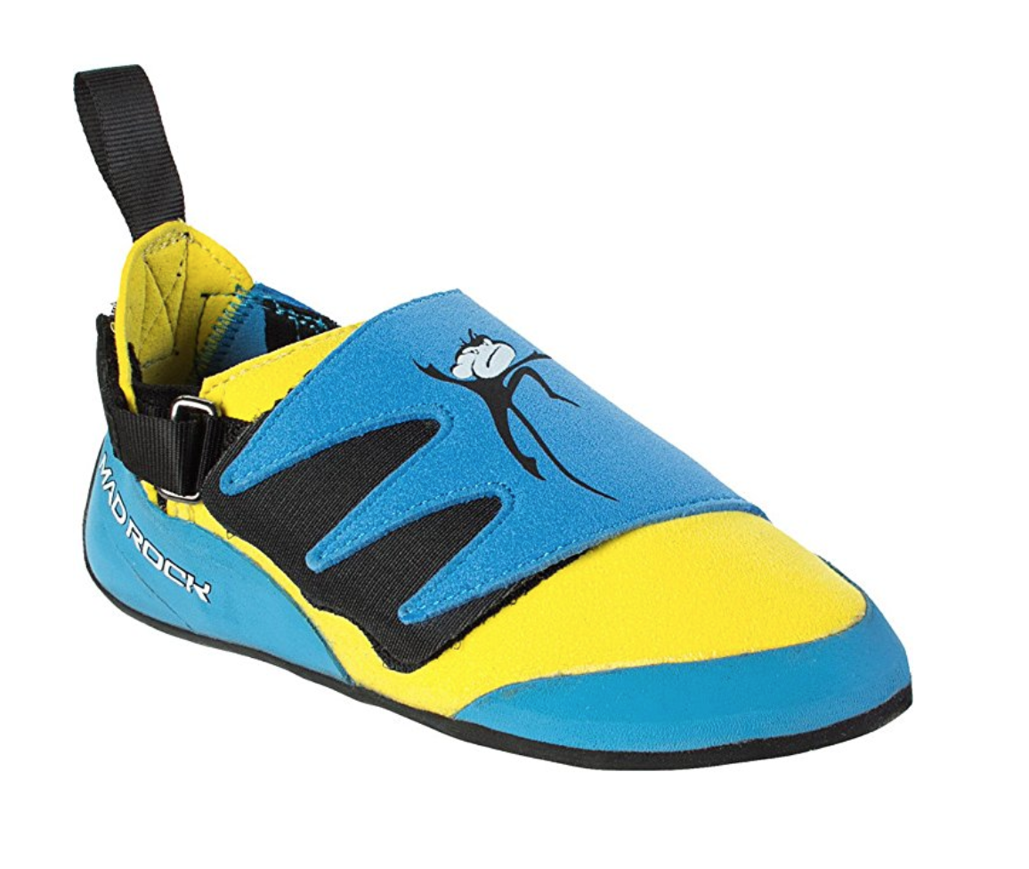

Now You’re Ready!

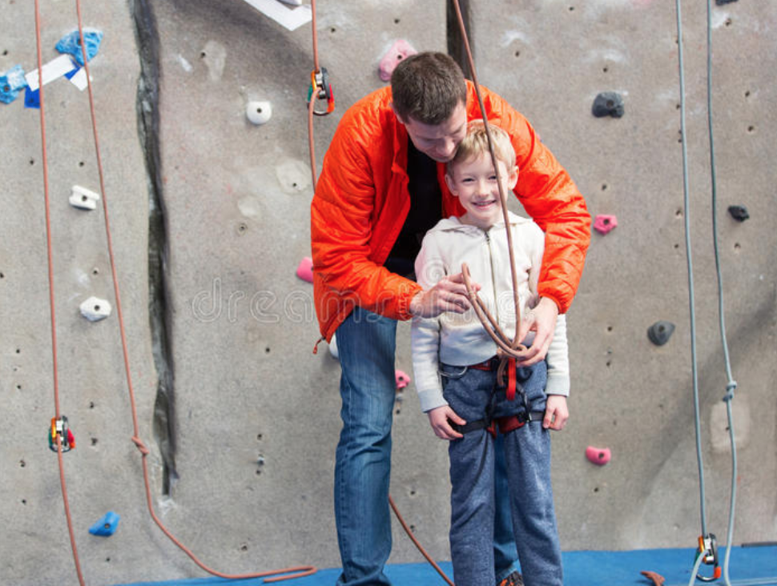

Disclaimer

Do NOT use this handout as a substitute for professional rock climbing instruction or for safety advice.

Rock climbing involves many risks and you should always seek professional assistance when attempting to learn to rock climb or to teach or take children rock climbing.

This handout is copyright of Kids Connect Us™. Do not alter, sell, or otherwise share this handout without written permission from Kids Connect Us™.

This handout was created for use as a social story for young children new to rock climbing, and for individuals with Autism.

Thank You!

Getting Back Down

After you climb up, you will need to come down. You might feel scared, but the rope will hold you.

Put your feet on the wall, lean back on the rope and walk down the wall. An adult may need to help you by showing you how.

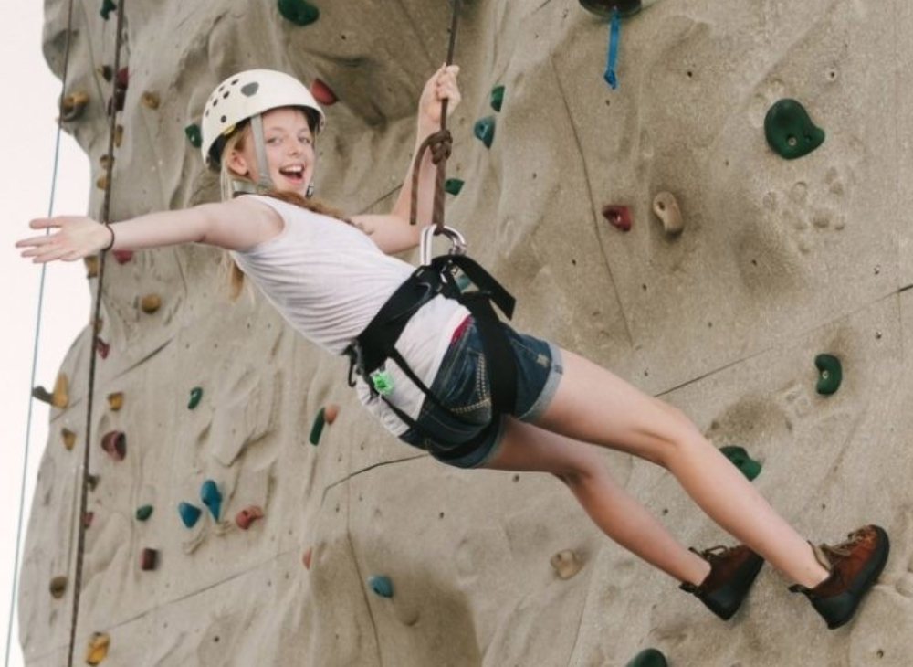

You did it! Everyone is proud of you!

Disclaimer

Do NOT use this handout as a substitute for professional rock climbing instruction or for safety advice.

Rock climbing involves many risks and you should always seek professional assistance when attempting to learn to rock climb or to teach or take children rock climbing.

This handout is copyright of Kids Connect Us™. Do not alter, sell, or otherwise share this handout without written permission from Kids Connect Us™.

This handout was created for use as a social story for young children new to rock climbing, and for individuals with Autism.

Thank you!

