Life by T.H.E. & Topanga

* 2018 Prints *

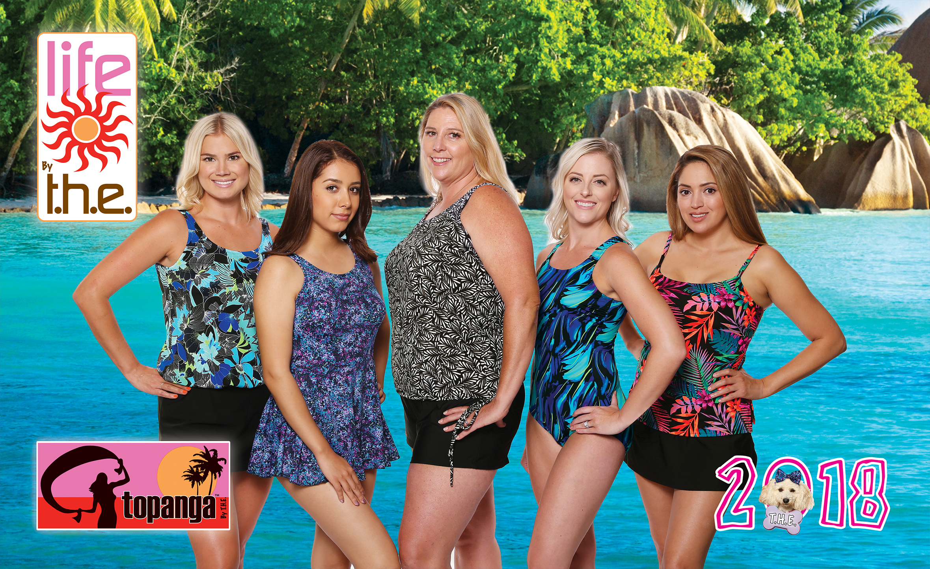

746 – Liquid Blue (Works with 409, 430, 440)
747 – Black & Tan (Works with 409, 420)
748 – Tropicana (Works with 409, 430)
749 – Wild Iris (Works with 409, 430, 440)
750 – Galaxy (Works with 409, 410, 430)
751 – Angelfish (Works with 409, 420, 430)
752 – Morikami Garden (Works with 409, 410, 430, 440)

Separate Solids:
409 – Black
410 – Marine Navy
420 – Dark Brown
430 – Caribbean Blue
440 – Deco Royal

www.the-swimwear.com

