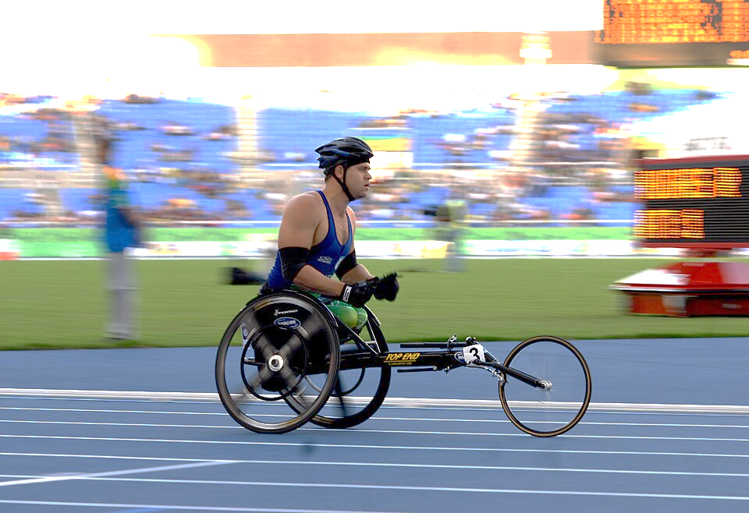
Disability Dialogue
“Communication is the key to inclusion”

Hello I'm Susan Schaffer. I have over 40 years of experience and a master’s degree in rehabilitation. What matters most is the life lessons that teach me every day. Projects I conducted are presenting, teaching, writing, job placement, job development, job coaching and skills training for individuals with intellectual disabilities. Contact me at 13suewheels13@gmail.com.
Employment- Locating/ recruiting people with challenges.
Benefits for hiring qualified disabled workers.
Accommodations explained with examples.
Professionals questions/concerns in the workplace.
Worship- Welcoming everyone to your temple.
Accommodating people with a variety of disabilities.
The benefits for individuals participating in services
“Worship as one “a video shown and discussed.
“Lunch & Learns” are about 30 minutes online or in person.

